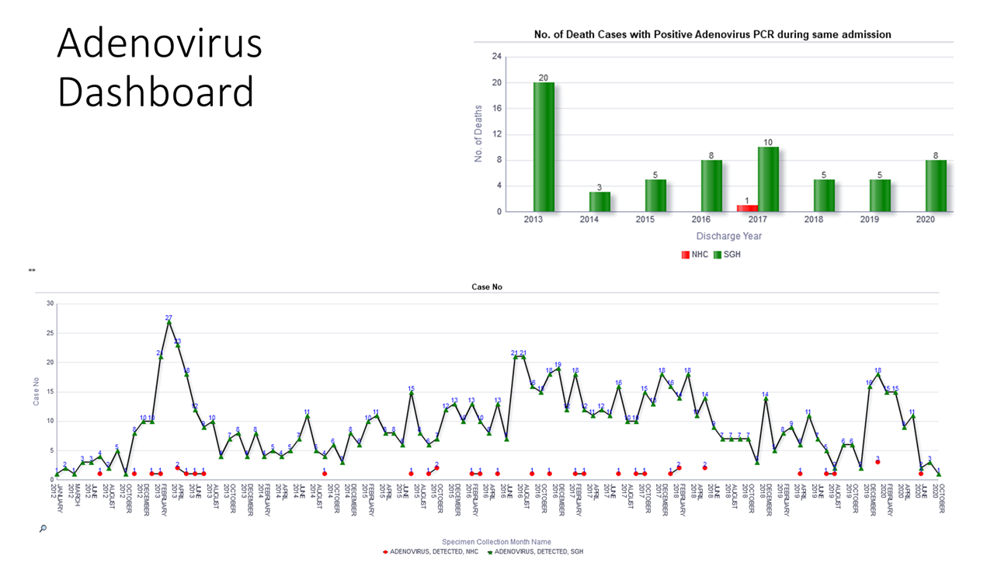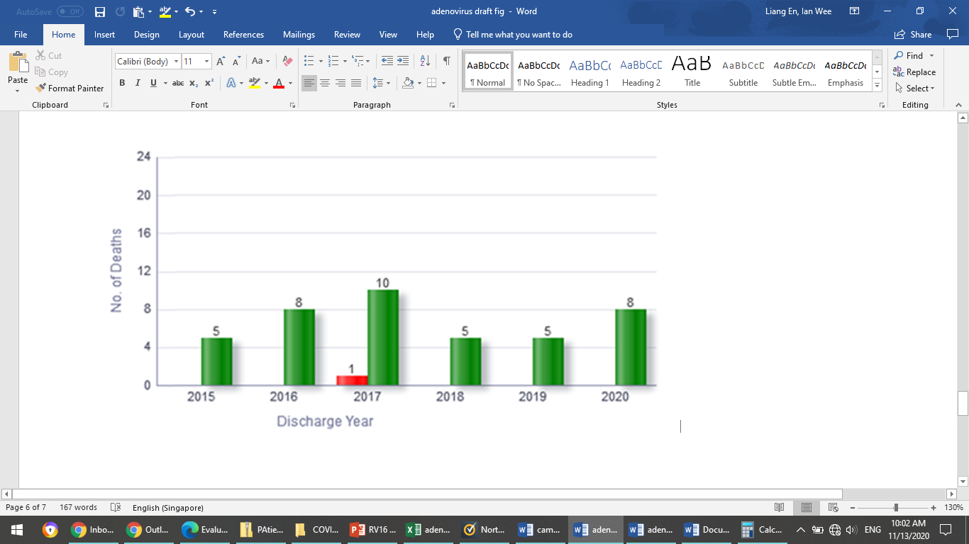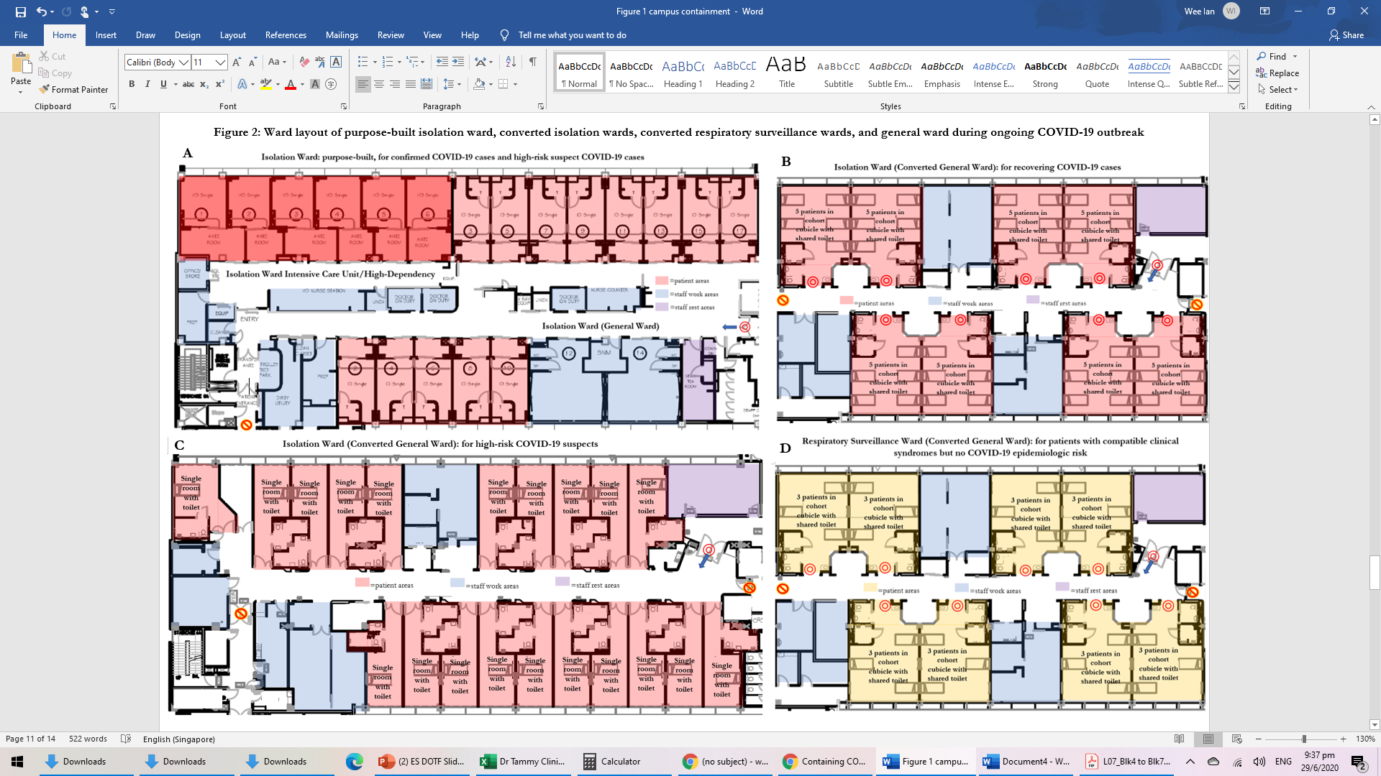

**NHC: National Heart Centre**

**SGH: Singapore General Hospital**

**Supplementary Figure 1: Details of solitary case of healthcare-associated adenoviral infection during COVID-19 pandemic; and number of death cases with PCR-proven adenoviral infections at a tertiary hospital in Singapore**

**Number of death cases with PCR-proven adenoviral infection, 2015-2020**

**B**

**Antechamber**

**Patient room**

**En-suite toilet**

**Purpose-built isolation ward**

Negative-pressure airborne isolation rooms, single occupancy, with en-suite toilet and antechamber; staff donned personal-protective-equipment prior to entry into antechamber

**Healthcare-associated adenoviral infection during COVID-19 pandemic**

Middle-aged returning traveller with concurrent COVID-19

* Duration of stay: 21 days
* Isolated in negative-pressure airborne-infection-isolation-room (AIIR) throughout admission
* No visitors allowed

Respiratory specimens on admission:

+ve for SARS-CoV-2, -ve for other viruses

Respiratory specimens on discharge:

-ve for SARS-CoV-2, +ve for adenovirus

Personal-protective-equipment in isolation ward:

Disposable gloves, gowns, eye protection, N95 respirators

(changed with every patient contact; no reuse)

**A**