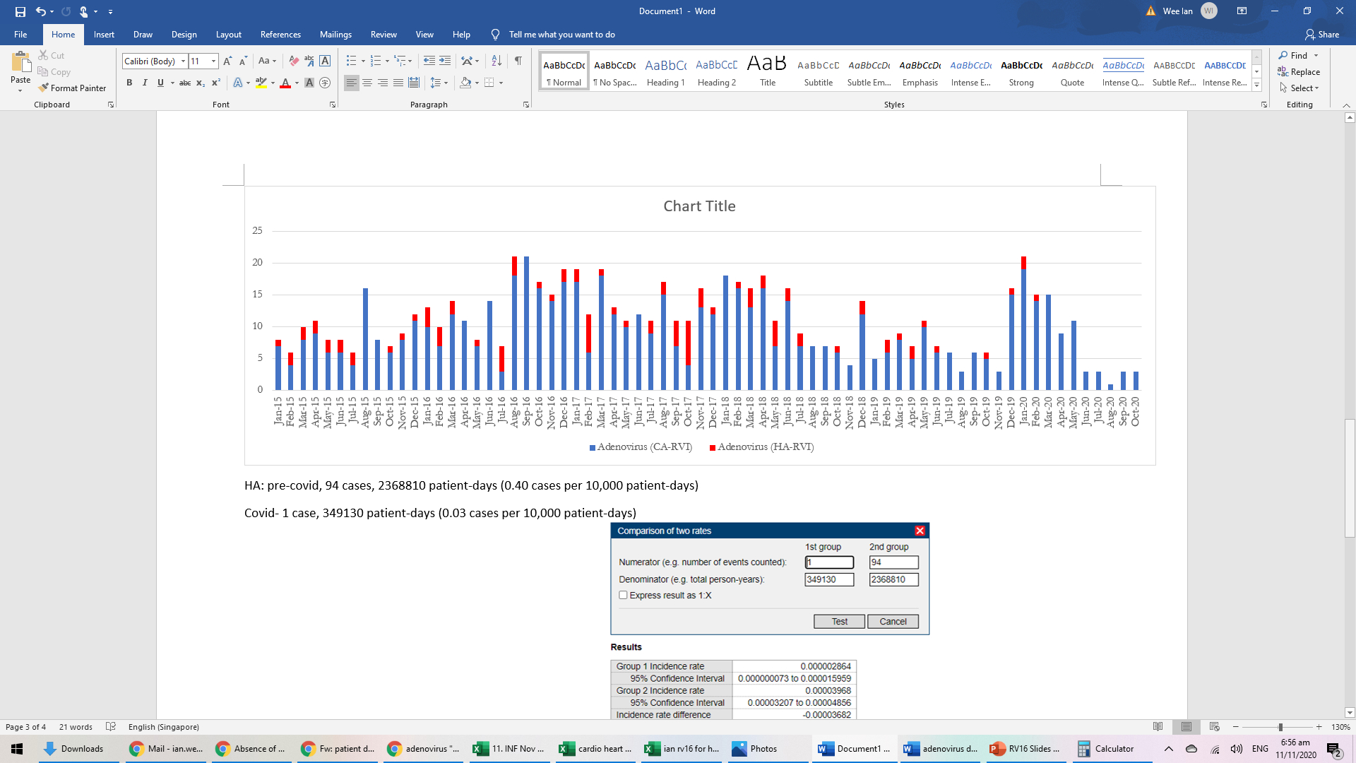

**Supplementary Figure 2: Trends in community-acquired (CA) and healthcare-associated (HA) adenoviral infections amongst all admissions to a tertiary hospital in Singapore**

**Trend in community-acquired (CA) and healthcare-associated (HA) adenoviral infections, 2015-2020, amongst all admissions**

Number of cases

COVID-19 pandemic