**Supplementary Appendix**

**Microbiologic and PICC Details**

For suspected infection in acute leukemia patients with central venous catheters during the study period, institutional guidelines recommended obtaining 2 sets of blood cultures (aerobic and anaerobic) from both a peripheral site and central line. Catheter lumen cultures were processed individually.

The BARD PowerPICC™ was the standard PICC placed during the study period, except for September 2017 – February 2018 when the BARD PowerPICC™ Provena™ was utilized. Double lumen PICCs were 4 Fr. and triple lumen PICCs were 5 Fr.

**Table S1: Univariable and Multivariable Analysis for Predictors of CLABSI**

|  |  |  |  |  |  |
| --- | --- | --- | --- | --- | --- |
|  | **Univariable Analysis** | | | **Multivariable Logistic Regression** | |
|  | **CLABSI**  **(n=47)** | **No CLABSI**  **(n=160)** | **P-value** | **OR (95% CI)** | **P-value** |
| *Demographic Variables* | | | | | |
| Age† | 60 (24 – 74) | 58 (21 – 82) | 0.775 |  |  |
| Gender, Female | 17 (36.2%) | 70 (43.8%) | 0.355 |  |  |
| Diabetes Mellitus | 13 (27.6%) | 29 (18.1%) | 0.153 | 1.721  (0.807 – 3.670) | 0.160 |
| Charlson Comorbidity Index† | 4 (2 – 7) | 4 (2 – 9) | 0.612 |  |  |
| *Disease Variables* | | | | | |
| AML Diagnosis | 35 (74.5%) | 115 (71.9%) | 0.726 |  |  |
| Newly Diagnosed | 43 (91.5%) | 146 (91.3%) | 1.000 |  |  |
| Antibiotic Use >72h | 45 (95.7%) | 143 (89.3%) | 0.255 |  |  |
| Chemo Regimen  3+7  FLAG  Other AML regimen  HyperCVAD A  Larson  Other ALL regimen | 23 (48.9%)  12 (25.5%)  3 (6.4%)  5 (10.6%)  5 (10.6%)  2 (4.3%) | 63 (39.4%)  51 (31.9%)  10 (6.3%)  10 (6.3%)  23 (14.4%)  8 (5.0%) | 0.242  0.406  1.000  0.339  0.510  1.000 |  |  |
| *Number of PICC Lumens* | | | | | |
| Triple Lumen PICC | 25 (53.2%) | 88 (55%) | 0.827 | 0.961  (0.498 – 1.854) | 0.905 |

†Median (range); Other AML regimens include MEC, FLAG-Ida, Clofarabine-based, Other ALL regimens include HyperCVAD B, and CALGB10403

**Table S2: Microbiology of CLABSI**

|  |  |
| --- | --- |
| **Pathogen** | **Number of Infections (n=47) (%)** |
| **Gram-negative Organisms** | **30 (63%)** |
| *Escherichia coli* | 14 (28%) |
| *Pseudomonas aeruginosa* | 5 (11%) |
| *Enterobacter* spp. | 4 (9%) |
| *Leptotrichia* spp. | 2 (4%) |
| *Citrobacter* spp. | 1 (2%) |
| *Proteus* spp. | 1 (2%) |
| Other gram-negative organisms | 3 (6%) |
| **Gram-positive Organisms** | **28 (57%)** |
| *Streptococcus* spp. | 8 (17%) |
| *Staphylococcus* *aureus* | 7 (15%) |
| *Enterococcus* spp. | 6 (13%) |
| Coagulase-negative *staphylococcus* | 2 (4%) |
| *Clostridium* spp. | 2 (4%) |
| Other gram-positive organisms | 5 (10%) |

Overall number of organisms does not total 47 due to polymicrobial infections; Percentages are rounded to the closest whole number

**Figure S1. Patient Enrollment and Screening**

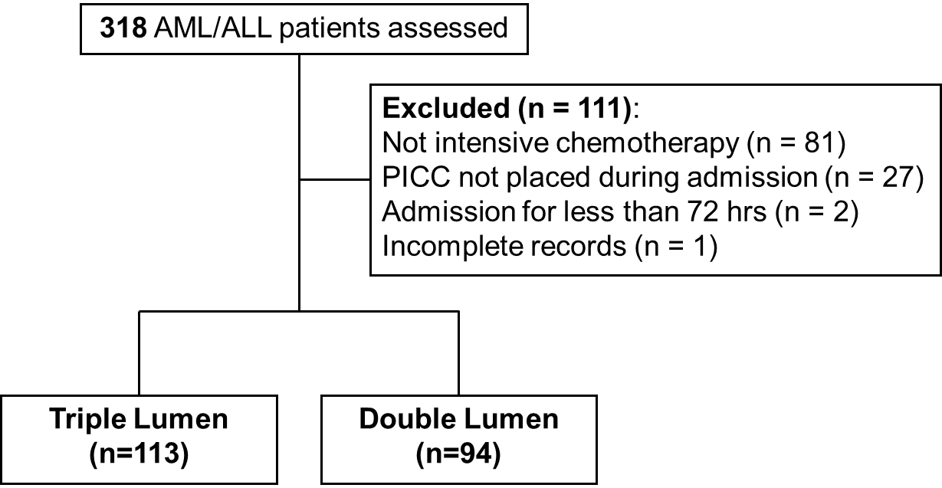

AML, acute myeloid leukemia; ALL, acute lymphoblastic leukemia; PICC, peripherally inserted central catheter

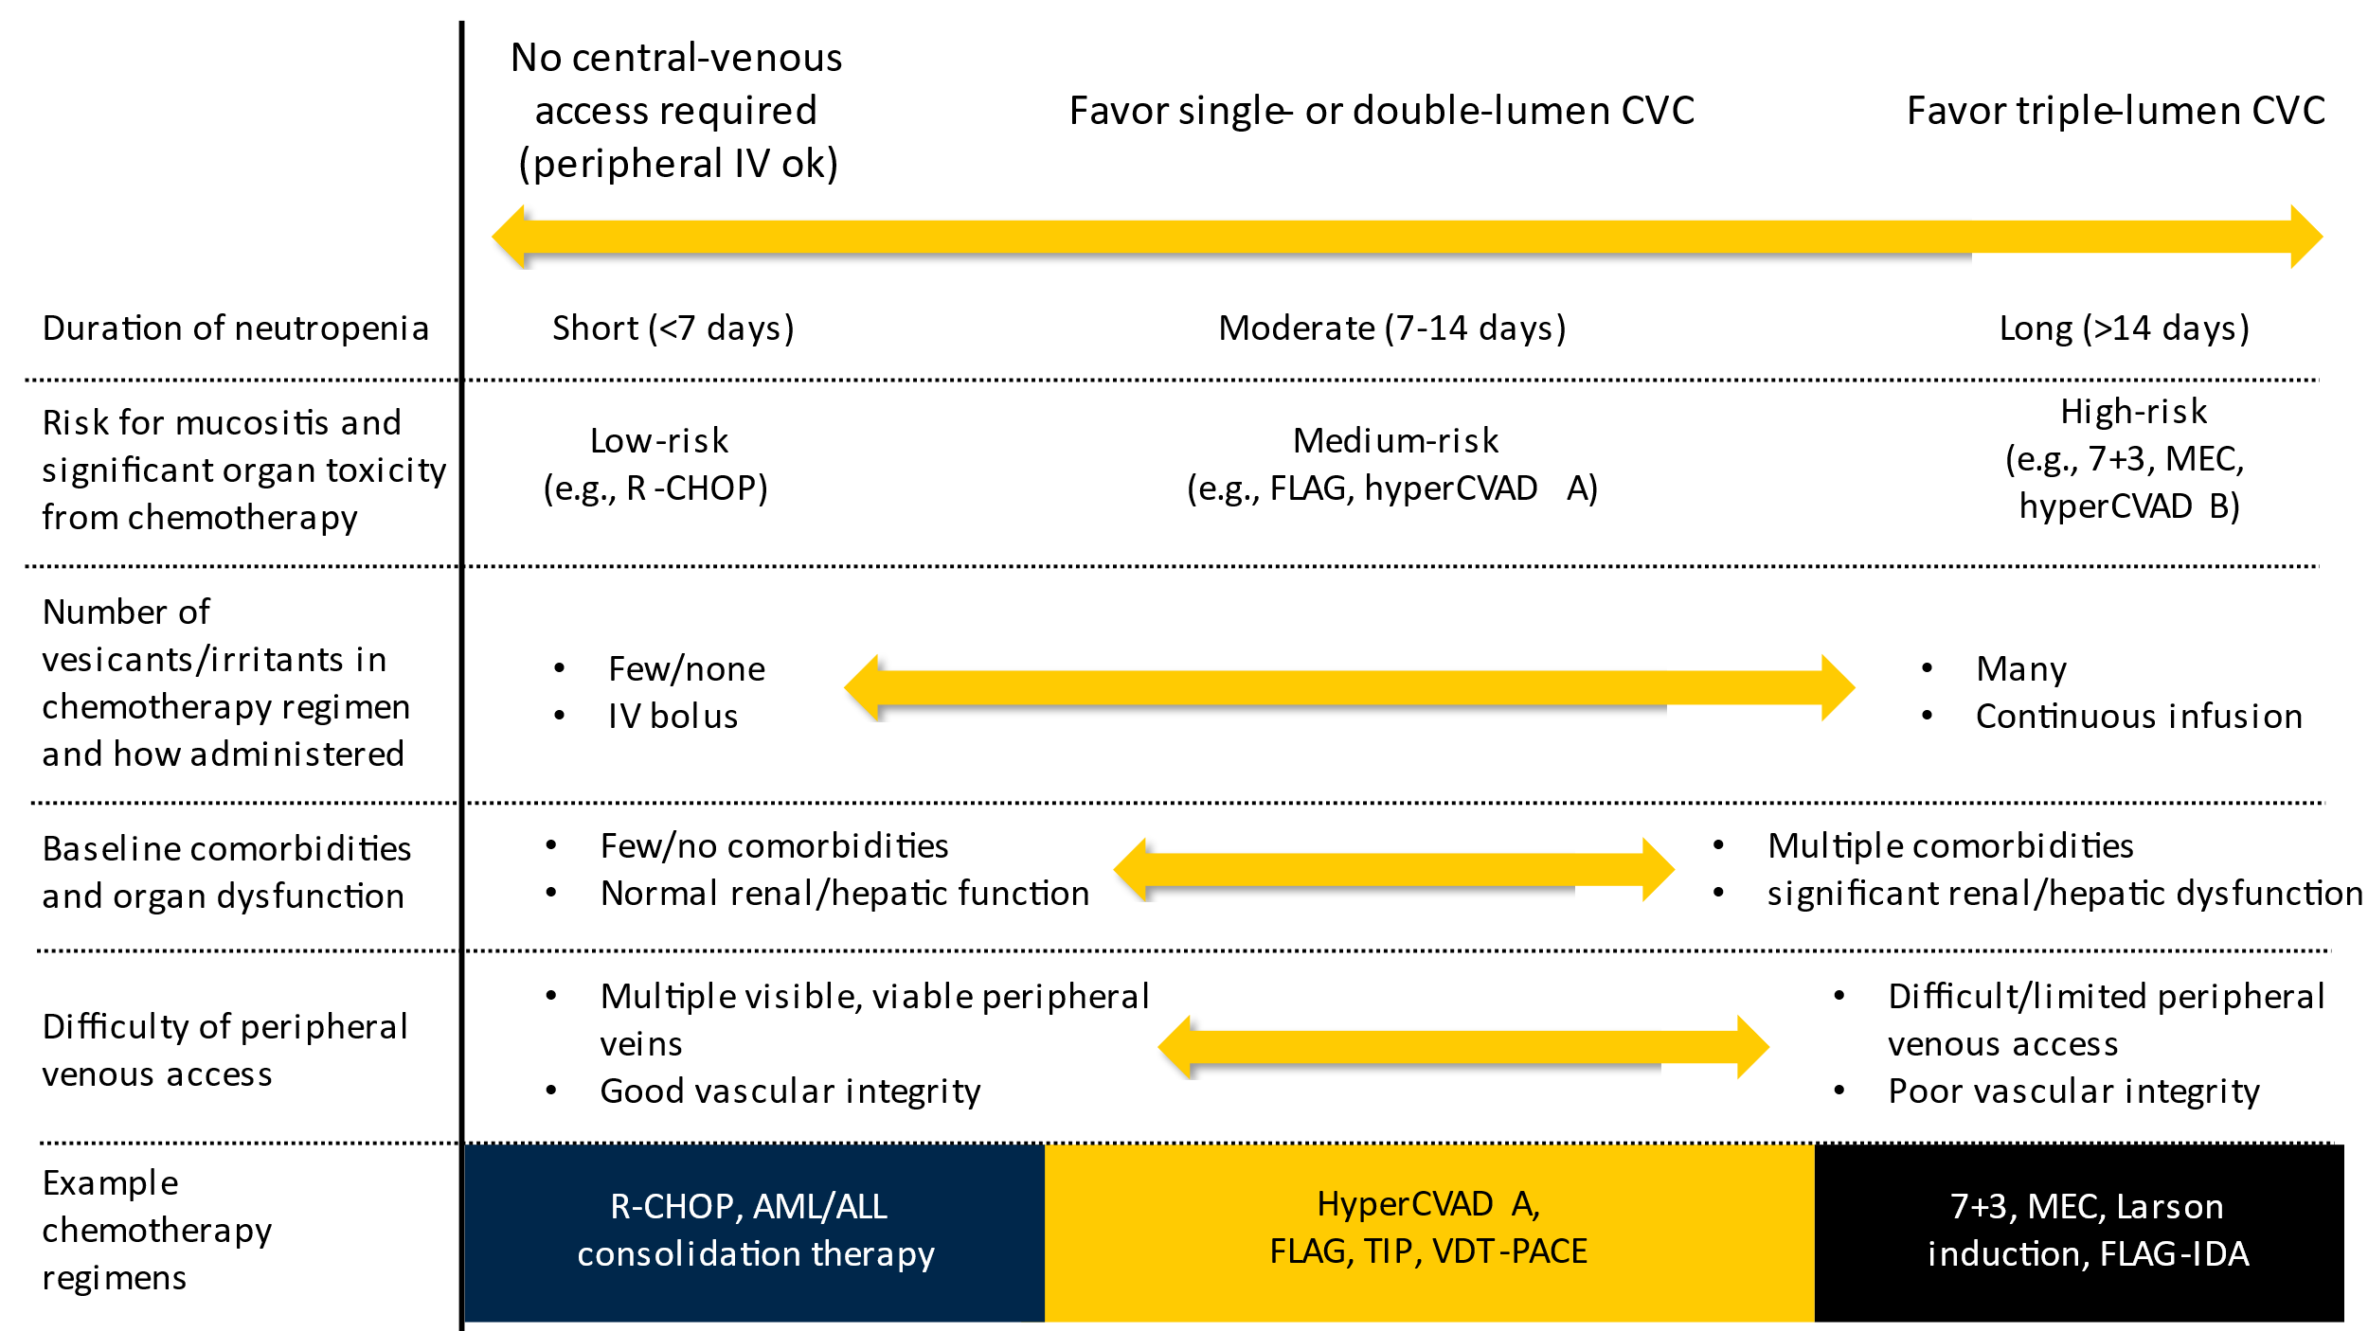**Figure S2. Factors Guiding the Selection of the Number of CVC Lumens in Hematology/Oncology Patients**

IV, intravenous; CVC, central venous catheter; R-CHOP, rituximab + cyclophosphamide + doxorubicin + vincristine + prednisone; FLAG, fludarabine + high-dose cytarabine + granulocyte colony-stimulating factor; HyperCVAD A, hyperfractionated cyclophosphamide + vincristine + doxorubicin + dexamethasone; 7+3, anthracycline (daunorubicin or idarubicin) + cytarabine continuous infusion; MEC, mitoxantrone + etoposide + cytarabine; hyperCVAD B, high-dose methotrexate + high-dose cytarabine; AML, acute myeloid leukemia; ALL, acute lymphoblastic leukemia; TIP, paclitaxel + ifosfamide + cisplatin; VDT-PACE, bortezomib + dexamethasone + thalidomide + cisplatin + doxorubicin + cyclophosphamide + etoposide; FLAG-IDA, FLAG + idarubicin

**Figure S3: Example Risk-Guided Approach to Central Venous Access Requirements for Hematology / Oncology Patients Receiving Chemotherapy**

|  |  |  |
| --- | --- | --- |
| **Disease State** | **Regimen** | **Line Requirement** |
| Acute Myeloid Leukemia | 3+7 | Triple Lumen CVC |
|  | FLAG-Ida Induction | Triple Lumen CVC |
|  | FLAG Induction | Triple Lumen CVC |
|  | FLAG Consolidation | Peripheral line |
|  | G-CLAC | Triple Lumen CVC |
|  | MEC | Triple Lumen CVC |
|  | Decitabine +/- Venetoclax | Double Lumen CVC |
|  | Decitabine +/- Venetoclax Consolidation | Peripheral line |
|  | Azacitidine +/- Venetoclax | Double Lumen CVC |
|  | Azacitidine +/- Venetoclax Consolidation | Peripheral line |
|  | HiDAC Consolidation | Peripheral line |
| Acute Lymphoblastic Leukemia | Larson +/- R | Triple Lumen CVC (Induction only; remainder peripheral line) |
|  | C10403 +/- R | Triple Lumen CVC (Induction only; remainder peripheral line) |
|  | Hyper-CVAD +/- R | Triple Lumen CVC (only for first cycle); Peripheral line for cycle 2+ |
|  | Blinatumumab | Double lumen CVC |
|  | Inotuzumab | Double lumen CVC as an IP/Peripheral line as an OP |
|  | MOAD +/- R | Triple Lumen CVC (Induction) |
| Lymphoma | EPOCH +/- R | Port |
|  | ICE +/- R | Port or single lumen CVC |
|  | ESHAP +/- R | Port or single lumen CVC |
|  | DHAP +/- R | Port or single lumen CVC |
|  | CHOP +/- R | Peripheral line |
|  | CHOEP | Peripheral line |
|  | Hyper-CVAD +/- R | Port or Double Lumen CVC (only for first cycle); Peripheral line for cycle 2+ |
|  | CODOX-M | Peripheral line |
|  | IVAC | Peripheral line |
|  | HD-Methotrexate | Peripheral line |
| Multiple Myeloma | VDT-PACE | Double Lumen CVC |
|  | Hyper-CBAD | Single Lumen CVC |
| Solid Tumor Malignancies | TIP | Port or double lumen CVC |
|  | BEP | Port or double lumen CVC |
|  | Carboplatin/etoposide | Peripheral line |

*For regimens requiring only peripheral access and contain a vesicant or irritant without a stable peripheral line, every effort should be made to ensure placement of a functioning peripheral line. If a peripheral line cannot be placed, single lumen central line may be used.*

*All regimens NOT containing a continuous infusion chemotherapy agent may be started via a peripheral line if central access cannot be placed in a timely manner*

*For regimens not listed above, please consult with Hematology Attending and/or PharmD*