Supplementary Fig. 1. Percent of incident COVID-19 hospitalizations meeting criteria for moderate-to-severe disease from March 1, 2020, to November 22, 2021, stratified by US Census region. Points represent observed percentages of incident hospitalizations with documented oxygen saturation (SpO₂) <94% or any supplemental oxygen usage (circles) or use of dexamethasone (squares) in each week of the study period, among unvaccinated (blank) or vaccinated (cross) patients. Lines (respectively, shaded areas) represent smoothed estimates (respectively, their 95% confidence intervals) over time based on Poisson regression with a penalized spline term, among unvaccinated (solid) and vaccinated (dashed) patients. Panel A is the North Atlantic Region, panel B is the Midwest Region, panel C is the Continental Region, panel D is the South East Region, and panel E is the Pacific Region.
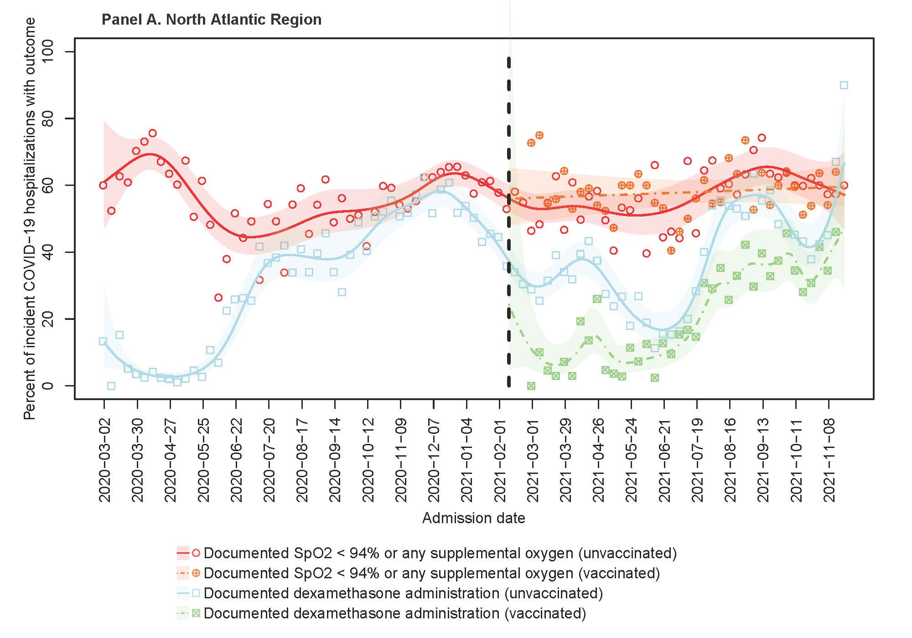
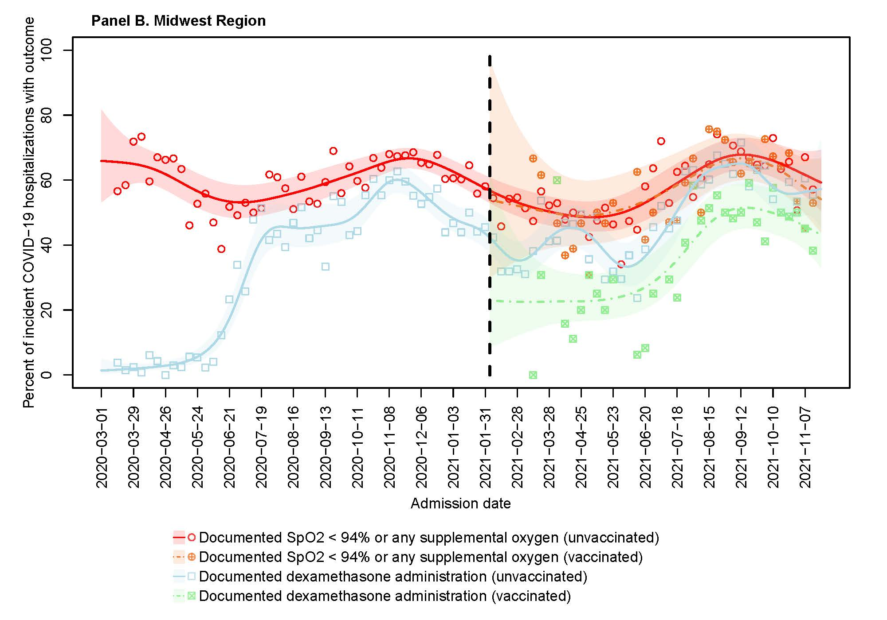
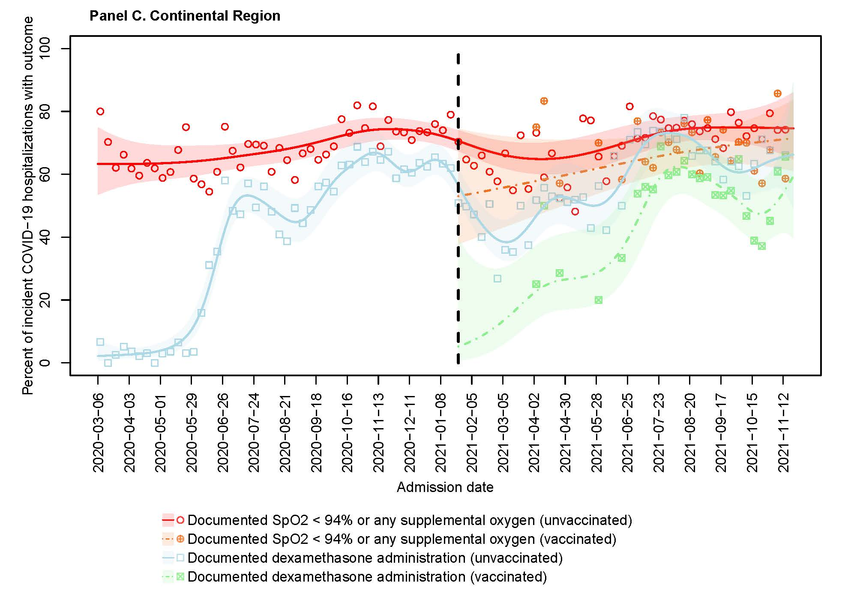

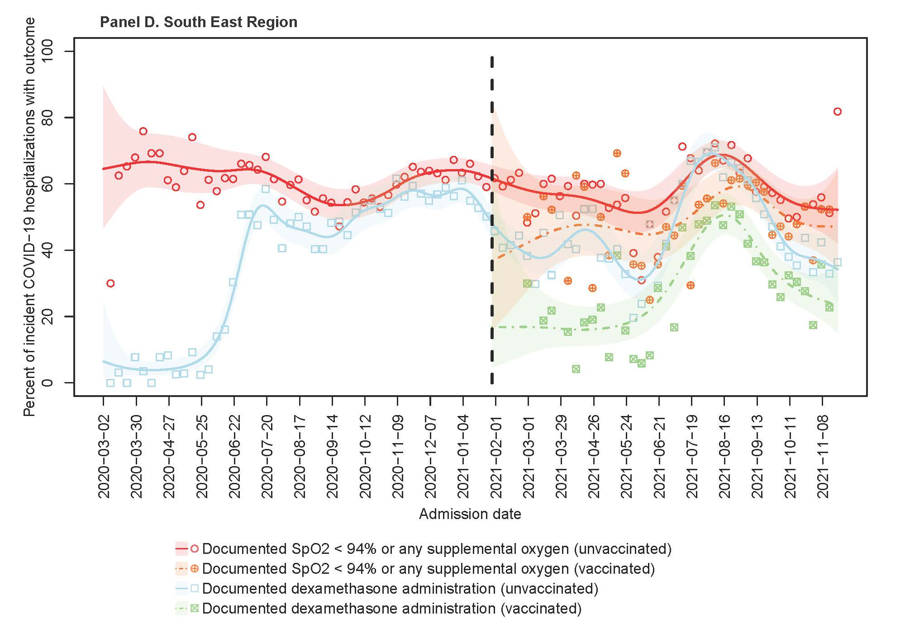
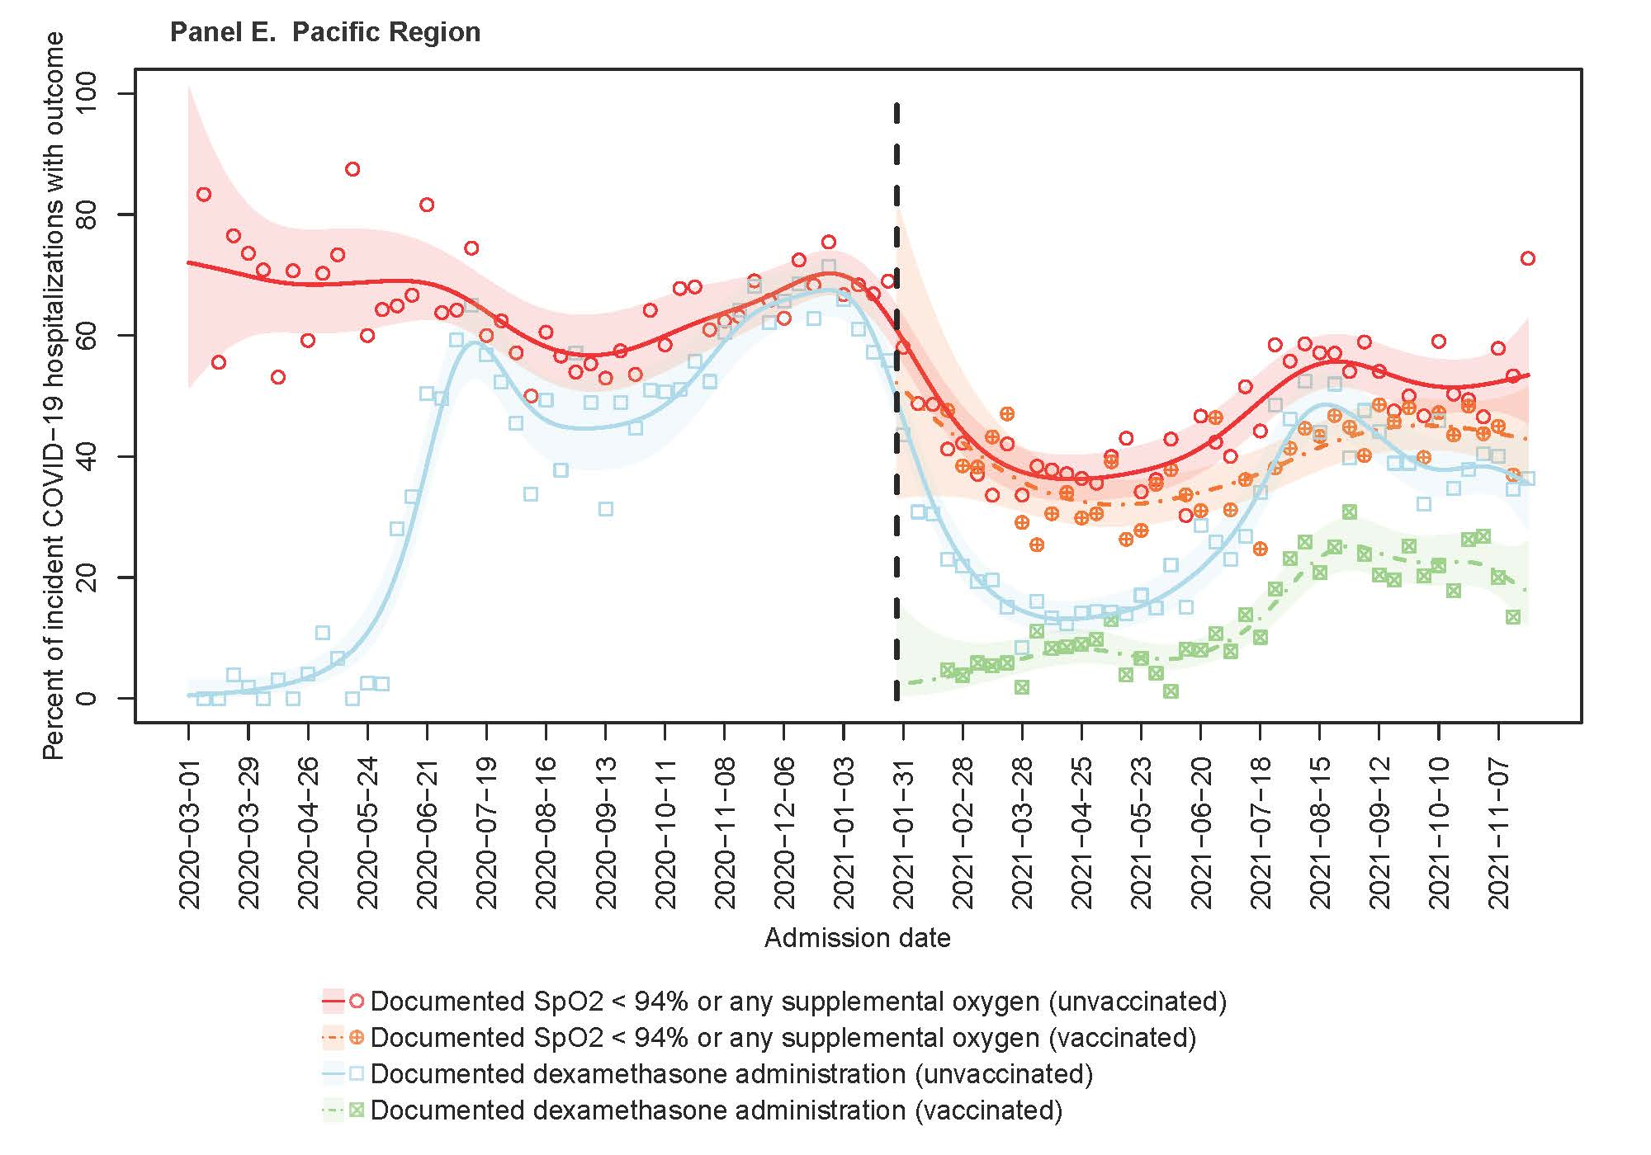

Supplementary Fig. 2. Percent of incident COVID-19 hospitalizations meeting criteria for moderate-to-severe disease from March 1, 2020, to November 22, 2021, excluding patients with lung cancer diagnosis. Points represent observed percentages of incident hospitalizations with documented oxygen saturation (SpO₂) <94% or any supplemental oxygen usage (circles) or use of dexamethasone (squares) in each week of the study period, among unvaccinated (blank) or vaccinated (cross) patients. Lines (respectively, shaded areas) represent smoothed estimates (respectively, their 95% confidence intervals) over time based on Poisson regression with a penalized spline term, among unvaccinated (solid) and vaccinated (dashed) patients. Lung cancer diagnosis was identified using the Chronic Conditions Warehouse definitions.
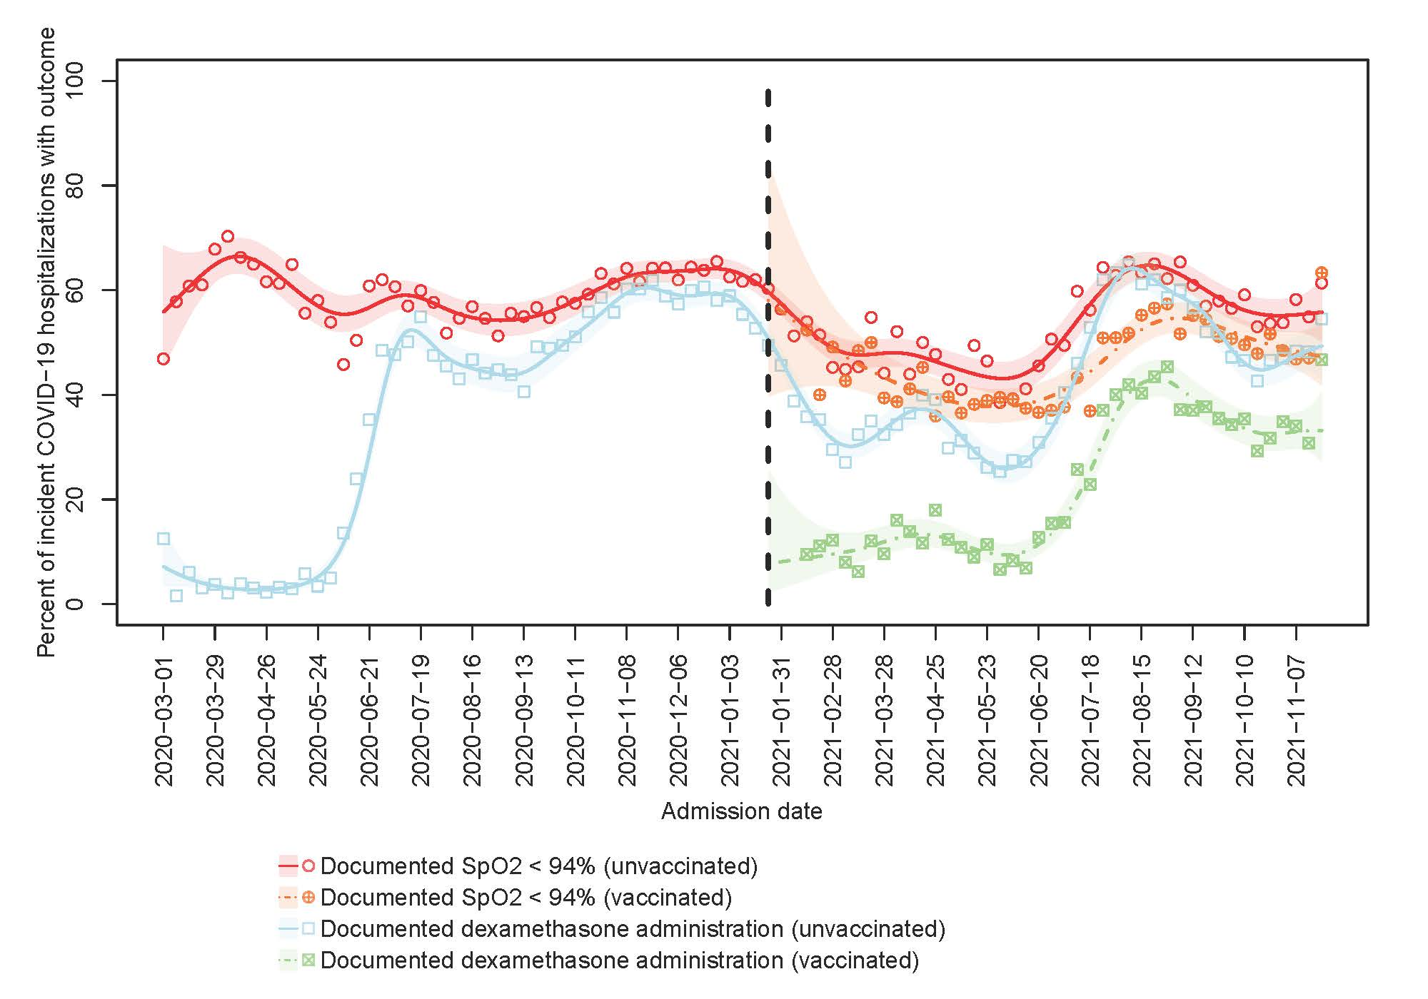

Supplementary Fig. 3. Percent of incident COVID-19 hospitalizations meeting criteria for moderate-to-severe disease from March 1, 2020, to November 22, 2021, excluding patients with chronic obstructive pulmonary disease or related conditions. Points represent observed percentages of incident hospitalizations with documented oxygen saturation (SpO₂) <94% or any supplemental oxygen usage (circles) or use of dexamethasone (squares) in each week of the study period, among unvaccinated (blank) or vaccinated (cross) patients. Lines (respectively, shaded areas) represent smoothed estimates (respectively, their 95% confidence intervals) over time based on Poisson regression with a penalized spline term, among unvaccinated (solid) and vaccinated (dashed) patients. Chronic obstructive pulmonary disease or related conditions was identified using the Chronic Conditions Warehouse definitions.
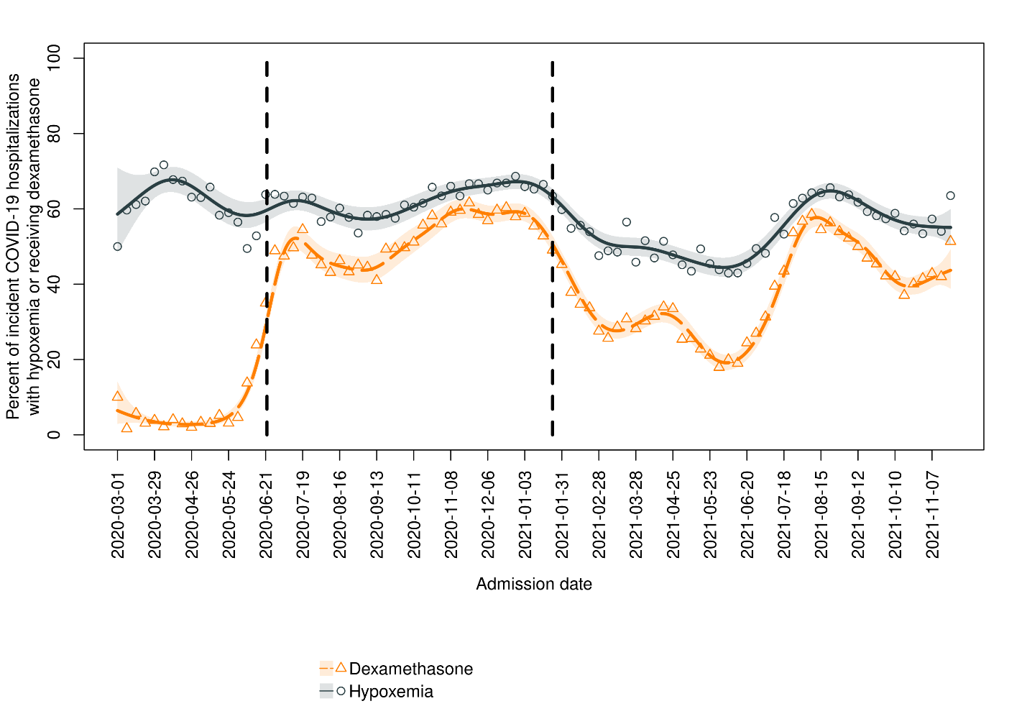

Supplementary Fig. 4. 