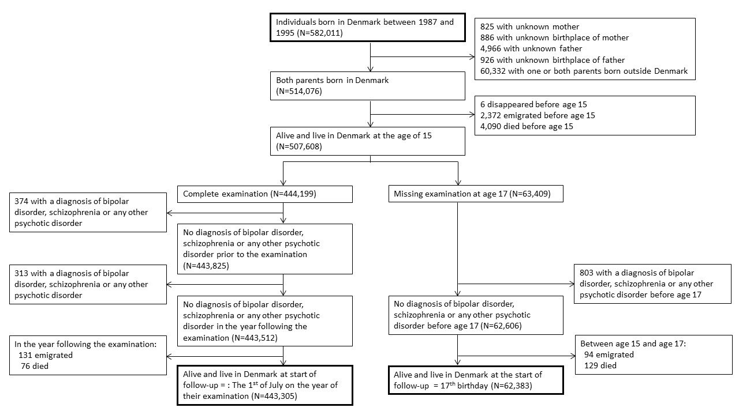**Supplementary Figure 1**: Flowchart showing the steps defining the final the study population.