Supplemental Material

1. Binary Logistic Regression Analysis

Method
As major confounders such as severity of depression, concurrent psychotropic medication, as well as the control for or substance abuse might affect our results, we validated our main findings using the analyses described below. Binary logistic regression analysis was performed to predict a positive or negative suicidal ideation as the dependent variable entering severity of depression (HAMD_17 scores), psychotropic medication status, and GMVs in significantly different clusters cross the three groups. All statistical tests were carried out using SPSS 22.0 for Windows.

Result
According to the model in which only significant predictor was included, GMVs in left DLPFC were inversely associated with suicidal ideation. In addition, suicidal ideation was no association with GMVs in right DLPFC and right VLPFC and suicidal ideation. None of the possible confounders, including severity of depression, concurrent psychotropic medication, had a significant predictor on the possibility of suicidal ideation (Table S1).

2. Two-Sample t Test

Method
Within the MDD with ideation group, we performed the further comparison between the 21 MDD without suicidal attempt and the 14 MDD with suicide attempts in the regions showing the significant differences among the MDD suicidal ideation, MDD without suicidal ideation and healthy controls. Statistical significance was determined by p < 0.05.
Result:
Significant differences in GMV were found among the two groups in the left dorsolateral PFC (DLPFC; p < 0.05; Figure S2). Figure S2 demonstrated that there was not significant GMVs in the right DLPFC and right VLPFC between the MDD with suicide attempt group and MDD with suicidal ideation group (p > 0.05).
Table S1 Logistic regression models in which patients with suicidal ideation is predicted by gray matter volume, severity of depression, concurrent psychotropic medication

Predictor | B | SE | P | OR | 95%CI
GMVs in DLPFC_L | -22.03 | 6.84 | 0.001* | 2.71ⅹ10⁻¹⁰ | (4.05ⅹ10⁻¹⁶, 1.81ⅹ10⁻⁰⁴)

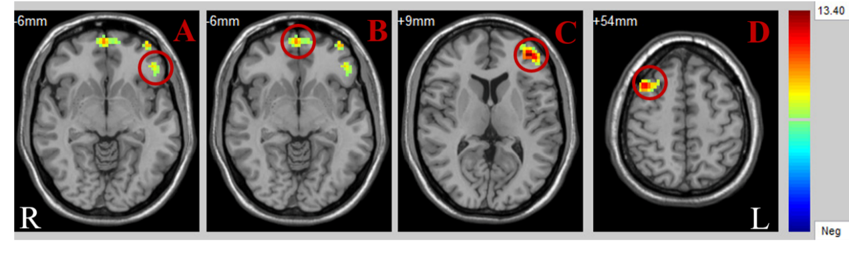
Figure S1. Significant differences in GMV between four group. p < 0.001, GRF corrected. A: left inferior orbitofrontal cortex (IOFC); B: medial orbitofrontal cortex (MOFC); C: left dorsolateral PFC (DLPFC_L); D: right dorsolateral PFC (DLPFC_R); Abbreviations: R, right; L, left.
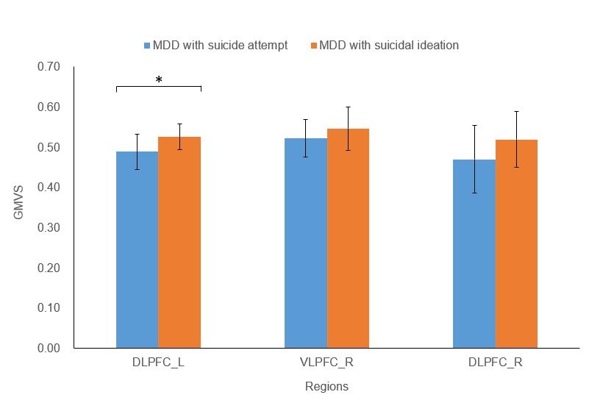
Figure S2. Two-sample t test of the brain regions with significant differences among the two groups. * p < 0.05.

