MMC1
eTable 1. Moose checklist.
Criteria |  | Brief description of how the criteria were handled in the meta-analysis
Reporting of background should include
√ | Problem definition | Preventative intervention in subjects at clinical high risk for psychosis (CHR-P) is a unique and unprecedented challenge in the history of psychiatry. It is the first psychiatric treatment that can alter the onset of devastating illnesses such as schizophrenia. Current psychometric instruments allow assessing help-seeking subjects to identify a group of people with a heightened risk of psychosis onset as compared to the general population. While meta-analytical diagnostic accuracy of diagnostic interviews for help seeking subjects for CHR-P symptoms has been investigated, that of the CAARMS (Comprehensive Assessment for At Risk Mental States) is unknown.
√ | Hypothesis statement | We tested consistency of diagnostic accuracy of the CAARMS for help seeking subjects for CHR-P. We also addressed the potential modulating effect of several confounders.
√ | Description of study outcomes | Diagnostic accuracy of the CAARMS:  * Area Under the Curve  * Summary Receiver Operating Characteristics Curves (SROC)  * Point estimates and 95% CI for Sensitivity and Specificity  * Model diagnostics
√ | Type of exposure or intervention used | CAARMS currently used as predictors of psychosis onset in people at high clinical risk
√ | Type of study designs used | Longitudinal studies
√ | Study population | Subject with a CHR-P state for psychosis defined according to international and established criteria.
Reporting of search strategy should include
√ | Qualifications of searchers | The credentials of the two investigators DO and PFP are indicated in the author list and in the acknowledgements.
√ | Search strategy, including time period included in the synthesis and keywords | The search was extended until August 2017, including only abstracts in English. The electronic research adopted several combinations of the following keywords: “at risk mental state”, “psychosis risk”, “prodrome”, “prodromal psychosis”, “ultra-high risk”, “high risk”, “help- seeking”, “diagnostic accuracy”, “sensitivity”, “specificity”, “psychosis prediction”, “psychosis onset”. The second step involved the use of Scopus to investigate citations of previous systematic reviews on transition outcomes in CHR-P subjects and a manual search of the reference lists of the retrieved articles.
√ | Databases and registries searched | Web of ScienceSM, MEDLINE® and Scopus®.
√ | Search software used, name and version, including special features | Web of KnowledgeSM and Scopus®.
√ | Use of hand searching | We hand-searched bibliographies of retrieved papers for additional references.
√ | List of citations located and those excluded, including justifications | Details of the literature search process are outlined in the supplementary materials.
√ | Method of addressing articles published in languages other than English | The search included abstract in English only
√ | Method of handling abstracts and unpublished studies | Abstracts and unpublished studies were excluded.
√ | Description of any contact with authors | We contacted all the corresponding authors to provide additional data when needed.
Reporting of methods should include
√ | Description of relevance or appropriateness of studies assembled for assessing the hypothesis to be tested | Detailed inclusion and exclusion criteria were described in the methods section.
√ | Rationale for the selection and coding of data | Data extracted from each of the studies were relevant to the population characteristics, study design, exposure, outcome, and possible effect of confounders.
√ | Assessment of confounding | Sub-groups analyses and meta-regressions were used to examine the influence of age, gender, sample size, exposure to antipsychotics, and quality of study on sensitivity and specificity.
√ | Assessment of study quality, including blinding of quality assessors; stratification or regression on possible predictors of study results | We assessed the quality of the selected studies using a pre-developed checklist referring to the QUADAS checklist. This tool has been adopted in several diagnostic accuracy meta-analyses.
√ | Assessment of heterogeneity | Heterogeneity across studies was assessed using the I^{2,} with values of 25%, 50%, and 75% representing mild, moderate, and severe inconsistency, respectively. The meta-regression was planned to be used if there was substantial heterogeneity (I²>50%).
√ | Description of statistical methods in sufficient detail to be replicated | Description of methods of meta-analyses, sensitivity analyses, meta-regression and assessment of publication bias are detailed in the methods.
√ | Provision of appropriate tables and graphics | We included the PRISMA flow-chart and several tables to describe the literature search and its results. Several graphs were used to describe the main findings of the analyses.
Reporting of results should include
√ | Graph summarizing individual study estimates and overall estimate | We have appended them in the main text. Additional graphs were presented as supplementary material to fully describe the results.
√ | Table giving descriptive information for each study included | Results appended in specific tables are requested
√ | Results of sensitivity testing | Sensitivity analyses (i.e. exclusion of 1 study at a time) after outliers’ identification were reported in the main text and supplementary results when appropriate.
√ | Indication of statistical uncertainty of findings | A SROC graph was used to plot around the summary estimates, a 95% confidence region and a 95% prediction region to illustrate the precision with which the summary values were estimated (confidence ellipse of a mean) and to show the amount of between-study variation (prediction ellipse; the likely range of values for a new study).
Reporting of discussion should include
√ | Quantitative assessment of bias | Not performed as indicated in the methods.
√ | Justification for exclusion | Exclusion criteria were: (a) abstracts, pilot datasets, reviews, articles in language other than English; (b) articles failing to report enough data to perform a meta-analysis; (c) articles with overlapping datasets. Specifically, in case of multiple publications deriving from the same study population, we selected the articles reporting the largest and most recent data set.
√ | Assessment of quality of included studies | We discussed the results of the QUADAS assessment and the relevant meta-regression analyses in the main text. We have specifically tested the impact of QUADAS scores in a specific plot appended as supplementary material.
Reporting of conclusions should include
√ | Consideration of alternative explanations for observed results | We discussed alternative explanations for our findings, specifically considering potential methodological shortcomings.
√ | Generalization of the conclusions | We presented estimates based on 95% CI of meta-analytical transition risks in people at high clinical risk for psychosis. The results were appended in the main text and in the supplementary material. This analysis was further complemented by the probability modifying plot.
√ | Guidelines for future research | This study will allow multicenter studies and consensus conferences in the CHR-P field
√ | Disclosure of funding source | None

eTable 2. QUADAS assessment
Study | Total  score | Representative  spectrum | Patient  selection | Reliability of reference standard | Diagnostic  verification | Consistency of reference standard | Reference Standard – Index test independence | Satisfactory description of index test | Satisfactory description of reference standard | Blinded index test interpretation | Blinded reference standard interpretation | Availability of clinical information | Clear interpretation of results | Satisfactory reporting of results | No Exposure to Antipsychotic
(Yung et al. 2008) ¹ | 12 | 1 | 1 | 1 | 1 | 1 | 0 | 1 | 1 | 1 | 1 | 0.5 | 1 | 1 | 0.5
(Lee et al. 2013) ² | 13 | 1 | 1 | 1 | 1 | 1 | 1 | 1 | 1 | 1 | 1 | 1 | 1 | 0 | 1
(Fusar-Poli et al. 2017) ³ | 11.5 | 1 | 1 | 1 | 1 | 1 | 0 | 1 | 1 | 0.5 | 0.5 | 1 | 1 | 1 | 0.5
(Francesconi et al. 2017) ⁴ | 12 | 1 | 1 | 1 | 1 | 1 | 0 | 1 | 1 | 0.5 | 0.5 | 1 | 1 | 1 | 1
(Kotlicka-Antczak et al. 2015) ⁵ | 11.5 | 1 | 1 | 1 | 1 | 1 | 0 | 1 | 1 | 0.5 | 0.5 | 0.5 | 1 | 1 | 1
(Spada et al. 2016) ⁶ | 11 | 0 | 1 | 1 | 1 | 1 | 1 | 1 | 1 | 1 | 1 | 1 | 0 | 1 | 0

eFigure 1. QUADAS results 251658240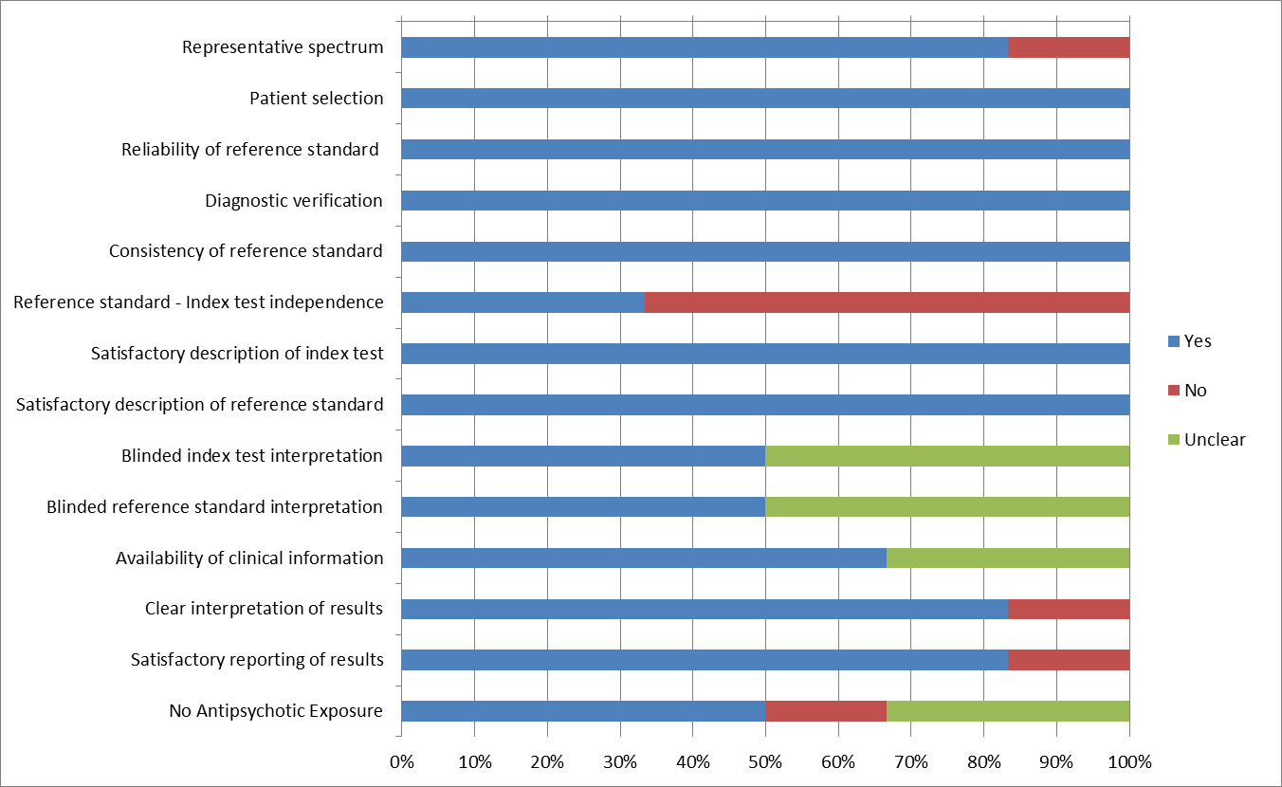
eFigure 2. Assessment of Heterogeneity
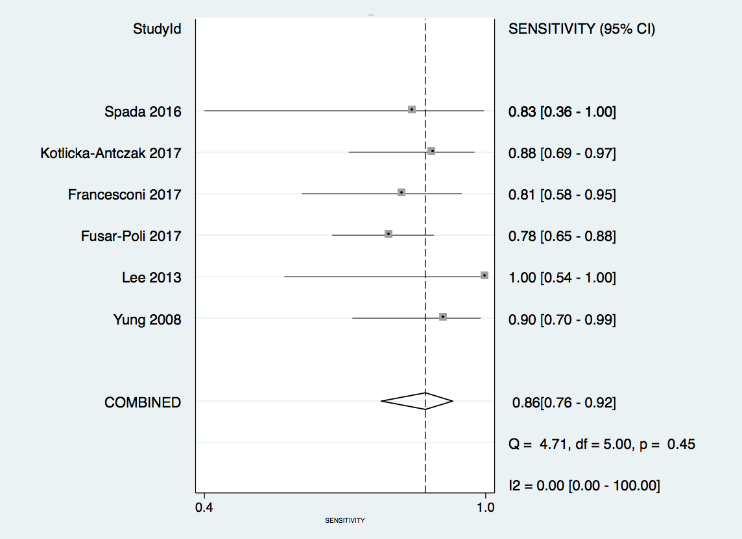
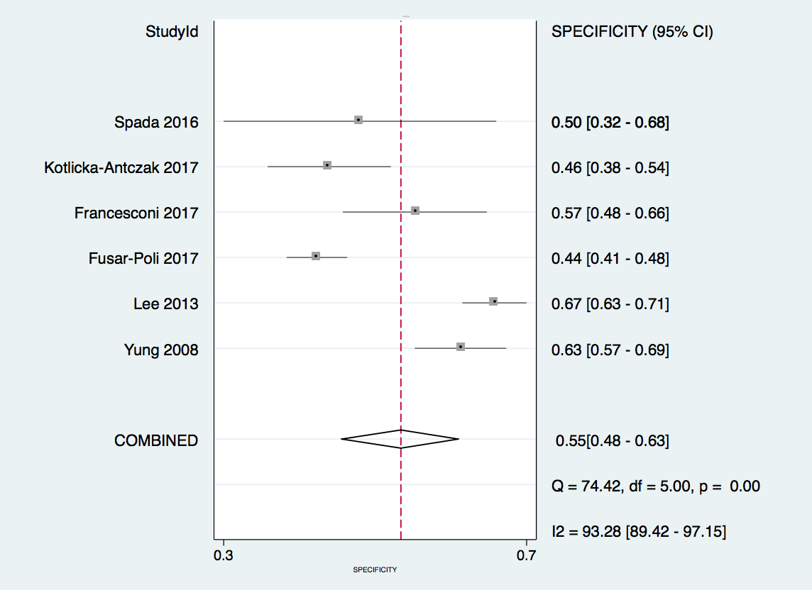
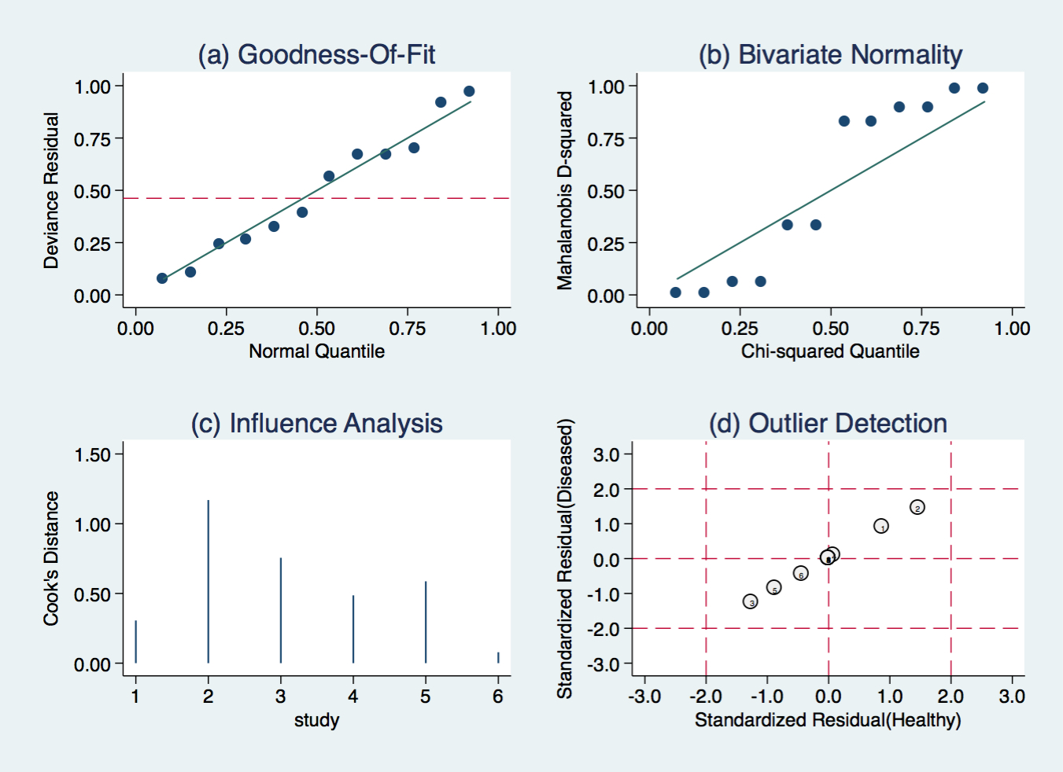
eFigure 3. Model diagnostics

REFERENCES
- Yung AR, Nelson B, Stanford C, Simmons MB, Cosgrave EM, Killackey E, et al. Validation of “prodromal” criteria to detect individuals at ultra high risk of psychosis: 2 year follow-up. Schizophr Res. 2008 Oct;105(1-3):10–7.
- Lee J, Rekhi G, Mitter N, Bong YL, Kraus MS, Lam M, et al. The Longitudinal Youth at Risk Study (LYRIKS)--an Asian UHR perspective. Schizophr Res. 2013 Dec;151(1-3):279–83.
- Fusar-Poli P, Rutigliano G, Stahl D, Davies C, De Micheli A, Ramella-Cravaro V, et al. Long-term validity of the At Risk Mental State (ARMS) for predicting psychotic and non-psychotic mental disorders. Eur Psychiatry. 2017 May;42:49–54.
- Francesconi M, Minichino A, Carrión RE, et al. Psychosis prediction in secondary mental health services. A broad, comprehensive approach to the “at risk mental state” syndrome. Eur Psychiatry 2017;40:96-104. doi:10.1016/j.eurpsy.2016.09.002.
- Kotlicka-Antczak M, Pawełczyk T, Rabe-Jabłońska J, Pawełczyk A. PORT (Programme of Recognition and Therapy): the first Polish recognition and treatment programme for patients with an at-risk mental state. Early Interv Psychiatry. 2015 Aug;9(4):339–42.
- Spada G, Molteni S, Pistone C, Chiappedi M, McGuire P, Fusar-Poli P, et al. Identifying children and adolescents at ultra high risk of psychosis in Italian neuropsychiatry services: a feasibility study. Eur Child Adolesc Psychiatry. 2016 Jan;25(1):91–106.

