**Supplementary Online Content**

**eAppendix.** Bootstrap resampling.

**eMethods.** CAARMS-based definition of at-risk mental state status (ARMS)  
**eTable1**. Potential Predictor domains and individual variables for the Cox Proportional Hazards Model.  
**eTable2.** Predictive transition to psychosis models adjusted for confounding variables  
**eFigure1.** Receiver-Operating characteristics (ROC) curve for the Four Variables-Cox Proportional Hazards Model.  
**eFigure2**. Receiver-Operating characteristics (ROC) curve for the SPS Variable Removed (trait markers only) Cox Proportional Hazards Model.

**eFigure3**. Receiver-Operating characteristics (ROC) curve for the CAARMS only-Cox Proportional Hazards Model.

**eModel.** Predictive model of psychosis transition in ARMS+ only (n=67)

**eMatrix**. Intercorrelations among measures included in the final models

**eAppendix**.

*Bootstrap resampling*

Bootstrap resampling with replacement was used to internally validate the predictors in the final models on the whole group participants1. Bootstrapping involved randomly sampling the data with replacement (B=10,000 bootstrap samples) for the predictors in the final model and repeating the Cox Proportional Hazards Model analyses to assess the accuracy of the confidence intervals. The bootstrap corrected 95% confidence intervals (95% CI) for each of the significant predictors in the final models did not overlap with 0, suggesting that the final predictor models was not overfit to the data.

**eMethods**

*CAARMS-based definition of at-risk mental state status (ARMS)*

ARMS+ individuals were identified by one or more of the following characteristics: 1) Attenuated Psychotic Symptoms (APS) — individuals who have experienced subthreshold, attenuated forms of positive psychotic symptoms during the past year, 2) Brief Limited Intermittent Psychotic Symptoms (BLIPS) — individuals who have experienced episodes of frank psychotic symptoms that have not lasted longer than a week and have spontaneously abated, and 3) Trait and State Risk Factor (Trait) — individuals who have a first-degree relative with a psychotic disorder or who have a schizotypal personality disorder in addition to a significant decrease in functioning during the previous year.

**eTable1.** Potential Predictor Domains and Individual Variables for the Cox Proportional Hazard Model *“Transition to Psychosis”.*

|  |  |  |  |  |
| --- | --- | --- | --- | --- |
| **Domain** | **Variables** | **Variables Retained after Univariable screening procedure for “Transition to Psychosis” (p<.10)** | **Variables Retained**  **After Multivariate Cox Regression**  **Across Domains, Blockwise (p<.15)** | **Final Model** |
| **Demographics** | -Age at baseline -Education (years) -Gender -Employment |  |  |  |
| **Clinical information** | Diagnosis:  -Any mood disorder -Any anxiety disorder -Any personality disorder -Multiple diagnoses  Risk Status:  APS  BLIPS  GRD  -Duration of illness (years)  -Medication exposure at baseline  -PANSS General total Score  -Drug Exposure during follow up |  |  |  |
| **Positive Symptoms** | CAARMS:  -Disorder of Thought Content  -Non bizarre Ideas  -Perceptual Abnormalities  -Disorganized Speech -Total Positive Score  -PANSS:  -Positive total score | CAARMS:  -Disorder of Thought Content  -Non bizarre Ideas  -Perceptual Abnormalities  -Disorganized Speech -Total Positive Score  -PANSS:  -Positive total score | CAARMS:  -Disorder of Thought Content  -Total Positive Score | CAARMS:  -Disorder of Thought Content |
| **Negative Symptoms** | CAARMS:  -Avolition  -Anhedonia  -Alogia -Total Negative Score  PANSS:  -Negative total score | CAARMS:  -Avolition -Total Negative Score | CAARMS:  -Avolition |  |
| **Emotional Disturbances, CAARMS** | -Subjective Emotional Disturbances -Observed Blunted Affect -Observed Inappropriate Affect -Total Emotional Disturbances | None |  |  |
| **Cognitive Change, CAARMS** | -Subjective Experience  -Observed Cognitive Change -Total Cognitive Change Score | None |  |  |
| **Behavioral Change, CAARMS** | -Social Isolation  -Impaired Role Functioning  -Disorganized Odds Stigmatizing Behavior  -Aggression Dangerous Behavior -Total Behavioral Change Score | None |  |  |
| **Neurocognitive Performance,**  **RBANS** | -Immediate Memory -Language -Visuospatial -Attention -Delayed Memory | -Visuospatial -Attention | -Visuospatial | -Visuospatial |
| **Neurological Soft Signs, NES** | -Motor Coordination -Sensory Integration -Sequencing of complex motor acts -Others -Total NES Score | -Sensory Integration | -Sensory Integration | -Sensory Integration |
| **Theory of Mind** | -Faux Pas  -RMET  -Th.o.m.a.s A  -Th.o.m.a.s B  -Th.o.m.a.s C  -Th.o.m.a.s D | *-*Faux Pas  -Th.o.m.a.s A  -Th.o.m.a.s B  -Th.o.m.a.s C  -Th.o.m.a.s D | -Faux Pas  -Th.o.m.a.s B | -Faux Pas |
| **Baseline Functioning** | -GAF  LSP-39: -Self Care -Non Turbulence -Social Contact -Communication -Responsibility -Total LSP-39 Score | LSP-39:  -Social Contact -Communication | -Communication |  |

Abbreviations: CAARMS, Comprehensive Assessment of At Risk Mental State ; PANSS, Positive And Negative Syndrome Scale; GAF, Global Assessment of Functioning; LSP-39, Life Skill Profile 39 item; RBANS, Repeatable Battery for the Assessment of Neuropsychological Status; RMET, Reading the Mind Eyes in the Test; Th.o.m.a.s., Theory Of Mind Assessment Scale; NES, Neurological Evaluation Scale.

**eTable2**. Predictive transition to psychosis models adjusted for confounding variables

|  |  |  |  |  |  |  |
| --- | --- | --- | --- | --- | --- | --- |
| **[Confounding variable]** | **β** | **SE** | **Wald *X2*** | **Hazard Ratio** | ***P* Value** | |
| ***Drug Abuse in the Four Variables Model*** | | | | | | |
| Disorder of Thought Content ≥ 3 | 1.50 | 0.54 | 7.58 | 4.48 | **0.006** | |
| Visuospatial Index ≤ 89 | 1.68 | 0.50 | 11.00 | 5.39 | **0.001** | |
| Sensory Integration subscale ≥ 3 | 1.44 | 0.46 | 9.71 | 4.24 | **0.002** | |
| Faux Pas ≤ 16 | 1.42 | 0.48 | 8.71 | 4.14 | **0.003** | |
| [Drug Abuse] | 0.308 | 0.34 | 0.785 | 1.36 | 0.375 | |
| ***Drug Abuse in the SPS Variable Removed-trait markers only Model*** | | | | | | |
| Visuospatial Index ≤ 89 | 1.40 | 0.489 | 8.28 | 4.08 | **0.004** | |
| Sensory Integration subscale ≥ 3 | 1.50 | 0.464 | 10.48 | 4.49 | **0.001** | |
| Faux Pas ≤ 16 | 1.82 | 0.472 | 15.02 | 6.22 | **0.000** | |
| [Drug Abuse] | 0.274 | 0.333 | 0.67 | 1.31 | 0.410 | |
| ***Psychotherapy intervention at follow up in the Four Variables Model*** | | | | | | |
| Disorder of Thought Content ≥ 3 | 1.60 | 0.542 | 8.72 | 4.95 | **0.003** | |
| Visuospatial Index ≤ 89 | 1.86 | 0.517 | 13.04 | 6.46 | **0.000** | |
| Sensory Integration subscale ≥ 3 | 1.42 | 0.462 | 9.50 | 4.14 | **0.002** | |
| Faux Pas ≤ 16 | 1.46 | 0.463 | 10.06 | 4.34 | **0.002** | |
| [Psychotherapy] | -0.880 | 0.591 | 2.21 | 0.415 | 0.137 | |
| ***Psychotherapy intervention at follow up in the SPS Variable Removed-trait markers only*** | | | | | | |
| Visuospatial Index ≤ 89 | 1.50 | 0.49 | 9.26 | 4.49 | | **0.002** |
| Sensory Integration subscale ≥ 3 | 1.39 | 0.46 | 8.99 | 4.02 | | **0.003** |
| Faux Pas ≤ 16 | 1.84 | 0.45 | 16.23 | 6.35 | | **0.000** |
| [Psychotherapy] | -0.59 | 0.58 | 1.03 | 0.55 | | 0.308 |
| ***Antipsychotic Exposure at follow up in the Four Variables Model*** | | | | | | |
| Disorder of Thought Content ≥ 3 | 1.14 | 0.53 | 4.61 | 3.13 | | **0.032** |
| Visuospatial Index ≤ 89 | 1.20 | 0.49 | 5.90 | 3.33 | | **0.015** |
| Sensory Integration subscale ≥ 3 | 0.89 | 0.46 | 3.64 | 2.44 | | **0.056** |
| Faux Pas ≤ 16 | 0.97 | 0.41 | 4.46 | 2.64 | | **0.035** |
| [Antipsychotic Exposure] | 12.24 | 104.04 | 0.01 | 207992.45 | | 0.906 |
| ***Antipsychotic Exposure at follow up in the*** ***SPS Variable Removed-trait markers only*** | | | | | | |
| Visuospatial Index ≤ 89 | 1.13 | 0.48 | 5.41 | 3.12 | **0.020** | |
| Sensory Integration subscale ≥ 3 | 0.96 | 0.47 | 4.16 | 2.63 | **0.041** | |
| Faux Pas ≤ 16 | 1.22 | 0.461 | 7.09 | 3.41 | **0.008** | |
| [Antipsychotic Exposure] | 11.64 | 71.16 | 0.027 | 114145.12 | 0.870 | |
| ***Diagnosis of Mood Disorder in the Four Variables Model*** | | | | | | |
| Disorder of Thought Content ≥ 3 | 1.56 | 0.53 | 8.50 | 4.78 | **0.004** | |
| Visuospatial Index ≤ 89 | 1.53 | 0.50 | 9.20 | 4.64 | **0.002** | |
| Sensory Integration subscale ≥ 3 | 1.60 | 0.47 | 11.48 | 4.98 | **0.001** | |
| Faux Pas ≤ 16 | 1.49 | 0.47 | 10.07 | 4.44 | **0.002** | |
| [Mood Disorders] | -0.856 | 0.52 | 2.67 | 0.425 | 0.102 | |
| ***Diagnosis of Mood Disorder in the*** ***SPS Variable Removed-trait markers only*** | | | | | | |
| Visuospatial Index ≤ 89 | 1.28 | 0.50 | 6.55 | 3.59 | **0.010** | |
| Sensory Integration subscale ≥ 3 | 1.50 | 0.46 | 10.60 | 4.49 | **0.001** | |
| Faux Pas ≤ 16 | 1.80 | 0.45 | 15.80 | 6.06 | **0.000** | |
| [Mood Disorders] | -0.61 | 0.49 | 1.51 | 0.543 | 0.218 | |
| ***Diagnosis of Anxiety Disorder in the Four Variables Model*** | | | | | | |
| Disorder of Thought Content ≥ 3 | 1.46 | 0.542 | 7.28 | 4.31 | **0.007** | |
| Visuospatial Index ≤ 89 | 1.63 | 0.504 | 10.47 | 5.10 | **0.001** | |
| Sensory Integration subscale ≥ 3 | 1.41 | 0.464 | 9.27 | 4.11 | **0.002** | |
| Faux Pas ≤ 16 | 1.37 | 0.500 | 7.59 | 3.97 | **0.006** | |
| [Anxiety Disorders] | 0.22 | 0.799 | 0.07 | 1.25 | 0.779 | |
| ***Diagnosis of Anxiety Disorder*** ***in the SPS Variable Removed-trait markers only*** | | | | | | |
| Visuospatial Index ≤ 89 | 1.37 | 0.49 | 7.89 | 3.97 | **0.005** | |
| Sensory Integration subscale ≥ 3 | 1.47 | 0.46 | 10.10 | 4.37 | **0.001** | |
| Faux Pas ≤ 16 | 1.81 | 0.48 | 13.97 | 6.13 | **0.000** | |
| [Anxiety Disorders] | 0.401 | 0.80 | 0.25 | 1.49 | 0.616 | |
| ***Diagnosis of Personality Disorder in the Four Variables Model*** | | | | | | |
| Disorder of Thought Content ≥ 3 | 1.41 | 0.546 | 6.68 | 4.10 | **0.010** | |
| Visuospatial Index ≤ 89 | 1.58 | 0.506 | 9.75 | 4.85 | **0.002** | |
| Sensory Integration subscale ≥ 3 | 1.44 | 0.464 | 9.66 | 4.23 | **0.002** | |
| Faux Pas ≤ 16 | 1.41 | 0.482 | 8.61 | 4.11 | **0.003** | |
| [Personality Disorders] | 0.38 | 0.548 | 0.49 | 1.46 | 0.484 | |
| ***Diagnosis of Personality Disorder in the*** ***SPS Variable Removed-trait markers only*** | | | | | | |
| Visuospatial Index ≤ 89 | 1.36 | 0.49 | 7.72 | 3.90 | **0.005** | |
| Sensory Integration subscale ≥ 3 | 1.51 | 0.46 | 10.70 | 4.54 | **0.001** | |
| Faux Pas ≤ 16 | 1.84 | 0.46 | 16.04 | 6.31 | **0.000** | |
| [Personality Disorders] | 0.649 | 0.53 | 1.47 | 1.91 | 0.224 | |
| ***Comorbidity Mood and Anxiety disorders in the Four Variables Model*** | | | | | | |
| Disorder of Thought Content ≥ 3 | 1.63 | 0.56 | 8.36 | 5.13 | **0.004** | |
| Visuospatial Index ≤ 89 | 1.68 | 0.50 | 10.92 | 5.38 | **0.001** | |
| Sensory Integration subscale ≥ 3 | 1.50 | 0.46 | 10.34 | 4.51 | **0.001** | |
| Faux Pas ≤ 16 | 1.21 | 0.48 | 6.42 | 3.37 | **0.011** | |
| [Comorbidity] | 0.524 | 0.48 | 1.15 | 1.68 | 0.282 | |
| ***Comorbidity Mood and Anxiety disorders in the*** ***SPS Variable Removed-trait markers only*** | | | | | | |
| Visuospatial Index ≤ 89 | 1.39 | 0.49 | 8.02 | 4.02 | **0.005** | |
| Sensory Integration subscale ≥ 3 | 1.46 | 0.46 | 9.96 | 4.31 | **0.002** | |
| Faux Pas ≤ 16 | 1.73 | 0.46 | 14.05 | 5.66 | **0.000** | |
| [Comorbidity] | 0.05 | 0.46 | 0.0 | 1.05 | .910 | |
| ***Baseline PANSS General Symptoms in the Four Variables Model*** | | | | | | |
| Disorder of Thought Content ≥ 3 | 1.55 | 0.53 | 8.35 | 4.72 | **0.004** | |
| Visuospatial Index ≤ 89 | 1.66 | 0.50 | 10.94 | 5.30 | **0.001** | |
| Sensory Integration subscale ≥ 3 | 1.45 | 0.46 | 9.78 | 4.29 | **0.002** | |
| Faux Pas ≤ 16 | 1.39 | 0.46 | 9.16 | 4.03 | **0.002** | |
| [PANSS General Symptoms] | 0.13 | 0.09 | 1.91 | 1.13 | 0.167 | |
| ***Baseline PANSS General Symptoms in the*** ***SPS Variable Removed-trait markers only*** | | | | | | |
| Visuospatial Index ≤ 89 | 1.37 | 0.48 | 7.85 | 3.93 | **0.005** | |
| Sensory Integration subscale ≥ 3 | 1.44 | 0.45 | 9.96 | 4.26 | **0.002** | |
| Faux Pas ≤ 16 | 1.77 | 0.45 | 15.33 | 5.88 | **0.000** | |
| [PANSS General Symptoms] | 0.09 | 0.09 | 0.98 | 1.10 | 0.322 | |

**eFigure1.** Receiver-Operating characteristics (ROC) curve for the Four Variables - Cox Proportional Hazards Model.

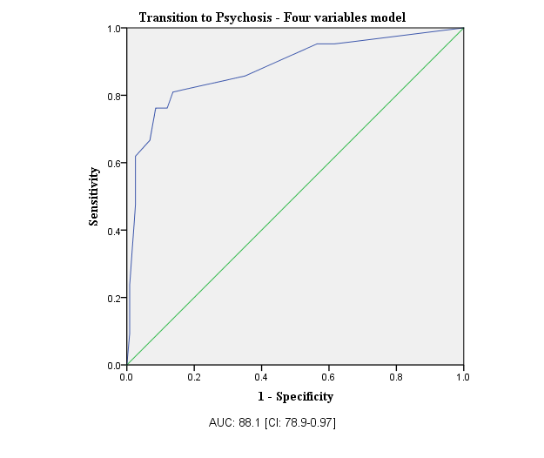

**eFigure2**. Receiver-Operating characteristics (ROC) curve for the SPS Variable Removed (trait markers only) Cox Proportional Hazards Model.

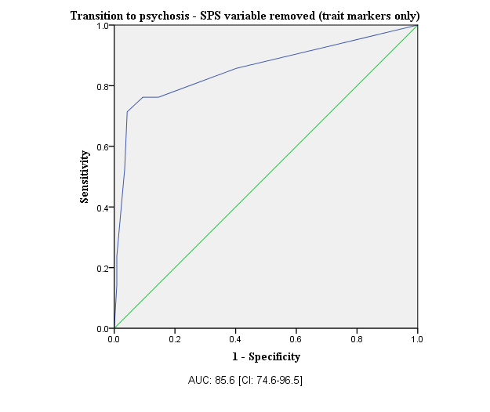

**eFigure3**. Receiver-Operating characteristics (ROC) curve for the CAARMS only-Cox Proportional Hazards Model.

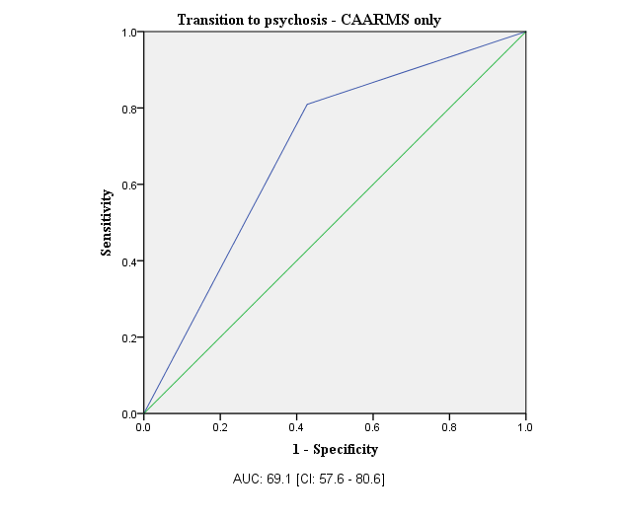

**eModel.** Predictive model of psychosis transition in ARMS+ only (n=67)

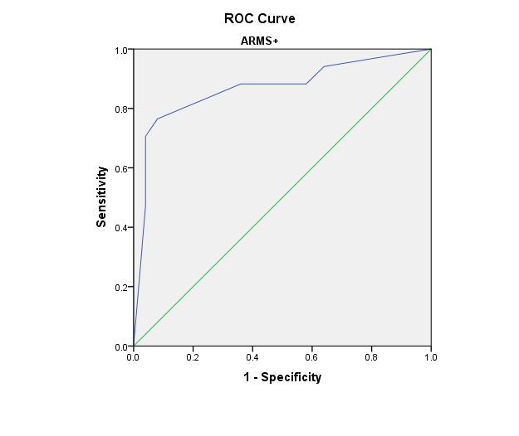

|  |  |  |  |  |  |  |  |  |  |
| --- | --- | --- | --- | --- | --- | --- | --- | --- | --- |
| **Predictor Variable** | **β** | **SE** | **Wald *X2*** | **Hazard Ratio** | ***P* Value** | **AUCa (SE)** **[95% CI]** | ***R*2N** | **Sensitivity** | **Specificity** |
| Avolition>3 (CAARMS) | 1.340 | 0.52 | 6.66 | 3.82 | 0.010 |  |  |  |  |
| Sensory Integration>2 (NES) | 1.673 | 0.65 | 6.68 | 5.33 | 0.010 | 0.868 (0.060)  [0.751-0.984] | 0.495 | 0.765 | 0.920 |
| Faux Pas<16 | 1.305 | 0.52 | 6.37 | 3.69 | 0.012 |  |  |  |  |

**Positive predictive value (PPV): 81.25%**

*ARMS+ only (n=67).* Potential Predictor Domains and Individual Variables for the Cox Proportional Hazard Model *“Transition to Psychosis”.*

|  |  |  |  |  |
| --- | --- | --- | --- | --- |
| **Domain** | **Variables** | **Variables Retained after Univariable screening procedure for “Transition to Psychosis” (p<.10)** | **Variables Retained**  **After Multivariate Cox Regression**  **Across Domains, Blockwise (p<.15)** | **Final Model** |
| **Demographics** | -Age at baseline -Education (years) -Gender -Employment | None |  |  |
| **Clinical information** | Diagnosis:  -Any mood disorder -Any anxiety disorder -Any personality disorder -Multiple diagnoses  Risk Status:  APS  BLIPS  GRD  -Duration of illness (years)  -Medication exposure at baseline  -PANSS General total Score  -Drug Exposure during follow up | Risk Status :  BLIPS |  |  |
| **Positive Symptoms** | CAARMS:  -Disorder of Thought Content  -Non bizarre Ideas  -Perceptual Abnormalities  -Disorganized Speech -Total Positive Score  -PANSS:  -Positive total score | None |  |  |
| **Negative Symptoms** | CAARMS:  -Avolition  -Anhedonia  -Alogia -Total Negative Score  PANSS:  -Negative total score | CAARMS:  -Alogia -Avolition -Total Negative Score | CAARMS:  -Avolition | -Avolition |
| **Emotional Disturbances, CAARMS** | -Subjective Emotional Disturbances -Observed Blunted Affect -Observed Inappropriate Affect -Total Emotional Disturbances | -Subjective Emotional Disturbances  -Observed Inappropriate Affect  -Total Emotional Disturbances | -Observed Inappropriate Affect |  |
| **Cognitive Change, CAARMS** | -Subjective Experience  -Observed Cognitive Change -Total Cognitive Change Score | None |  |  |
| **Behavioral Change, CAARMS** | -Social Isolation  -Impaired Role Functioning  -Disorganized Odds Stigmatizing Behavior  -Aggression Dangerous Behavior -Total Behavioral Change Score | None |  |  |
| **Neurocognitive Performance,**  **RBANS** | -Immediate Memory -Language -Visuospatial -Attention -Delayed Memory | -Visuospatial -Attention | -Visuospatial |  |
| **Neurological Soft Signs, NES** | -Motor Coordination -Sensory Integration -Sequencing of complex motor acts -Others -Total NES Score | -Sensory Integration | -Sensory Integration | -Sensory Integration |
| **Theory of Mind** | -Faux Pas  -RMET  -Th.o.m.a.s A  -Th.o.m.a.s B  -Th.o.m.a.s C  -Th.o.m.a.s D | *-*Faux Pas  -Th.o.m.a.s B  -Th.o.m.a.s C  -Th.o.m.a.s D | -Faux Pas  -Th.o.m.a.s C | -Faux Pas -Th.o.m.a.s C |
| **Baseline Functioning** | -GAF  -SOFAS  LSP-39: -Self Care -Non Turbulence -Social Contact -Communication -Responsibility -Total LSP-39 Score | LSP-39:  -Social Contact -Communication | -Communication |  |

The final model was independent of: DSM-IV diagnosis at baseline; APS, BLIPS and GRD categories of psychosis risk; PANSS general subscale score at baseline; antipsychotic and psychotherapy intervention at follow-up; and drug/alcohol abuse at follow-up.

*None of the SPS significantly predicted psychosis conversion.*

**eMatrix.** Intercorrelations among measures included in the final models

**ap<0.01  
bp<0.05**

|  |  |  |  |  |
| --- | --- | --- | --- | --- |
|  | **Disorder of Thought Content** | **Sensory Integration** | **Visuospatial abilities** | **Faux Pas** |
| **Disorder of Thought Content** |  | **0.246a** | 0.037 | -**0.179b** |
| **Sensory Integration** | **0.246a** |  | -0.122 | **0.170b** |
| **Visuospatial abilities** | 0.037 | **-**0.122 |  | **0.168b** |

References

1. Sauerbrei W, Schumacher M. A bootstrap resampling procedure for model building: application to the Cox regression model. *Stat Med*. 1992;11(16):2093-2109..