Supplementary Information

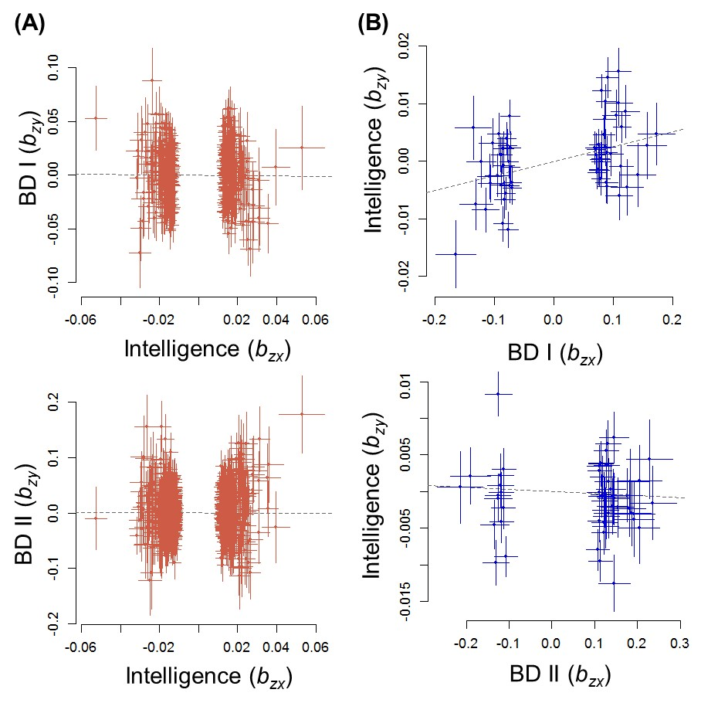
Supplementary Figure 1. Effects (b_{xy}) of intelligence (b_{zx}) on risk for BD I or BD II (b_{zy}) (A) and risk for BD I or BD II (b_{zx}) on intelligence (b_{zy}) (B). Thresholds of p<1.0×10⁻⁵ for BD I vs CON and p<1.0×10⁻⁴ for BD II vs CON were used for the selection of lead SNPs because there were <10 lead SNPs available at the stringent GWAS threshold (p<5.0×10⁻⁸). BD, bipolar disorder; CON, control.

