Supplementary Fig. 1. Excess all-cause mortality rates per 100 population for 1918-1920 pandemic period in Japan, calculated using the seasonal regression method.
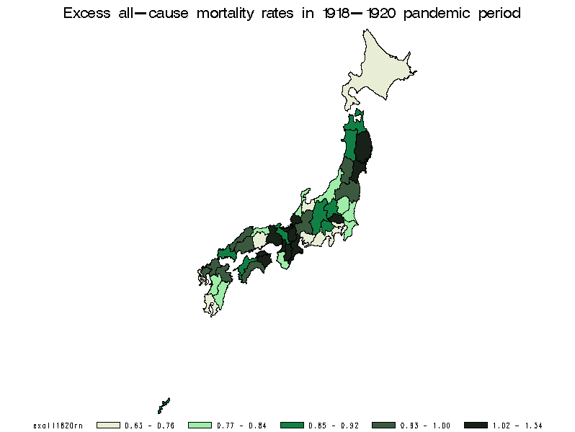

Supplementary Fig, 2. Excess all-cause mortality (calculated using the seasonal regression method) and population size in Japanese prefectures.

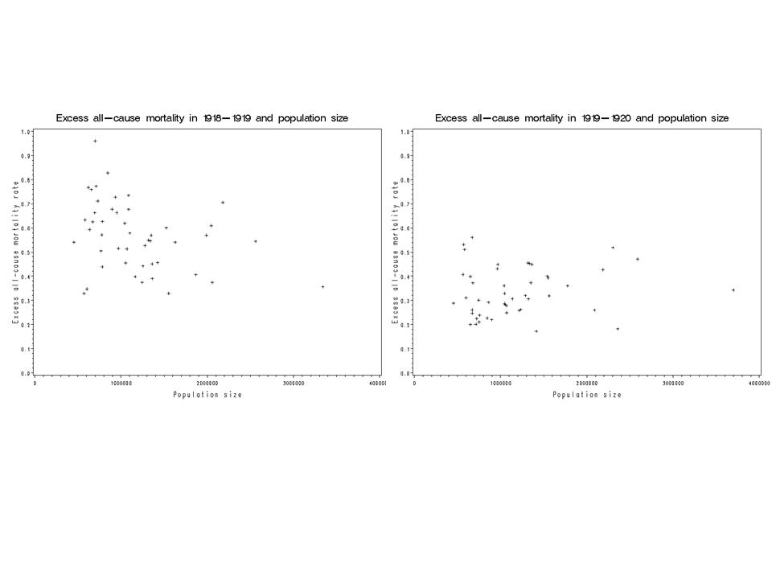

Supplementary Fig. 3. Excess all-case mortality (calculated using the seasonal regression method) and population density in Japanese prefectures.

