SUPPLEMENTARY ONLINE MATERIAL

Section 1: Model Descriptions

The model is defined by:
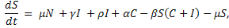
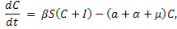
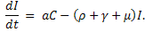
The model is defined by:
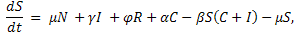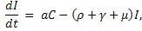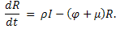
The model is defined by:

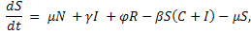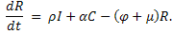

The model is defined by:

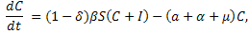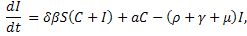

Section 2: Dynamical transitions
The following shows in greater detail the transitions between different dynamical regimes in the SCIRS^{CI} model. We vary , and fix the other parameters with the same values as in Figure 3: .
a)
c)
b)
d)
Fig. S1. (a) - Epidemics at regular 6 year intervals. (b) - Smaller and larger epidemics in alternating years. (c) - Smaller and larger epidemics in alternating years. (d) - Epidemics at regular 6 year intervals.
In this area of parameter space, a small difference in can make a large difference in dynamics, such as between Figures S1a) and S1b). Occasionally there is a substantial transient period before the model reaches its long term pattern of behaviour, as shown in Figure S1c). This often happens near bifurcation points. For example, there is a bifurcation as increases from 63 to 66. is near this bifurcation point, and exhibits behaviour similar to that when for a short time, before settling down to long term behaviour similar to that when .

Fig. S2. (a) - Epidemics at irregular times. (b) - Epidemics at regular 5 year intervals. (c) - Epidemics at irregular times. (d) - Epidemics every 4 years, but with an overall period of 16 years.
d)
b)
a)
c)
As can be seen in Figure 3, for much of the parameter space, the system alternates between regions of regular and irregular regimes, as can be seen here. Figure S2a) illustrates that whilst epidemics in consecutive years are common, the larger epidemic normally comes second. Note in particular that in some cases, such as Figure S2d), the system can have multiple integer periods.

