Supplementary Material

Sensitivity analyses for Wallinga-Teunis method

Fig. S1 Results for estimating the effective reproductive number, varying the mean generation interval (panel A) and its variance (panel B).
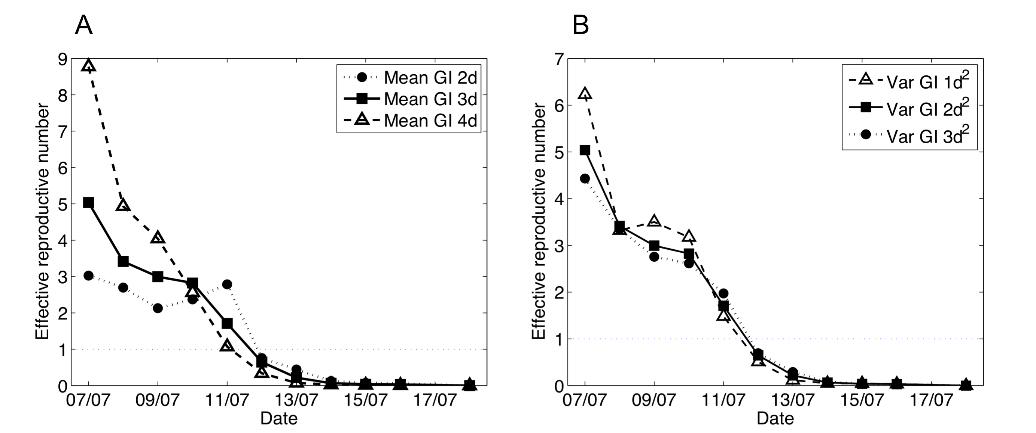
Deterministic transmission model – further mathematical details

The student population is partitioned into n groups, to allow for different infection risks. The transmission matrix λ_{ij} denotes the rate of infection in group i, due to an infected case in group j. It can be constructed on the basis of assumptions about the underlying contact structure: we consider in turn each of the mixing scenarios described in the main text.

- Homogeneous mixing: In this ‘baseline scenario’, infected cases from each group contribute equally to the force of infection, so that λ_{ij} = b, a single parameter to be estimated, for all i, j. It is straightforward to show that, in this simple case, we have R₀^{(pre)} = nb / γ.

- Within- & between- group mixing, uniform: Here we write b_{W} for within-group mixing and b_{B} for between-group mixing, thus giving two parameters to be estimated. The transmission matrix is then constructed as
$λ_{\text{ij}}=\left\{\begin{matrix}b_{W}i=j \\ b_{B}\text{otherwise}\end{matrix}\right.$, with $R_{0}^{(\text{pre})}=\frac{1}{g}\left[b_{W}+(n−1)b_{B}\right]$

- Within- & between- group mixing, non-uniform: We generalise (ii) to associate a separate within-group coefficient b_{W}^{(i)} with each group i, thus allowing independent, internal mixing for each building. The between-group mixing parameter is once again b_{B}. The transmission matrix is then constructed as
$λ_{\text{ij}}=\left\{\begin{matrix}b_{W}^{(i)}i=j \\ b_{B}\text{otherwise}\end{matrix}\right.$
In the absence of a closed, analytical expression for R₀^{(pre)} , we numerically compute the largest eigenvalue ρ of λ_{ij}, and divide by γ.

Building-specific results

Fig. S2 Simulations vs. data for each of the model scenarios described in the main text, assuming a mean infectious period of 3 days. Results for infectious periods of 2 and 4 days are qualitatively similar.
Results for alternative assumptions for the infectious period

Table S1. Parameters estimated from transmission models, assuming an infectious period before intervention of 2 days.

Model scenario | (i) Homogeneous mixing | (ii) Within- & between-group mixing, uniform | (iii): Within- & between-group mixing, non-uniform
Transmission matrix parameters | 0.24 | Within-gp: 0.87  Between-gp: 0.085 | Within-gp:  [1.5, 2.0, 1.0, 1.04, 2.02] for A - E respectively.  Between-gp: 0.0032
Change in transmissibility, $\bar{c}$ | 1.2 | 1.1 | 0.62
Mean infectious period after intervention, $1/{\bar{g}}$ | 0.79 days | 0.75 days | 0.78 days
R₀, pre (vs. post) intervention | 2.5 (0.95) | 2.6 (0.96) | 4.1 (0.98)
Least squares with (vs. without) interventions | 255 (389) | 235 (379) | 165 (343)

Table S2. Parameters estimated from transmission models, assuming an infectious period before intervention of 4 days.

Model scenario | (i) Homogeneous mixing | (ii) Within- & between-group mixing, uniform | (iii): Within- & between-group mixing, non-uniform
Transmission matrix parameters | 0.19 | Within-gp: 0.59  Between-gp: 0.080 | Within-gp: [1.1, 1.6, 0.76, 0.82, 1.6] for A - E respectively.  Between-gp: 0.0058
Change in transmissibility, $\bar{c}$ | 1.1 | 1.1 | 0.67
Mean infectious period after intervention, $1/{\bar{g}}$ | 0.80 days | 0.81 days | 0.91 days
R₀, pre (post) intervention | 3.7 (0.86) | 3.8 (0.86) | 6.4 (0.92)
Least squares with (vs. without) interventions | 237 (503) | 222 (488) | 148 (411)

