Supplementary Figure S2
Reported cases of meningococcal meningitis in Niger
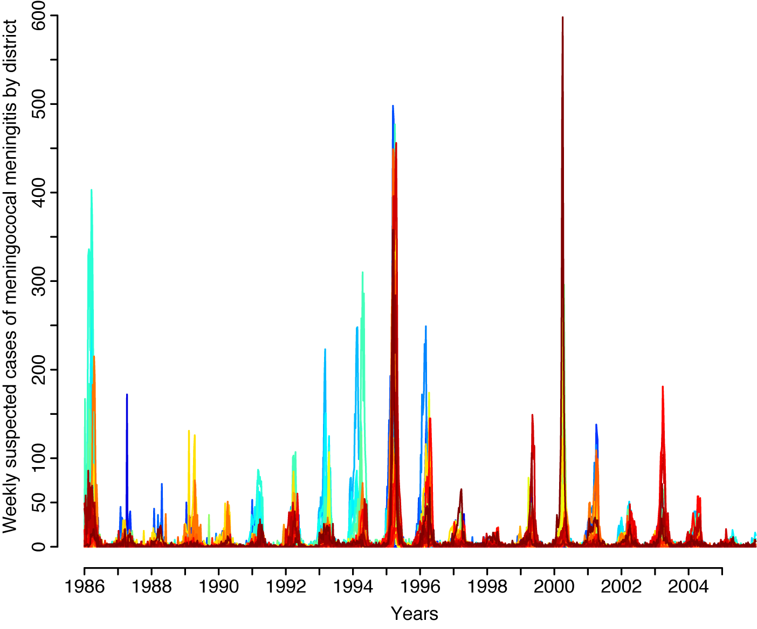
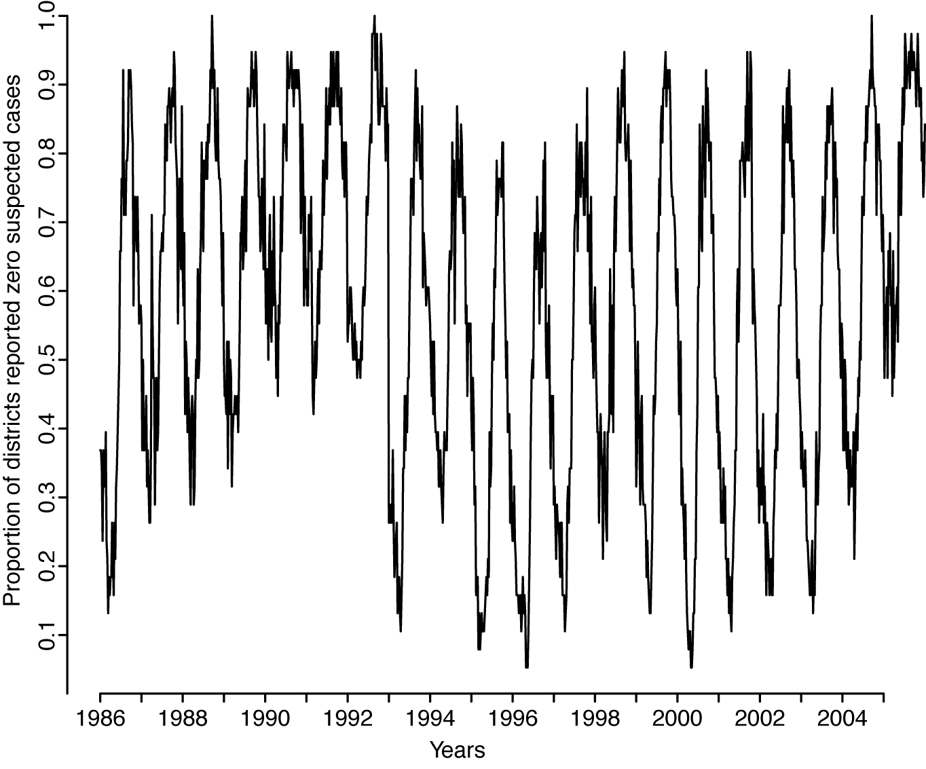
Figure S2. Top: Weekly suspected cases of meningococcal meningitis by district in Niger from 1986-2005. Each color represents a different district. Bottom: Proportion of districts reporting zero suspected meningitis cases each week.

