Supplementary Material Text S2
Identifying high risk districts using alert and epidemic thresholds

Introduction
Meningococcal meningitis outbreaks in the African meningitis belt are often assessed using standard thresholds for alert (5 cases per 100,000 people per district per week, respectively) and epidemic (10 cases per 100,000 people per district per week, respectively) classification, as defined by the World Health Organization (WHO) [1]. The crossing of these thresholds, as scaled by district population size, determines whether surveillance is heightened or a reactive immunization campaign is launched. In the main paper, we avoided the use of these thresholds for two reasons. First, using a denominator for district population size by which to scale the number of cases introduces a second dimension of uncertainty, in addition to the actual number of cases. Second, and most relevant to this study, scaling cases by population size can mask the effects of host population density. Though these thresholds are certainly useful when comparing real-time disease burden and assessing immediate health care needs between locations of different sizes, this measurement can fail to detect patterns of transmission early in an epidemic and during periods with low numbers of cases. This includes importations of infection, transitions from asymptomatic carriage to clinical disease, and low levels of transmission.
Despite the lack of detailed information surrounding asymptomatic meningococcal meningitis carriage, it is known that meningococcal meningitis is transmitted directly between individuals. As with any directly transmitted infection in a population with some proportion of susceptible hosts, the number of contacts between individuals is positively related to the likelihood of transmission, and therefore strongly dependent on host population density. Due to the non-linear properties of disease transmission, particularly during the early phases of an epidemic, a high-density population poses a greater risk of infectious cases rapidly resulting in a number of secondary cases than does a low-density population. If importation events or transmission events occur more frequently in more populated districts, which would be expected of most directly transmitted infections [2, 3], the use of the alert and epidemic thresholds could diminish the strength of these signals. As this analysis was primarily interested in the effects of population density, we focused our initial analysis on the weekly reported cases for each district, which may reveal information that the threshold metrics would not detect.
To complement our spatial and statistical analyses of case counts, we completed an additional spatial analysis with the commonly used public health thresholds mentioned above. Because these thresholds account for the population size of each district, we did not focus our analyses on the relationship between the threshold indicators and population size (details below), as we did for the analysis of meningococcal meningitis case reappearances. Instead, we measured the total number of weeks spent above each threshold and the total number of threshold transitions to identify high risk districts and compare these to the ‘hotspots’ identified by using the suspected case counts, as detailed in the main paper.

Methods
We measured the total number of weeks spent above the alert threshold while remaining below the epidemic threshold for each district. Second, we measured the frequency of transitions from below the alert threshold to reaching or crossing the alert threshold while staying below the epidemic threshold for each district. Then, we measured the total number of weeks spent above the epidemic threshold for each district. Finally, we measured the frequency of transitions from below the epidemic threshold to reaching or crossing the epidemic threshold for each district.
We assessed the correlation between the number of weeks spent at or above either transition, for both the alert and epidemic thresholds, and population size for each district, as well as the correlation between the frequency of threshold transitions and population size. We also measured the spatial clustering by calculating Moran’s I with neighbors defined as districts with contiguous boundaries for the districts where the total weeks at or above either threshold exceeded the national median [4]. Finally, we completed the same spatial analysis for the districts with more threshold transitions than exceeded the national median. We compared these results to the results of similar analyses, as completed for reappearances of weekly district case counts, discussed in the main paper.
We measured the spatial correlation of the total number of weeks spent at or above the alert threshold while remaining below the epidemic threshold for each district with values that exceeded the national median. We also measured the spatial clustering in frequency of transitions from below the alert threshold to reaching or crossing the alert threshold while staying below the epidemic threshold for districts with values that exceeded the national median. We did the same spatial analysis for 1) for the total number of weeks spent above the epidemic threshold for each district when district values exceeded the national median and 2) the number transitions from below the epidemic threshold to equal or above the epidemic threshold for districts with values that exceeded the national median.
Description and sources for reported cases, population sizes, and district boundaries are detailed in the main paper.
Results
We found low positive correlation values between population size and the total number of weeks spent above the alert threshold (correlation = 0.23, p > 0.1). We also found low correlation values between population size and the total number of weeks spent above the epidemic threshold (correlation = 0.24, p > 0.1). We found no correlation between population size and the total number transitions to either threshold (alert threshold correlation = 0.16, epidemic threshold correlation = 0.06) (Fig. S2.1).

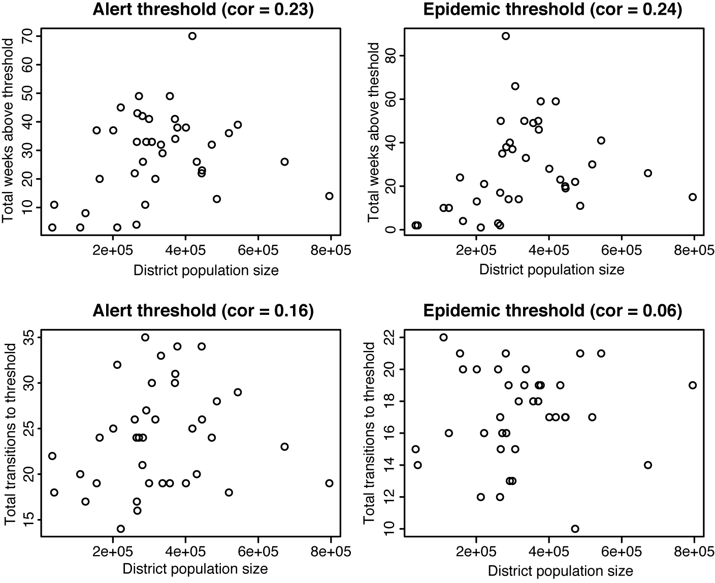
Fig. S2.1. Based on weekly, district level reports of suspected meningococcal meningitis cases from 1986-2005 from each district in Niger. Top row: total number of weeks spent at or above the alert threshold by district (left) and epidemic threshold (right). Bottom row: total number transitions to or above the alert threshold (left) and the epidemic threshold (right) by district.
We found a clustered spatial pattern in the total number of weeks spent at or above both the alert and epidemic thresholds. A positive Moran’s I statistic indicates spatial autocorrelation (clustering) and a significant p-value indicates a significant departure from randomness. For the districts with a total number of weeks above the alert threshold that was greater than the national median value, we calculated Moran’s I = 0.35, p < 0.01. For the districts where the total number of weeks spent at or above the epidemic threshold was greater than the national median value, we calculated Moran’s I = 0.48, p < 0.01. The total number of transitions to either threshold did not show any spatial clustering. For the districts with a total number of alert threshold transitions above the national median, Moran’s I = 0.14, p = 0.36. For the districts with a total number of epidemic threshold transitions above the national median, Moran’s = 0.11, p = 0.11 (Fig. S2.2). For the 17 meningococcal meningitis hotspots identified in the main paper, Moran’s I = 0.34, p < 0.01.
The 20 districts for which the total number of weeks spent at or above the alert threshold exceeded the national median included 16 of the 17 meningococcal meningitis hotspots, which were identified by the reappearance of suspected cases against district population size, based on weekly suspected case counts. The 19 districts for which the total number of weeks spent at or above the epidemic threshold exceeded the national median included 15 of the 17 meningococcal meningitis hotspots, as calculated by the reappearance of suspected cases against population size based on weekly suspected case counts. The 16 districts for which the total number transitions to the alert threshold exceeded the national median included only 7 of the 17 meningococcal meningitis hotspots. The 18 districts that exceeded the national median for transitions to the epidemic threshold also included only 7 of the 17 previously identified meningococcal meningitis hotspots.

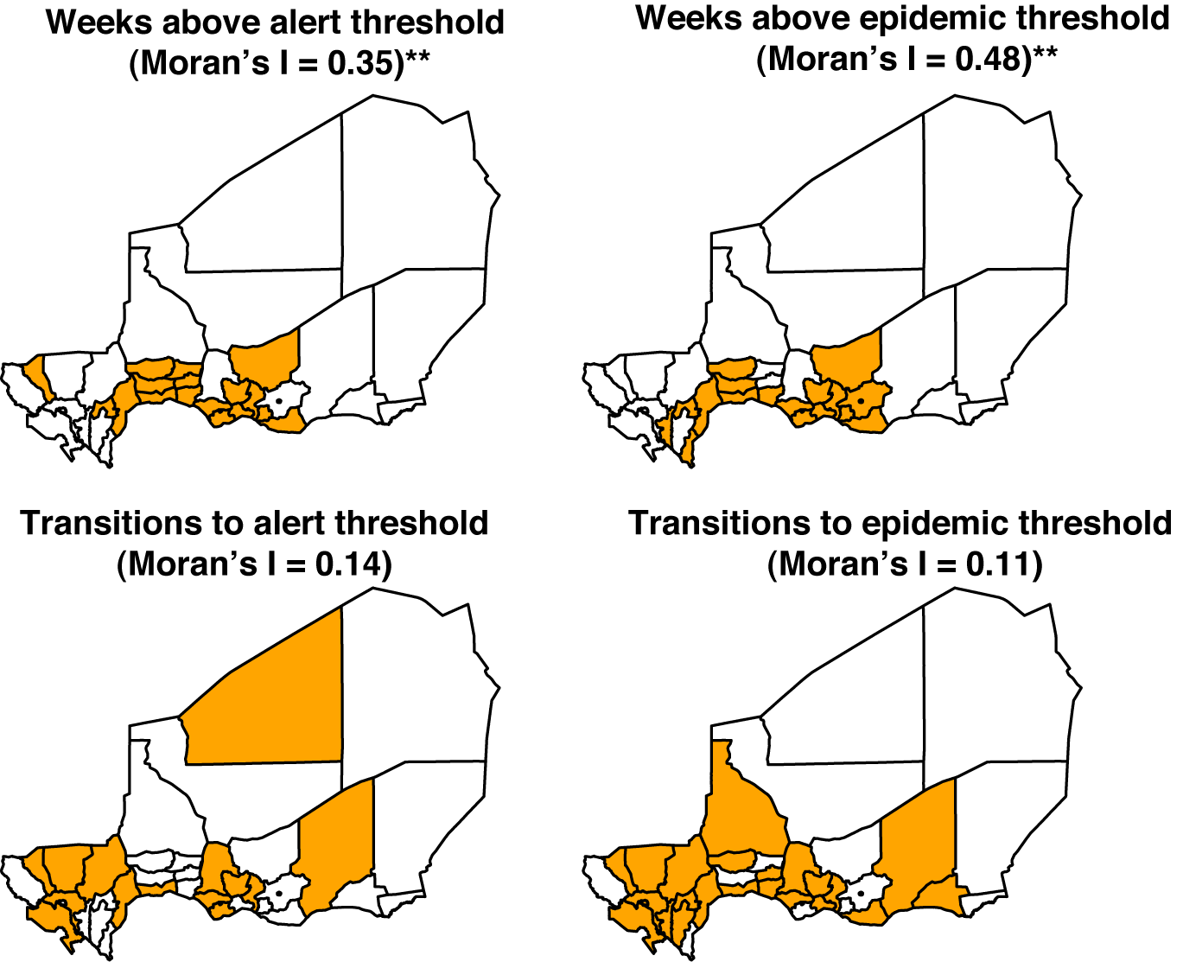
Fig. S2.2. Spatial analyses. Top row: districts are shown in orange for which total number of weeks spent above alert threshold (left) and epidemic threshold (right) exceeded the national median. Bottom row: districts are shown in orange if total number of transitions from below alert threshold to equal or above alert threshold (left) and for epidemic threshold (right) exceeded national median.
Discussion
The analyses of spatial patterns of weeks spent at or above both the district-level alert and epidemic thresholds indicate that, when correcting for population size, large numbers of suspected cases of meningococcal meningitis seem to follow a clustered spatial pattern. These results are very similar to the pattern we detected using reappearances of weekly suspected case counts. This shows that the spatial patterns that exist early in epidemics with low numbers of cases, as detected by the hotspots, are the same spatial patterns detected by the thresholds that govern intervention strategies and that case counts may allow for earlier detection than threshold triggers. We have found that case importation and reappearances may seed chains of continued local transmission, which can result in a sufficient number of cases to cross the alert and epidemic thresholds. If direct transmission is important in the spread of meningococcal meningitis, high numbers of contacts and high population density in these districts would encourage comparatively high rates of local transmission and increase the likelihood that these districts would remain above the alert or epidemic thresholds. As coverage of the conjugate vaccine increases, the patterns detected here highlight districts that spend the most weeks above the alert and epidemic thresholds. Our analysis on absences and reappearances indicates that outbreaks in these districts may be caused by case importations or increased transitions from asymptomatic carriage to clinical cases. The set of districts that spend the most weeks above the attack and epidemic thresholds is very similar to the set of districts with high levels of reappearances of invasive meningococcal meningitis.
The total number of transitions to either threshold reveals no spatial pattern. This may indicate that the number of threshold transitions is not representative of the overall proportional caseload in any district. Some districts may be more likely to cross the thresholds, despite a low number of cases, if the population size is small. These districts may simply transition back and forth the across thresholds every year when the total number of cases rises and falls slightly throughout the meningitis belt. The total number of threshold transitions does not ultimately seem to indicate that a district will have a greater proportion of cases overall.
Conclusions
As progress continues towards eliminating the devastating meningococcal meningitis outbreaks in the African belt, there is hope that high levels of coverage with the conjugate vaccine will increase herd immunity in these vulnerable populations, breaking chains of transmission, and reducing the size and frequency of outbreaks [5]. Unfortunately, as we have seen with many other infections with long-term vaccine-derived immunity, complete vaccine coverage is nearly impossible to achieve, such that cases and outbreaks will likely continue to occur. Ideally, these will become rare events but they will continue to require reactive attention. The early detection of meningococcal meningitis continues to be very important and, using these two complementary analyses, we show that identifying districts where reappearances of meningococcal meningitis are common can help detect districts that should be of concern for surveillance due to high attack rates.
References
(1) World Health Organization. Managing meningitis epidemics in Africa: A quick reference guide for health authorities and health-care workers. In: Response GAa, ed. Geneva: WHO Press, 2010: 30.
(2) Bartlett MS. Measles periodicity and community size. Journal of the Royal Statistical Society Series a-General 1957; 120(1): 48-70.
(3) Xia YC, Bjornstad ON, Grenfell BT. Measles metapopulation dynamics: A gravity model for epidemiological coupling and dynamics. American Naturalist 2004; 164(2): 267-281.
(4) Moran PAP. Notes on continuous stochastic phenomena. Biometrika 1950; 37: 17:33.
(5) Kieny M, LaForce F. The promise of conjugate vaccines for Africa. Vaccine 2007; 25(S1): A108-A110.

