Supplementary Table S1. Annual mortality rate with underlying causes of cardiorespiratory diseases (CRD) and pneumonia and influenza (P&I) per 100,000 population in Hong Kong

Disease | Year | <20 | 20-39 | 40-64 | 65-84 | 85+ | All (crude) | All  (age-standardized)*
CRD | 1998 | 3.4 | 7.2 | 95.2 | 1405.7 | 7846.5 | 227.3 | 321.2
 | 1999 | 3.4 | 6.3 | 84.8 | 1347.5 | 7714.9 | 222.2 | 308.3
 | 2000 | 4.0 | 6.9 | 79.1 | 1305.8 | 7621.8 | 223.0 | 300.3
 | 2001 | 3.9 | 7.0 | 63.4 | 1171.1 | 6683.7 | 206.5 | 264.3
 | 2002 | 3.0 | 6.0 | 64.3 | 1166.6 | 6596.8 | 213.0 | 262.3
 | 2003 | 3.3 | 7.8 | 69.0 | 1279.8 | 7443.7 | 244.1 | 290.8
 | 2004 | 3.1 | 6.6 | 64.3 | 1175.8 | 7221.4 | 236.0 | 273.4
 | 2005 | 4.0 | 6.5 | 57.2 | 1225.0 | 7316.8 | 247.6 | 277.9
 | 2006 | 2.8 | 6.8 | 57.9 | 1116.8 | 6355.0 | 232.1 | 250.6
 | 2007 | 2.2 | 6.1 | 61.5 | 1159.4 | 6765.1 | 250.4 | 262.9
 | 2008 | 3.8 | 5.8 | 60.4 | 1172.0 | 6905.0 | 258.7 | 266.4
 | 2009 | 3.4 | 6.8 | 64.9 | 1127.2 | 6352.8 | 254.6 | 254.6
P&I | 1998 | 1.5 | 1.2 | 14.3 | 295.9 | 3002.1 | 56.3 | 86.9
 | 1999 | 1.6 | 1.0 | 10.8 | 224.1 | 2415.8 | 44.9 | 68.2
 | 2000 | 1.2 | 1.5 | 9.6 | 223.2 | 2243.6 | 44.9 | 65.0
 | 2001 | 0.8 | 1.1 | 8.5 | 211.8 | 2094.2 | 44.7 | 60.7
 | 2002 | 0.4 | 1.0 | 7.6 | 221.2 | 2050.2 | 46.8 | 60.6
 | 2003 | 0.7 | 1.9 | 12.0 | 260.0 | 2432.5 | 58.8 | 73.0
 | 2004 | 1.0 | 1.2 | 8.0 | 223.9 | 2261.7 | 53.6 | 64.6
 | 2005 | 1.0 | 1.6 | 7.9 | 259.6 | 2530.8 | 63.0 | 73.0
 | 2006 | 0.7 | 1.2 | 8.0 | 244.2 | 2283.4 | 60.8 | 67.1
 | 2007 | 0.7 | 1.2 | 9.1 | 281.2 | 2503.6 | 70.7 | 75.2
 | 2008 | 1.2 | 1.1 | 9.7 | 293.4 | 2699.6 | 77.1 | 80.0
 | 2009 | 0.8 | 1.4 | 9.6 | 291.0 | 2454.2 | 75.8 | 75.8

Supplementary Table S2. Excess rate of influenza associated mortality per 100,000 population (ER) with underlying causes of cardiovascular diseases (CRD), or pneumonia and influenza (P&I) for different age groups

Year | 40-64 |  | 65-84 |  | 85+ |  | All-ages
Year | ER | (95%CI) | ER | (95%CI) | ER | (95%CI) | ER | (95%CI)
CRD
1998 | 0.3 | (-2.2, 2.8) | 19.7 | (-0.1, 38.5) | 27.5 | (-113.8, 161.6) | 2.3 | (-0.4, 4.8)
1999 | 2.4 | (0.6, 4.3) | 28.7 | (11.7, 45.4) | 358.0 | (234.5, 470.6) | 6.3 | (4.0, 8.5)
2000 | 2.9 | (0.9, 4.8) | 33.8 | (15.7, 51.2) | 128.0 | (-17.5, 259.1) | 5.4 | (2.8, 7.9)
2001 | -0.6 | (-2.2, 0.9) | 10.4 | (-6.0, 26.7) | 78.9 | (-41.4, 187.8) | 1.6 | (-0.9, 4.0)
2002 | 2.6 | (1.0, 3.9) | 33.6 | (18.2, 48.1) | 203.2 | (87.1, 294.9) | 6.3 | (3.8, 8.6)
2003 | 0.8 | (-1.0, 2.3) | 32.9 | (16.4, 48.1) | 113.1 | (-10.4, 230.8) | 4.9 | (2.1, 7.3)
2004 | 1.4 | (0.0, 2.8) | 22.2 | (6.9, 36.1) | 182.7 | (56.3, 298.2) | 5.0 | (2.4, 7.4)
2005 | 1.1 | (-0.4, 2.7) | 36.1 | (18.0, 53.4) | 251.0 | (113.4, 384.1) | 7.3 | (4.0, 10.2)
2006 | 1.6 | (0.1, 3.1) | 17.3 | (2.0, 33.2) | 162.7 | (44.5, 275.8) | 4.7 | (1.9, 7.5)
2007 | 1.9 | (0.5, 3.3) | 32.7 | (19.0, 46.0) | 171.8 | (62.9, 281.4) | 6.6 | (4.0, 9.2)
2008 | 0.4 | (-1.2, 2.0) | 20.5 | (4.7, 36.0) | 281.0 | (155.4, 403.9) | 6.3 | (3.1, 9.3)
2009 | 1.6 | (0.1, 2.9) | 27.2 | (13.4, 41.6) | 219.2 | (121.3, 312.6) | 7.1 | (4.5, 9.6)
P&I
1998 | -0.5 | (-1.5, 0.6) | 8.6 | (0.7, 16.0) | 39.0 | (-42.3, 113.2) | 1.0 | (-0.1, 2.1)
1999 | 0.4 | (-0.3, 1.1) | 1.6 | (-3.8, 6.6) | 126.3 | (71.0, 176.1) | 1.2 | (0.4, 2.0)
2000 | -0.6 | (-1.3, 0.1) | 7.7 | (1.7, 13.2) | 31.4 | (-27.4, 85.3) | 0.9 | (0.0, 1.8)
2001 | 0.1 | (-0.5, 0.7) | 4.3 | (-1.6, 9.8) | 28.9 | (-25.8, 76.9) | 0.7 | (-0.2, 1.6)
2002 | 0.3 | (-0.3, 0.7) | 5.4 | (-0.5, 11.0) | 70.7 | (19.3, 111.9) | 1.4 | (0.4, 2.1)
2003 | 0.5 | (-0.3, 1.3) | 9.2 | (2.5, 15.5) | 28.2 | (-31.9, 82.5) | 1.4 | (0.3, 2.4)
2004 | -0.3 | (-0.9, 0.3) | 6.4 | (1.0, 12.0) | 77.4 | (22.4, 126.9) | 1.5 | (0.5, 2.4)
2005 | 0.1 | (-0.5, 0.7) | 6.0 | (-1.5, 13.2) | 70.6 | (-2.0, 135.4) | 1.5 | (0.2, 2.9)
2006 | 0.1 | (-0.6, 0.7) | 2.4 | (-4.6, 8.9) | 71.9 | (8.2, 131.3) | 1.2 | (-0.1, 2.4)
2007 | -0.1 | (-0.8, 0.4) | 7.4 | (0.7, 13.4) | 52.3 | (-11.3, 108.7) | 1.5 | (0.1, 2.7)
2008 | 0.1 | (-0.7, 0.8) | 13.2 | (5.8, 20.6) | 155.8 | (81.5, 224.6) | 3.8 | (2.2, 5.3)
2009 | 0.1 | (-0.5, 0.8) | 8.3 | (1.7, 15.0) | 99.2 | (44.7, 153.1) | 2.5 | (1.2, 3.8)

Supplementary Table S3. Sensitivity analysis for the excess rates per 100,000 population (ER) of all-cause deaths associated with influenza

 | Model 1 |  | Model 2 |  | Model 3 |  | Model 4 |  | Model 5
Year | ER | (95% CI) | ER | (95% CI) | ER | (95% CI) | ER | (95% CI) | ER | (95% CI)
1998 | 4.3 | (0.4, 7.8) | 4.4 | (0.4, 7.8) | 4.4 | (0.4, 7.8) | 4.5 | (0.6, 7.9) | 14.8 | (10.9, 18.7)
1999 | 8.0 | (4.4, 11.3) | 7.6 | (4.1, 11.0) | 7.6 | (4.1, 11.0) | 7.6 | (4.1, 11.0) | 10.6 | (7.8, 13.3)
2000 | 7.6 | (3.7, 11.3) | 7.7 | (3.7, 11.3) | 7.7 | (3.7, 11.3) | 7.7 | (3.8, 11.4) | 15.8 | (11.6, 19.9)
2001 | 4.3 | (0.3, 8.2) | 4.9 | (1.0, 8.6) | 4.9 | (1.0, 8.6) | 5.0 | (1.1, 8.6) | 13.3 | (9.8, 16.9)
2002 | 8.8 | (4.8, 12.3) | 8.8 | (4.9, 12.3) | 8.8 | (4.9, 12.3) | 8.7 | (4.7, 12.1) | 9.0 | (6.6, 11.4)
2003 | 7.3 | (2.9, 11.1) | 7.4 | (3.1, 11.2) | 7.4 | (3.1, 11.2) | 7.6 | (3.3, 11.4) | 13.0 | (9.5, 16.4)
2004 | 6.9 | (3.0, 10.7) | 6.2 | (2.5, 10.0) | 6.2 | (2.5, 10.0) | 6.1 | (2.4, 9.8) | 8.7 | (6.4, 11.0)
2005 | 12.7 | (8.2, 16.9) | 13.1 | (8.5, 17.3) | 13.1 | (8.5, 17.3) | 13.1 | (8.5, 17.3) | 19.2 | (14.1, 24.2)
2006 | 5.4 | (0.9, 9.4) | 6.4 | (2.2, 10.4) | 6.4 | (2.2, 10.4) | 6.3 | (2.2, 10.3) | 14.8 | (10.9, 18.7)
2007 | 10.3 | (6.5, 13.9) | 10.1 | (6.0, 14.0) | 10.1 | (6.0, 14.0) | 10.0 | (6.2, 13.7) | 10.6 | (7.8, 13.3)
2008 | 8.9 | (4.6, 12.9) | 8.4 | (3.9, 12.4) | 8.4 | (3.9, 12.4) | 8.2 | (3.8, 12.1) | 15.8 | (11.6, 19.9)
2009 | 9.3 | (5.3, 13.0) | 9.1 | (5.1, 12.9) | 9.1 | (5.1, 12.9) | 9.1 | (5.1, 12.9) | 13.3 | (9.8, 16.9)

Note: CI, confidence interval; df, degrees of freedom
Model 1: df=5 for temperature, df=4 for humidity
Model 2: df=3 for temperature, df=4 for humidity
Model 3: df=4 for temperature, df=5 for humidity
Model 4: df=4 for temperature, df=3 for humidity
Model 5: Poisson regression models were fitted to the 1998-2009 data as described in reference 8.

Supplementary Table S4. Validation of models by an empirical dataset of hospital admissions with laboratory confirmed influenza in pediatric patients aged between 0 and 18 years

Season | Directly observed | Poisson regression |  | Poisson prediction
2003-2004 | 15.0 | 36.7 | (28.1, 44.5) | 23.9 | (15.5, 32.0)
2004-2005 | 19.3 | 40.9 | (31.3, 49.6) | 30.3 | (12.7, 46.0)
2005-2006 | 18.2 | 32.5 | (24.1, 39.9) | 48.0 | (36.7, 58.8)
2006-2007 | 25.0 | 36.8 | (27.8, 44.7) | 24.3 | (14.1, 34.2)
2007-2008 | 23.6 | 27.1 | (20.3, 33.4) | 30.5 | (21.8, 38.8)

Note. The influenza season was defined as the period from October to next September

Supplementary Fig. S1. Time series plots of observed mortality (blue line) and predicted baseline mortality from Poisson models (red line) for CRD in the 40-64, 65-84 and 85+ age groups (A-C) and for P&I in the 40-64, 65-84 and 85+ age groups (D-F)

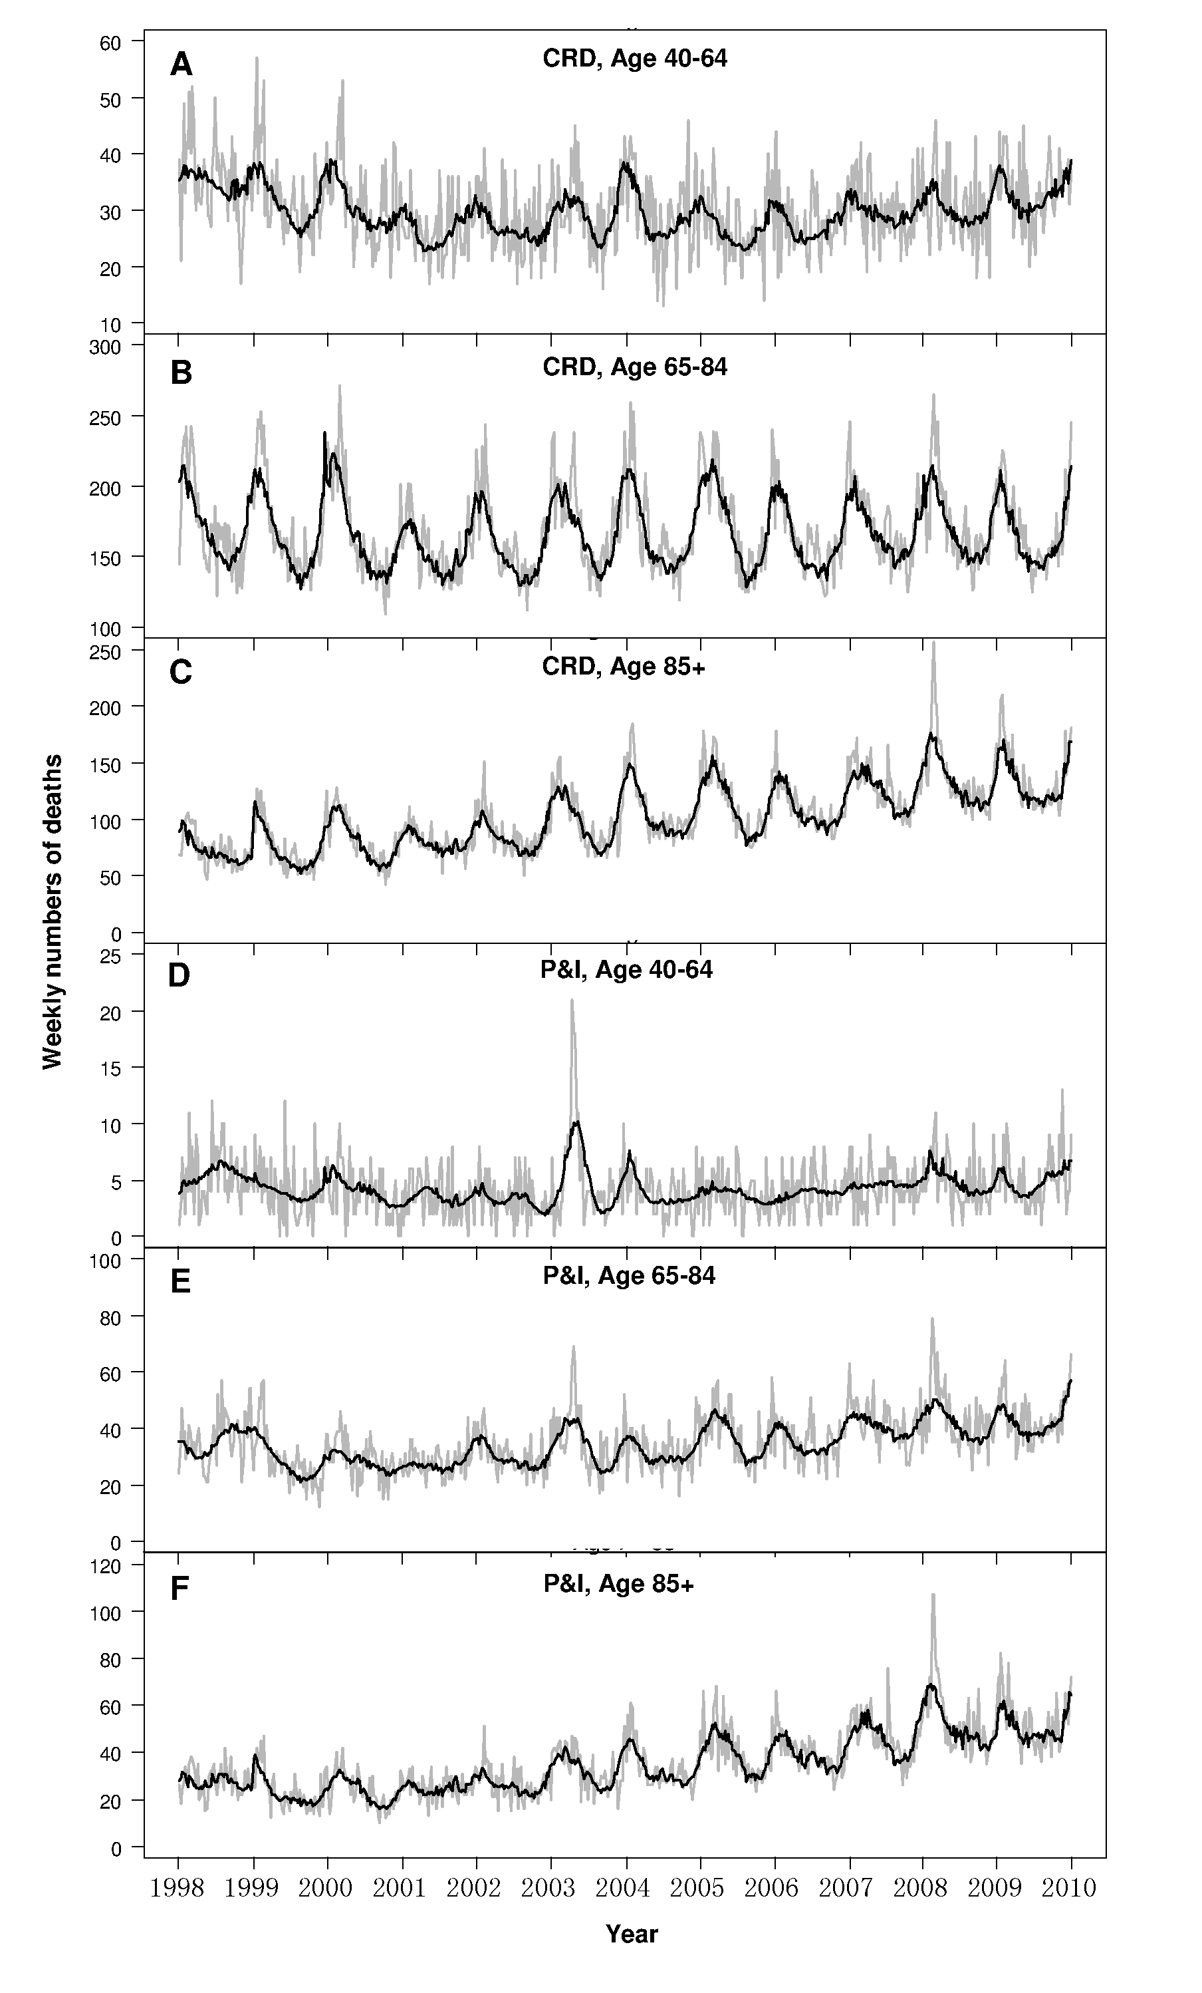
Supplementary Material

In this study we modified our previous Poisson modeling approach to develop a “Poisson prediction” method. There are two steps in this method. The first step is detrending the weekly mortality data of entire study period (12 years in our study) as follows:
(i)
where E(y_{t}) denotes the expected value for numbers of deaths at week t, ns(t.df) represents the natural spline smoothing functions of time trend t (where t =1,2….,625) with 3 degrees of freedom (df) chosen for each year, in order to adjust for seasonal variations longer than four months.The residuals of model (i) were taken as detrended mortality data for subsequent analyses.

In the second step, we fitted a Poisson regression model to the detrended mortality data of 1998-2008 with the data of that year removed. This model contains the predictor variables of weekly average temperature and humidity, as well as an influenza proxy variable of weekly proportions of specimens positive for influenza (influenza proportions). The typical form of this model is:
(ii)
where t = 1,2…,520 to represent the weeks of ten years surrounding the assessment year, or immediately after it (or before) if that year was 1998 (or 2008). E() denotes the expected value for detrended numbers of deaths at week t, and ns represents the natural cubic spline smoothing functions for temperature and relative humidity with 4 df. Influenza variable (flu_{t}) is the proportion of specimens positive for influenza at week t. The overdispersion of variance was controlled by a quasi-likelihood method. This ten-year Poisson model (model ii) was then used to predict a mortality level for the assessment year, with the data of temperature and humidity taking the values as observed in that year and the influenza variable simultaneously set to zero. Then the time trend removed in the first step was added back to the predicted mortality to derive the “baseline mortality”. Excess mortality for the assessment year was then calculated by deducting the baseline mortality from the observed mortality data in that year. The residuals of model (ii) were later bootstrapped for 1,000 times to derive the 95% CI for excess mortality. The excess mortality rate associated with influenza was calculated by dividing the excess mortality with the mid-year population of Hong Kong each year during the study period.

