SUPPLEMENTARY MATERIAL
Estimation of the force of infection
Age-dependent FOIs were estimated by using a method developed by van Boven et al. [1]. This method is based on the underlying model structure and allows to take different types of infection and waning immunity into account in a consistent manner [1]. To estimate age specific FOIs a steady state (stable age distribution and endemic equilibrium) had to be assumed. We used the mean Dutch age-specific incidence, after correction for underreporting, over the period 1996 until 2000. Furthermore, we assumed that everyone exactly die at the age of 75. Subsequently, we used the following set of ordinary differential equations to estimate the age specific FOI:

$$\frac{{\text{dS}}_{1}(a)}{da}=−λ(a)S_{1}(a)−v(a)S_{1}(a)$$
$$\frac{{\text{dI}}_{1}(a)}{da}=λ(a)S_{1}(a)−ρ_{1}I_{1}(a)$$
$$\frac{{\text{dR}}_{\text{n1}}(a)}{da}=ρ_{1}I_{1}(a)+ρ_{2}I_{2}(a)+ρ_{3}I_{3}(a)−σ_{n1}R_{n1}(a)$$
$$\frac{{\text{dR}}_{\text{n2}}(a)}{da}=σ_{n1}R_{n1}(a)−σ_{n2}R_{n2}(a)−λ(a)R_{n2}(a)$$
$$\frac{{\text{dR}}_{\text{v1}}(a)}{da}=v(a)S_{1}(a)−σ_{v1}R_{v1}(a)$$
$$\frac{{\text{dR}}_{\text{v2}}(a)}{da}=σ_{v1}R_{v1}(a)−σ_{v2}R_{v2}(a)−λ(a)R_{v2}(a)$$
$$\frac{{\text{dS}}_{2}(a)}{da}=σ_{n2}R_{n2}(a)+σ_{v2}R_{v2}(a)−λ(a)S_{2}(a)$$
$$\frac{{\text{dI}}_{2}(a)}{da}=λ(a)S_{2}(a)−ρ_{2}I_{2}(a)$$
$$\frac{{\text{dI}}_{3}(a)}{da}=λ(a)R_{n2}(a)+λ(a)R_{v2}(a)−ρ_{3}I_{3}(a)$$
The epidemiologic parameters and their values in these equations are given in Table S1. Since, we assumed an endemic equilibrium before the introduction of the booster at 4 years of age, only the vaccination within the first year of life was included in the estimation process. For a complete description of the methodology to estimate the age-specific FOI we refer to van Boven et al. [1].

Table S1. Epidemiologic parameter values used for estimation of the age-specific force of infection
Parameter | Symbol | Value used in the base case (scenarios)#
Density of susceptible individuals | S₁(a) | Age dependent
Density of susceptible individuals after loss of immunity | S₂(a) | Age dependent
Density of primary infected individuals | I₁(a) | Age dependent
Density of breakthrough infected individuals | I₂(a) | Age dependent
Density of asymptomatic infected individuals | I₃(a) | Age dependent
Density of recovered and fully immune individuals after infection | R_{n1}(a) | Age dependent
Density of recovered and partially immune individuals after infection | R_{n2}(a) | Age dependent
Density of recovered and fully immune individuals after vaccination | R_{v1}(a) | Age dependent
Density of recovered and partially immune individuals after vaccination | R_{v2}(a) | Age dependent
Force of infection | λ(a) | Age dependent
Vaccination function* | ν(a) | Age dependent
Recovery rate after primary infection | ρ₁ | 13.0 (17.4; 26.1)
Recovery rate after breakthrough infection | ρ₂ | 17.4 (26.1)
Recovery rate asymptomatic infection | ρ₃ | 52.1 (26.1)
Loss of full immunity rate after infection | σ_{n1} | 0.50 (0.50)
Loss of partial immunity rate after infection | σ_{n2} | 0.10 (0.17; 0.07)
Loss of full immunity rate after vaccination | σ_{v1} | 0.50 (0.50)
Loss of partial immunity rate after vaccination | σ_{v2} | 0.17 (0.17)

a = age.
S = scenario (see ‘Methods’ section for a definition of all scenarios).
# = yearly rates.
*We assumed that a specific fraction of the population (coverage × efficacy) would be protected exactly after 4 months.

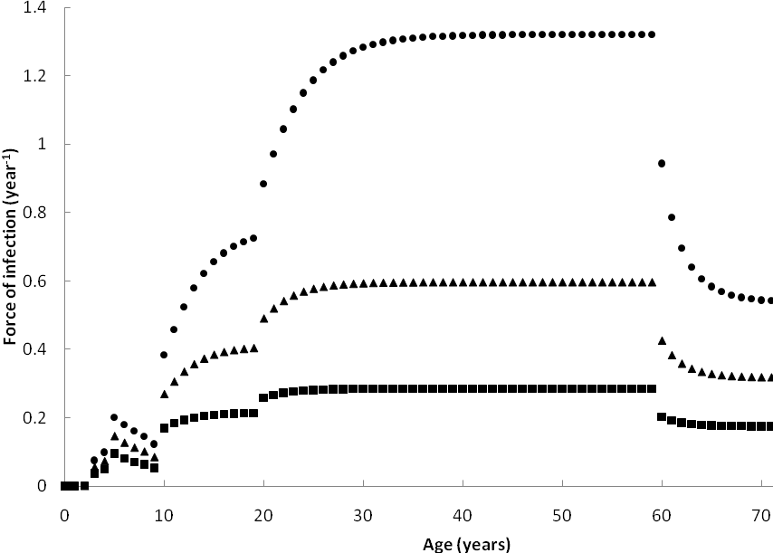
Supplementary Figure S1. Age-dependent force of infection (FOI) estimated from the Dutch 1996-2000 pertussis incidence data. Circles represents the base-case FOIs estimated based on incidence data that were corrected for underreporting based on data from de Melker et al. [2]. Triangles and squares show the estimated FOIs by applying a reduction of 25% (triangles) or 50% (squares) on the estimated base-case incidence for children aged 3 years and older (for children aged less than 3 years of age the incidence was not corrected for underreporting).

References
1. van Boven M, et al. Waning immunity and sub-clinical infection in an epidemic model: implications for pertussis in The Netherlands. Mathematical Biosciences 2000; 164: 161-182.
2. de Melker HE, et al. The incidence of Bordetella pertussis infections estimated in the population from a combination of serological surveys. Journal of Infection 2006; 53: 106-113.

