SUPPLEMENTARY MATERIAL

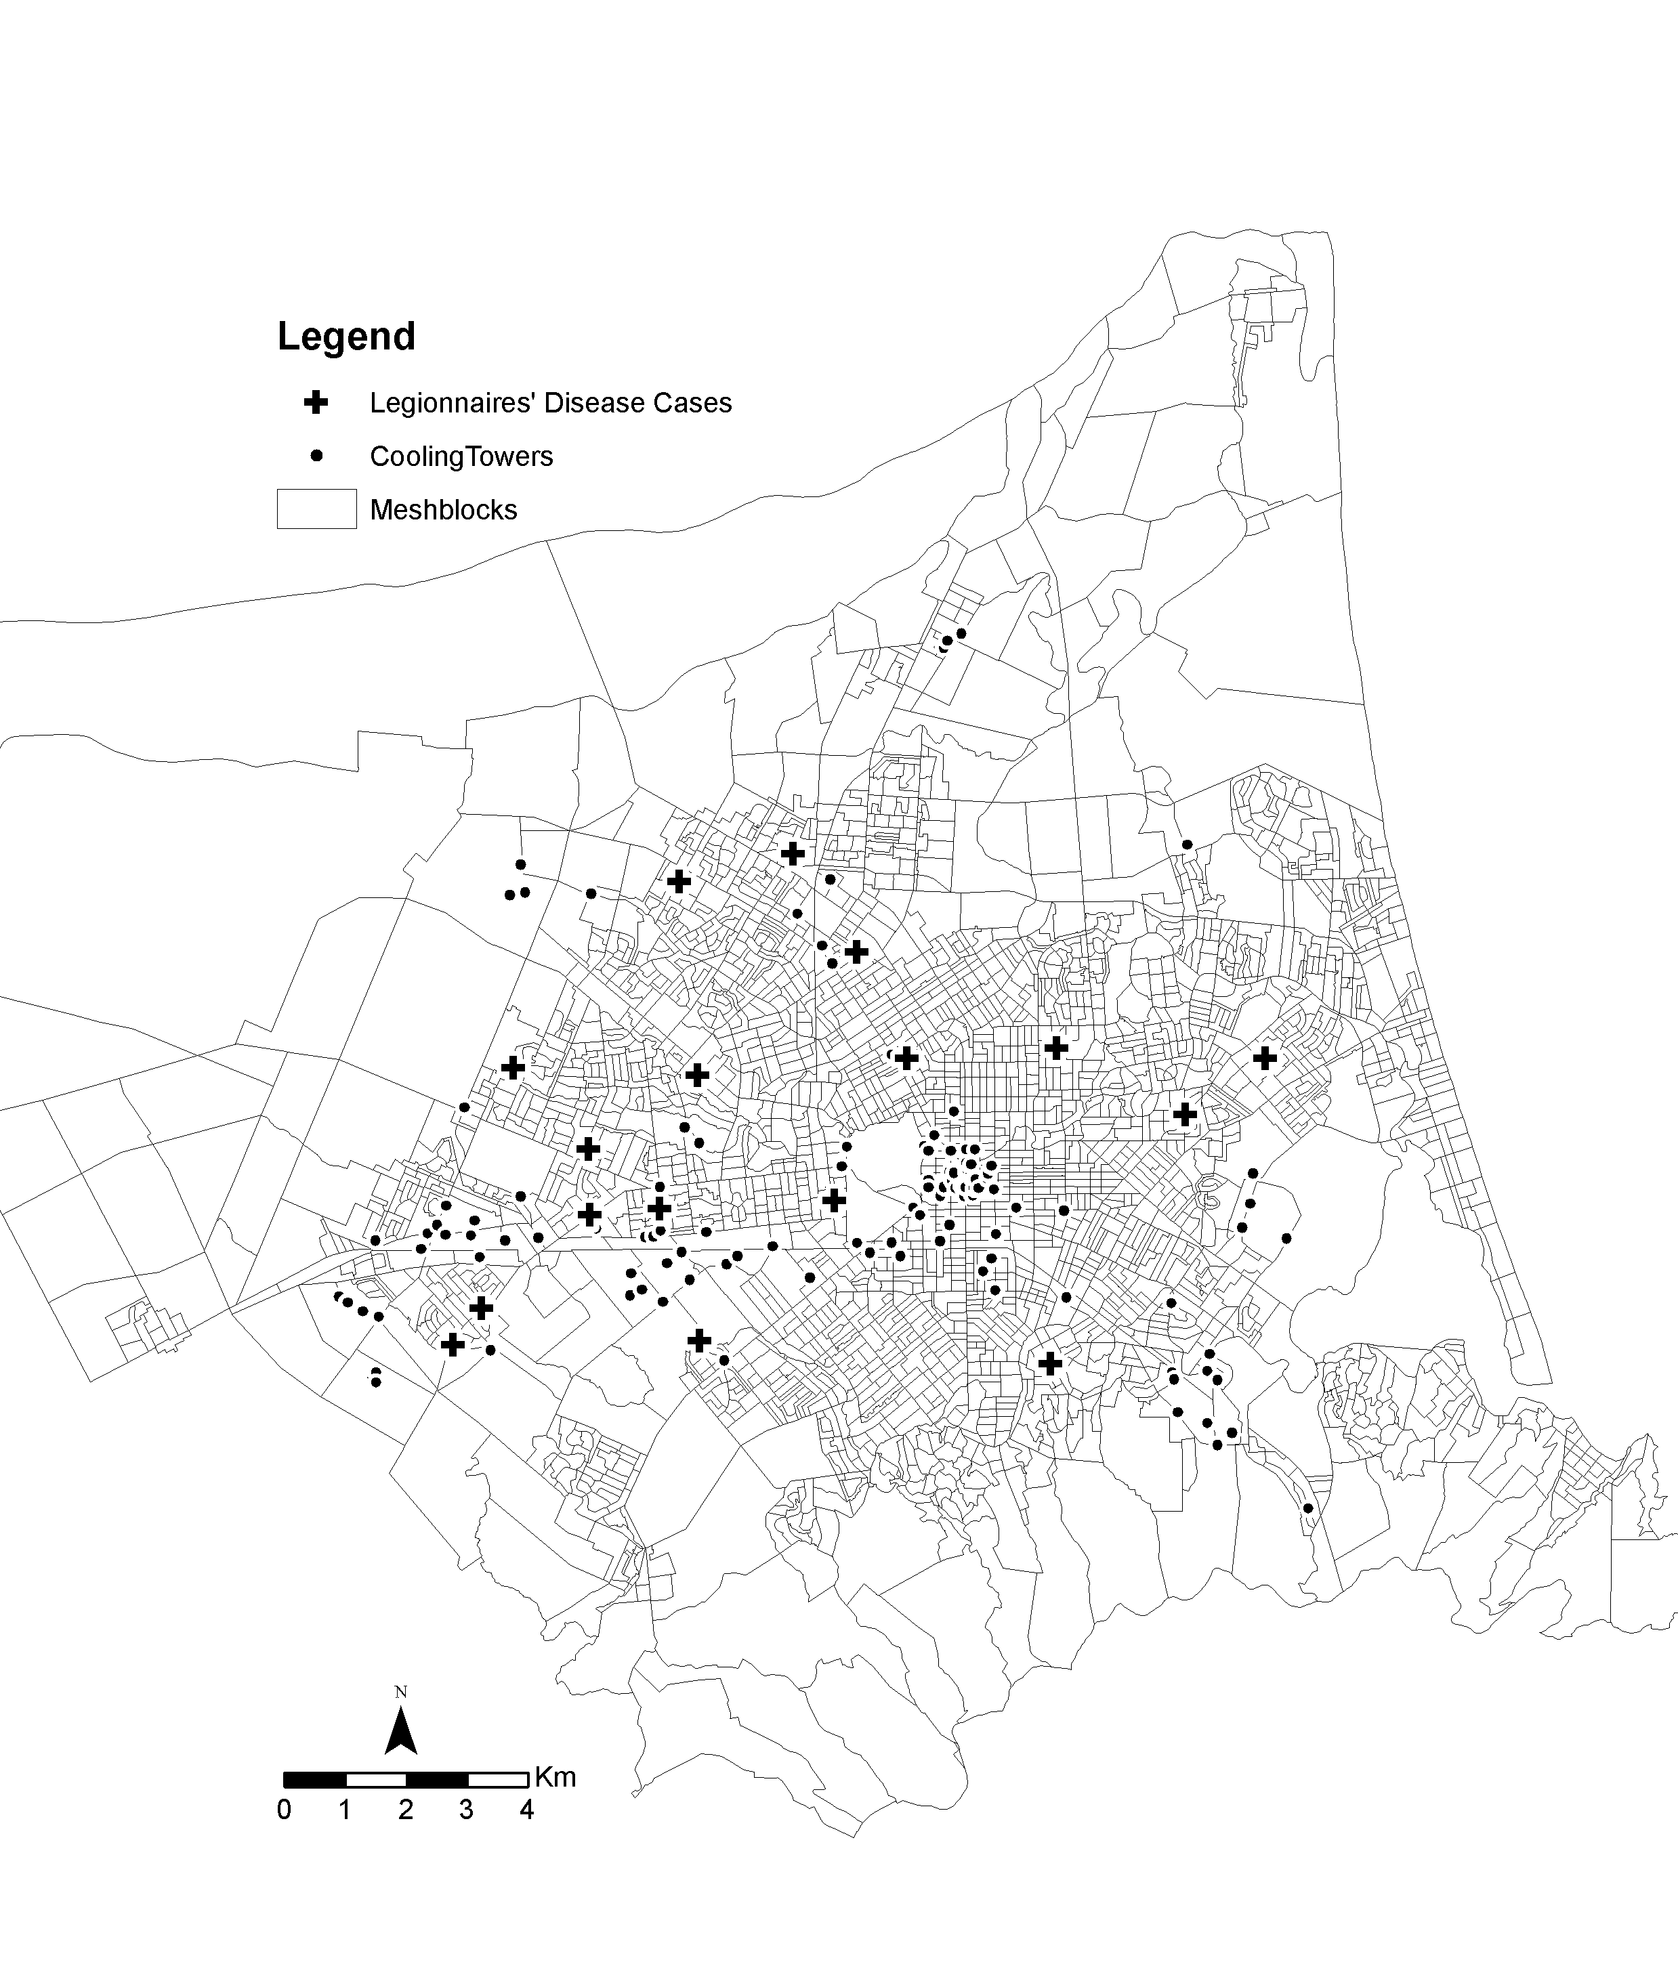
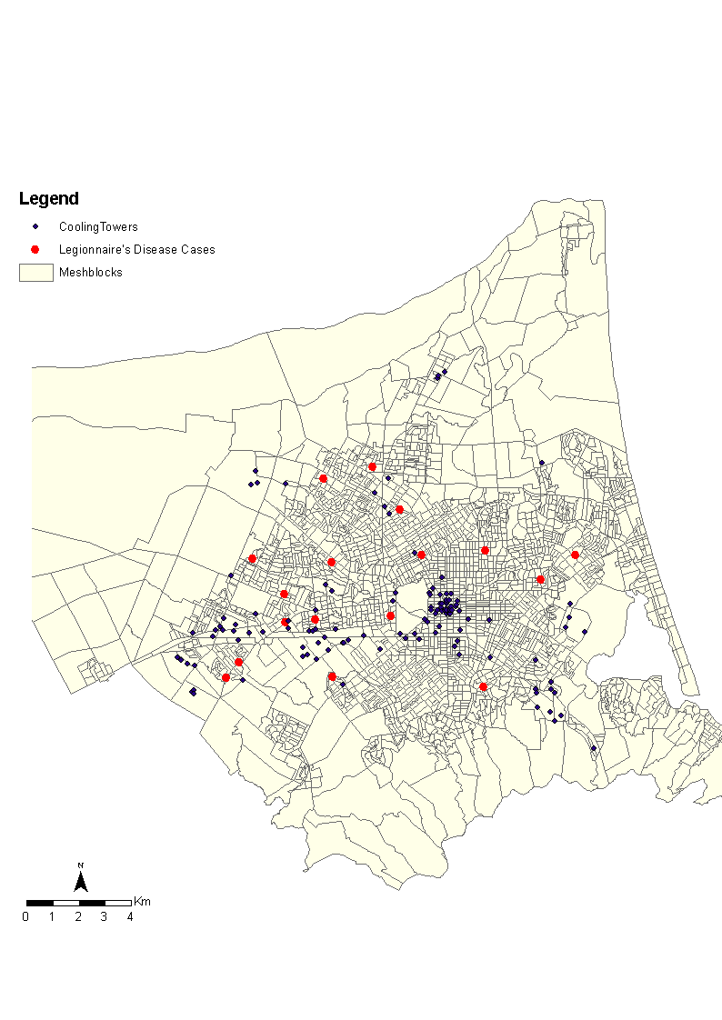

Supplementary Fig. S1. Distribution of Legionnaires’ disease cases and cooling towers across the territorial authority region of Christchurch City Council.

Map 1 Map 2
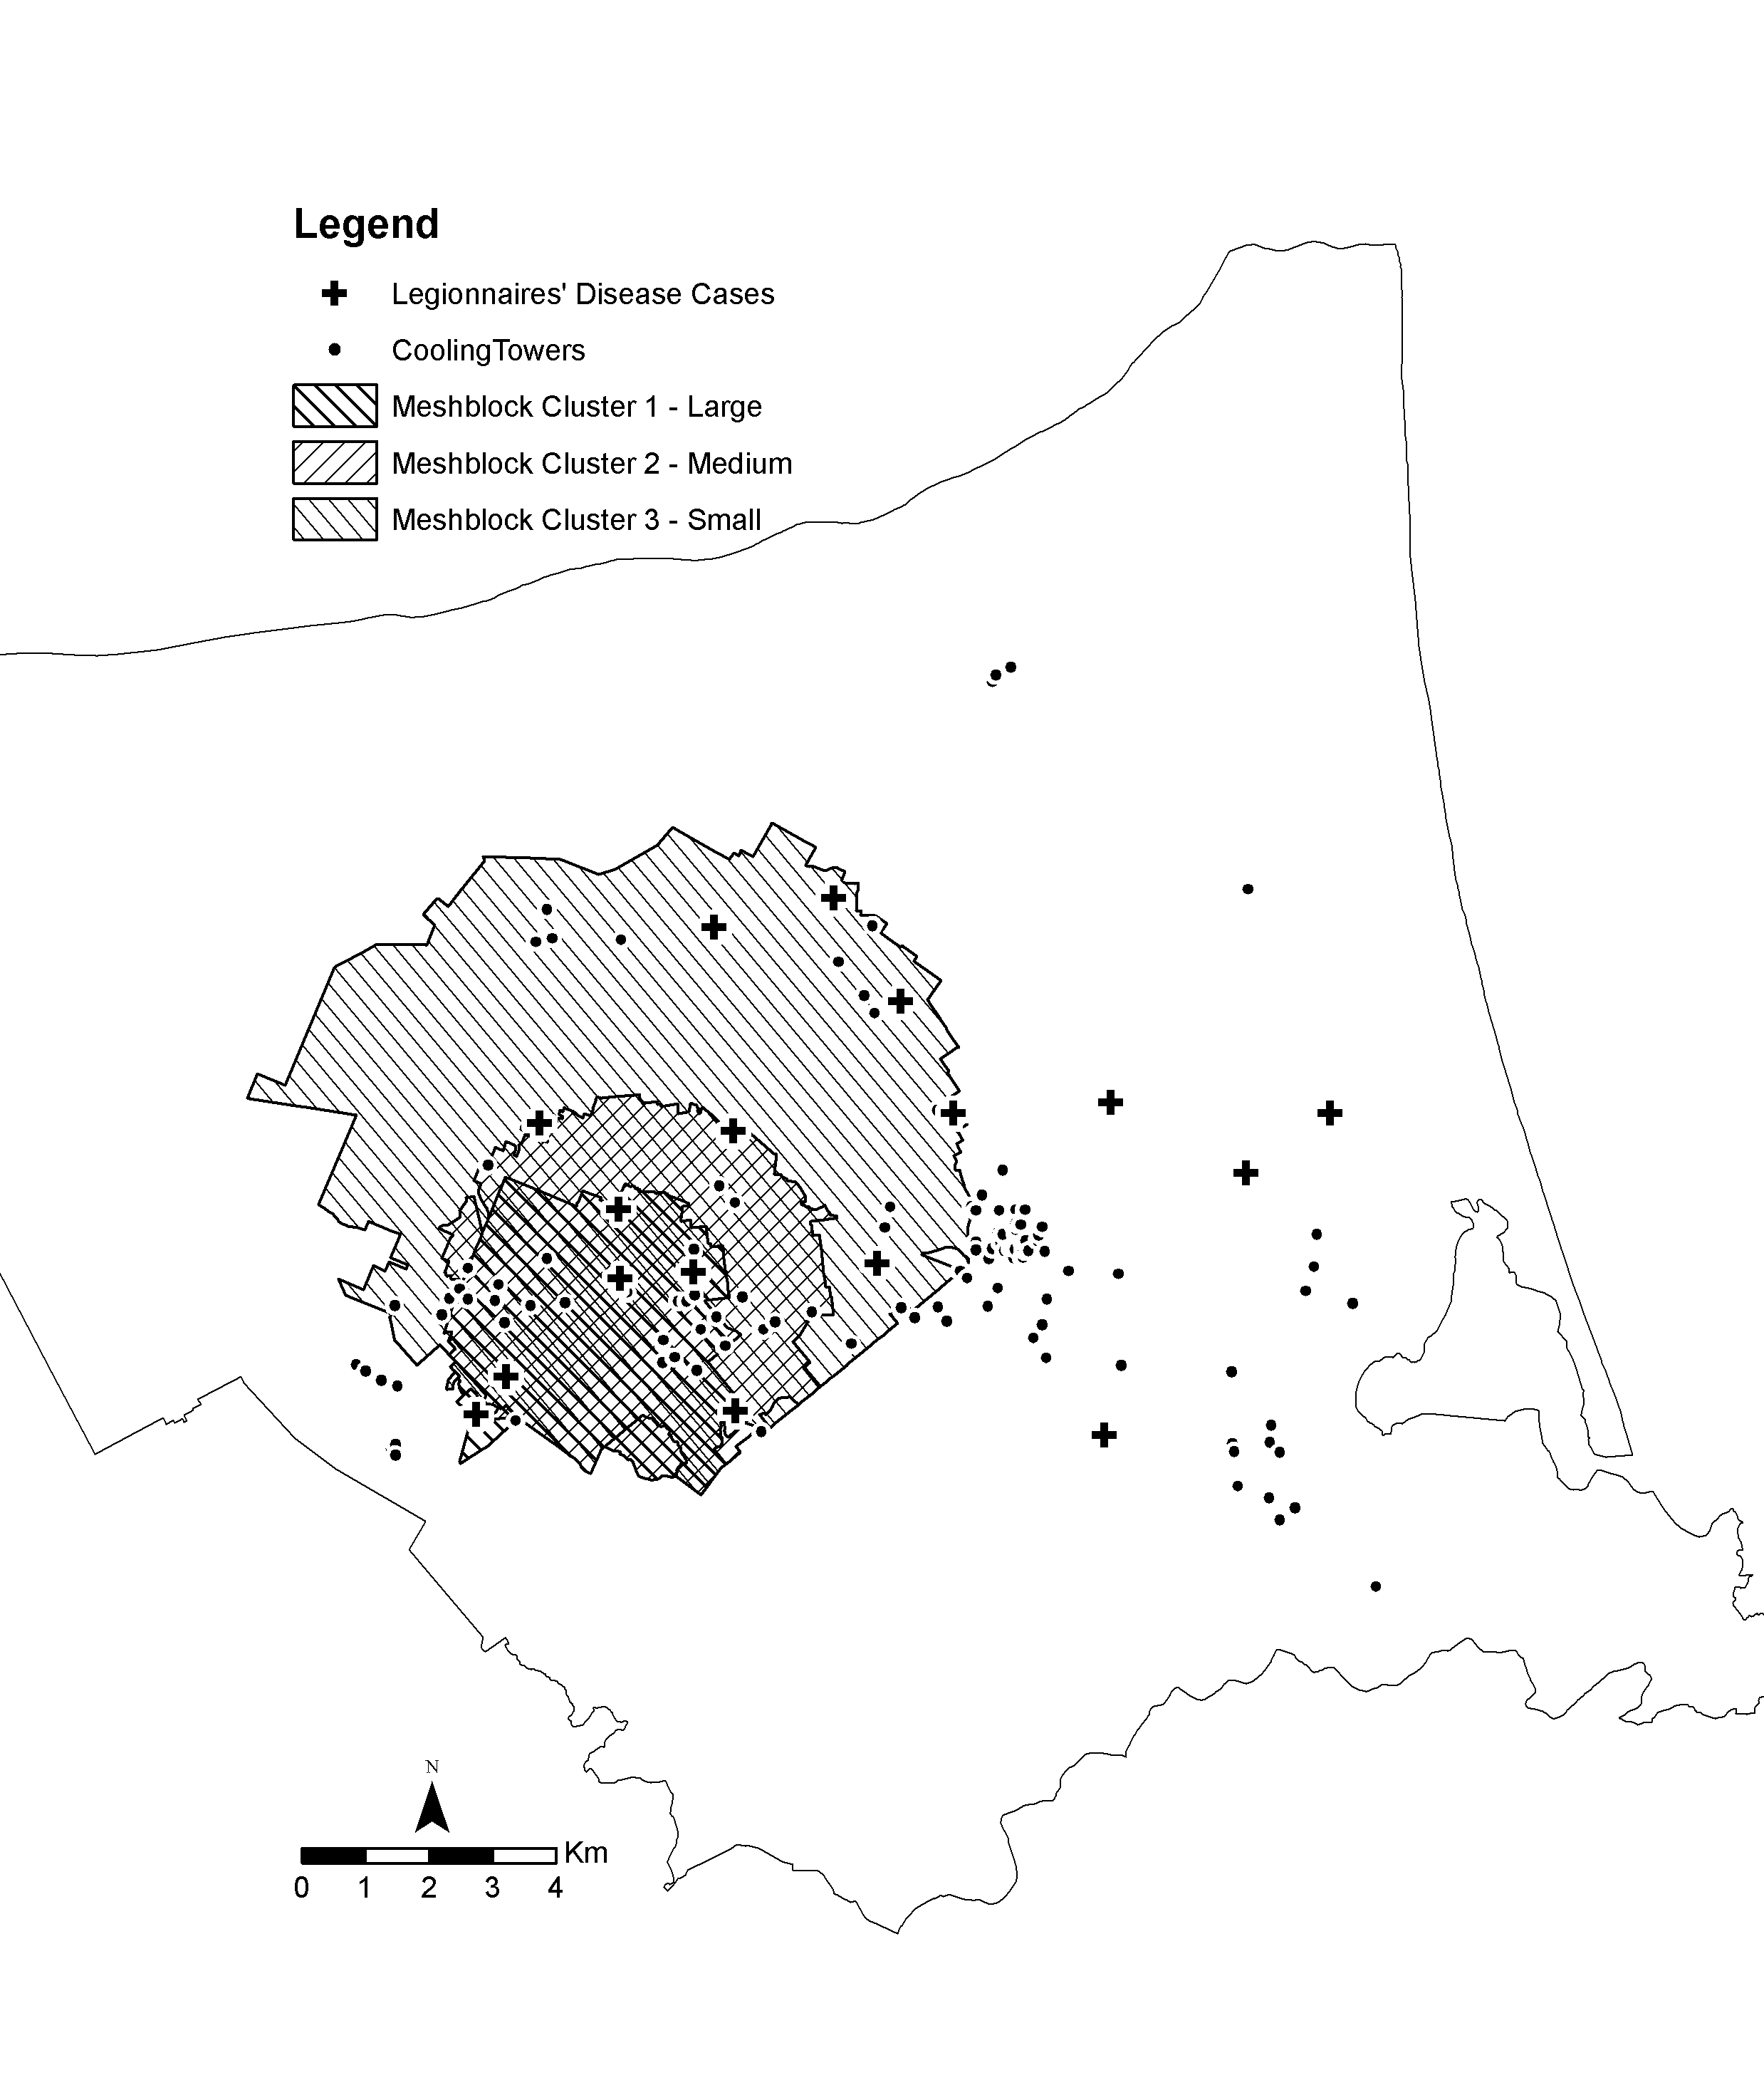
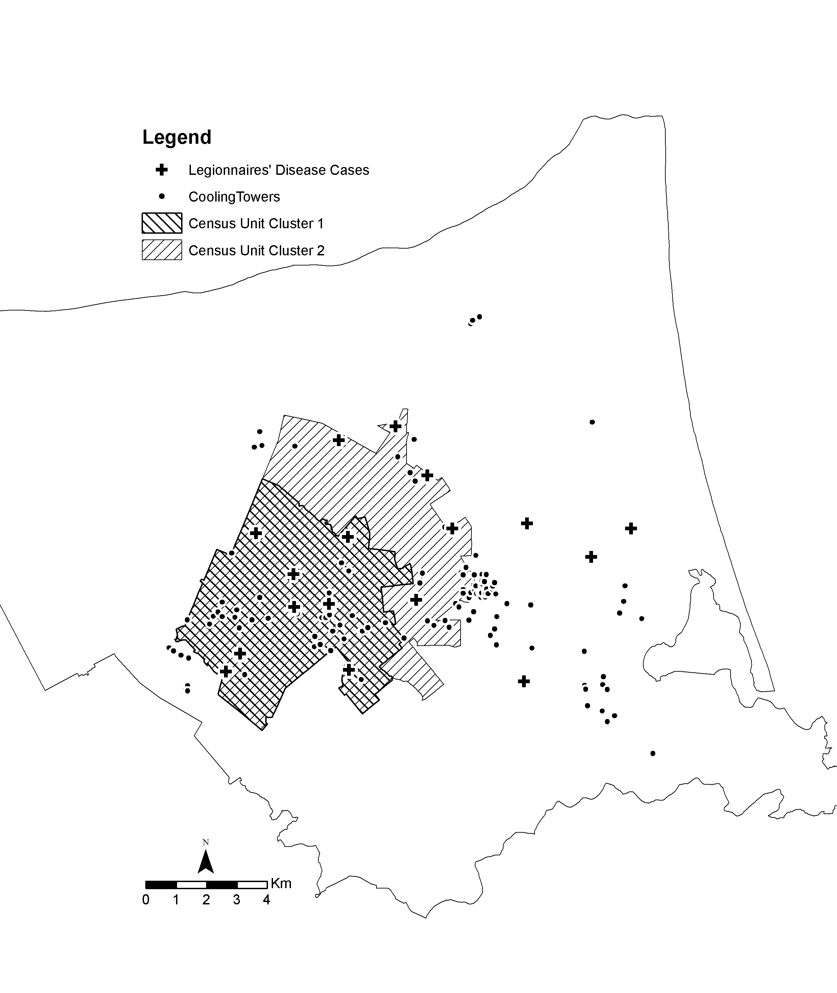

Map 1 Map 2
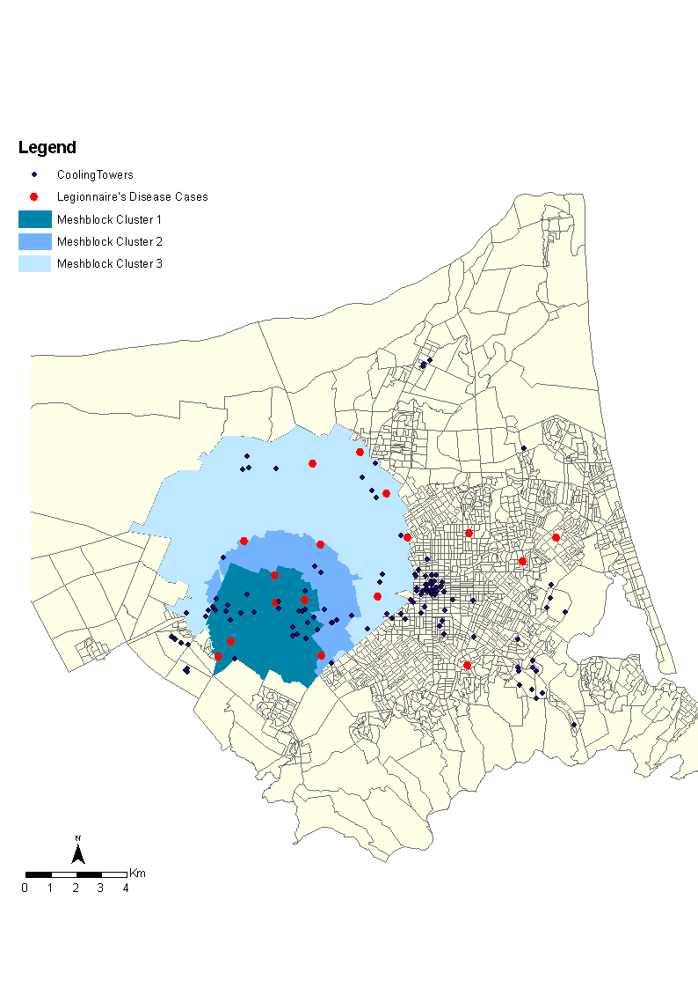
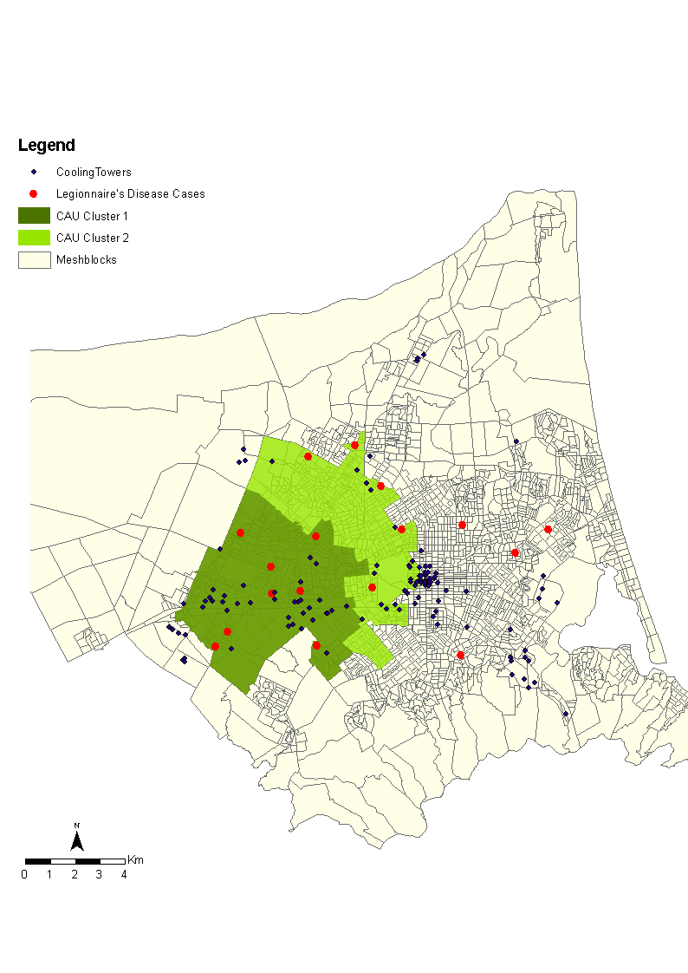

Supplementary Fig. S2. Spatial intensity clusters. Map 1: Meshblock clusters (three clusters); map 2: Census Area Unit clusters (two clusters).

Map 1 Map 2
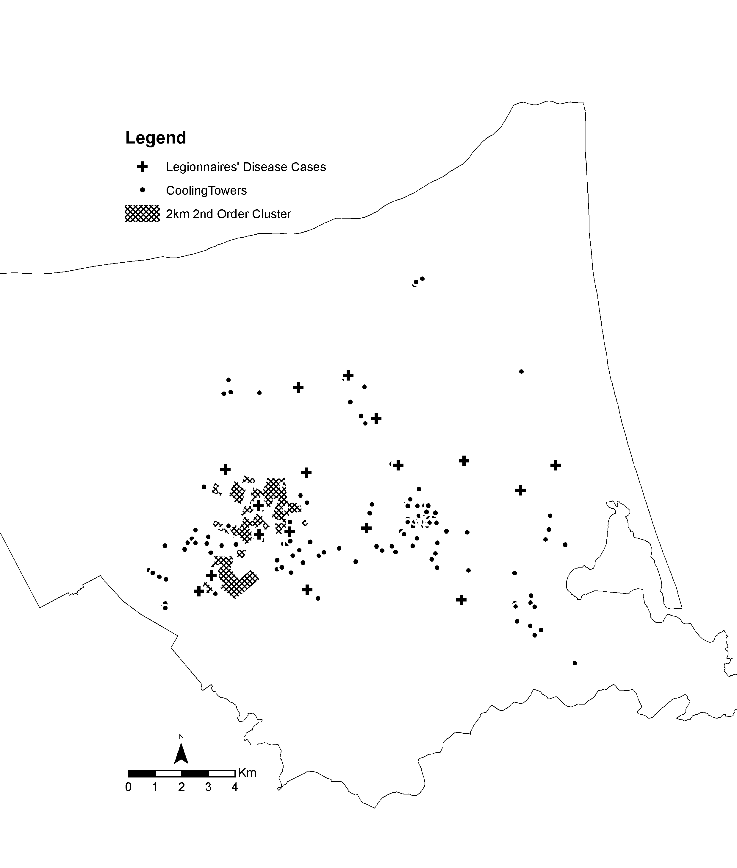
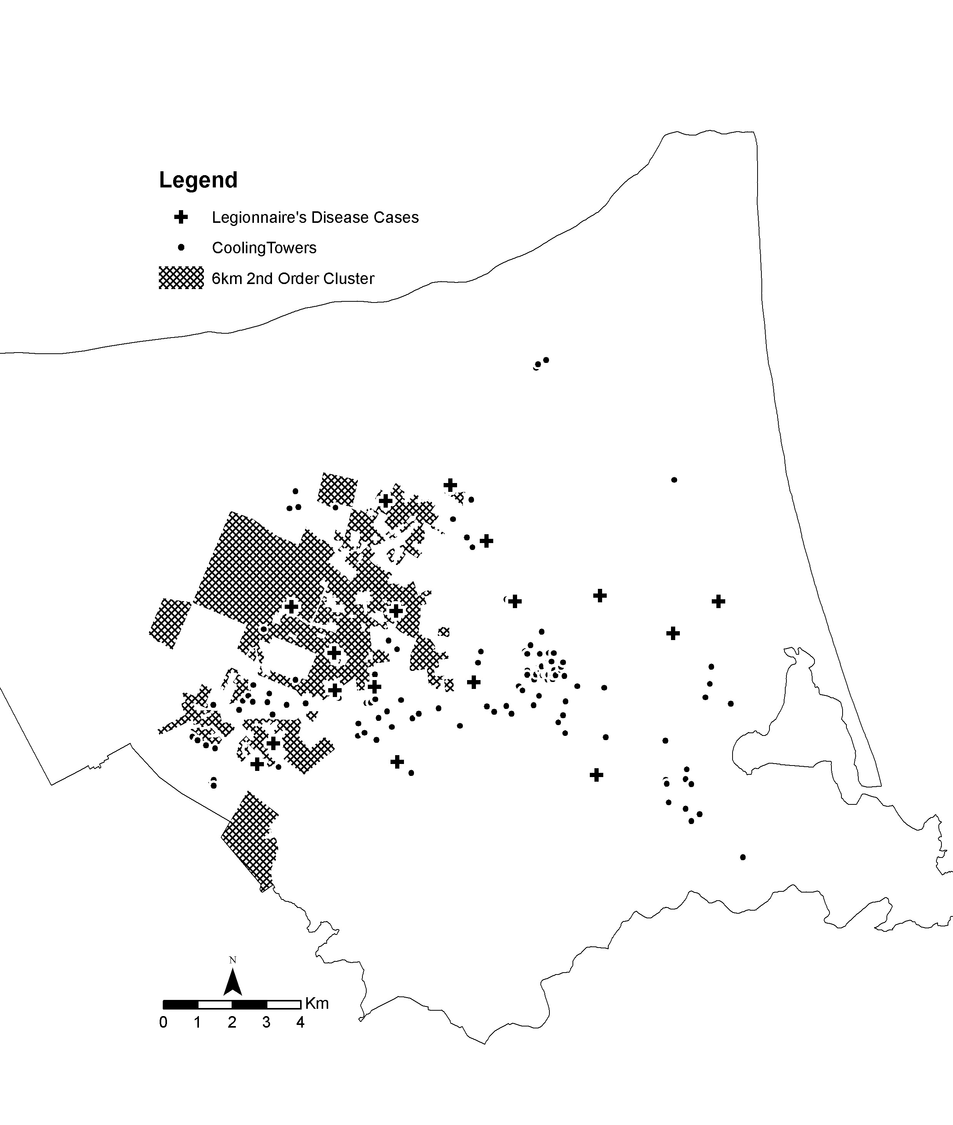

Map 1 Map 2
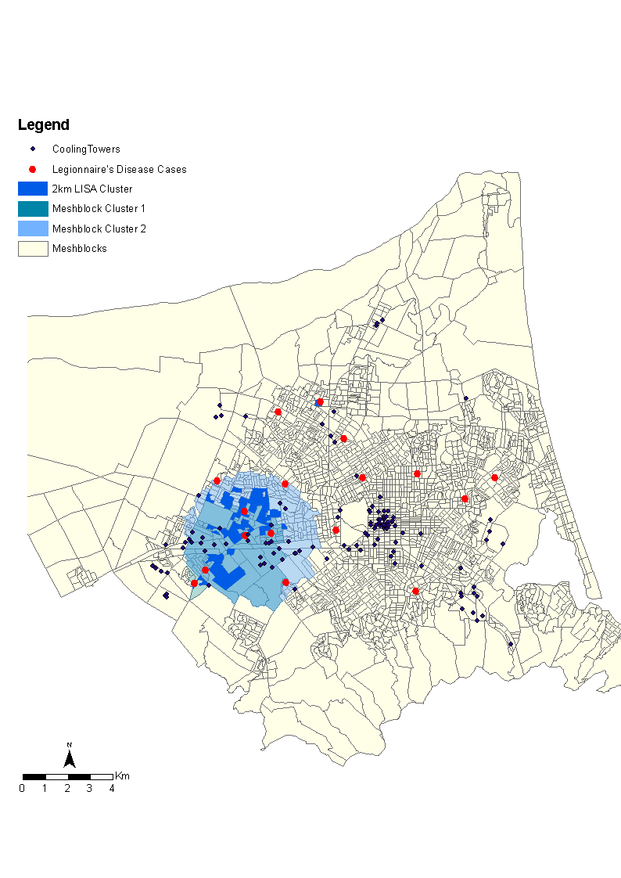
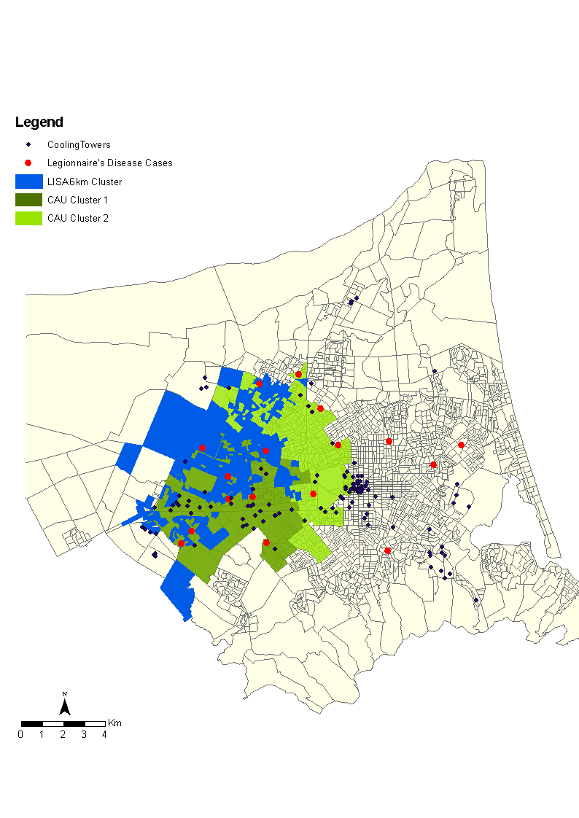

Supplementary Fig. S3. Statistically significant spatial dependency clusters. Map 1: 2 km distance; map 2: 6 km distance.

