SUPPLEMENTARY MATERIAL
Figure S1. Illustration of the baseline model governing equations
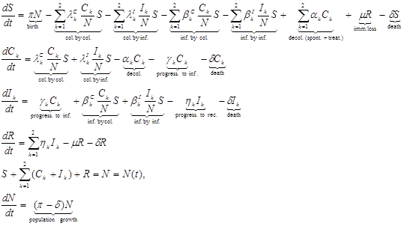
Where:
: MRSA, : MSSA
: Susceptible (not yet colonized or infected) population.
π: Birth rate.
N: Total US population.
: Colonized population.
: Infected population (symptomatic disease).
: Recovered population (from MRSA or MSSA infections).
: Average transmission rates (reflecting likelihood of a susceptible to be colonized or directly infected upon an adequate contact with another colonized or infected person/fomite).
: Rate of carriage clearance.
: Rate at which carriers become ill (infection).
: Rate of recovery from infection.
: Rate of potential immunity loss.
: Death rate – here, for simplicity, disease-related death is assumed negligible compared to natural death rate; however, disease-specific death-rates for MRSA and MSSA, respectively, can be also added.
We make the following additional assumptions here, in order to enforce biological/epidemiological plausibility and constrain our parameter-estimation problem:
- The likelihood of getting colonized via adequate contact with a colonized person is lower than the likelihood of getting colonized via adequate contact with an infected person, both for MRSA and MSSA. Similarly for direct infections, higher likelihood of occurrence via contact with infected people/fomites than colonized people/fomites. Presumably, infected individuals are more contagious than colonized individuals (e.g. due to higher bacterial load) – assuming that at the general population level, special precautions are not taken before individuals actually need treatment, etc.
- The likelihood of getting directly infected via adequate contact with a colonized/infected person/fomite is lower than the corresponding likelihood of getting colonized, both for MRSA and MSSA [1]). In addition, this likelihood of direct infection is lower for MSSA than for MRSA [2].
- The recovery period is longer for MRSA infection vs. MSSA infection [3].
- At the population level, the risk of infection in MRSA carriers is assumed higher than in MSSA carriers. This is apparent from the combined infection [4]/colonization [5] data, and has been documented [6], with published studies reporting at least a 4-fold difference [7].
- The hospitalized infections for each MRSA and MSSA represent just a percentage of the overall (inpatient + outpatient) corresponding infections at the population level.
- The “Recovered” compartment here is mainly considered as a way to allow the possibility for short periods of time with reduced susceptibility after infection (e.g. a direct consequence of treatment).
- Model parameters should lie within some acceptable ranges – here we use as guidance existing literature whenever available [8;9].
There are very few studies that actually looked at such parameters, and references [8;9] were the ones we identified that could be used here to provide some preliminary assessment of potentially reasonable orders of magnitude/ranges for what would otherwise be an open-ended estimation problem. In practice, in the absence of strong available evidence, such ranges can usually be adjusted by trial-and-error (sampling) to ensure qualitative plausibility of corresponding model projections, rule out unrealistic model behaviors, and subsequently better localize the parameter space to enable actual search for optimal values. In the absence of better data, we only use references [8;9] here to guide us towards potential feasible regions in the parameter space, which we further refine by trial and error to narrow down the search for the actual values that minimize the difference (in the least square sense) between the data and the corresponding model outcomes.
In order to assess model output variations to small perturbations in the model parameters, we conducted a parametric sensitivity analysis for the model governing system of Ordinary Differential Equations (ODEs) shown in Figure S1 above. We computed numerically derivatives (sensitivities) for all the six model state variables with respect to the seventeen model parameters listed in Table 1, over the timeframe used for the simulations in Figures 3 and 4. This analysis is summarized and illustrated in Figure S2 below, indicating the ranking of the seventeen model parameters listed in Table 1 for model outputs sensitivity, as follows:
- For each of these seventeen model parameters, we construct the sensitivity matrix corresponding to the derivatives of all the model state variables with respect to the respective parameter as estimated in Table 1, over time. We thus obtain seventeen corresponding sensitivity matrices here.
- We estimate the Frobenius norm for each of these seventeen sensitivity matrices, and then normalize it by the maximum one across all seventeen. These are the results illustrated in Figure S2, with the interpretation that the closer to 1 the point is, the more sensitive the model is with respect to that corresponding parameter, and conversely, the closer to 0, the less model sensitivity.
Figure S2. Illustration of the parametric sensitivity analysis
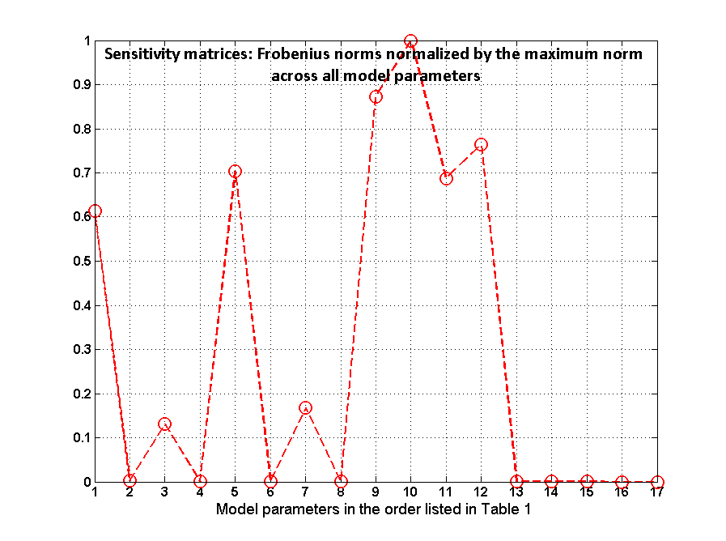
References
- van Belkum A. Staphylococcal colonization and infection: homeostasis versus disbalance of human (innate) immunity and bacterial virulence. Current Opinion in Infectious Diseases 2006; 19:339-344.
- Miller LG, Diep BA. Clinical practice: colonization, fomites, and virulence: rethinking the pathogenesis of community-associated methicillin-resistant Staphylococcus aureus infection. Clinical Infectious Diseases 2008; 46: 752-760.
- Cosgrove SE. The relationship between antimicrobial resistance and patient outcomes: mortality, length of hospital stay, and health care costs. Clinical Infectious Diseases 2006; 42 (Suppl. 2): S82-S89.
- Klein E, Smith DL, Laxminarayan R. Hospitalizations and deaths caused by methicillin-resistant Staphylococcus aureus, United States, 1999-2005. Emerging Infectious Diseases 2007; 13: 1840-1846.
- Gorwitz RJ, et al. Changes in the prevalence of nasal colonization with Staphylococcus aureus in the United States, 2001-2004. The Journal of Infectious Diseases 2008; 197: 1226-1234.
- Ellis MW, et al. Natural history of community-acquired methicillin-resistant Staphylococcus aureus colonization and infection in soldiers. Clinical Infectious Diseases 2004; 39: 971-979.
- Safdar N, Bradley EA. The risk of infection after nasal colonization with Staphylococcus aureus. The American Journal of Medicine 2008; 121: 310-315.
- D'Agata EM, et al. Modeling the invasion of community-acquired methicillin-resistant Staphylococcus aureus into hospitals. Clinical Infectious Diseases 2009; 48: 274-284.
- Kajita E, et al. Modelling an outbreak of an emerging pathogen. Nature Reviews Microbiology 2007; 5: 700-709.

