SUPPLEMENTARY ONLINE APPENDIX
to
Optimal design of studies of influenza transmission in households II: comparison between cohort and case-ascertained studies

We used a simulation approach to evaluate alternative study designs for household cohort and case-ascertained household influenza transmission studies. In household cohort studies a household is recruited before the start of an influenza season and monitored during an influenza season for influenza infection. In case-ascertained studies, households including an ‘index case’ are recruited and followed up. In our simulations we assumed that in each family one index case was indentified and that there were no co-primary infections. Furthermore, we assume all families contained in addition to the index case 3 susceptible, initially uninfected family members. Once enrolled, we compared four designs:

- Household cohort study with confirmatory diagnosis of index cases with RT-PCR followed by routine collection of specimens of all household members and testing with RT-PCR regardless of reported illness.
- Household cohort study with confirmatory diagnosis of index cases with RT-PCR followed by collection of specimens and testing with RT-PCR of household members upon report of ARI.
- Case-ascertained study with routine virological testing of all household members with RT-PCR regardless of reported illness.
- Case-ascertained study with ARI-triggered collection and testing of specimens in the household members.
We defined acute respiratory illness (ARI) as presence of 2 of the following symptoms: fever (>37.8 °C), cough, headache, sore throat, or myalgia. Our data and assumptions regarding the sensitivity and specificity of virological confirmation and ARI case definition are given in Table 1 in the main text.

Basic assumptions
The total number of families enrolled, n, was calculated for a wide range of fixed field work budgets ranging from US2$50,000 to US$6,000,000. The number of families per arm was n/2 and the total of number of individuals per arm was 3n/2. We adopt the following procedures to simulation infections within that study population.
- The mean secondary attack proportion for the control group was 0.1
- The secondary attack proportion is allowed to very stochastically between 0.05 to 0.15 for each household. This assumption is to allow some inter-household correlation in the risk of secondary attack.
- Household secondary attack was weekly correlated (0.4) with symptom severity (see Table 1). This was made to allow index cases with more severe infections to be more infectious to their household contacts.
- Relative risk between the intervention and control arms was defined as SAP in the intervention are divided by the SAP in the control arm. Therefore for a relative risk of 0.7 the SAP in the intervention arm was 0.07. Relative risks were converted into odds ratios using the following equation
[(SAP intervention)/(1 - SAP intervention)]/ [(SAP control)/(1 - SAP control)
- Each uninfected individual had a probability of getting infected equal to the secondary attack proportion in that household. Therefore in each simulation infection for each individual (3n) was simulated from a Bernoulli distribution with p = SAP_{i}. where i represents the household.
- If an individual was infected, we then take a stochastic realization from a Weibull distribution with parameters shape = 2.8 and scale = 3.6 (see Table 1). This realization was considered to be that individual’s symptom onset time.
- It is assumed that the latent period is the same as the incubation period and that the duration is 1.5 days [1,2]. Therefore time of infection is the individual’s stochastically generated serial interval (from step 5) minus 1.5.
- If the intervention was implemented during the incubation period (after infectious contact but before symptom onset), the intervention was assumed to be a failure and the individual became infected.
- For cohort studies it is assumed that the intervention is implemented within 12 hours of symptom onset in the index case.
- For case-ascertained studies it assumed that the intervention is implemented between 12-60 hours (at discrete 12, 36, and 60 time points) after symptom onset in the index case. Time of intervention implementation is stochastically generated from a discrete uniform distribution.
- The probability of RT-PCR detection given the particular method of detection was calculated via the probability of detection relative to time since symptom onset for designs with home visits for all enrolled families (either case-ascertained or cohort once index case is confirmed). Probability of detection is presented in Figure 1 of Klick et al [3].

For all study designs a logistic general estimating equation model assuming an exchangeable correlation structure within households was used to compare attack proportion between the control and treatment arm. The null hypothesis was that odds ratio corresponding to the intervention as compared to control was equal to 1. If a p-value of less than or equal to 0.05 was observed, the null hypothesis was rejected.

This procedure was repeated 2500 times. The statistical power was calculated as the number of times the null hypothesis was rejected at a significance level of 0.05, divided by 2500. All simulations were conducted in R version 2.10.1 (R Development Core Team, Vienna, Austria).

References:

1. Lessler J, et al. Incubation periods of acute respiratory viral infections: a systematic review. Lancet Infect Dis 2009; 9: 291-300.
2. Nishiura H, Inaba H. Estimation of the incubation period of influenza A (H1N1-2009) among imported cases: addressing censoring using outbreak data at the origin of importation. Journal of Theoretical Biology 2011; 272: 123-30.
3. Klick B, Leung GM, Cowling BJ. Optimal design of studies of influenza transmission in households. I: case-ascertained studies. Epidemiology and Infection 2012; 140: 106-14.

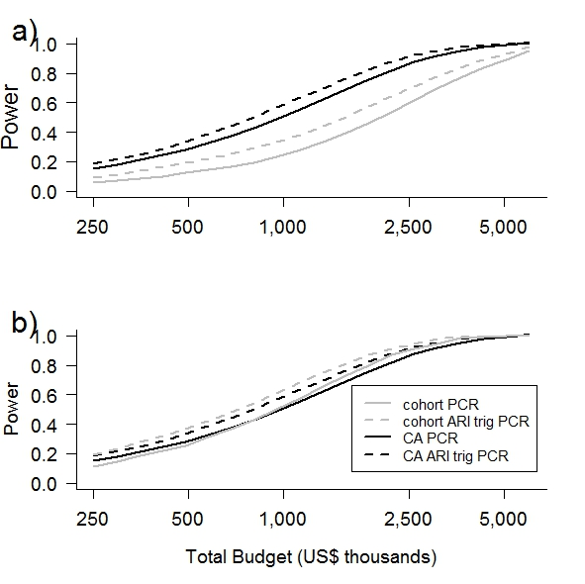
Appendix Figure S1: Sensitivity analysis showing the effect of changes to the Community Probability of Infection (CPI). Panel a) shows model results with a CPI of 0.10 and panel b) shows the model results with CPI of 0.30.
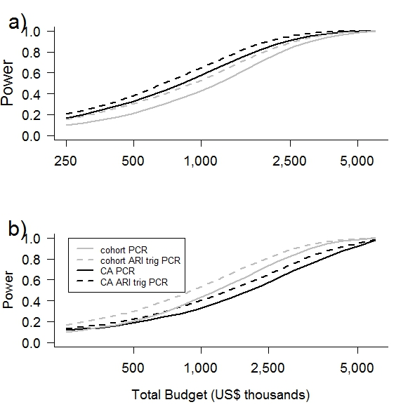
Appendix Figure S2: Sensitivity analysis showing the effect of changes to the Serial Interval of influenza. Panel a) shows model results with a mean serial interval of 3.6 and panel b) model results with a mean serial interval of 2.6.
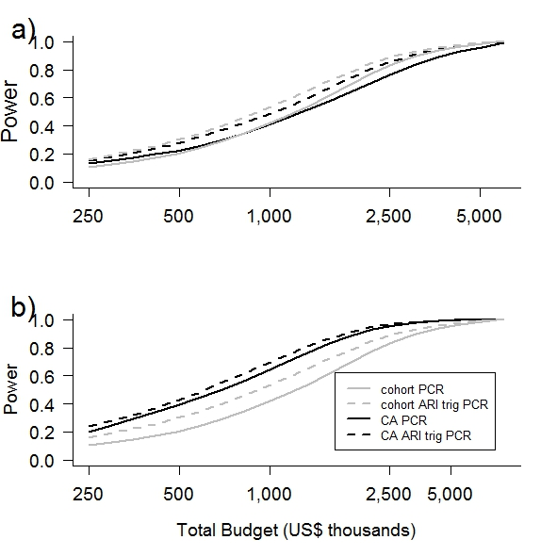
Appendix Figure S3: Sensitivity analysis showing the effect of changes to the enrollment cost of households in case-ascertained studies. Panel a) shows model results with a cost of enrollment of US$960 per household and panel b) shows model results with a cost of enrollment of US$480 per household.
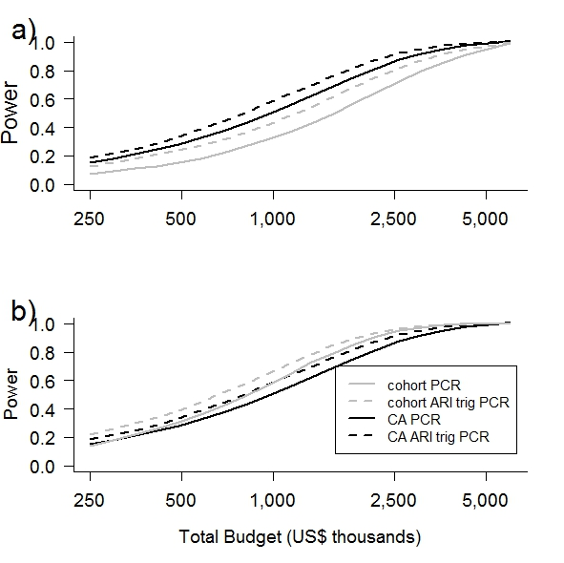
Appendix Figure S4: Sensitivity analysis showing the effect of changes to the enrollment cost of households in cohort studies. Panel a) shows model results with a cost of enrollment of US$800 per household and panel b) shows model results with a cost of enrollment of US$400 per household.

