Supplementary Online Appendix
The next generation matrix was computed from the transmission matrix F, which includes all new infections, and the transition matrix V, which includes all other transitions between states [58] as follows:
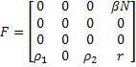
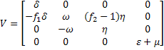
The next generation matrix, H, is then calculated as follows:
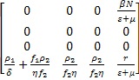
where, the element h₁₄ of matrix H can be interpreted as the average number of newly infected pigs (I₁) produced by one CFU of pathogen during its time in the environment. The elements h_{4i} (i = 1, 2, 3, 4) describe the average number of new STM contributed to the environment by introduction of an I₁ pig (h₄₁), L pig (h₄₂), I₂ pig (h₄₃) or one CFU of STM already in the environment (h₄₄). The basic reproduction number, R₀, is the spectral radius of the matrix H:
