APPENDIX 2: Total fertility rate (TFR) as an indicator for population growth

In the simulations of the present study, population growth was implemented by age-specific birthrates. A summation of age-specific birthrates between 15 and 49 years old is defined as TFR . This implies that TFR is the average number of children that would be born to a woman over her lifetime if she were to experience the current age-specific birthrates through her reproductive life.

The present study employed TFR as an input to each simulation because of the TFR’s convenient nature of a scholar variable. A given TFR was converted into a set of age-class specific birthrates. To do so, the relationships between the TFR and the age-class specific birthrates were expressed as second-order linear regressive equations, based on the data obtained from 194 countries/regions (see Figure in this file). As a result, the summation of the age-specific birthrates predicted by these regression equations reproduced the input TFR with accuracy greater than 99.999%.

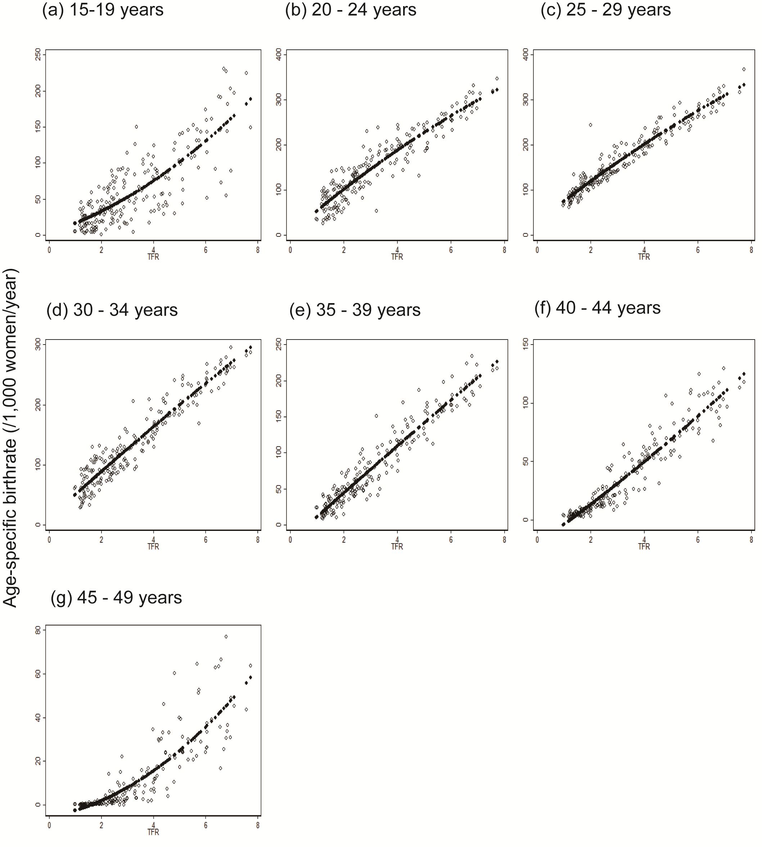
Fig. Second-order linear regression of age-specific birthrates against TFR, derived from 194 countries/regions, 1995-2005.
Reference

1. Russel J, Cohn R. Total fertility rate. Edinburgh: Lennex Corp, 2012.
2. United Nations Statistics Division. Age-specifi fertility rate (http://data.un.org). Accessed April 5 2013.

