APPENDIX 4: Effective reproductive number

Effective reproductive number is defined as the secondary infectious cases originating from a single primary infectious case in an actual population consisting of both naive and immune individuals. In the present study, effective reproductive number was estimated for the each time-step as E_{i}. Subsequently, E_{i} was averaged from the last 30 years of a simulation and plotted against the vaccination coverage and R₀ given to the simulation (see Figure in this file).
The absolute value of effective reproductive number exhibitedp complex responses to the vaccination coverage and R₀, depending on the type of vaccine (Figure a, b, c). However, the ratio of effective reproductive number over R₀ was stable throughout the vaccination coverage in any vaccines (Figure d, e, f).

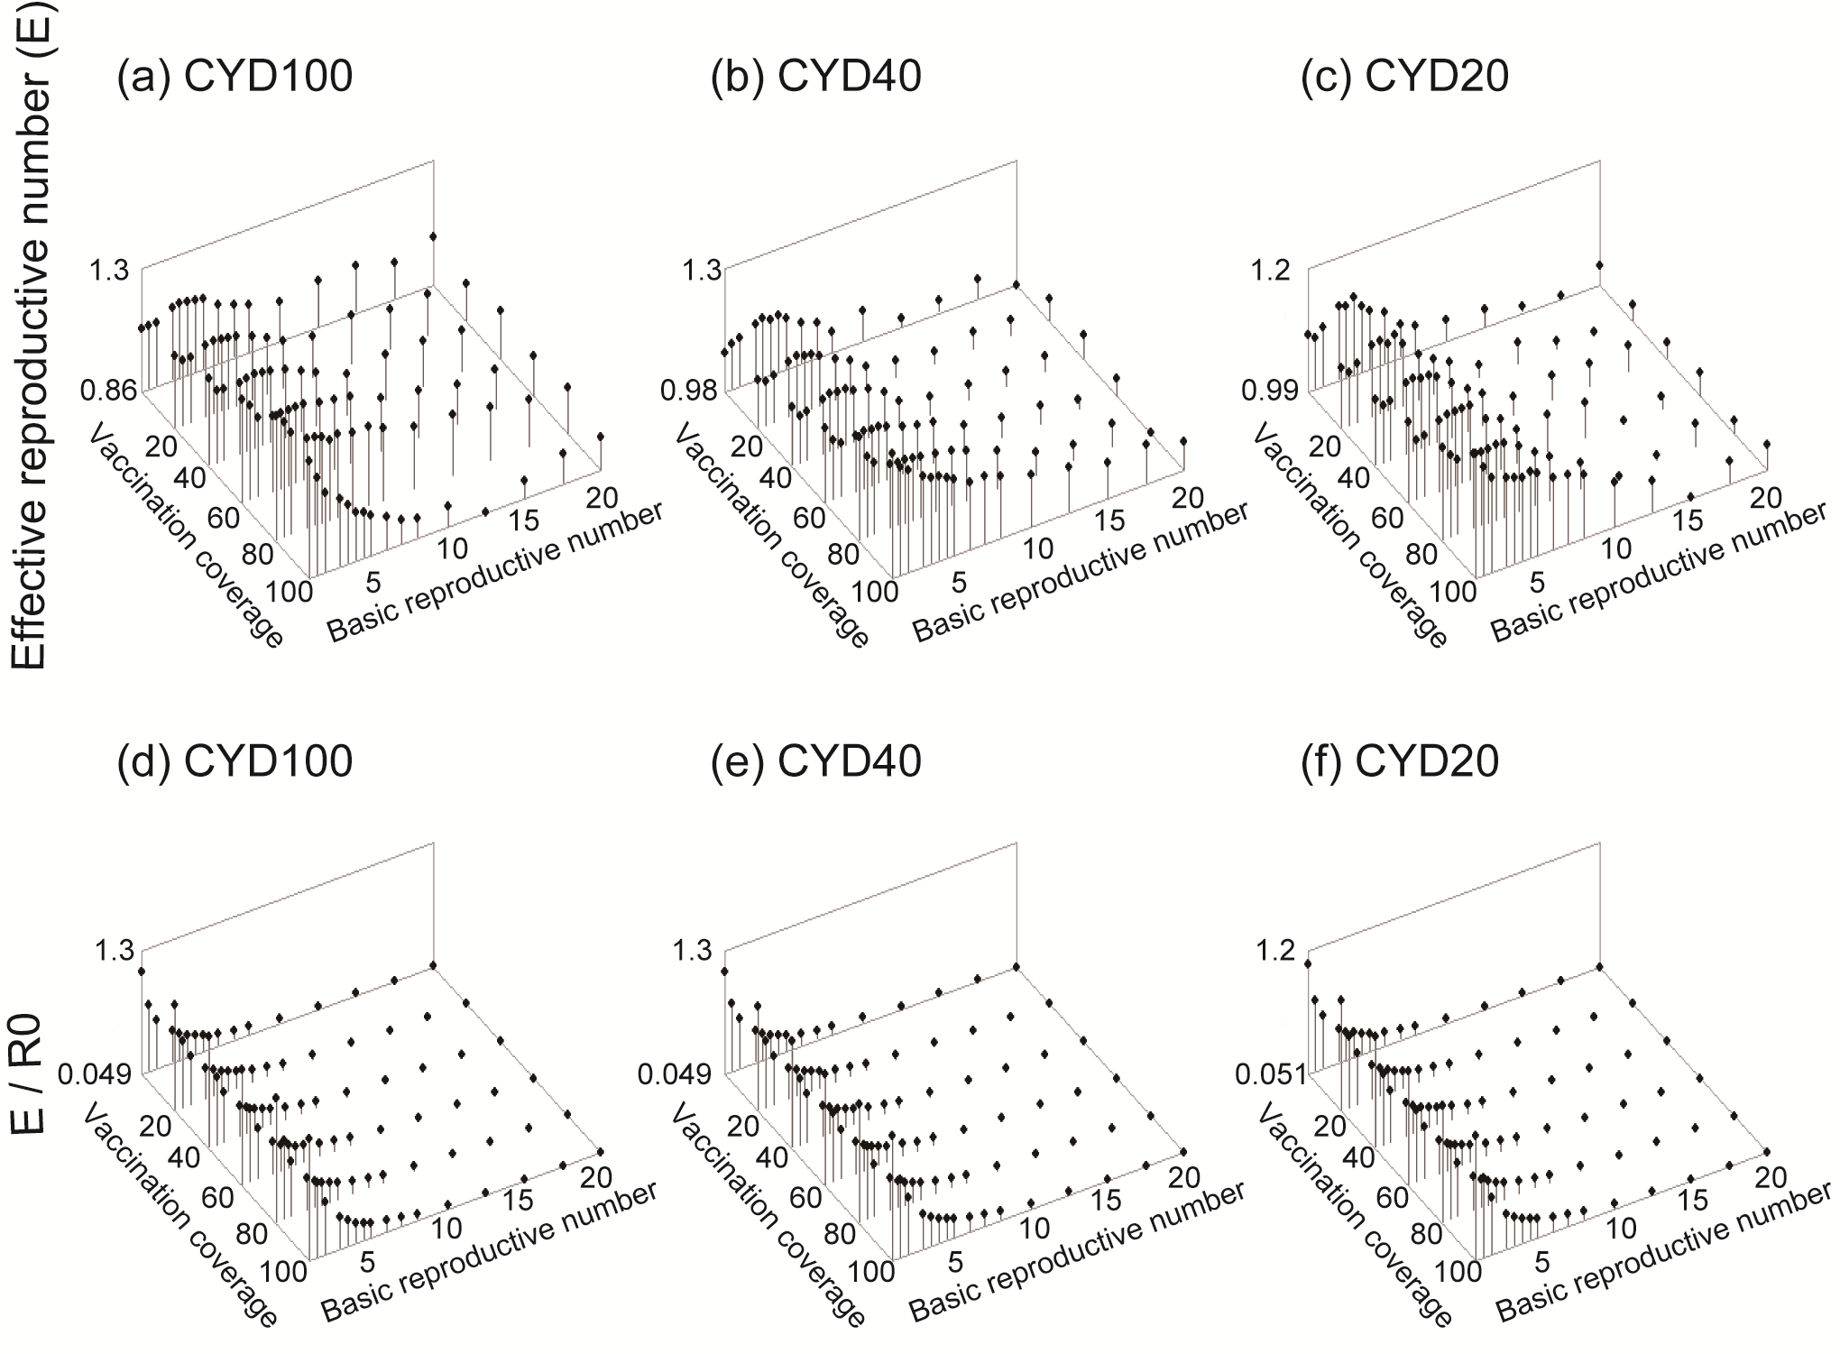
Fig. Effective reproductive number and its ratio over basic reproductive number (R0).
The parameter setting was the same as in Figure 3 in the main text.

