SUPPLEMENTARY MATERIAL

Rodent trappings
Eight localities were sampled for rodents in 2009 and 2010: Nan (19.15 N; 100.83 E), Loei (17.39 N; 101.77 E), Buriram (14.89 N; 103.01 E) and Kanchanaburi (14.07 N; 99.09 E) in Thailand, Luang Prabang (19.62 N; 102.05 E) and Champasak (15.12 N; 105.80 E) in Laos PDR, and Preah Sihanouk (10.71 N; 103.86 E) and Mondolkiri (12.04 N; 106.68 E) in Cambodia. Two trapping sessions were realized per locality in the wet and in the dry seasons from 2008 to 2009. Pictures, habitat description and coordinates of trap lines are available in the “research/study” areas and “research/protocols” sections of the CERoPath project web site (www.ceropath.org).
At each locality, 30 lines of 10 traps were placed during 4 nights in three different habitats:
(1) forests and mature plantations
(2) non-flooded lands or fields (shrubby waste land, young plantations, orchards),
(3) rain-fed lowland paddy rice fields (cultivated floodplain)
This corresponded for a total of 1200 night-traps in a session trapping. We repeated twice the trapping session in the wet season and in the dry season. The lines were settled in the same places (GPS recording).
The 30 lines were settled in a locality of around 10 km X10 km. A line is separated to another from 1 km (different habitats) to 3 km or more (same habitat).
Villages and isolated houses, which correspond to a fourth habitat category, the human settlement, were also sampled using cage-traps distributed to residents. The numbers of night traps were roughly similar with a mean of 550 night traps (range 521 to 693).
We used live-traps that are cage-traps locally made.
In addition, we added a sampling of 41 Rattus tanezumi trapped in Bangkhen, Bangkok (13.51 N, 100.34 E).

Geographical coordinates of trap line devices and households were systematically recorded with a GPS and the surrounding landscape was described by field observation with a three-level classification: “low resolution” for the main landscape categories (forest, non flooded agriculture fields, irrigated / rain fed agriculture field, settlement), “medium resolution” for a more detailed category nested in the “low resolution” (for example: isolated farm in “settlement”, rice field in “rain fed agriculture field”, corn field in “non flooded agriculture field” , dry evergreen in “forest) and “high resolution” nested “medium resolution” to give more precision (harvested in “rice field” in “rain fed agriculture field, flooded, etc.).
The accuracy of geographical coordinates ranges from: 1 (less than 10 meters, i.e. the precision of GPS) for geographical coordinates taken at the individual trap, 2 (less than 100 meters, i.e. a trap line of ten traps is less than 100 m long) for geographical coordinates taken in the middle of traps’ line, 3 (less than 1,000 meters, i.e. a rodent trapped in a given field or in a given village) for geographical coordinates for a rodent trapped by hunter in an area around these coordinates.

Rodent species and habitat
The number of individuals for each rodent species in each habitat types is given in the table bellow.

Species | forest | Non-flooded lands | Rain-fed lands | settlement
Bandicota indica | 5 | 3 | 6 | 2
Bandicota savilei | 1 | 40 | 14 | 1
Berylmys berdmorei | 1 | 6 | 0 | 3
Maxomys surifer | 25 | 23 | 0 | 5
Niviventer fulvescens | 4 | 0 | 0 | 1
Rattus argentiventer | 1 | 0 | 3 | 10
Rattus exulans | 0 | 3 | 8 | 124
Rattus losea | 0 | 2 | 27 | 0
Rattus nitidus | 1 | 2 | 1 | 0
Rattus norvegicus | 0 | 0 | 3 | 13
Rattus tanezumi | 21 | 24 | 18 | 78
Suncus murinus | 0 | 0 | 1 | 28

A correspondence analysis plot (Figure below) shows the associations between the rodent species and habitats. The first and second dimensions explain 80% of the total variance. Most rodent species seem to have some habitat preferences: Rattus losea tended to be found in rainfed fields; Rattus nitidus and Bandicota berdmorei in dry lands; Niviventer fulvescens and Maxomys surifier in forests; Rattus norvegicus, Rattus argentiventer, Suncus murinus and R. exulans preferred settlements. This latter species dominated the settlement data: 124 out of 135 individuals captured in the settlement are R. exulans (47 %). Some species showed less preference as Rattus tanezumi that can be found in any kind of environment.

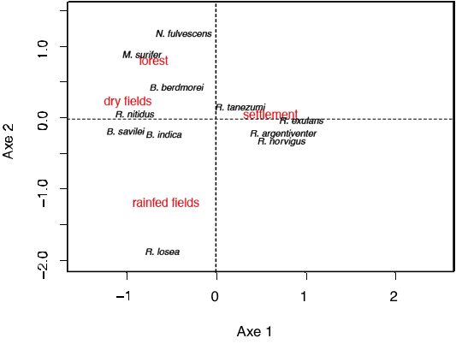

Primers using for the molecular study
Molecular amplification of the whole ITS1 region of the ribosomal DNA of the genus Trypanosoma sp. was carried out using primers TRYP1S (5’ CGT CCC TGC CAT TTG TAC ACA C 3’) and TRYP1R (5’ GGA AGC CAA GTC ATC CAT CG 3’).
Molecular amplification of the satellite genomic DNA of the sub-genus Trypanozoon was carried out using primers TBR1 (5’ GAA TAT TAA ACA ATG CGC AGC 3’) and TBR2 (5’ CCA TTT ATT AGC TTT GTT GC 3’).
Molecular amplification of a species-specific sub-fraction of ITS1 region of the ribosomal DNA was carried out using primers LEW1S (5’ ACC ACC ACA CGC TCT CTT CT 3’) and LEW1R (5’ TGT ATG TGC GTG CTT GTT CA 3’).
Interpretation of the results was based on the size of the PCR product estimated by comparison with the molecular marker GeneRuler®100Plus (Fermentas TM), and positive controls including T. evansi and T. lewisi DNA.

