SUPPLEMENTARY MATERIAL
Supplementary Figure S1. Flowchart used to determine the number of influenza infections and non-influenza infections according to vaccination status.

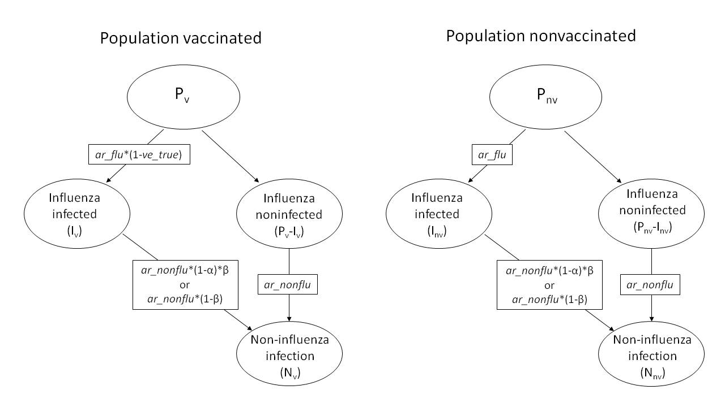

ve_true: true vaccine effectiveness against influenza infection; ar_flu: infection attack rate (IAR) of influenza in individuals not vaccinated or not effectively vaccinated; ar_nonflu: IAR of NIRV in individuals not protected by influenza-induced non-specific immunity; α: preventive effect of influenza infection-induced non-specific immunity against NIRV infection; β: ratio of the duration of influenza-induced non-specific immunity to the duration of the influenza season
Supplementary equations
Derivation of equation 1 of the main paper:
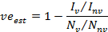
Using the expressions in the main paper for and we can write:
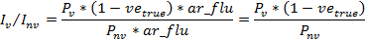
and
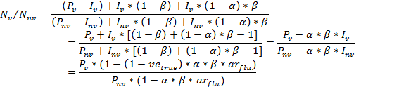
where the last equality is obtained by using the expressions and given in the main paper. Combining these two results we can now write:
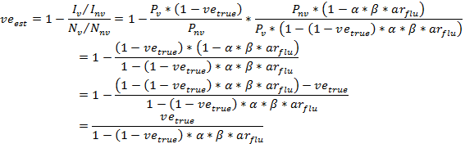
to obtain the equation 1 of the main paper.

Explicit formulae for absolute and relative biases:
Absolute bias: 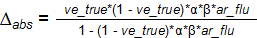

Relative bias: 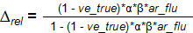

Analytical results:
It is trivial to see that increases with α, β, and ar_flu. In contrast, for fixed values of α, β, and ar_flu, can be shown to peak at an intermediate value of ve_true:

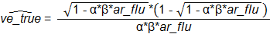

and is equal to

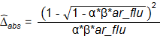

It can be shown that is a decreasing function of α, β, and ar_flu, whereas is an increasing function of α, β, and ar_flu (i.e., the greater the product of the influenza infection attack rate, intensity, and duration of non-specific immunity, the lower the value of the true vaccine effectiveness at which the absolute bias is maximised and the greater this absolute bias).

However, the analysis of relative bias is much simpler, as it is trivial to observe that increases with α, β, and ar_flu and decreases with ve_true.

