Epidemiology and Infection

Molecular epidemiology of Norovirus from patients with acute gastroenteritis in Galicia (NW Spain)

C.F. MANSO, J.L. ROMALDE

Supplemental Material

Table S1: Primers used for NoV characterization by amplification of a partial capsid gene region.
PRIMER | SEQUENCE | AIM
GOG1F | 5’- cgytggatgcgnttycatga- 3’ | Sequencing of NoV GI partial capsid region
G1SKR | 5’- CCAACCCARCCATTRTACA-3’ | Sequencing of NoV GI partial capsid region
G1SKF | 5’- CTGCCCGAATTYGTAAATGA-3’ | Sequencing of NoV GI partial capsid region
GOG2F | 5’-CARGARBCNATGTTYAGRTGGATGAG-3’ | Sequencing of NoV GII partial capsid region
G2SKR | 5’- CCRCCNGCATRHCCRTTRTACAT-3’ | Sequencing of NoV GII partial capsid region
G2SKF | 5’- CNTGGGAGGGCGATCGCAA-3’ | Sequencing of NoV GII partial capsid region

Figure S1.- Phylogenetic reconstruction based on the partial capsid gene sequences of NoV included in the study and reference strains by NJ method. Bar, expected nucleotide substitutions per site. Only bootstrap values above 70% are shown (1000 resamplings) at each branch point.

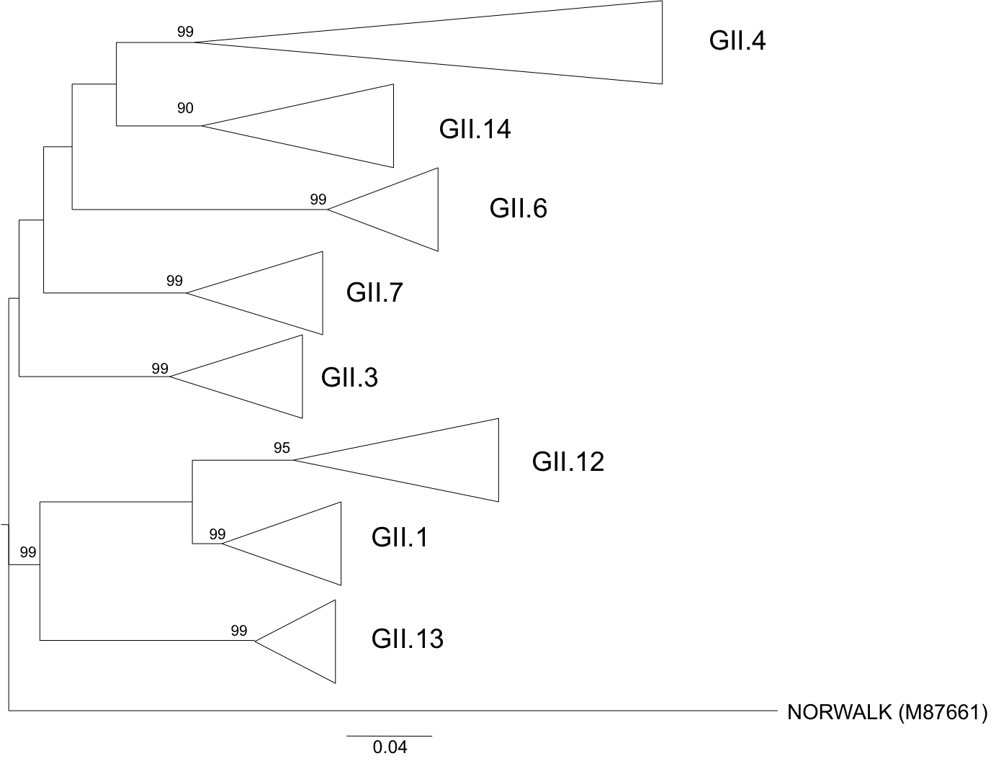

Figure S2: Phylogenetic reconstruction based on the partial capsid gene sequences of : A) NoV GII.7 strains and reference strains by NJ method, and B) NoV GII.13 strains and reference strains by NJ method. Bar, expected nucleotide substitutions per site. Only bootstrap values above 70% are shown (1000 resamplings) at each branch point. In parenthesis are indicated the GenBank accession number of reference sequences.

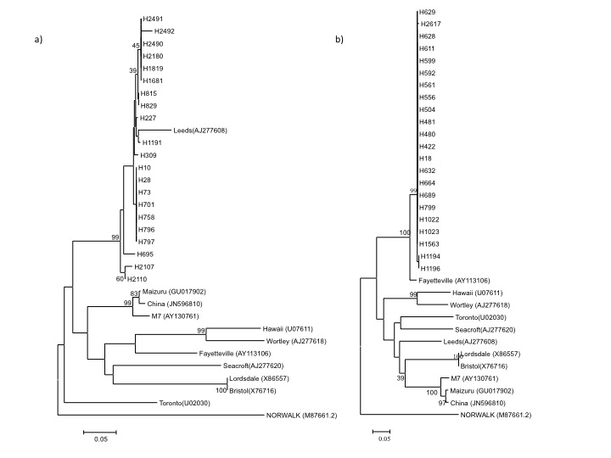

Figure S3.- Monthly prevalence for NoV GII.7 (A) and GII.13 (B) strains in the period from July 2010 to June 2011..

