SUPPLEMENTARY MATERIAL

S1. Additional network measures

Average degrees for specific age groups are 8.46 for toddlers (n=472), 9.62 for preschool children (n=290), 21.18 for school-age children (n=2582), 15.82 for adults (n=6039), 8.61 for elderly individuals living in the community (n=827), and 19.70 for elderly individuals living in nursing homes (n=94). The urban network has a transitivity ratio (the extent to which connected nodes tend to cluster together) of 0.0687 and assortativity (the extent to which nodes tend to be connected to similar nodes, in this case nodes of similar age) of 0.1858.

R0 values were calculated as

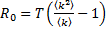
where T is transmissibility, <k> is the average degree of the network, and <k²> is the mean square degree of the network (see main text reference 31).

S2. Detailed efficacy/coverage of vaccines and antiviral drugs

Tables S1 and S2 display the values used for each age group for realistic vaccine coverage (1-10; Table S1) and realistic vaccine efficacy (11-16; Table S2). Table S3 summarizes results of our review of vaccine efficacy; Table S4 summarizes our review of antiviral efficacy.

S3. Outbreak size distribution

In order to justify our decision to include only those outbreaks during which over 5% of our population was infected, we include histograms of the distribution of outbreak size observed when the seasonal (Figure S1a) and pandemic (Figure S1b) scenarios were run in a naive population. For both scenarios, outbreaks overwhelmingly clustered around the average epidemic (20%) or pandemic (40%) size reported in the main text, or at very low outbreak sizes, usually far below 5% of the population. In fact, the vast majority of simulations in both the epidemic and pandemic scenarios did not result in any infections beyond the initially seeded infection, even in a naive population.

S4. Sensitivity analyses

First, we demonstrated that our decision not to consider existing natural immunity to influenza did not impact our results. Table S5 displays the age-specific impact of natural immunity on influenza susceptibility and infectivity, as well as age-specific coverage levels; as natural infection with influenza reduces the likelihood of subsequent infection, as well as the likelihood of infection being symptomatic if it does occur, we have implemented natural immunity as a reduction in both susceptibility and infectivity (17-21). These values are for seasonal influenza; as influenza pandemics are typically caused by strains that are only distantly related to previously circulating strains, it is expected that there will be little to no natural immunity present in the case of a pandemic. We considered two natural immunity scenarios. In the first, natural immunity was allocated randomly to 20% of the population, in whom susceptibility was reduced by 70% and infectivity by 50%, values obtained from taking the weighted averages of the values located in Table S5 (Figure S2a). In the second, natural immunity was employed in an age-based manner, according to Table S5 (Figure S2b). We then employed random vaccination or various coverage levels of random antiviral treatment, as described in the main text for Figure 2. When individuals who already had natural immunity were vaccinated or received antiviral treatment, their susceptibility or infectivity, respectively, was reduced further, according to the efficacy of the control measure in question. Note that, in order to ensure that the appropriate 20% of our population was infected by seasonal influenza when neither vaccination nor antiviral treatment was employed, we increased the transmissibility value used to 0.08 (R₀ = 1.41). We found that the overall qualitative patterns are exactly the same as observed in Figure 2, confirming that, even in the presence of natural immunity, realistic antiviral strategies are unlikely to outperform influenza vaccines.

Figure S3 displays attack rates and epidemic likelihoods when a variety of antiviral control strategies were employed during seasonal influenza epidemics. As in the pandemic case, preferentially treating infected children with antiviral drugs significantly decreased overall epidemic attack rates, particularly in the rapid case, despite requiring fewer courses of antivirals to achieve these reductions. After 40% coverage, the impact of treating children decreased. Providing susceptible contacts of treated individuals with prophylactic treatment also resulted in a reduction in attack rate, although more antiviral courses overall were needed. In the relaxed case, this reduction first increased, then decreased after 40% coverage among infected individuals was reached; in the rapid case, the reduction decreased with increasing coverage level. Finally, when early treatment was compared to random treatment of the same overall number of individuals, treating all infected individuals until a certain proportion of the entire population received treatment resulted in greatly reduced epidemic likelihood whether individuals were treated within 48 or 24 hours. As in the main text, results for all sensitivity analyses of attack rate were obtained by running 5000 simulations for each set of parameters, while results for epidemic likelihood were obtained by running 100 sets of 500 simulations.

In Figure S4, we compared the impact of random antiviral treatment to that of vaccination with vaccines of decreasing efficacy at a higher transmissibility likely to be a realistic value for the 1918 pandemic (T=0.1132, R₀=2.00) (Mills, et al. 2004). Control strategies were implemented as described for Figure 3 in the main text. We observed that vaccines began to outperform antivirals at efficacies between about 8% and 24%. Thus, our qualitative results hold for higher estimates of pandemic transmissibility.

In Figure S5, the effects of altering the efficacy and coverage levels of both antiviral drugs and influenza vaccine are shown in order to assess the impact of efficacy and coverage simultaneously. Methods were similar to those presented in the main text, and vaccine and antivirals were both implemented randomly. We found that small changes in antiviral coverage level had a greater impact on attack rate at higher efficacies, and vice versa. Therefore, at the lower values of coverage and efficacy most likely to be realistic, variation in either parameter is not expected to greatly alter the attack rate of the ensuing epidemic or pandemic. This suggests that, despite the lack of data on antiviral coverage and efficacy in reducing infectivity, our model provided us with reasonable results concerning the population-level impact of antiviral treatment. A similar pattern was seen for influenza vaccines. Thus, our conclusions concerning the ability of vaccines of relatively low efficacy to outperform antivirals in reducing attack rates appear to be sound.

Figure S6 displays the impact of random vaccination and antiviral treatment on epidemic and pandemic attack rates on computer-generated random networks of varying contact heterogeneity. Specifically, we observed results for a regular, a Poisson, a geometric, and a scale-free random network, each with 10,304 nodes and an average degree of 8. We found that, as contact heterogeneity increased, progressively higher antiviral coverage levels were required to outperform vaccines. This pattern held for both the seasonal and pandemic scenarios, as well as for both the relaxed and rapid antiviral treatment strategies. For all four random networks, results were qualitatively similar to those reported for the urban network in the main text, with 40-80% antiviral coverage rates generally required to outperform vaccines during the seasonal scenario and 80% coverage rates typically required to outperform vaccines during the pandemic scenario. We therefore conclude that antiviral treatment is unlikely to be a reasonable alternative to vaccination regardless of population structure.

In Figure S7, we compared our age-based strategy of preferentially treating children to random antiviral allocation at a range of antiviral efficacies for both seasonal and pandemic influenza. Unlike in the main text, preferentially treating children in this figure signifies that all infected children were treated, and that no antivirals were distributed among members of other age groups. The coverage levels among infected individuals for the random comparison scenarios were set equal to the calculated coverage achieved by the age-based strategy at each specific antiviral efficacy value. Preferentially treating children was seen to consistently outperform random allocation of antivirals among infected individuals, and this difference increased as antiviral efficacy increased (or, alternatively, as time to treatment decreased), particularly in the pandemic case.

Finally, Figure S8 compared the impact of preferentially treating those individuals at highest risk for severe complications and death (children age 0-4 and adults age 65+) to that of random antiviral treatment. Strategies were implemented as described in the main text. While random allocation of antiviral drugs did perform slightly better than treating those at high risk, particularly in the seasonal influenza scenario, this difference was very small. Furthermore, both strategies required very similar total numbers of antiviral courses.

S5. References

[1] Osterholm MT, et al. The compelling need for game-changing influenza vaccines: an analysis of the influenza vaccine enterprise and recommendations for the future. Minneapolis: Center for Infectious Disease Research & Policy; 2012. Sponsored by the Alfred P. Sloan Foundation. http://www.cidrap.umn.edu/sites/default/files/public/downloads/ccivi_report.pdf.

[2] TABLE: Self-reported influenza vaccination coverage trends 1989-2008 among adults by age group, risk group, race/ethnicity, health-care worker status, and pregnancy status, United States, National Health Interview Survey (NHIS) [Internet]. Atlanta: Centers for Disease Control and Prevention; [updated 2012 Sep 26] (http://www.cdc.gov/flu/fluvaxview/trends.htm). Accessed 7 Aug 2013.

[3] Age Groups: Estimates from the Behavioral Risk Factor Surveillance System (BRFSS), National Immunization Survey (NIS), and the National 2009 H1N1 Flu Survey (NHFS) [Internet]. Atlanta: Centers for Disease Control and Prevention; 2012 (http://www.cdc.gov/flu/professionals/vaccination/trends/age-groups.htm). Accessed 7 Aug 2013.

[4] Influenza Vaccination Coverage among Children Aged 6-23 Months – United States, 2008–9 Influenza Season [Internet]. Atlanta: Centers for Disease Control and Prevention; 2010 (http://www.cdc.gov/flu/professionals/vaccination/coverage_6-23months.htm). Accessed 7 Aug 2013.

[5] Centers for Disease Control and Prevention. Influenza vaccination coverage among children aged 6-59 months – six immunization information system sentinel sites, United States, 2006–07 influenza season. Morbidity and Mortality Weekly Report 2007; 56: 963–965. http://www.cdc.gov/mmwr/preview/mmwrhtml/mm5637a3.htm.

[6] Centers for Disease Control and Prevention. Influenza vaccination coverage among children aged 6 months-18 years – eight immunization information system sentinel sites, United States, 2008–09 influenza season. Morbidity and Mortality Weekly Report 2009 Oct; 58: 1059–1062. http://www.cdc.gov/mmwr/preview/mmwrhtml/mm5838a1.htm.

[7] Centers for Disease Control and Prevention. Influenza vaccination coverage among children and adults – United States, 2008–09 influenza season. Morbidity and Mortality Weekly Report 2009; 58: 1091–1095. http://www.cdc.gov/mmwr/preview/mmwrhtml/mm5839a1.htm.

[8] Centers for Disease Control and Prevention. Outbreak of influenza A in a nursing home – New York, December 1991 – January 1992. Morbidity and Mortality Weekly Report 1992; 41: 129–131. http://www.cdc.gov/mmwr/preview/mmwrhtml/00016138.htm.

[9] Shroufi A, et al. Influenza and pneumococcal vaccine uptake among nursing home residents in Nottingham, England: a postal questionnaire survey. BMC Geriatrics. Published online: 16 May 2008. doi:10.1186/1471-2318-8-11.

[10] Vaux S, et al. Influenza vaccination coverage of healthcare workers and residents and their determinants in nursing homes for elderly people in France: a cross-sectional survey. BMC Public Health. Published online: 25 Mar 2010. doi:10.1186/1471-2458-10-159.

[11] Osterholm MT, et al. Efficacy and effectiveness of influenza vaccines: a systematic review and meta-analysis. Lancet Infectious Diseases 2012; 12 :36–44.

[12] Ambrose CS, Levin MJ, Belshe RB. The relative efficacy of trivalent live attenuated and inactivated influenza vaccines in children and adults. Influenza and Other Respiratory Viruses 2011; 5: 67–75.

[13] Govaert ME, et al. The efficacy of influenza vaccination in elderly individuals. Journal of the American Medical Association 1994; 272: 1661–1665.

[14] Jackson LA, et al. Safety, efficacy, and immunogenicity of an inactivated influenza vaccine in healthy adults: a randomized, placebo-controlled trial over two influenza seasons. BMC Infectious Diseases. Published online: 17 Mar 2010. doi:10.1186/1471-2334-10-71.

[15] Jefferson T, et al. Assessment of the efficacy and effectiveness of influenza vaccines in healthy children: systematic review. Lancet 2005; 365: 773–780.

[16] Jefferson T, et al. Efficacy and effectiveness of influenza vaccines in elderly people: a systematic review. Lancet 2005; 366: 1165–1174.

[17] Davies JR, Grilli EA. Natural or vaccine-induced antibody as a predictor of immunity in the face of natural challenge with influenza viruses. Epidemiology and Infection 1989; 102: 325-333.

[18] Davies JR, Grilli EA, Smith AJ. Infection with influenza A H1N1. 2. The effect of past experience on natural challenge. Journal of Hygiene 1986; 96: 345-352.

[19] Couch RB, Kasel JA. Immunity to influenza in man. Annual Review of Microbiology 1983; 37: 529-549.

[20] Kucharski AJ, Gog JR. The role of social contacts and original antigenic sin in shaping the age pattern of immunity to seasonal influenza. PLoS Computational Biology. Published online: 25 Oct 2012. doi: 10.1371/journal.pcbi.1002741.

[21] Ross TM, et al. Prevalence of antibodies against seasonal influenza A and B viruses during the 2009-2010 and 2010-2011 influenza seasons in residents of Pittsburgh, PA, USA. PLoS Currents. Published online: 25 Oct 2011. doi: 10.1371/currents.RRN1265.

Table S1: Realistic, age-specific vaccine coverage levels for seasonal influenza vaccine and two pandemic vaccines

Age Group | Seasonal | Pandemic (High cov) | Pandemic (2009)
Toddlers (0-2) | 30% | 60% | 40%
Preschoolers (3-4) | 20% | 40% | 40%
Children (5-18) | 20% | 40% | 40%
Adults (19-64) | 20% | 40% | 22%
Seniors (community-dwelling) (65+) | 65% | 90% | 30%
Nursing home residents (65+) | 90% | 95% | 90%

Table S2: Population-level, age-specific vaccine efficacies of seasonal influenza vaccine and two pandemic vaccines

Age Group | Seasonal/Pandemic (High cov) | Pandemic (2009)
Toddlers (0-2) | 50% | 65%
Preschoolers (3-4) | 60% | 75%
Children (5-18) | 60% | 75%
Adults (19-64) | 70% | 85%
Seniors (65+) | 50% | 65%

Table S3: Literature review of seasonal and A(H1N1)pdm09 influenza vaccines
Paper | Paper type | Age group (years) | Vaccine efficacy
Osterholm, et al. 2012 | Meta-analysis | 18 – 64 | 59%
Ambrose, et al. 2011 | Review | 5 – 18 | 59%
Ambrose, et al. 2011 | Review | 5 – 18 | 63%
Ambrose, et al. 2011 | Review | 5 – 18 | 65%
Ambrose, et al. 2011 | Review | 17 – 49 | 71%
Ambrose, et al. 2011 | Review | 17 – 49 | 74–77%
Ambrose, et al. 2011 | Review | 17 – 49 | 68–73%
Govaert, et al. 1994 | RCT | 60+ | 50%
Jackson, et al. 2010 | RCT | 18 – 49 | 46%
Jefferson, et al. 2005 (a) | Meta-analysis | 65+ | Not significantly efficacious
Jefferson, et al. 2005 (b) | Meta-analysis | 3 – 16 | 65%
Simpson, et al. 2012* | Retrospective cohort | all | 77%
*A(H1N1)pdm09 monovalent vaccine
RCT = randomized controlled trial

Table S4: Literature review of household studies on the efficacy of antivirals on influenza transmission

Paper | Efficacy: <24 hrs (n) | Efficacy: <48 hrs (n)
Goldstein, et al. 2010 | 36% (29) | 20% (40)
Halloran, et al. 2007 | -- | 14% (180)
Ng, et al. 2010 | 46% (62) | 31%* (11)
Pebody, et al. 2011 | -- | 58% (104)

*includes only those treated between 24 and 48 hours after symptom onset

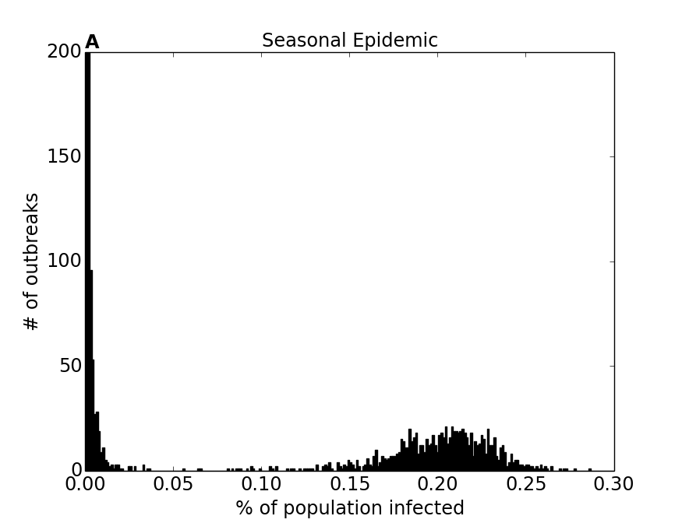
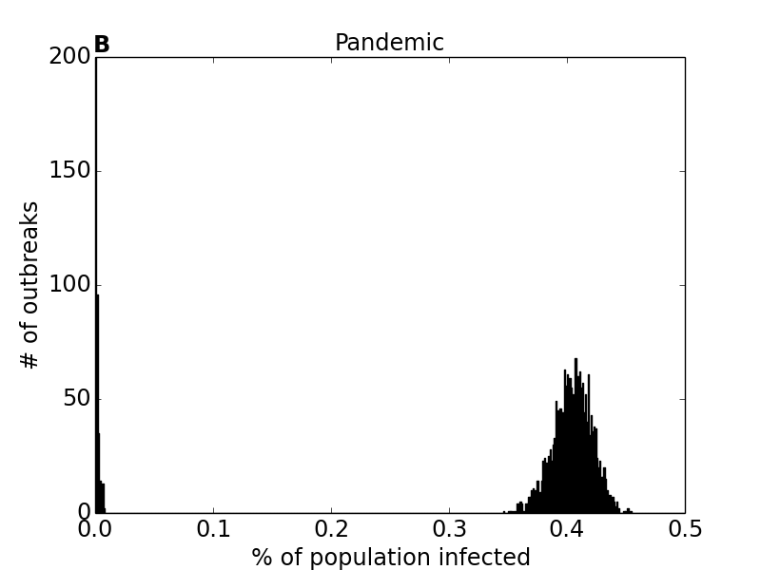

Figure S1: Frequency distribution of the percentage of individuals in a naive population infected by outbreaks for both the seasonal (A) and pandemic (B) scenarios. Each histogram summarizes the results of all 5000 runs. Note, in both scenarios, that over 2000 outbreaks result in only one individual (the individual in whom infection was originally seeded) being infected; the y-axes were cut off such that the bars representing other outbreak sizes could be more easily observed.

Table S5: Realistic, age-specific values describing the impact of natural immunity on susceptibility and infectivity, as well as prevalence of immunity

Age Group | Efficacy (s) | Efficacy (i) | Coverage
Toddlers (0-2) | 60% | 40% | 10%
Preschoolers (3-4) | 80% | 60% | 10%
Children (5-18) | 80% | 60% | 30%
Adults (19-64) | 70% | 50% | 15%
Seniors (65+) | 60% | 40% | 20%

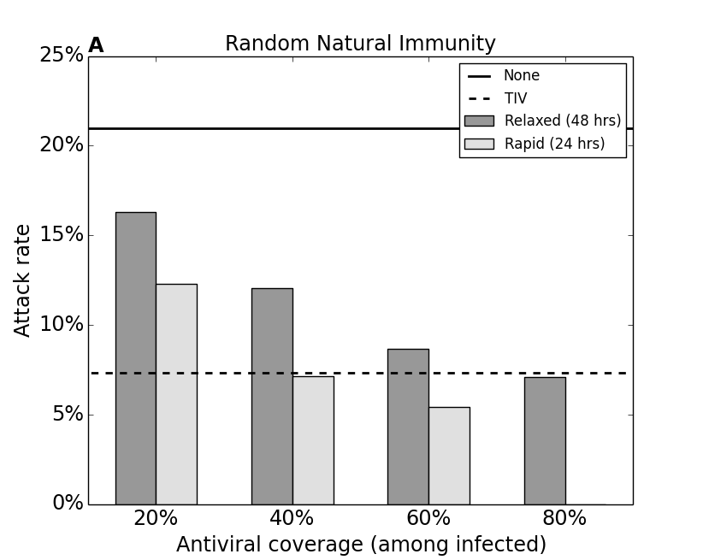
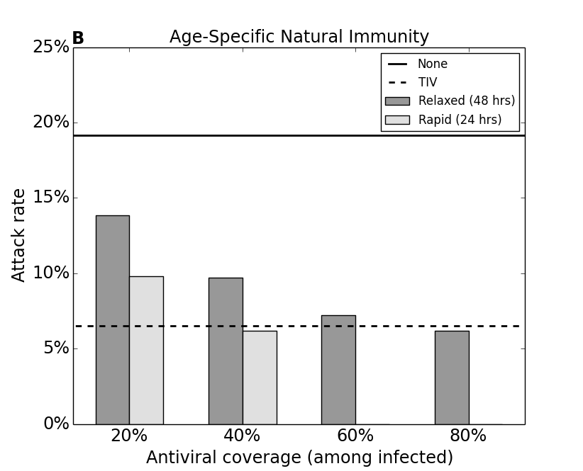

Figure S2: Analysis from Figure 2 repeated in a population with random (a) or age-specific (b) natural immunity. In the key, “None” refers to a population with only natural immunity, while both natural immunity and the control strategy in question are implemented in all other populations. Vaccination and antiviral treatment are implemented as described for Figure 2. All standard errors less than 0.003.

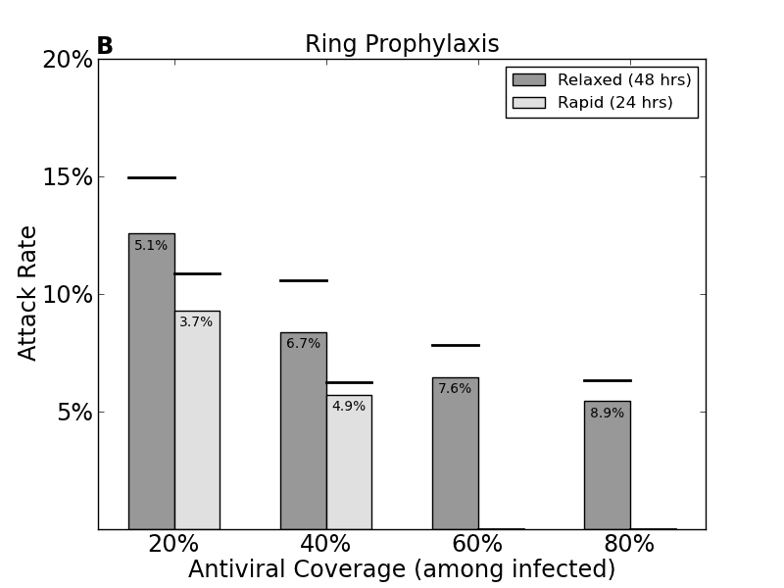
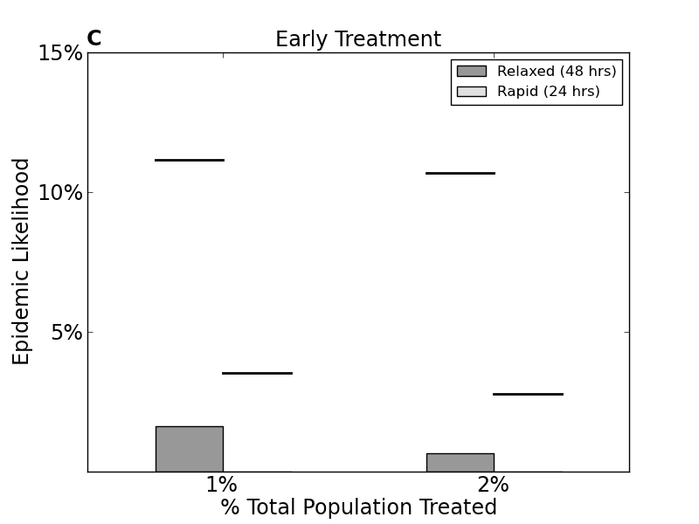
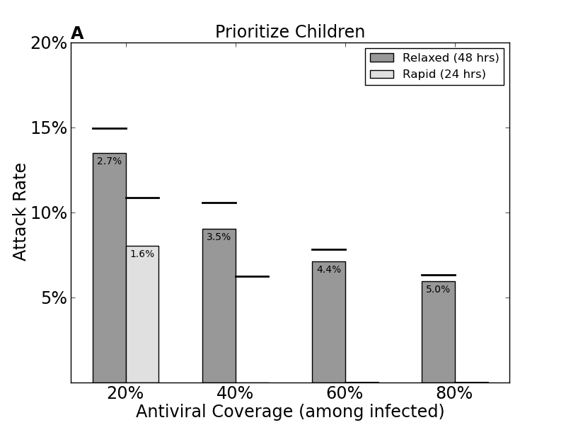

Figure S3: Seasonal antiviral treatment strategies.
Prioritizing children (a), ring prophylaxis (b), and early treatment (c) strategies for seasonal epidemic scenario. Antiviral coverage (x-axis; among infected individuals in (a,b), among total population in (c)) vs. attack rate (a,b) or epidemic likelihood (c). Standard errors less than 0.003 for (a,b) and less than 0.002 (c).

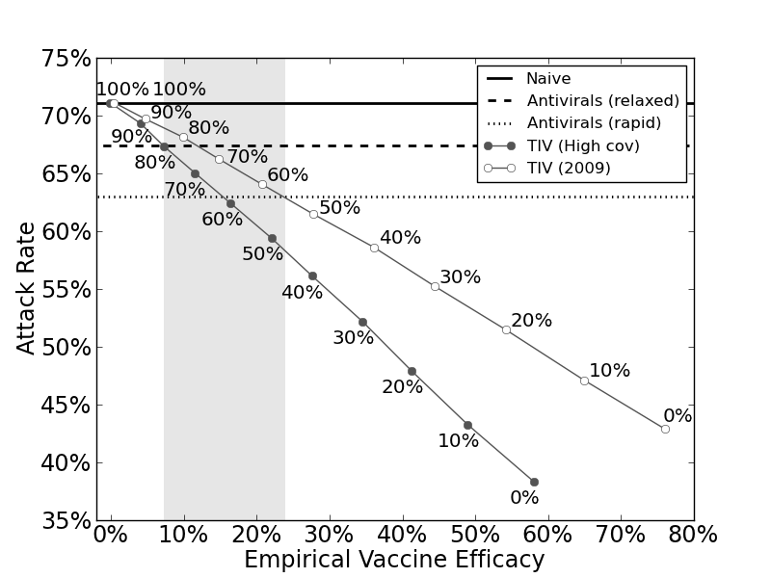

Figure S4: Analyses from Figure 3 repeated at high influenza transmissibility (T=0.1132; R₀=2.00). Same parameters used as for realistic vaccine and antiviral treatment in main text. All standard errors less than 0.0003.

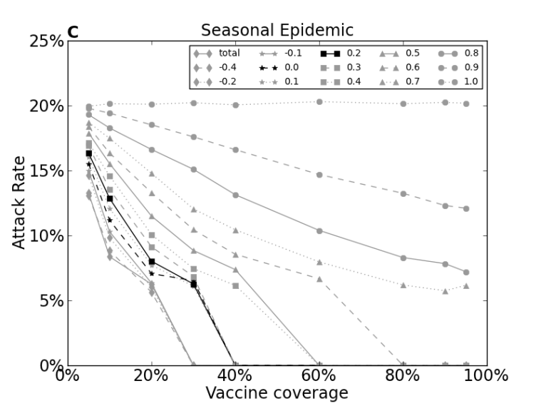
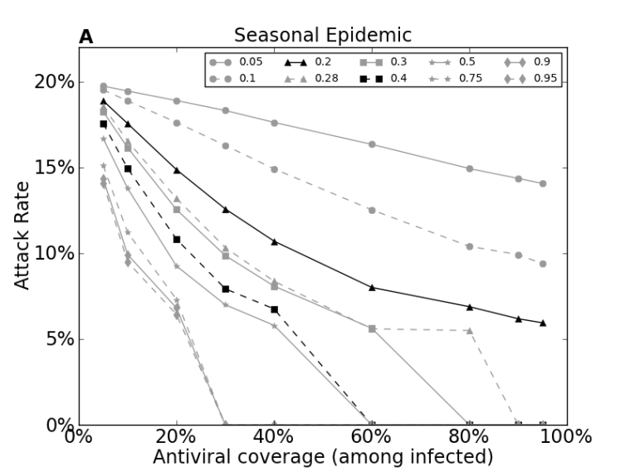
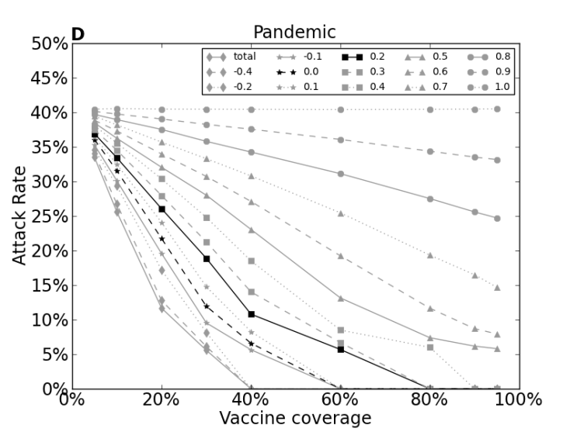
Figure S5: Attack rates when coverage level and efficacy of antivirals (a,b) or vaccines (c,d) is varied for both seasonal and pandemic influenza. Coverage is displayed on x-axis, while different lines represent different efficacy-values. Black lines represent relaxed and rapid antiviral strategies (a,b) or vaccines of similar efficacy to our seasonal vaccine (c) or our high coverage and 2009 pandemic vaccines (d). In (c) and (d), “total” represents a complete reduction in susceptibility of vaccinated individuals. Susceptibility varies by age group; coverage does not. All standard errors less than 0.011.
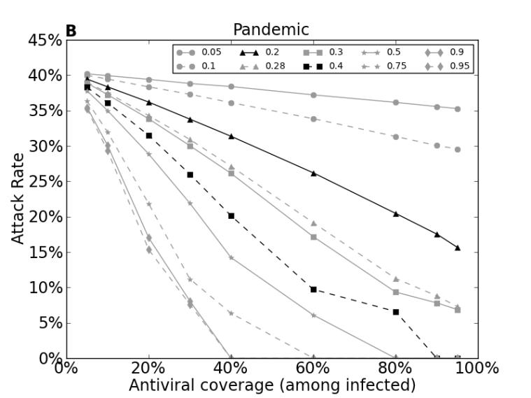

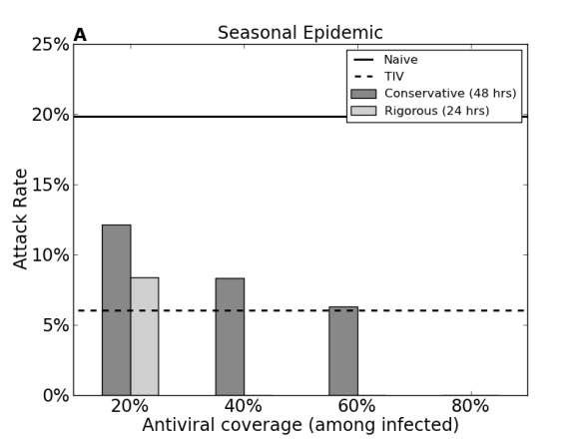
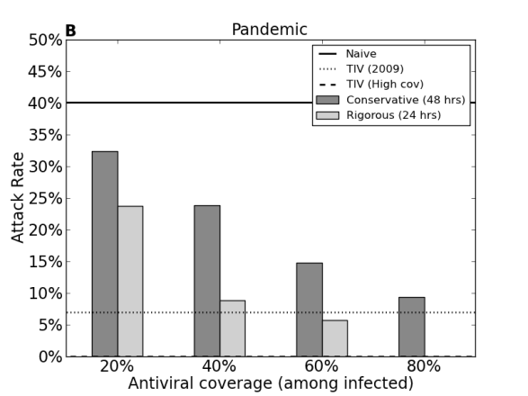

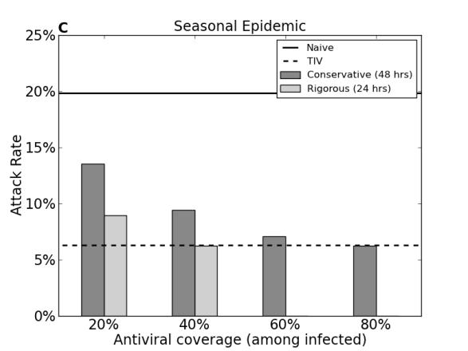
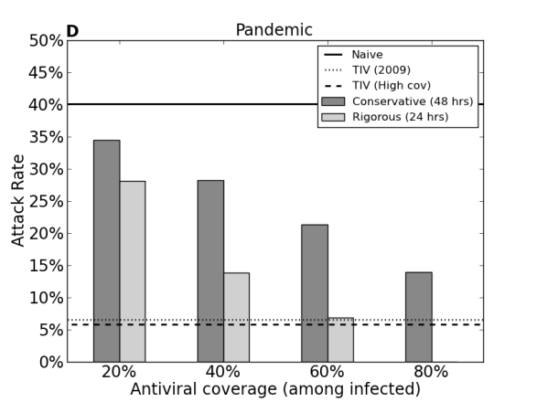

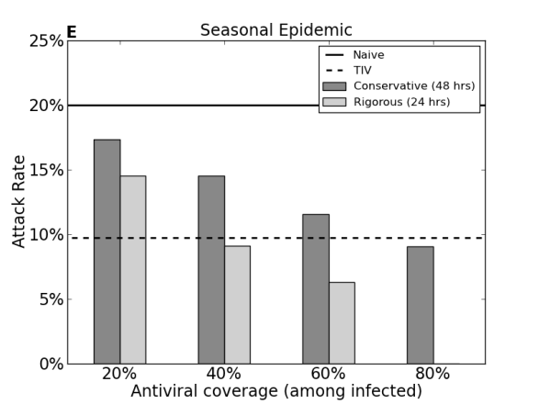
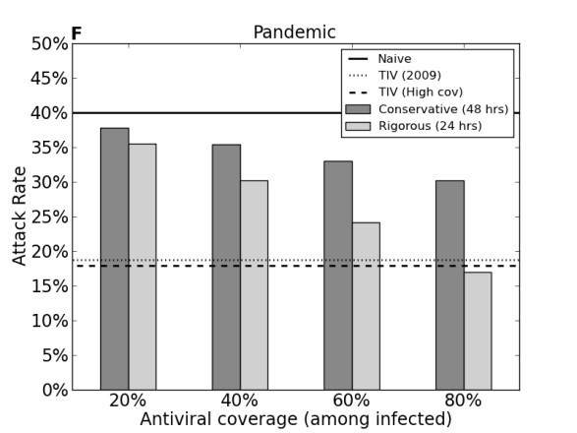

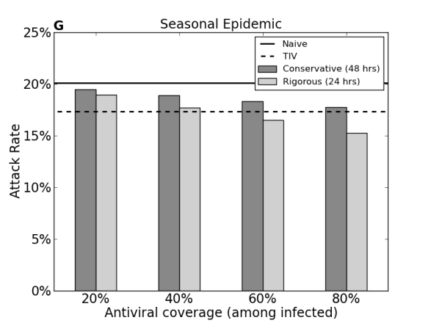
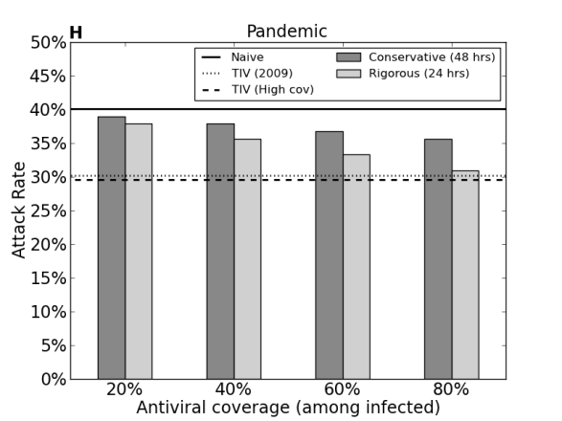
Figure S6: Analyses from Figure 2 repeated on computer generated (a) regular, (b) Poisson, (c) geometric, and (d) scale-free graphs. All standard errors less than 0.005.

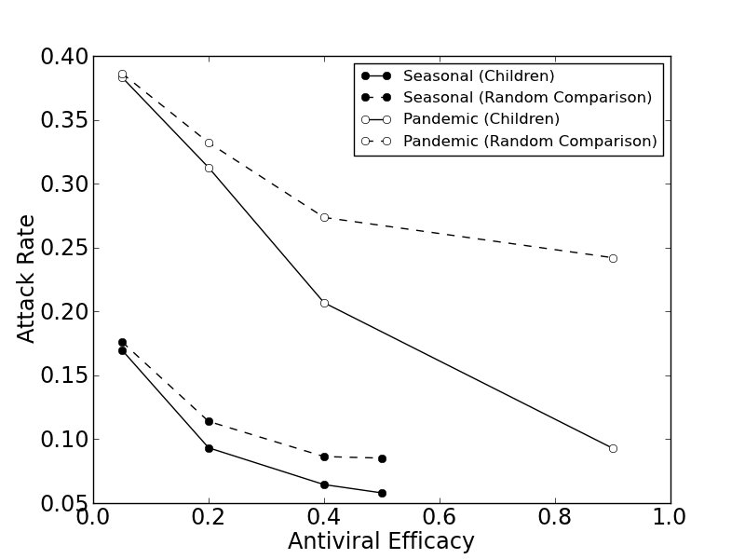

Figure S7: Attack rates when antivirals are distributed preferentially to children (solid lines) or randomly among the same proportion of infected individuals during seasonal (black) and pandemic (gray) influenza for several levels of antiviral efficacy. No seasonal epidemics emerged when antivirals of efficacy above 0.5 were provided to all infected children. Coverage levels approximately 20-30% when preferentially treating children. All standard errors less than 0.005.

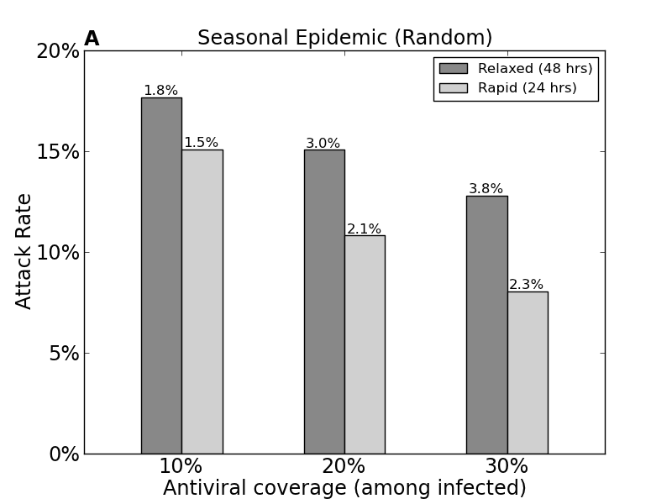
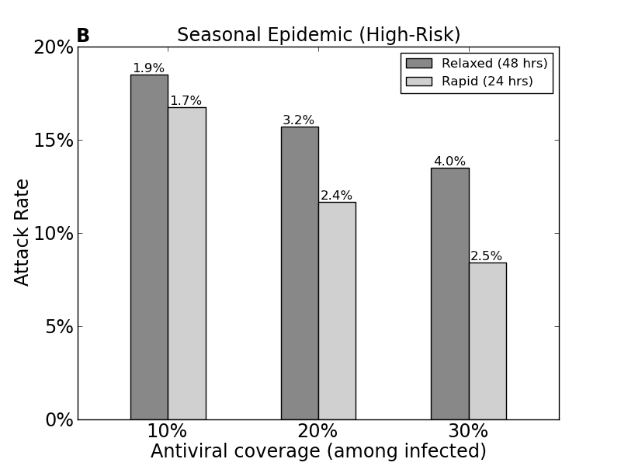
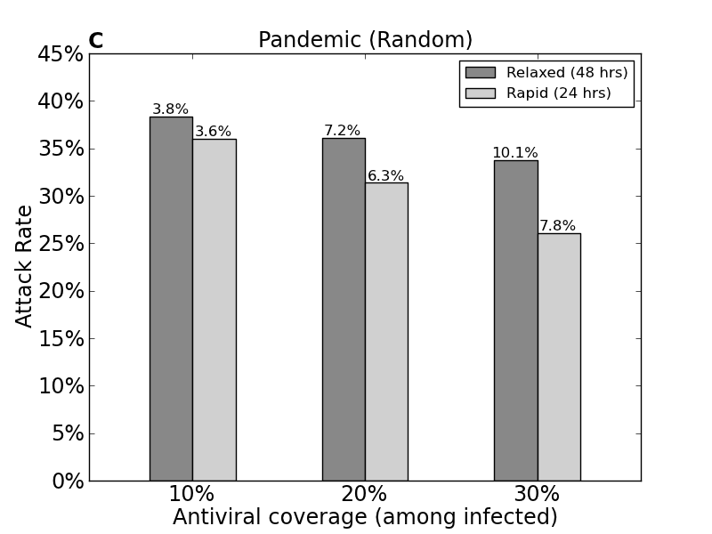
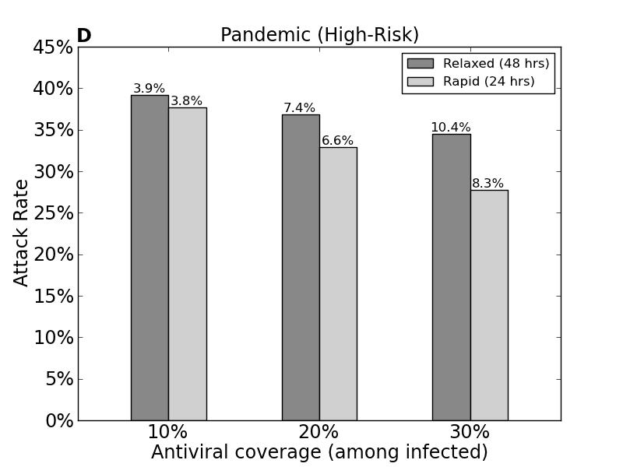
Figure S8: Attack rates when antivirals are distributed randomly among the population (a,c) or preferentially among high-risk individuals (b,d) for both seasonal and pandemic influenza. All standard errors less than 0.002.

