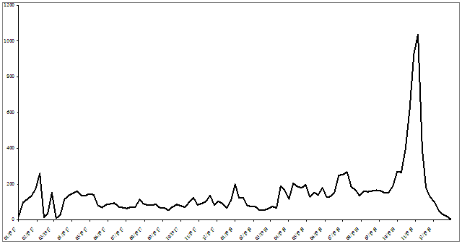

Supplementary Fig. S1. Weekly mortality in British Expeditionary Force used to construct text Figure 1.

