SUPPLEMENTARY MATERIAL

Supplementary Table S1.Seroconversions to Pe09 and Sw/VN10 by age group.
Age group | Total No. paired sera | A/H3/Pe09 only | A/Sw/VN10 only | Dual seroconversion
<5 | 13 | 1 | 0 | 0
5-9 | 31 | 2 | 1 | 0
10-14 | 32 | 4 | 1 | 0
15-19 | 29 | 1 | 1 | 0
20-29 | 19 | 1 | 0 | 0
30-39 | 28 | 1 | 2 | 2
40-49 | 24 | 2 | 0 | 0
50-59 | 30 | 3 | 1 | 0
60-69 | 39 | 5 | 3 | 0
>69 | 33 | 6 | 0 | 3
Total | 278 | 26 | 9 | 5

Supplementary Figure S1. Age profile of HI log₂ titers to Pe09 (blue) and Sw/VN10 (green) stratified by urban (Dong Da) and rural (BaVi) site.

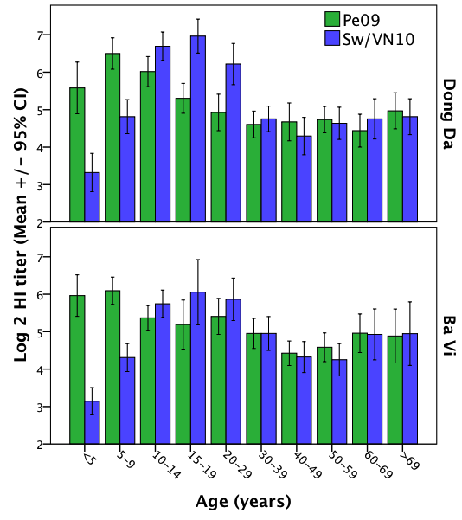

Supplementary Figure 2. Influenza vaccination history among participants with titers to Pe09 and Sw/VN10.

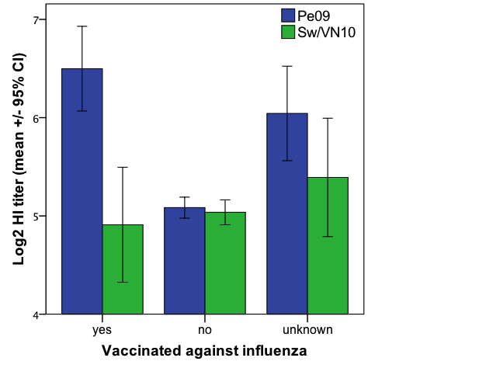

Supplementary Figure 3. Profiles of animal contact in urban versus rural settings. (a) Direct contact with pigs; (b) ownership of domestic animals in households.
(a)

(b)

