Increasing Herd Immunity with Influenza Revaccination
E. Q. Mooring and S. Bansal

Supplemental Materials
Sensitivity Analysis—Model Variables
We conducted numerous simulations to test how changing key parameters in the model affected the relationship between revaccination rate and epidemic size. Unless otherwise noted, 1000 iterations were conducted for each combination of values. We found that when natural immunity is stronger, increasing the rate of revaccination has a larger effect on the size of second season epidemics (Figure S1). This finding makes intuitive sense because in the limit where there is no natural immunity across seasons, each season can be thought of as independent and equivalent. As expected, we also found smaller second seasons when natural immunity is stronger, regardless of level of revaccination.
Additionally, we considered the consequences of changing efficacy of vaccination. The effect of revaccination on epidemic size is strongest when vaccine is fully protective (Figure S2). Regardless of the degree of revaccination, we found higher second season epidemic sizes when vaccine efficacy was greater, because greater vaccine efficacy in the first season limited the degree of natural immunity in the second season and vice versa. For this reason, we plotted the summed first and second season epidemic sizes.
Next, we considered the effect of changing the level of vaccine coverage. This sensitivity analysis is complicated by the fact that the level of vaccine coverage is not wholly independent of the rate of revaccination. Therefore, we analyzed the effect of changing rates of excess revaccination, which is measured as
$$\text{r'=}\frac{r−C}{1−C}$$
where r is the absolute degree of revaccination and C is the vaccine coverage. This can be thought of as the extent of revaccination beyond that which would be expected by chance (C) normalized by the magnitude of the range of possible excess revaccination (1-C). Figure S3 indicates that the effect of revaccination is greater at lower vaccine coverage levels, but this effect is largely because at lower vaccine coverage levels, the range of possible excess revaccination rates is larger. Specifically, figure S4 plots the same data but plots the absolute revaccination (r) as opposed to the excess revaccination (r’) on the x-axis. The effect of increasing revaccination at high vaccine coverage levels now appears magnified. Because the degree of vaccine coverage affects the first season epidemic size and hence the degree of natural immunity in the population, as with the sensitivity analysis on vaccine efficacy, we plot summed first and second season epidemic sizes.
Finally, we investigated whether assortativity with respect to vaccination affects the relationship between revaccination and epidemic size. There does not appear to be any systematic effect on the relationship, but assortativity affects the size of the first season epidemic and thus the amount of natural immunity in the community, so we therefore present summed first and second season epidemic sizes (Figure S5).
Assortative vaccination assignments were generated based on the algorithm of Salathé and Khandelwal [1]. Assortative first season vaccination assignments were created by first randomly assigning vaccination at a given coverage level and calculating the assortativity coefficient ρ. Next, two nodes with opposite vaccination status were selected and their assigned vaccination statuses were swapped; ρ was recalculated and if ρ was increased by the swap then it was preserved. If not, the pair of nodes reverted to their original assigned vaccination status. This process was repeated until the target assortativity was reached. In this sensitivity analysis, target assortativities of 0.05, 0.10, 0.15, 0.20, and 0.25 were used. The values span values observed in an empirical study of seasonal influenza vaccination on a contact network [2]. To generate second season vaccination assignments, the first season assignments and a given level of revaccination were used to generate preliminary second season assignments. Then, as before, the assortativity was boosted as needed by randomly selecting pairs of nodes with opposite second season vaccination status, swapping statuses, and recalculating ρ. But now, all pairs of nodes had to share the same first season vaccination status. (This process was unnecessary when revaccination was complete, because the first season assignments were reused and already met the target level of assortativity.) We did not investigate having the target level of assortativity vary between seasons.
Sensitivity Analysis—Network Variables
We conducted simulations to determine the effect of changing the structure of the network on the relationship between the degree of revaccination and second season epidemic size. To test the effect of network size, we computationally generated exponential random networks with 250, 500, 5,000, 15,000, and 25,000 nodes. While the degree distributions were drawn from theoretical distributions with mean degree of 10, the networks actually differ slightly in mean degree, which influenced the size of first seasons and, in turn, the extent of natural immunity. Therefore, for the same reason as in the assortativity sensitivity analysis, the response variable shown in this analysis is the summed first and second season epidemic size. Figure S6 shows the results of simulations on ten networks of each size. Note that simulations using the smaller networks exhibit greater variance in epidemic size. However, there does not appear to be a systematic effect of network size on the relationship between revaccination rate and epidemic size.
Next, we assessed the effect of changing variance of the degree distribution on the relationship between revaccination rate and epidemic size. We computationally generated negative binomial networks from negative binomial distributions with mean degree 10 and variances 10, 13.5, 18, 22.5, 36, and 90. The negative binomial distributions were shifted rightward by one unit so that zero was excluded from the degree distribution. We found that the effect of increasing revaccination was strongest when variance in degree was greatest (Figure S7). This finding confirms our explanation that non-randomness of natural immunity with respect to degree partially underlies the effect of revaccination on epidemic size. Because the variance of the degree distribution affects first season epidemic sizes, summed first and second season epidemic sizes are plotted in figure S7.
Finally, we investigated the effect of random rewiring in the contact network between seasons. We implemented random rewiring via double-edge swaps, in which two randomly chosen edges, u-v and x-y, are removed and two new edges u-x and v-y are added [3]. By this method, the degree of each node is held constant. The process was implemented so that no swap took place if it would have created an edge between two nodes than already shared an edge. Additionally, the network was forced to remain connected (i.e. no separate components). Figure S8 presents mean second season epidemic sizes by level of revaccination for zero, 10,000, and 20,000 swaps between seasons on 5,000 node networks. Because the process was constrained to disallow swaps that would have created duplicate edges, the number of completed swaps was typically approximately 9,500 and 19,000 for the latter two nominal levels, respectively. At the 10,000 swaps level, generally fewer than 12,000 of the about 25,000 edges in the network remained unchanged and at the 20,000 swaps level, about 5,500 or fewer of the edges were unchanged. We show that the effect of revaccination is insensitive to rewiring, which supports our conclusion that the degree of nodes, and not their particular place in the network, drives the underlying mechanism.

References

1. Salathé M, Khandelwal S. Assessing vaccination sentiments with online social media: Implications for infectious disease dynamics and control. PLoS Computational Biology 2011; 7: e1002199.
2. Barclay VC, et al. Positive network assortativity of influenza vaccination at a high school: implications for outbreak risk and herd immunity. PLoS One 2014; 9: e87042.
3. Maslov S, Sneppen K. Specificity and stability in topology of protein networks. Science 2002; 296: 910-913.

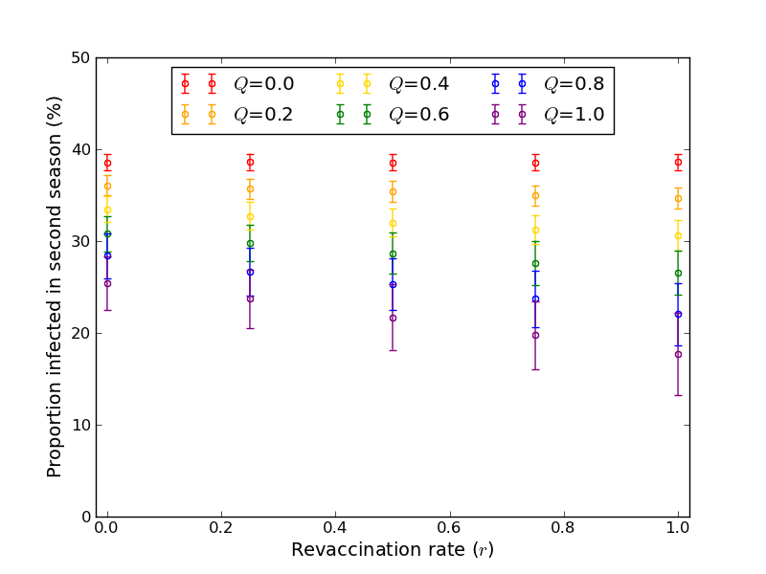
Figure S1. When natural immunity is stronger, the effect of revaccination on mean second season epidemic size is more pronounced. Q is the efficacy of natural immunity, measured as the proportion of naturally infected individuals who are immune in the subsequent season. This figure is based on results from 1000 simulated second season large epidemics on a single 5000 node exponential random network with T₁=0.09, T₂=0.18, E=1.0, and C=0.25. Error bars are ± 1 standard deviation.
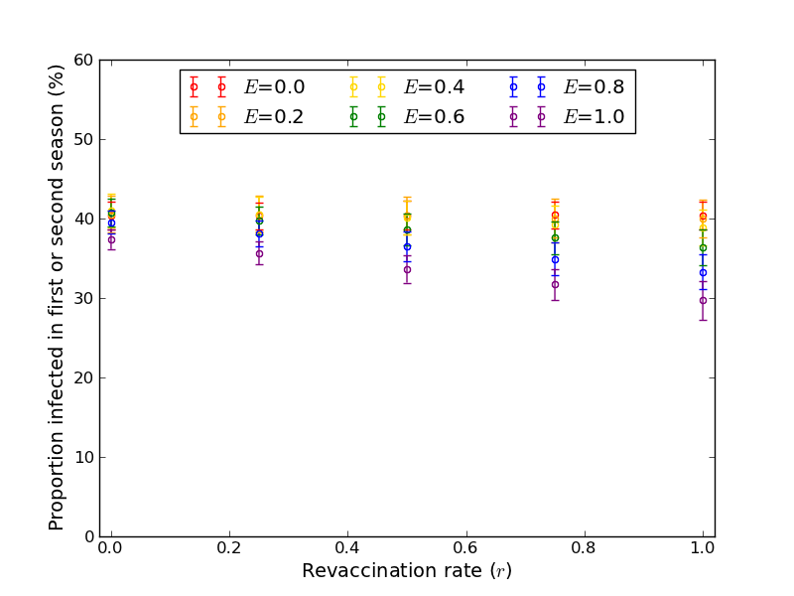
Figure S2. When the efficacy of vaccination is greater, the effect of revaccination on epidemic size is more pronounced. E is the efficacy of vaccination, measured as the proportion of vaccinated individuals who develop immunity. This figure is based on results from 1000 simulated second season large epidemics on a single 5000 node exponential random network with T₁=0.09, T₂=0.18, Q=1.0, and C=0.25. Error bars are ± 1 standard deviation.
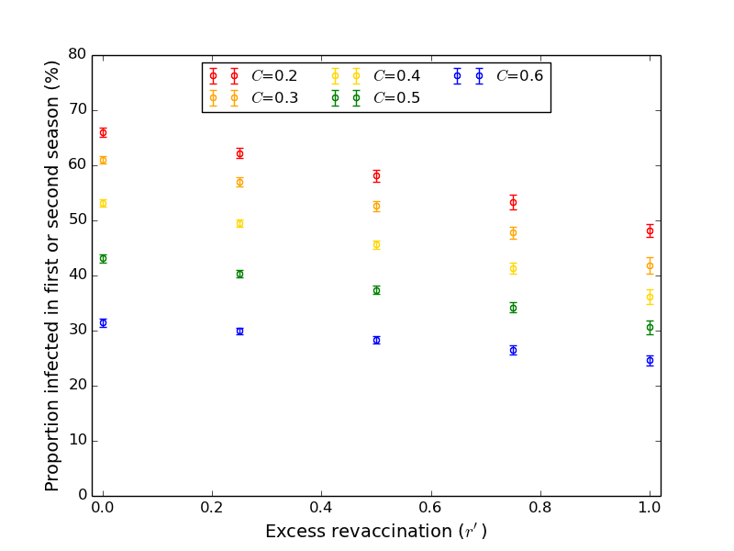
Figure S3. When plotted as a function of excess revaccination, lower vaccine coverage appears to increase the effect of revaccination on epidemic size, at least for the range of vaccine coverage levels simulated here. C is vaccine coverage, the proportion of the population that is vaccinated. (However, see figure S4.) This figure is based on results from 1000 simulated second season large epidemics on a single 5000 node exponential random network with T₁=0.17, T₂=0.6, E=1.0, and Q=1.0. Error bars are ± 1 standard deviation.
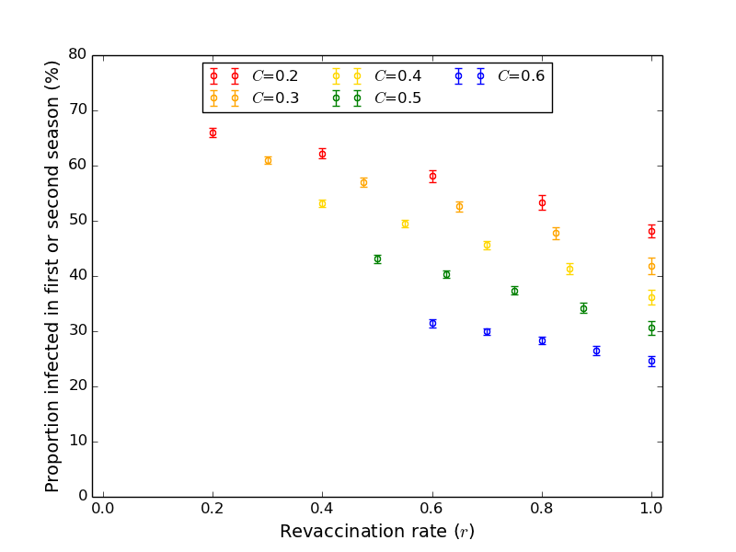
Figure S4. This figure plots the same data as figure S3, but as a function of the absolute degree of revaccination. Note that the series of points for each vaccine coverage level appear more parallel in this figure than in figure S3. C is vaccine coverage, the proportion of the population that is vaccinated. This figure is based on results from 1000 simulated second season large epidemics on a single 5000 node exponential random network with T₁=0.17, T₂=0.6, E=1.0, and Q=1.0. Error bars are ± 1 standard deviation.
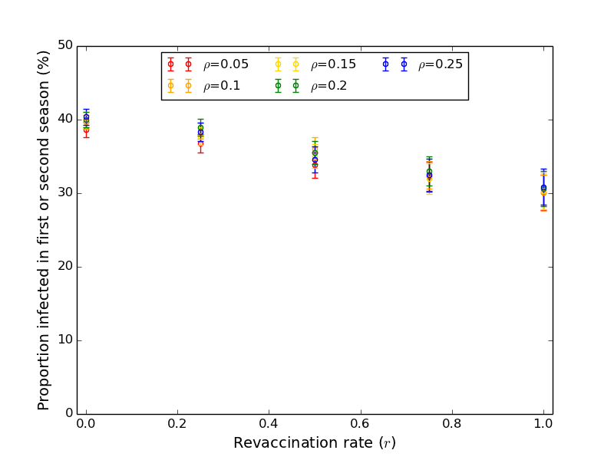
Figure S5. It does not appear that vaccine assortativity, ρ, modifies the relationship between revaccination and epidemic size. Each point is based on 2000 simulated first and second season epidemics, but unlike in the other model simulations in this article, the same vaccine assignments were used for all simulations at each combination of assortativity and revaccination. Epidemics were simulated on a single 5000 node exponential random network with T₁=0.09, T₂=0.18, E=1.0, Q=1.0, and C=0.25. Error bars are ± 1 standard deviation.
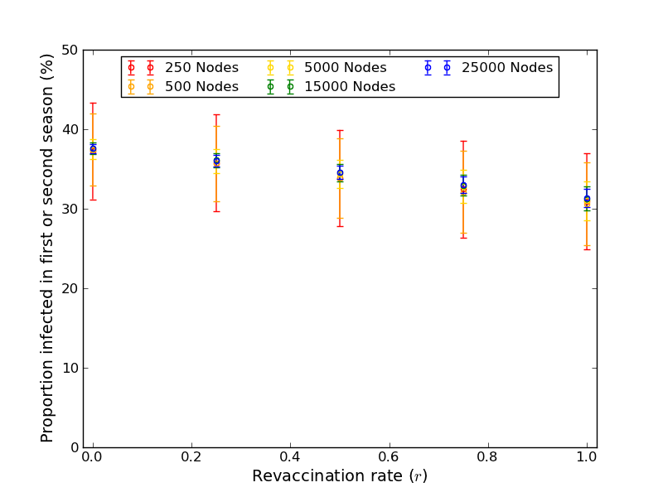
Figure S6. There does not appear to be a major effect of network size on the relationship between revaccination and epidemic size. Simulations on ten different networks of each listed size were conducted. This figure is based on pooling results from 500 simulations on each exponential random network with T₁=0.09, T₂=0.18, E=1.0, Q=1.0, and C=0.25. Error bars are ± 1 standard deviation.
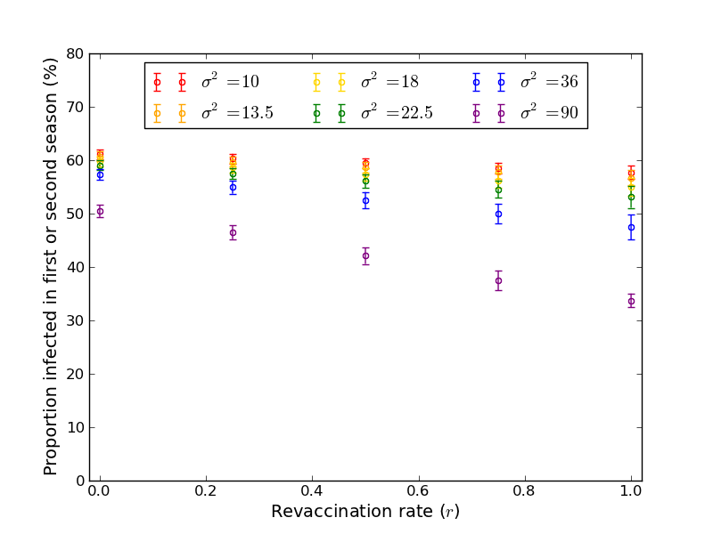
Figure S7. When the variance of the degree distribution is greater, the effect of revaccination on epidemic size is more pronounced. This figure is based on results from 1000 simulated second season large epidemics on each 5000 node, mean degree 10 negative binomial random network with T₁=0.13, T₂=0.17, E=1.0, Q=1.0, and C=.25. Error bars are ± 1 standard deviation.
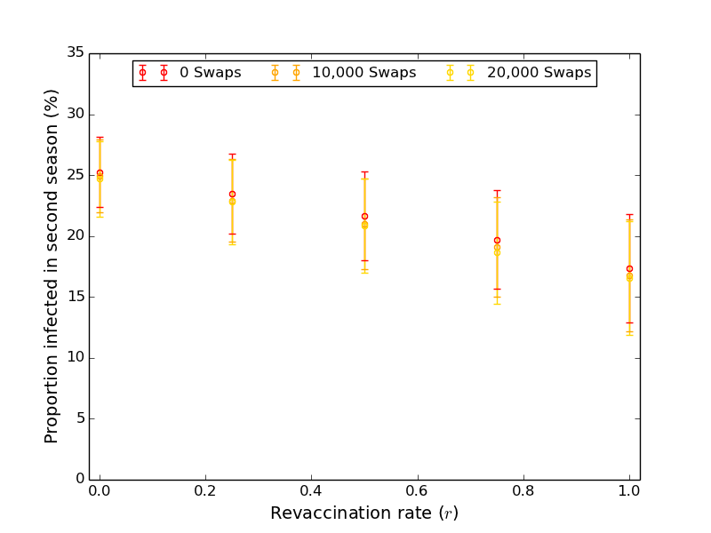
Figure S8. There does not appear to be an effect of rewiring on the relationship between revaccination and epidemic size. The numbers of double edge swaps given in the legend are nominal. See the supplementary text for further discussion. Simulations on five different 5000 node networks were conducted. This figure is based on pooling results from 200 simulations on each exponential random network with T₁=0.09, T₂=0.18, E=1.0, Q=1.0, and C=0.25. Error bars are ± 1 standard deviation.

