SUPPLEMENTARY MATERIAL

Model
We constructed the model at the individual level; thus, for a given patient and a given day, λ, the risk of HA-ILI can be modeled as follows:

y ~ Bernoulli(λ)
$$λ=1−(1−λ^{\text{unrecorded}−\text{source}})\prod_{\text{ij}}{(1−λ_{\text{ij}}^{\text{recorded}−\text{patient}}})^{w_{\text{ij}}^{\text{recorded}−\text{patient}}}\prod_{\text{ij}}{(1−λ_{\text{ij}}^{\text{recorded}−\text{HCW}})^{w_{\text{ij}}^{\text{recorded}−\text{HCW}}}}$$

In this model, y = 1 if the patient has a HA-ILI and y = 0 if not. $w_{\text{ij}}^{\text{recorded}−\text{patient}}$ is the exposure to recorded patients that equals 1 if the patient has been exposed i days earlier to ≥1 source being at his/her j^{th} day of contagiousness and 0 if not. $w_{\text{ij}}^{\text{recorded}−\text{HCW}}$ is the exposure to recorded HCWs that equals 1 if the patient has been exposed i days earlier to ≥1 source being at his/her j^{th} day of contagiousness and 0 if not. $λ_{\text{ij}}^{\text{recorded}−\text{patient}}$ and $λ_{\text{ij}}^{\text{recorded}−\text{HCW}}$ are the risks of HA-ILI associated with exposure to recorded patients and HCWs, respectively. $λ^{\text{unrecorded}−\text{source}}$ is the risk of HA-ILI associated with exposure to unrecorded sources.

Inference methods
Bayesian inference was used to estimate the parameters of the model and the contributions of various sources of exposure. Markov Chain Monte Carlo (MCMC) methods [1] were used to obtain the posterior parameter means and 95% credible intervals (95% CrI) from the 2.5% and 97.5% quantiles of the parameters' posterior distributions. The parameters were assigned non-informative priors [2]. Three independent MCMC with 3 different initial values were run in parallel to assess the convergence of the posterior parameter distributions and check that the results were not sensitive to the choice of the initial values. Gelman and Rubin convergence criteria [3] were also calculated and examined. After an initial burn-in step of 20,000 iterations, 80,000 iterations were used to compute the posterior parameter distributions. MCMC computations were performed with OpenBugs software, the BRugs and coda packages of R (http://www.r-project.org).

Relative contribution of exposures
The following contributions were separately estimated:
- exposure to recorded vs. unrecorded sources
- exposure to contagious patients vs. exposure to contagious HCWs
- exposure 2 to 5 days before time t vs. exposure the day before t
- exposure during observable vs. unobservable contagious periods of the recorded sources.

The risk of HA-ILI associated with exposure to recorded patients is then written as follow:
$λ_{\text{ij}}^{\text{recorded}−\text{patient}}=1−\text{exp} (−k_{1} (a_{\text{11}}b_{\text{11}}+a_{\text{12}}b_{\text{11}}+a_{\text{11}}b_{\text{12}}+a_{\text{12}}b_{\text{12}}))$
where:
- i = 1, 2 and j = 1, 2,
- k₁ is a scale parameter representing HA-ILI risk associated with exposure to recorded patients,
- a₁₁ and a₁₂ (a₁₁ + a₁₂ = 1) representing the distribution of this risk according to recorded exposures the day before and 2 to 5 days before time t respectively,
- b₁₁ and b₁₂ (b₁₁ + b₁₂ = 1) representing the distribution of this risk according to exposure during unobservable and observable contagious period of recorded sources respectively.

The risk of HA-ILI associated with exposure to recorded HCWs is then written as follow:
$λ_{\text{ij}}^{\text{recorded}−\text{HCW}}=1−\text{exp} (−k_{2} (a_{\text{21}}b_{\text{21}}+a_{\text{22}}b_{\text{21}}+a_{\text{21}}b_{\text{22}}+a_{\text{22}}b_{\text{22}}))$
where:
- i = 1, 2 and j = 1, 2,
- k₂ is a scale parameter representing HA-ILI risk associated with exposure to recorded HCWs,
- a₂₁ and a₂₂ (a₂₁ + a₂₂ = 1) representing the distribution of this risk according to recorded exposures the day before and 2 to 5 days before time t respectively,
- b₂₁ and b₂₂ (b₂₁ + b₂₂ = 1) representing the distribution of this risk according to exposure during unobservable and observable contagious period of recorded sources respectively.

The risk of HA-ILI associated with exposure to unrecorded source is:
$$λ^{\text{unrecorded}−\text{source}}=\text{exp}(β^{\text{sporadic}}+β^{\text{epidemic}}x)$$
where x = 1 if the epidemic threshold has been reached on a given day in the community and x = 0 if it has not been reached.

We calculated the attributability of HA-ILI to these different types of exposures.
HA-ILI risk at hospital:
$$λ^{\text{hospital}}=1−\prod_{\text{ij}}{(1−λ_{\text{ij}}^{\text{recorded}−\text{patient}}})^{w_{\text{ij}}^{\text{recorded}−\text{patient}}}\prod_{\text{ij}}{(1−λ_{\text{ij}}^{\text{recorded}−\text{HCW}})^{w_{\text{ij}}^{\text{recorded}−\text{HCW}}}}$$

HA-ILI risk when ILI is epidemic in the general population:
$$\begin{aligned}\left\{λ^{\text{epidemic}}=1−(1−λ^{\text{unrecorded}−\text{source}})\prod_{\text{ij}}{(1−λ_{\text{ij}}^{\text{recorded}−\text{patient}}})^{w_{\text{ij}}^{\text{recorded}−\text{patient}}}\prod_{\text{ij}}{(1−λ_{\text{ij}}^{\text{recorded}−\text{HCW}})^{w_{\text{ij}}^{\text{recorded}−\text{HCW}}}} | \right.\end{aligned}$$

HA-ILI risk when ILI is sporadic in the general population:
$$\begin{aligned}\left\{λ^{\text{sporadic}}=1−(1−λ^{\text{unrecorded}−\text{source}})\prod_{\text{ij}}{(1−λ_{\text{ij}}^{\text{recorded}−\text{patient}}})^{w_{\text{ij}}^{\text{recorded}−\text{patient}}}\prod_{\text{ij}}{(1−λ_{\text{ij}}^{\text{recorded}−\text{HCW}})^{w_{\text{ij}}^{\text{recorded}−\text{HCW}}}} | \right.\end{aligned}$$

Attributability of HA-ILI to recorded sources when ILI is sporadic in the general population:
$$A^{\text{recorded}−\text{source}−\text{non}−\text{epidemic}}=\frac{λ^{\text{hospital}}}{λ^{\text{non}−\text{epidemic}}}$$

Attributability of HA-ILI to recorded sources when ILI is epidemic in the general population:
$$A^{\text{recorded}−\text{source}−\text{epidemic}}=\frac{λ^{\text{hospital}}}{λ^{\text{epidemic}}}$$

Attributability of HA-ILI to exposure to patients among recorded sources:
$$A^{\text{recorded}−\text{patient}}=\frac{λ^{\text{recored}−\text{patient}}}{λ^{\text{hospital}}}$$

Attributability of HA-ILI to exposure to HCWs among recorded sources:
$$A^{\text{recorded}−\text{HCW}}=\frac{λ^{\text{recored}−\text{HCW}}}{λ^{\text{hospital}}}$$

References
- Gilks WR, Richardson S, Spiegelhalter DJ: Markov Chain Monte Carlo in Practice. London: Chapman & Hall; 1996.
- Gelman A, Carlin JB, Stern HS, et al: Bayesian Data Analysis. 2nd edition. Boca Raton, FL: Chapman & Hall/CRC Press; 2004:182–184.
- Gelman A, Rubin DB: Inference from iterative simulation using multiple sequences. Stat Sci 1992, 7:457–511.
- Payet C, Voirin N, Vanhems P, Ecochard R. A statistical model to assess the risk of communicable diseases associated with multiple exposures in healthcare settings. BMC Med Res Methodol. 2013 Feb 20;13:26-31

Sensitivity analyses
We performed a first sensitivity analysis by shortening the contagious period from a maximum of 6 days to a maximum of 5 days. A second sensitivity analysis was done by varying the incubation period (i.e. the window compatible with a transmission of HA-ILI) from a maximum of 5 days to a minimum of 2 days. The table below indicates the 5 models used in the sensitivity analysis. Supplementary Table 1 and Supplementary Figures 1 to 5 showed that similar estimates and 95% credible intervals were obtained.

Model | Periods of exposure |  | Duration and observability of contagious period
Model | 1st period | 2nd period | Unobservable | Observable
Model 1 | 1 day before | 2 to 5 days before time t | 1 day | 5 days
Model 2 | 1 day before | 2 to 4 days before time t | 1 day | 5 days
Model 3 | 1 day before | 2 to 3 days before time t | 1 day | 5 days
Model 4 | 1 day before | 2 days before time t | 1 day | 5 days
Model 5 | 1 day before | 2 to 5 days before time t | 1 day | 4 days

Supplementary Figure 1. Sensitivity analysis for the risk of HA-ILI associated with exposure to unrecorded sources, per 10,000 patient-days, during the sporadic period in the community and during the epidemic in the community.

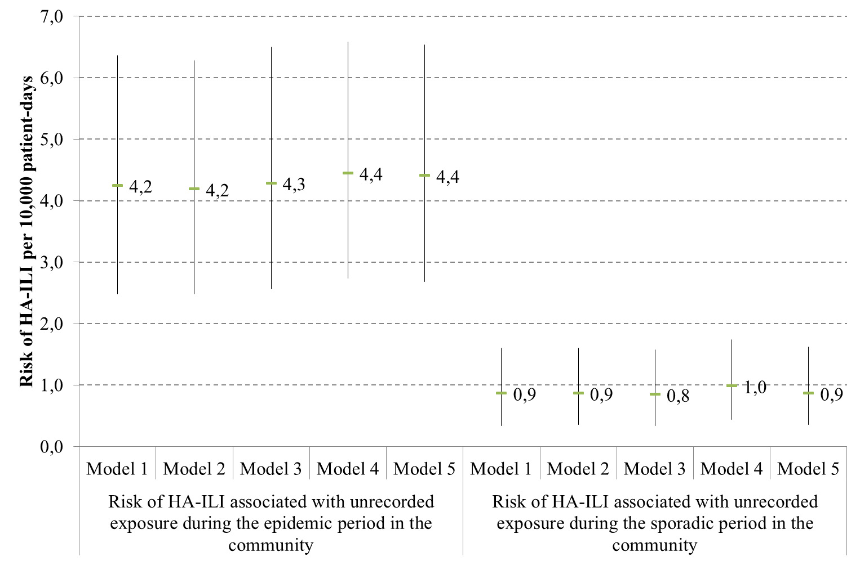

Supplementary Figure 2. Sensitivity analysis for the risk of HA-ILI associated with the role (patients or HCWs) of the recorded sources, per 10,000 patient-days.

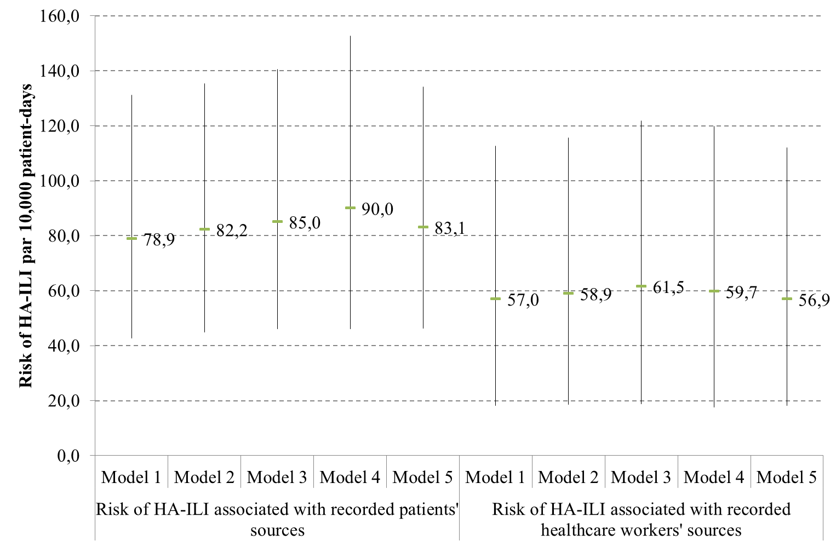

Supplementary Figure 3. Sensitivity analysis for the attributability of HA-ILI according to the role of the source.

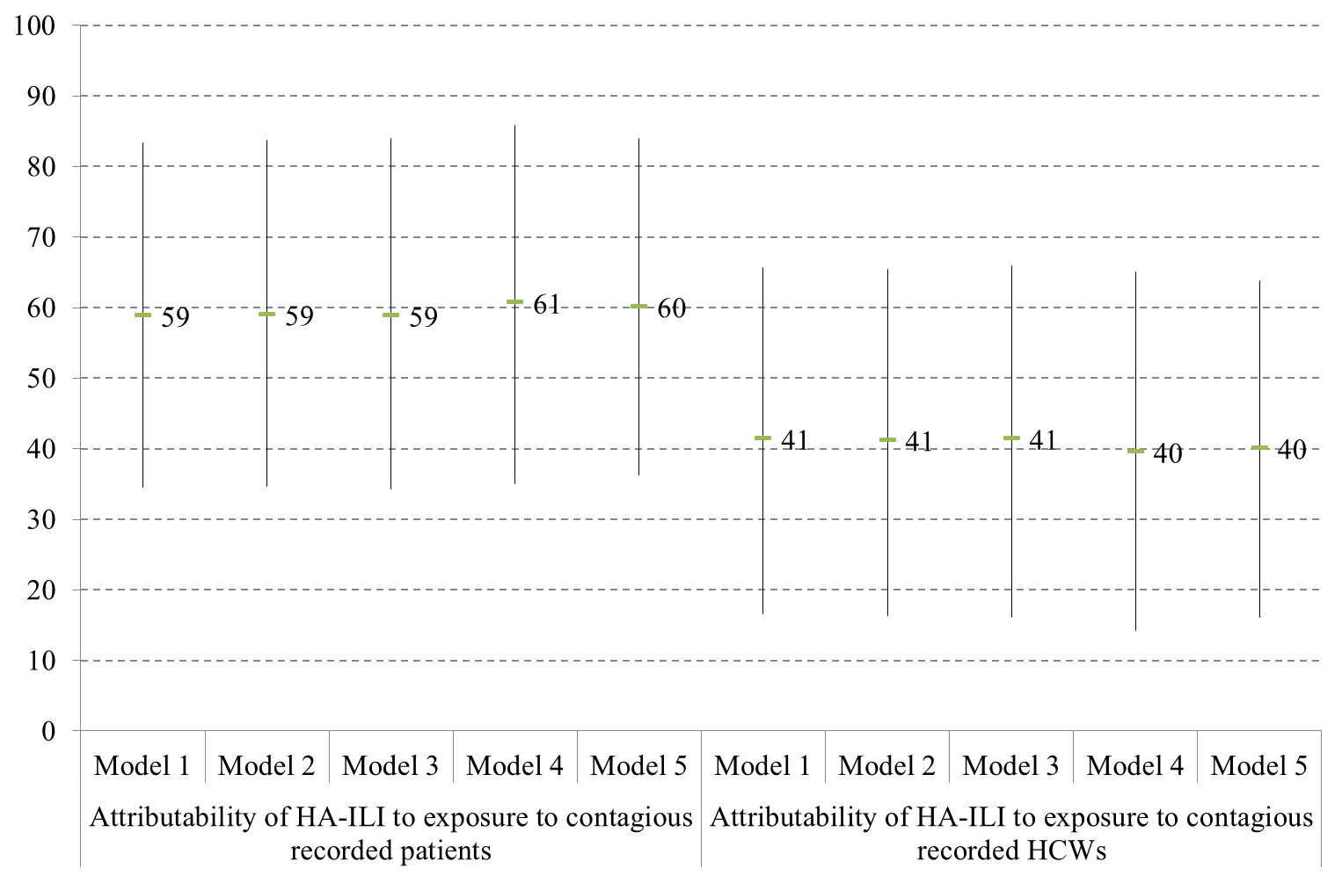

Supplementary Figure 4. Sensitivity analysis for the attributability of HA-ILI according to observability of the contagious period and role (patients or HCWs) of the recorded sources.

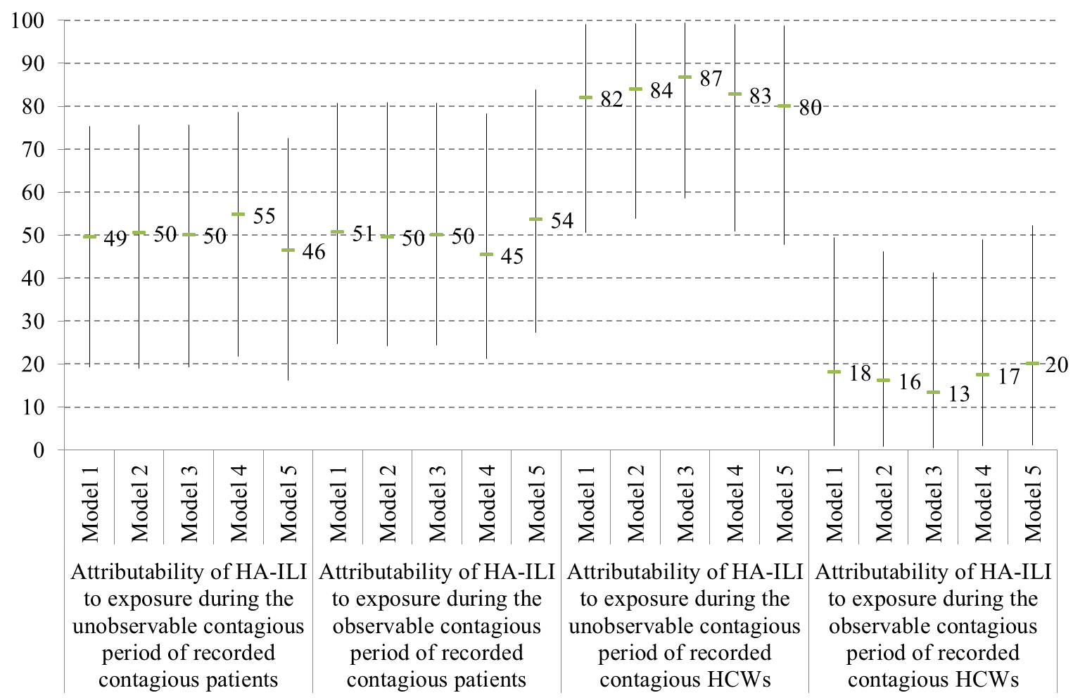

Supplementary Figure 5. Sensitivity analysis for the attributability of HA-ILI according to moment of exposures and role (patients or HCWs) of the recorded sources.

