Supplementary Materials

Impacts of ambient temperature on the burden of bacillary dysentery
in urban and rural Hefei, China
J. CHENG ¹, M.Y. XIE ¹, K.F. ZHAO ², J.J WU ², Z.W. XU ³, J. SONG ⁴, D.S. ZHAO ¹, K.S. LI ¹, X. WANG ¹, H.H. YANG ¹, L.Y. WEN ¹, H. Su ^{1,}*, S.L. TONG ³
¹ Department of Epidemiology and Health Statistics, School of Public Health, Anhui Medical University, Hefei, Anhui 230032, China
² Hefei Center for Disease Control and Prevention of Anhui xprovince, Hefei, Anhui 230061, China
³ School of Public Health and Social Work & Institute of Health and Biomedical Innovation, Queensland University of Technology, Kelvin Grove, Brisbane, Qld. 4509, Australia
⁴ Department of Preventive Medicine, Bengbu Medical College, Bengbu, Anhui 233000, China

* Address correspondence to: Hong Su, Department of Epidemiology and Health Statistics, School of Public Health, Anhui Medical University, 81 Meishan Road, Hefei, Anhui Province 230032, China. Tel.: +86 55163869140; Fax: +86 55163869140. E-mail address: suhong5151@sina.com (H. Su)

Table of contents

Supplemental Material, Fig. S1: The monthly distribution of bacillary dysentery during 2006–2012 in Hefei, China. | 3
Supplemental Material, Fig. S2: The relationship between temperature and BD using various reference values (17°C-22°C) during warm season in 2006–2012 in Hefei, China. | 4
Supplemental Material, Fig. S3: The scatter plot of model residuals over time and histogram of model residuals. | 4
Supplemental Material, Fig. S4: Sensitivity analysis by changing df (5-7) for long-term trend in the DLNM model. | 5
Supplemental Material, Fig. S5: Sensitivity analysis by changing df (4-7) for relative humidity in the DLNM model. | 5
Supplemental Material, Fig. S6: Sensitivity analysis by controlling for rainfall in the DLNM model. | 6
Supplemental Material, Fig. S7: The attributable number of BD cases from hot temperatures, including from mild hot temperatures and extreme hot temperatures. | 6
Supplemental Material, Fig. S8: The attributable number of BD cases from hot temperatures and not hot temperatures. | 7
Supplemental Material, Table S1: Projected total morbidity fraction (%) attributable to temperature among urban and rural Hefei, China. | 8

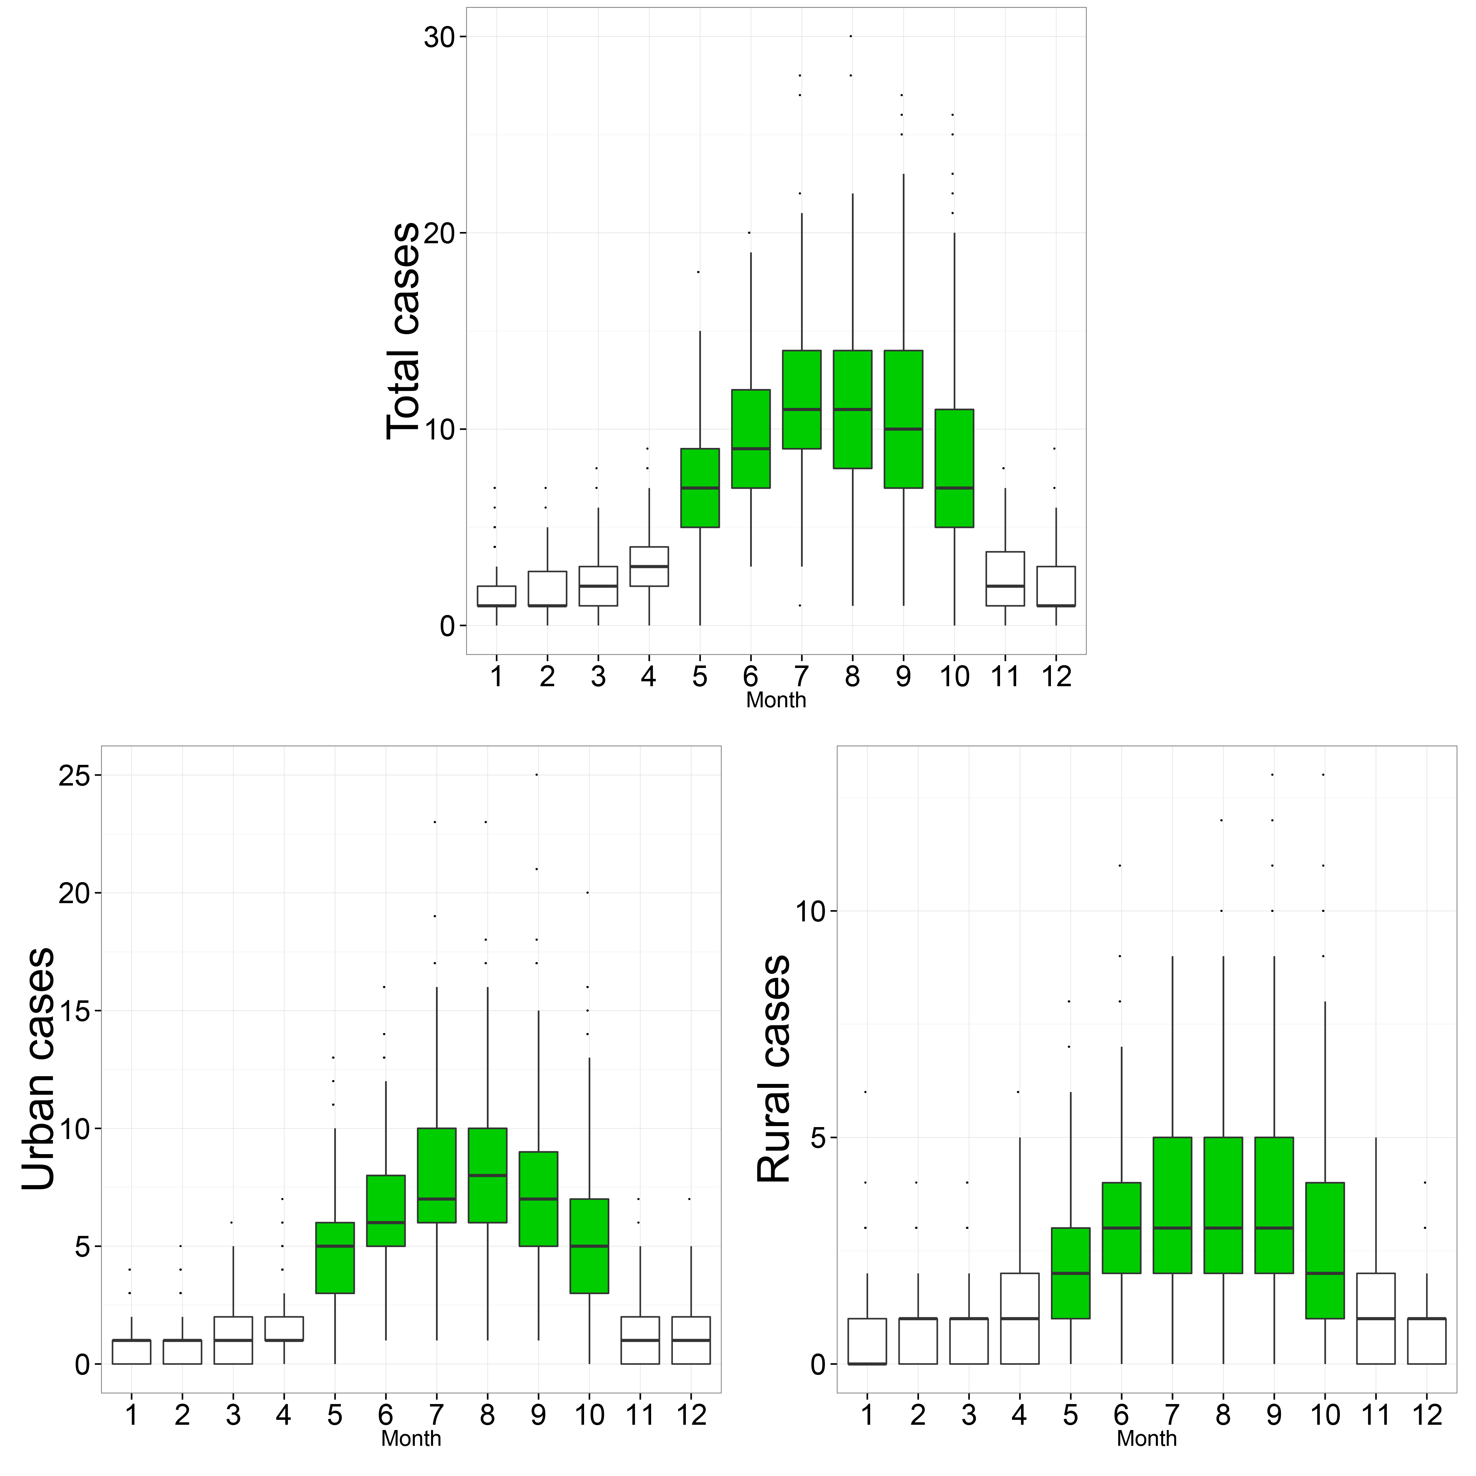
Supplemental Material, Fig. S1: The monthly distribution of bacillary dysentery during 2006–2012 in Hefei, China.

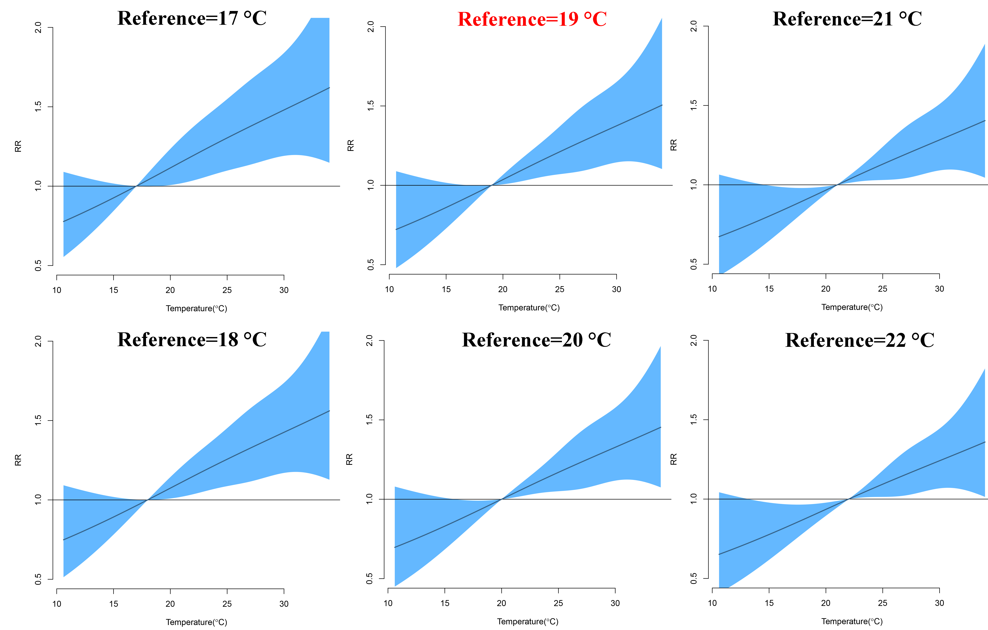
Supplemental Material, Fig. S2: The relationship between temperature and BD using various reference values (17°C-22°C) during warm season in 2006–2012 in Hefei, China.

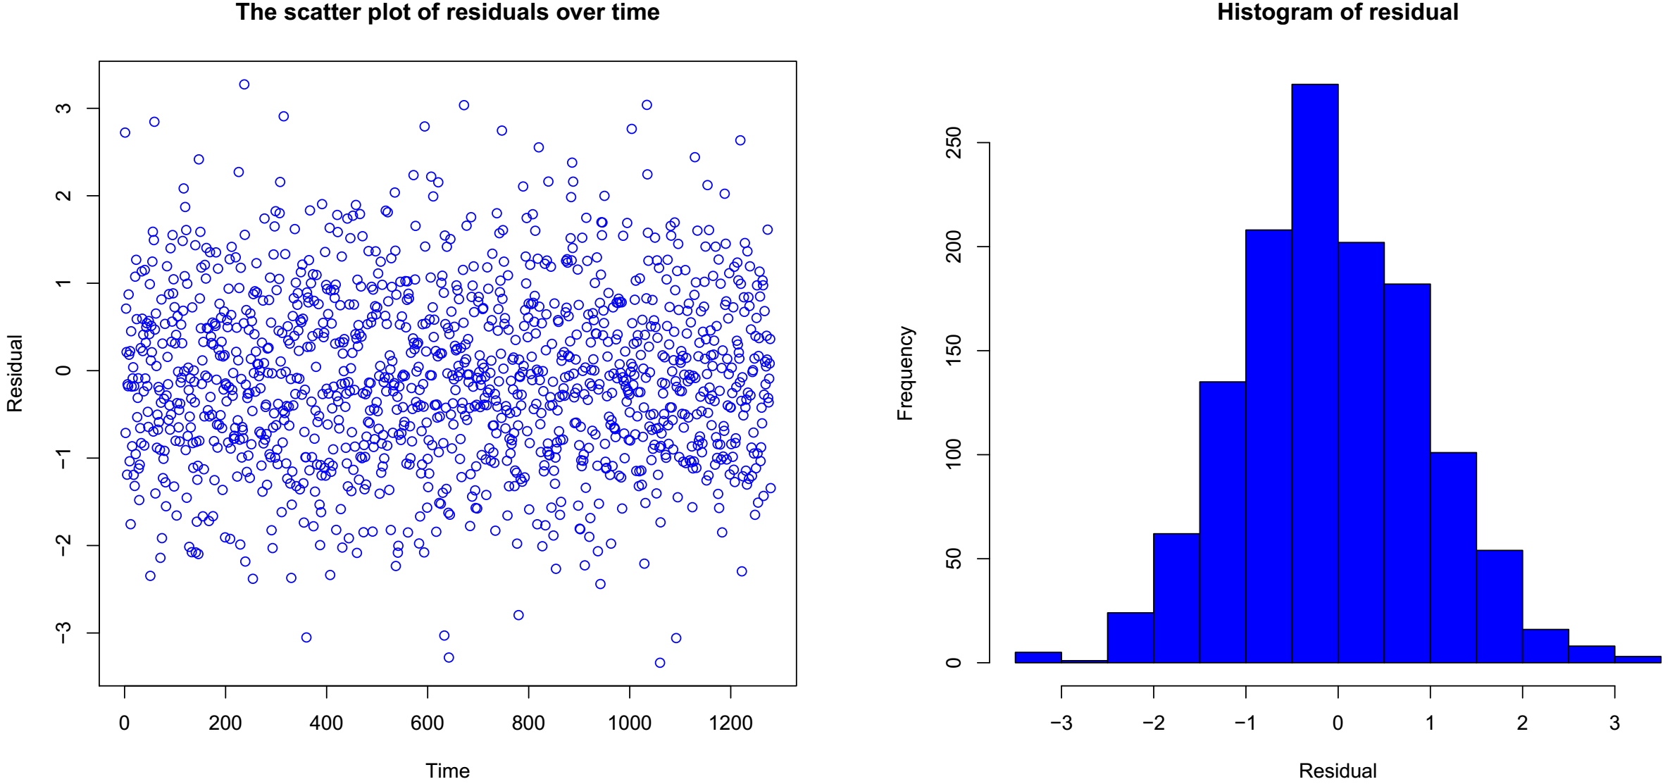
Supplemental Material, Fig. S3: The scatter plot of model residuals over time and histogram of model residuals. (Model residuals were independent over time and normally distributed)

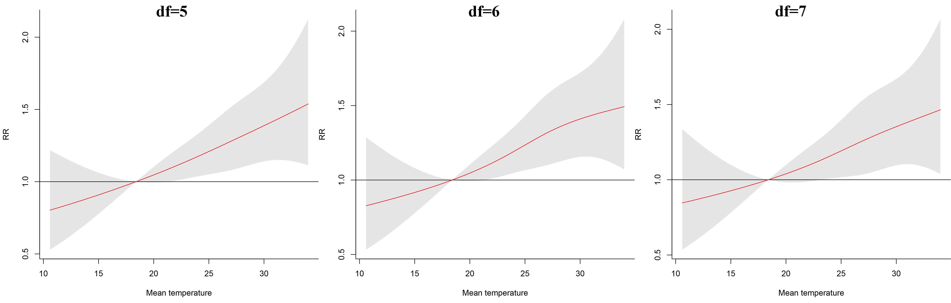
Supplemental Material, Fig. S4: Sensitivity analysis by changing df (5-7) for long-term trend in the DLNM model.

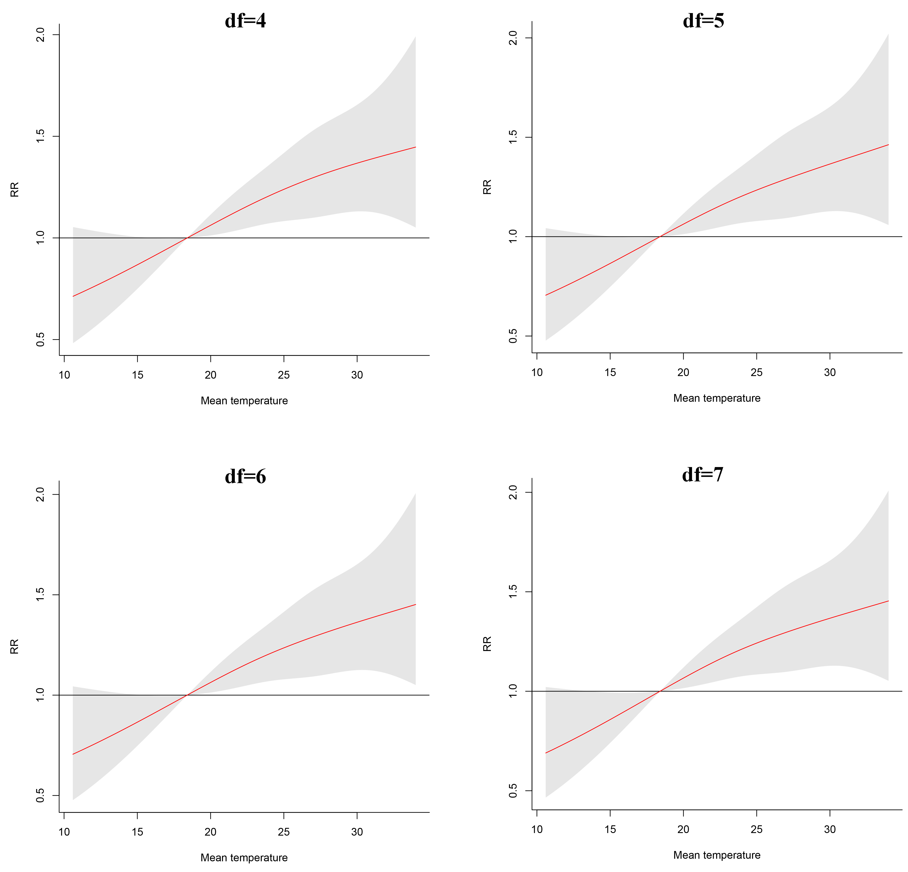
Supplemental Material, Fig. S5: Sensitivity analysis by changing df (4-7) for relative humidity in the DLNM model.

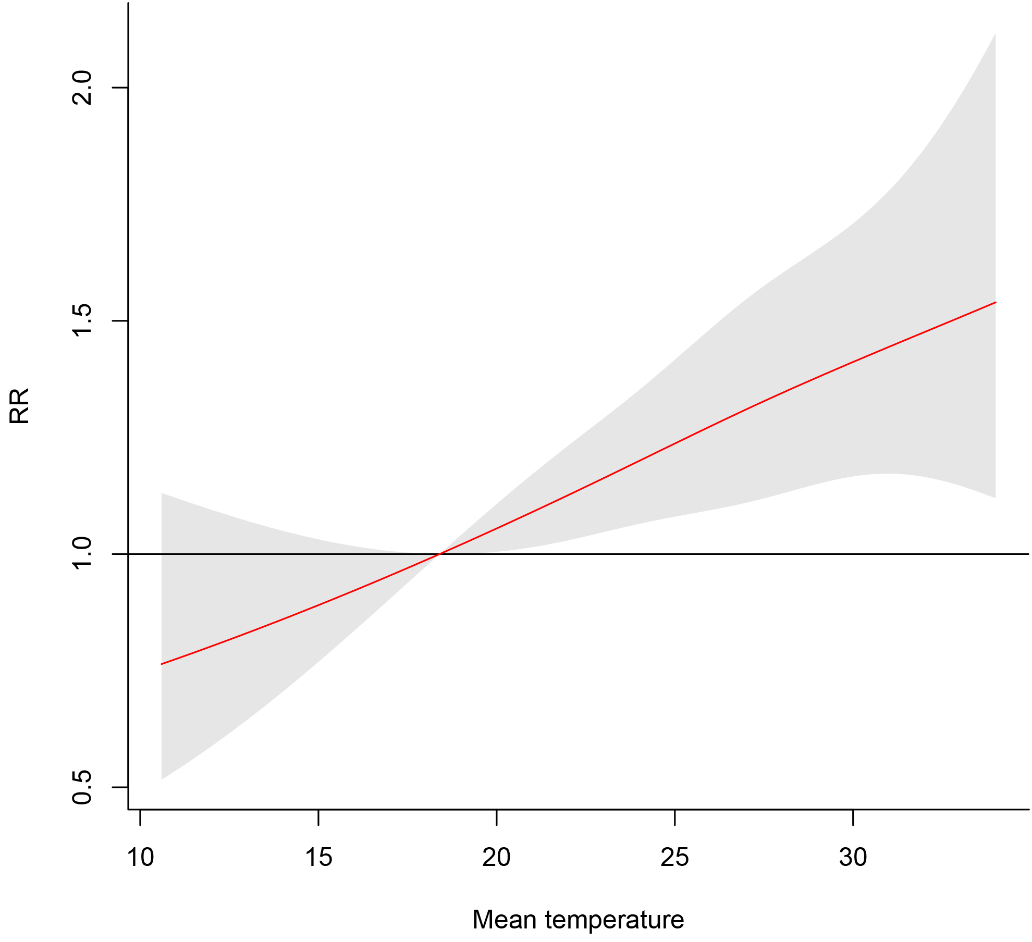
Supplemental Material, Fig. S6: Sensitivity analysis by controlling for rainfall in the DLNM model.
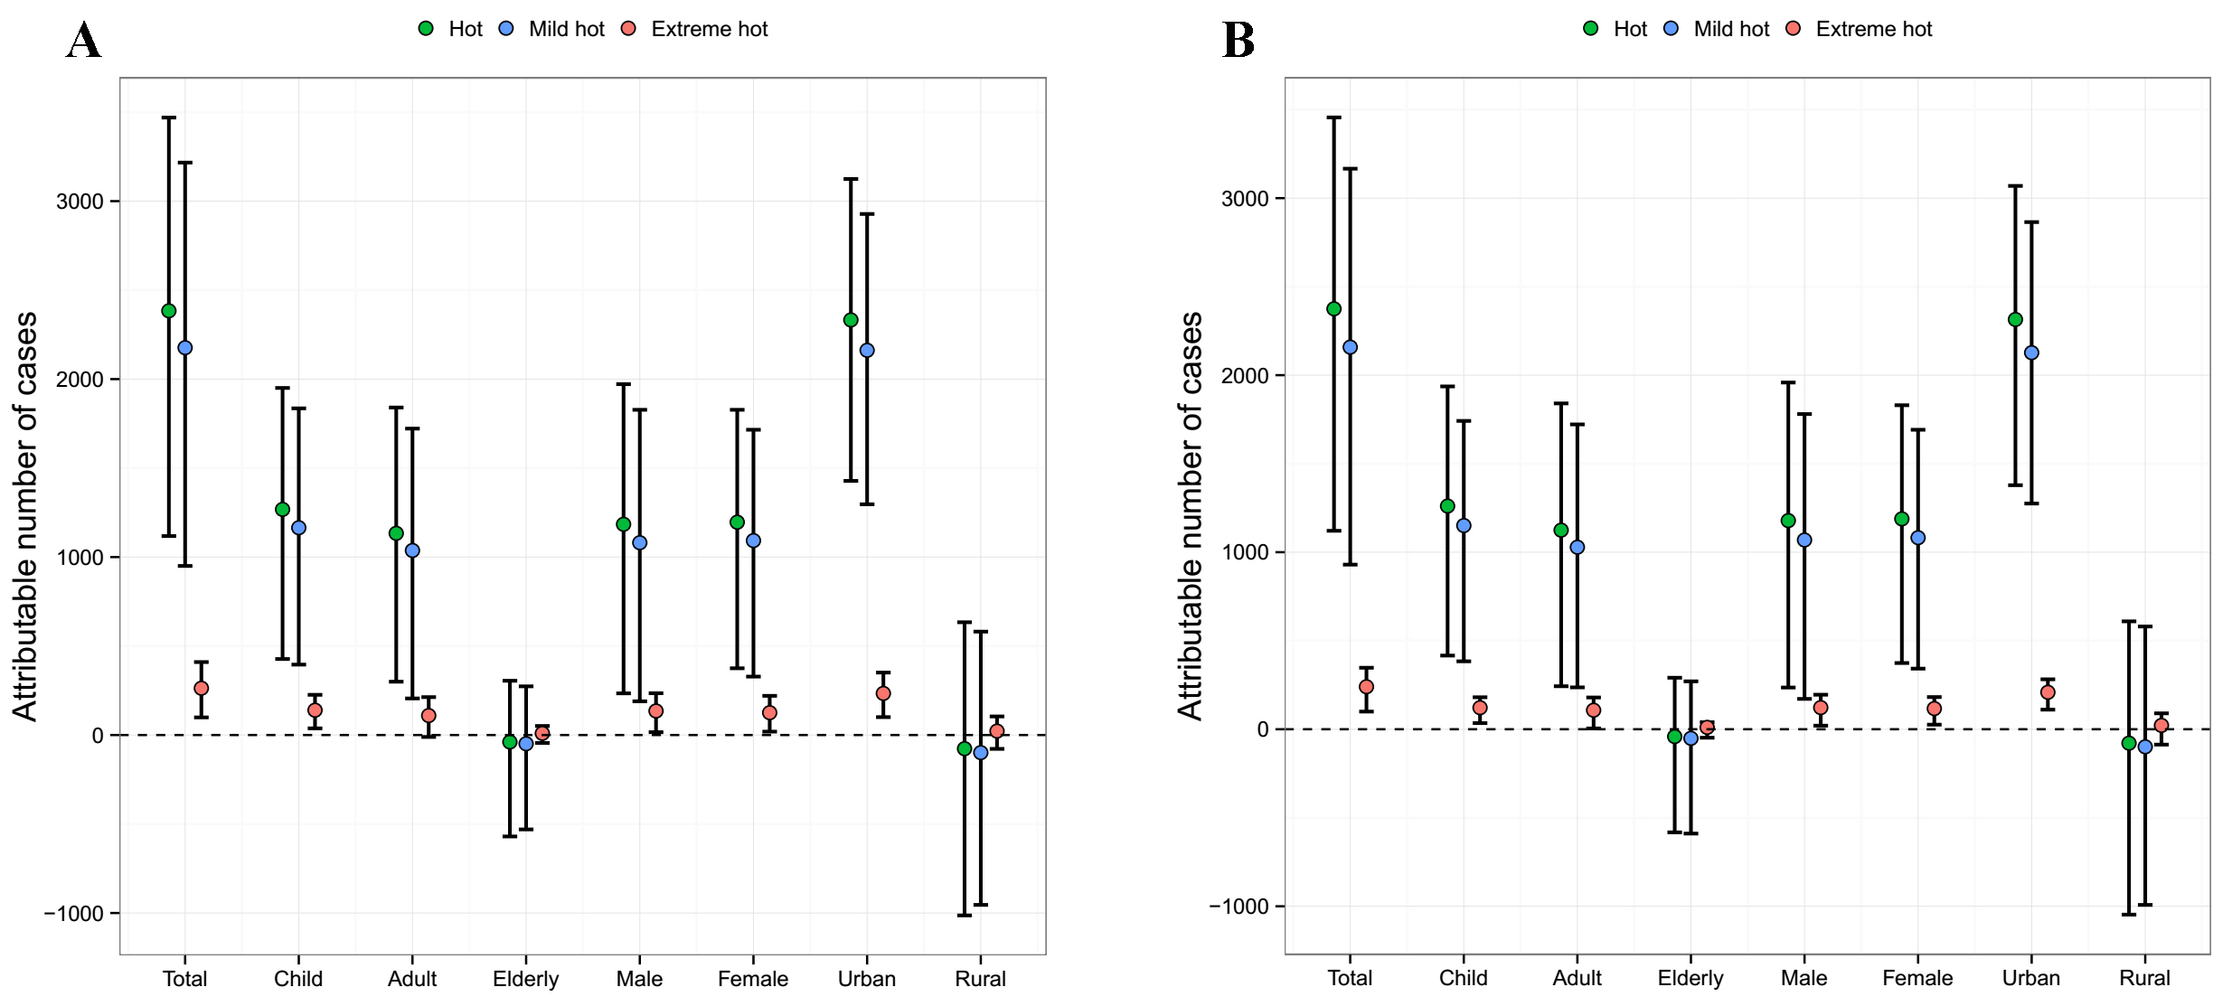
Supplemental Material, Fig. S7: The attributable number of BD cases from hot temperatures, including from mild hot temperatures and extreme hot temperatures.
The attributable number of cases is calculated from backward perspective (A) and forward perspective (B).
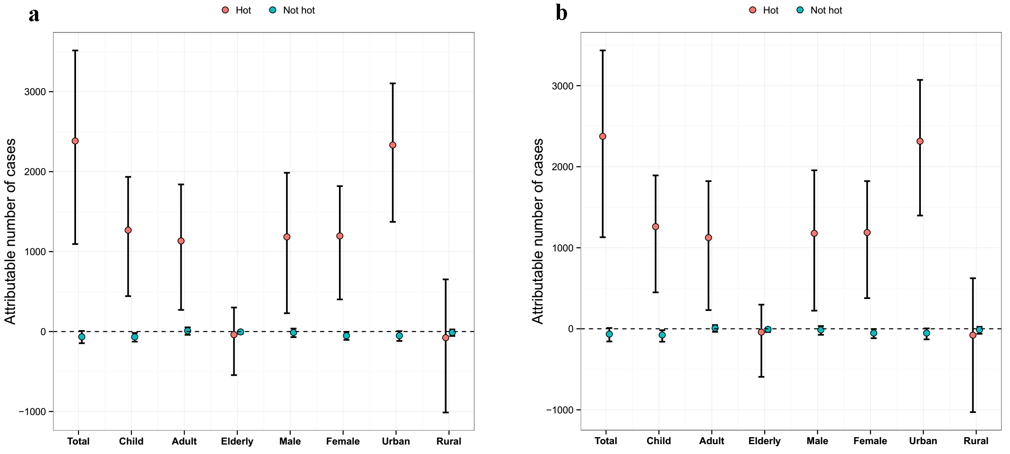
Supplemental Material, Fig. S8: The attributable number of BD cases from hot temperatures and not hot temperatures.
The attributable number of cases is calculated from backward perspective (a) and forward perspective (b).

Supplemental Material, Table S1 Projected total morbidity fraction (%) attributable to temperature among urban and rural Hefei, China.
 | AF | Climate change scenarios
 | AF | 1°C increase | 2°C increase | 3°C increase | 4°C increase
 | AF | Male
Hot | b-AF  f-AF | 17.82 (1.60-30.64)  17.82 (1.96-30.45) | 18.99 (-1.06-34.16)  18.99 (-0.79-34.10) | 20.00 (-3.36-37.89)  20.00 (-3.43-37.60) | 20.89 (-7.89-41.63)  20.89 (-8.07-41.74)
Mild hot | b-AF  f-AF | 15.01 (0.77-26.74)  14.83 (0.83-26.12) | 13.67 (-2.12-26.78)  13.52 (-2.10-25.69) | 12.05 (-5.81-26.01)  11.96 (-5.21-25.39) | 9.68 (-9.53-24.15)  9.79 (-8.78-23.51)
Extreme hot | b-AF  f-AF | 3.08 (0.51-5.65)  2.84 (0.59-4.81) | 4.98 (0.62-9.03)  4.70 (0.84-7.84) | 6.27 (0.15-11.97)  6.02 (0.69-10.46) | 7.46 (-1.26-15.05)  7.34 (-0.26-13.29)
 |  | Female
Hot | b-AF  f-AF | 25.21 (9.67-37.53)  25.08 (9.22-36.82) | 29.99 (11.81-44.03)  29.87 (11.60-43.47) | 34.71 (12.23-51.08)  34.60 (13.21-50.49) | 39.31 (14.38-56.85)  39.20 (14.22-56.49)
Mild hot | b-AF  f-AF | 21.91 (6.69-33.42)  21.70 (7.70-33.09) | 23.04 (6.89-35.22)  22.77 (8.11-34.42) | 23.69 (6.52-35.96)  23.11 (7.21-34.75) | 22.93 (5.34-35.59)  22.10 (6.42-33.43)
Extreme hot | b-AF  f-AF | 4.06 (1.15-7.02)  3.67 (1.33-5.74) | 7.12 (2.42-11.50)  6.33 (2.54-9.44) | 9.80 (3.80-15.83)  8.69 (3.40-12.86) | 12.69 (4.24-20.26)  11.31 (4.83-16.60)
 |  | Child
Hot | b-AF  f-AF | 27.82 (11.56-40.40)  27.55 (11.23-39.41) | 33.95 (13.95-48.31)  33.71 (14.88-47.53) | 39.95 (17.55-55.79)  39.73 (18.52-54.98) | 45.70 (20.01-62.53)  45.50 (21.43-61.84)
Mild hot | b-AF  f-AF | 24.63 (8.56-36.59)  24.23 (9.64-35.95) | 26.92 (10.39-39.14)  26.24 (11.05-37.84) | 28.48 (11.00-40.82)  27.47 (11.20-39.03) | 27.87 (10.16-40.19)  26.74 (10.85-37.61)
Extreme hot | b-AF  f-AF | 4.42 (1.62-7.39)  3.84 (1.64-5.80) | 7.68 (3.04-11.96)  6.71 (2.91-9.64) | 10.60 (4.64-16.65)  9.32 (4.41-13.38) | 14.46 (6.38-22.16)  12.58 (6.05-17.55)
 |  | Adult
Hot | b-AF  f-AF | 18.57 (0.78-32.22)  18.52 (1.21-32.07) | 17.70 (-5.26-34.75)  17.64 (-4.27-34.51) | 16.31 (-12.46-36.84)  16.25 (-11.24-36.81) | 14.48 (-22.62-39.59)  14.42 (-20.37-39.22)
Mild hot | b-AF  f-AF | 15.26 (-0.63-27.84)  15.25 (0.21-27.45) | 11.69 (-6.95-25.53)  12.07 (-5.34-25.53) | 7.99 (-13.13-23.30)  8.51 (-11.70-23.70) | 3.91 (-19.90-20.41)  4.58 (-18.26-20.78)
Extreme hot | b-AF  f-AF | 3.02 (-0.13-5.97)  2.94 (0.25-5.14) | 4.84 (-0.23-9.60)  4.78 (0.13-8.39) | 5.93 (-1.26-12.45)  5.91 (-0.89-10.92) | 6.18 (-4.12-14.89)  6.64 (-3.18-13.44)
 |  | Elderly
Hot | b-AF  f-AF | -0.91 (-58.36-31.72)  -1.34 (-55.29-31.55) | 2.72 (-66.46-39.68)  2.31 (-62.62-39.29) | 6.87 (-76.71-47.86)  6.48 (-72.24-47.42) | 11.37 (-89.16-56.30)  10.99 (-84.03-55.99)
Mild hot | b-AF  f-AF | -2.17 (-50.22-26.99)  -2.30 (-50.19-27.59) | 0.60 (-50.11-30.93)  0.58 (-50.96-30.69) | 3.91 (-50.48-34.35)  3.75 (-51.78-33.51) | 6.83 (-50.52-36.48)  6.68 (-52.55-35.04)
Extreme hot | b-AF  f-AF | 1.19 (-7.15-7.04)  1.19 (-8.50-5.78) | 1.29 (-12.51-10.40)  1.32 (-14.70-8.77) | 1.09 (-18.08-13.50)  1.36 (-22.46-11.60) | 1.09 (-24.28-17.25)  1.70 (-29.94-14.83)
b-AF, backward attributable fraction; f-AF, forward attributable fraction

