SUPPLEMENTARY MATERIAL
Supplementary Table S1: Number of pre- and post-slaughter samples collected from 60 calves, followed as cohorts from six dairy farms to slaughter at a regional calf-processing plant, stratified by study day and farm. Losses of follow-up of carcasses are explained in superscripts (a-c).
 |  |  | Pre-slaughter (RAMS) |  |  | Post-slaughter (carcass swab)
Study day | Farm | No. of calves tested | On-farm | On-plant |  | Hide | Pre-intervention | Post-intervention
1 | A2 | 10 | 10 | 10 |  | 9ª | 8ª | 1^{b}
 | A3 | 10 | 10 | 10 |  | 10 | 10 | 7^{b}
2 | B1 | 8 | 8 | 8 |  | 8 | 8 | 8
 | B2 | 10 | 10 | 10 |  | 10 | 10 | 9^{c}
3 | C2 | 11 | 11 | 11 |  | 11 | 11 | 11
 | C3 | 11 | 11 | 11 |  | 11 | 11 | 11
RAMS: recto-anal mucosal swab.
ª Carcass missed on processing chain.
^{b} Identification tags lost during hot water wash (intervention).
^{c} Carcass condemned at pre-intervention.

Supplementary Table S2: Results of real-time PCR and culture isolation of E. coli O157 and O26 (STEC and non-STEC) from pre-slaughter recto-anal mucosal swab samples (on-farm, on-plant) and post-slaughter carcass swab samples (hide, pre- and post-intervention) collected from 60 calves, stratified by sample type and farm on study day. Losses of follow-up of carcasses are explained in superscripts (a–c).
 |  |  |  | E. coli O157 |  |  | E. coli O26
Study day | Sample type | Farm | No. of samples collected | Real-time PCR-positive (%) | Culture isolation (%) |  | Real-time PCR-positive (%) | Culture isolation (%)
1 | On-farm | A2 | 10 | 1 (10) | 0 (0) |  | 1 (10) | 0 (0)
 |  | A3 | 10 | 10 (100) | 3 (30) |  | 10 (100) | 10 (100)
 | On-plant | A2 | 10 | 2 (20) | 0 (0) |  | 4 (40) | 1 (10)
 |  | A3 | 10 | 9 (90) | 0 (0) |  | 9 (90) | 9 (90)
 | Hide | A2 | 9ª | 9 (100) | 1 (11) |  | 9 (100) | 8 (89)
 |  | A3 | 10 | 10 (100) | 2 (20) |  | 10 (100) | 9 (90)
 | Pre-intervention | A2 | 8ª | 1 (13) | 0 (0) |  | 4 (50) | 3 (38)
 |  | A3 | 10 | 4 (40) | 1 (10) |  | 5 (50) | 4 (40)
 | Post-intervention | A2 | 1^{b} | 0 (0) | 0 (0) |  | 1 (100) | 1 (100)
 |  | A3 | 7^{b} | 0 (0) | 0 (0) |  | 4 (57) | 4 (57)
2 | On-farm | B1 | 8 | 5 (63) | 5 (63) |  | 1 (13) | 1 (13)
 |  | B2 | 10 | 10 (100) | 1 (10) |  | 9 (90) | 8 (80)
 | On-plant | B1 | 8 | 4 (50) | 3 (38) |  | 1 (13) | 0 (0)
 |  | B2 | 10 | 10 (100) | 0 (0) |  | 10 (100) | 7 (70)
 | Hide | B1 | 8 | 7 (88) | 6 (75) |  | 8 (100) | 8 (100)
 |  | B2 | 10 | 10 (100) | 1 (10) |  | 10 (100) | 10 (100)
 | Pre-intervention | B1 | 8 | 0 (0) | 0 (0) |  | 3 (38) | 2 (25)
 |  | B2 | 10 | 1 (10) | 0 (10) |  | 3 (30) | 1 (10)
 | Post-intervention | B1 | 8 | 0 (0) | 0 (0) |  | 0 (0) | 0 (0)
 |  | B2 | 9^{c} | 0 (0) | 0 (0) |  | 0 (0) | 0 (0)
3 | On-farm | C2 | 11 | 3 (27) | 0 (0) |  | 8 (73) | 0 (0)
 |  | C3 | 11 | 9 (82) | 6 (55) |  | 8 (73) | 0 (0)
 | On-plant | C2 | 11 | 5 (45) | 1 (9) |  | 10 (91) | 0 (0)
 |  | C3 | 11 | 9 (82) | 6 (55) |  | 10 (91) | 0 (0)
 | Hide | C2 | 11 | 10 (91) | 6 (55) |  | 11 (100) | 8 (73)
 |  | C3 | 11 | 10 (91) | 8 (73) |  | 11 (100) | 5 (45)
 | Pre-intervention | C2 | 11 | 0 (0) | 0 (0) |  | 2 (18) | 0 (0)
 |  | C3 | 11 | 2 (18) | 2 (18) |  | 3 (27) | 0 (0)
 | Post-intervention | C2 | 11 | 1 (9) | 0 (0) |  | 1 (9) | 0 (0)
 |  | C3 | 11 | 1 (9) | 1 (9) |  | 1 (9) | 0 (0)
ª Carcass missed on processing chain.
^{b} Identification tags lost in hot water wash (intervention).
^{c} Carcass condemned pre-intervention.

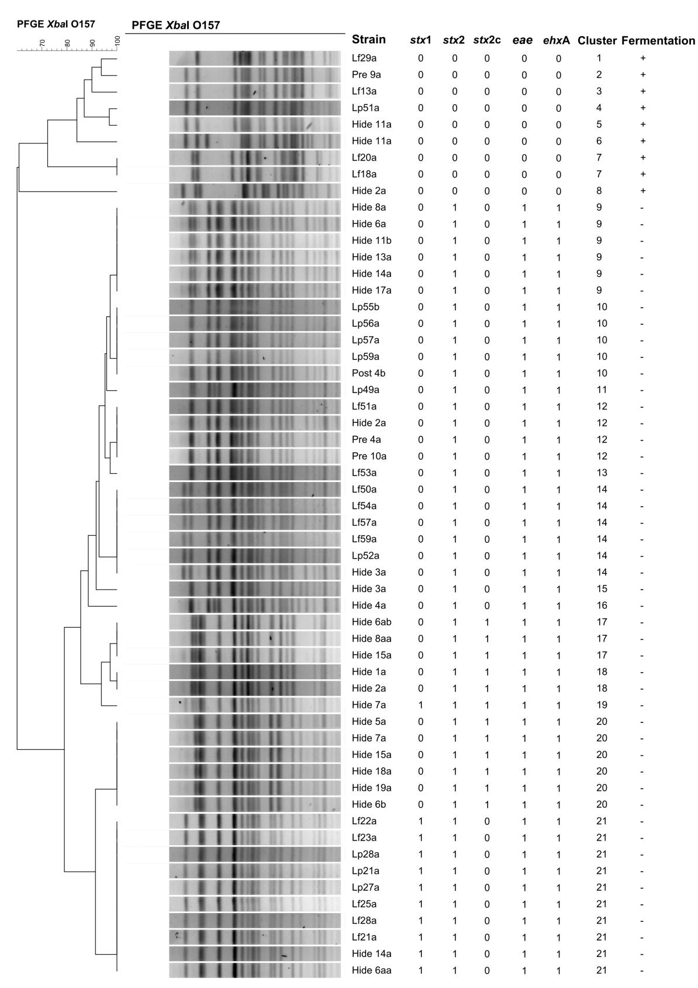
Supplementary Figure S1: PFGE profile comparison of E. coli O157 isolates (n = 56) performed using UPGMA cluster analysis, Dice similarity coefficient, and 1% band matching tolerance. ‘Lf’, ‘Lp’, ‘Hide’, ‘Pre’, and ‘Post’ represent isolates recovered from on-farm, on-plant, hide, pre- and post-intervention samples, respectively. stx1, stx2, stx2c (encoding for Shiga toxins), eae (encoding for intimin), and ehxA (encoding for enterohaemolysin) virulence genes present (1) or absent (0). PFGE cluster numbers ranging from 1 to 21. Fermentation of sorbitol present (+) or absent (–).
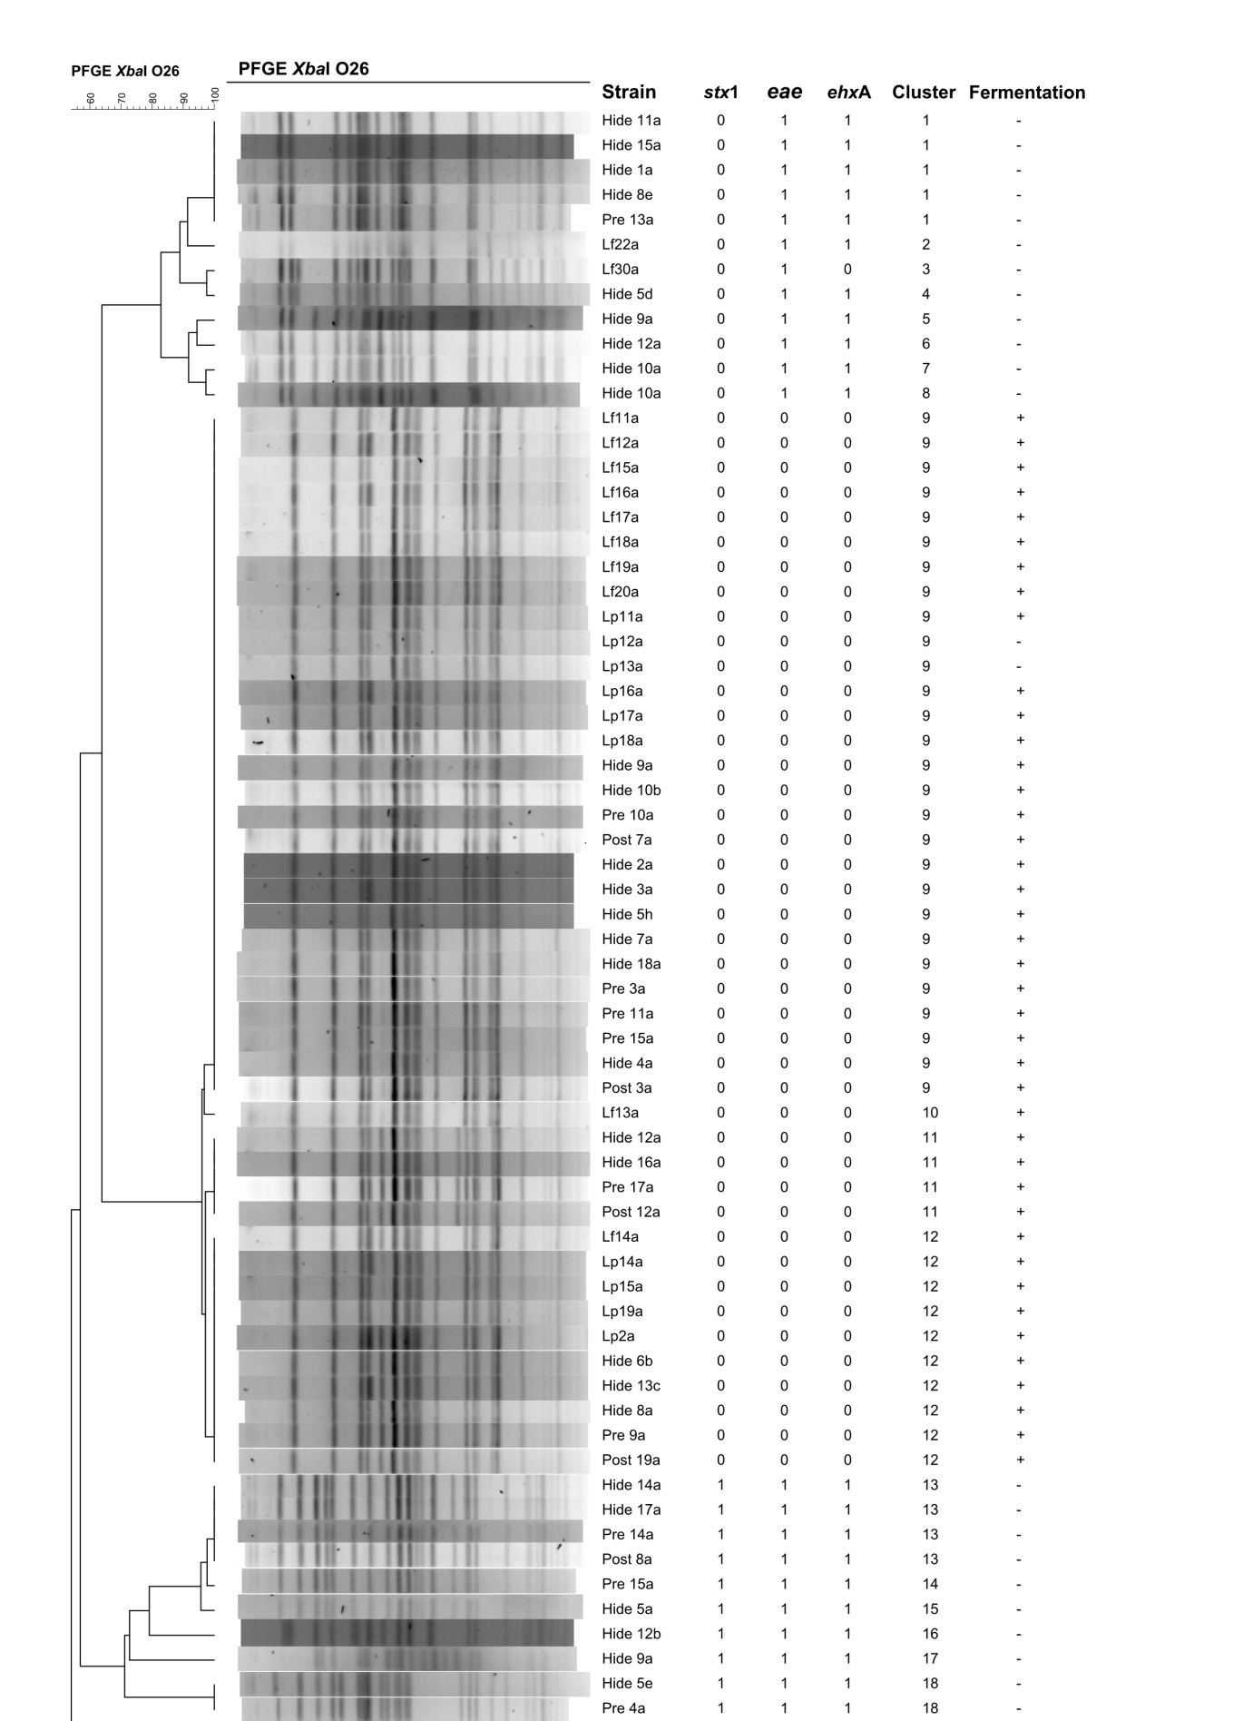
Supplementary Figure S2 continued

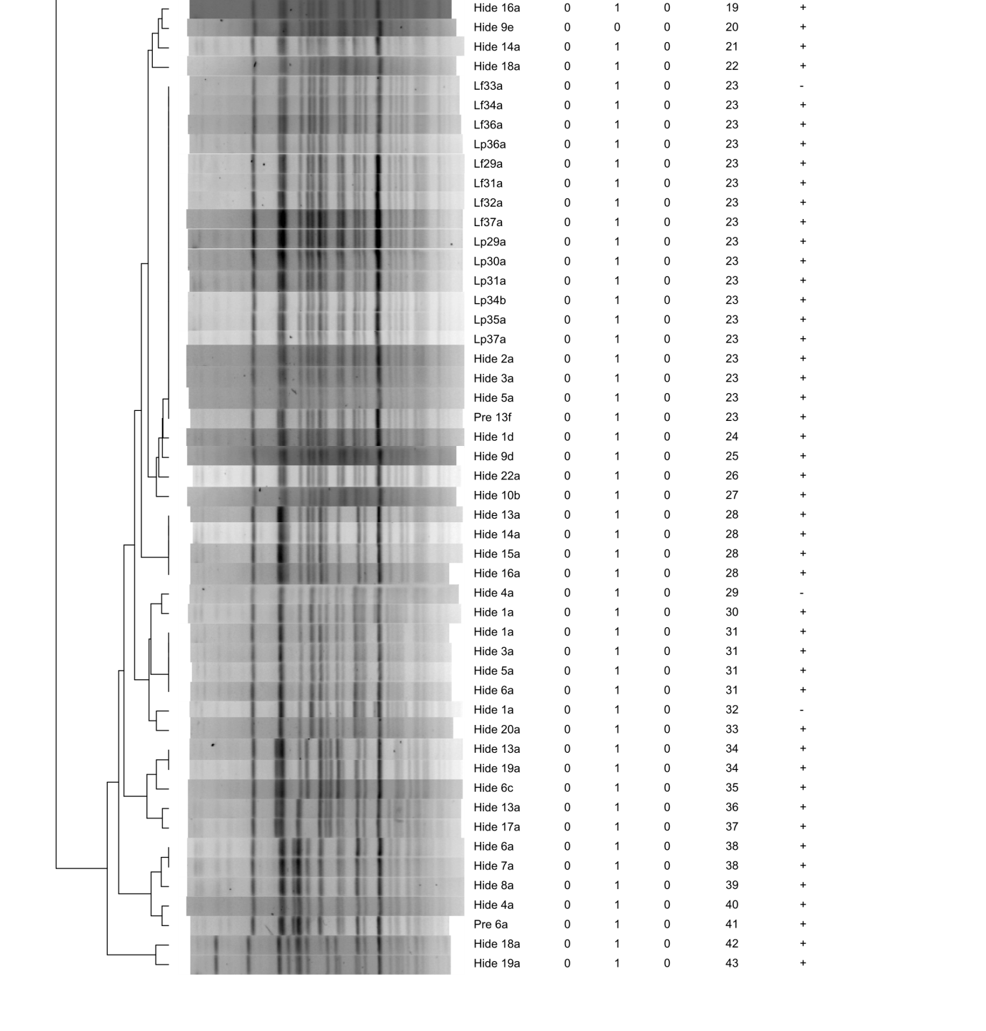
Supplementary Figure S1: PFGE profile comparison of E. coli O26 isolates (n = 115) performed using UPGMA cluster analysis, Dice similarity coefficient, and 1% band matching tolerance. ‘Lf’, ‘Lp’, ‘Hide’, ‘Pre’, and ‘Post’ represent isolates recovered from on-farm, on-plant, hide, pre- and post-intervention samples, respectively. stx1 (encoding for Shiga toxin), eae (encoding for intimin), and ehxA (encoding for enterohaemolysin) virulence genes present (1) or absent (0). PFGE cluster numbers ranging from 1 to 43. Fermentation of rhamnose present (+) or absent (–).

