Epidemiology and Infection, Time series analysis of tuberculosis from 2005 to 2017 in China, H. Wang, C.W. Tian, W.M. Wang, X.M. Luo Supplementary Material

Supplementary Table 1 Comparison of candidate models
Model | AIC | BIC | Parametric test |  |  | Residual series are white noise at lags(30)
 |  |  | Parameter | Coef. | P value | Residual series are white noise at lags(30)
sarima(3,1,1) (1,1,1)₁₂ | 311.4954 | 332.2353 | AR1  AR2  AR3  MA1  SAR1  SMA1 | 0.09  0.06  0.01  -0.91  -0.18  -0.54 | 0.34  0.43  0.93  0.00  0.17  0.00 | Yes
sarima(3,1,1) (0,1,1)₁₂ | 311.8445 | 329.6216 | AR1  AR2  AR3  MA1  SMA1 | 0.08  0.05  -0.02  -1.09  -0.63 | 0.37  0.51  0.84  0.00  0.00 | Yes
sarima(3,1,1) (1,1,0)₁₂ | 330.4631 | 351.1539 | AR1  AR2  AR3  MA1  SAR1 | 0.06  0.10  0.01  -1.07  -0.45 | 0.52  0.23  0.87  0.00  0.00 | No
sarima(3,1,1) (0,1,0)12 | 355.4425 | 373.1775 | AR1  AR2  AR3  MA1 | 0.01  0.07  -0.03  -1.01 | 0.95  0.41  0.75  0.00 | No
sarima(0,1,1) (1,1,1)₁₂ | 306.4448 | 318.2962 | MA1  SAR1  SMA1 | -1.14  -0.18  -0.54 | 0.00  0.15  0.00 | Yes
sarima(0,1,1) (0,1,1)₁₂ | 306.7389 | 315.6274 | MA1  SMA1 | -1.12  -0.62 | 0.00  0.00 | Yes
sarima(0,1,1) (1,1,0)₁₂ | 325.1539 | 334.0425 | MA1  SAR1 | -1.12  -0.45 | 0.00  0.00 | Yes
sarima(0,1,1) (0,1,0)₁₂ | 350.3094 | 356.2351 | MA1 | -1.02 | 0.00 | No
sarima(3,1,0) (1,1,1)₁₂ | 324.5348 | 345.2256 | AR1  AR2  AR3  SAR1  SMA1 | -0.69  -0.40  -0.17  -0.22  -0.53 | 0.00  0.00  0.04  0.05  0.00 | No
sarima(3,1,0) (0,1,1)₁₂ | 325.3347 | 340.149 | AR1  AR2  AR3  SMA1 | -0.69  -0.42  -0.21  -0.62 | 0.00  0.00  0.01  0.00 | No
sarima(3,1,0) (1,1,0)₁₂ | 342.6185 | 357.4327 | AR1  AR2  AR3  SAR1 | -0.74  -0.44  -0.23  -0.47 | 0.00  0.00  0.01  0.00 | No
sarima(3,1,0) (0,1,0)₁₂ | 371.694 | 383.5454 | AR1  AR2  AR3 | -0.79  -0.51  -0.32 | 0.00  0.00  0.00 | No

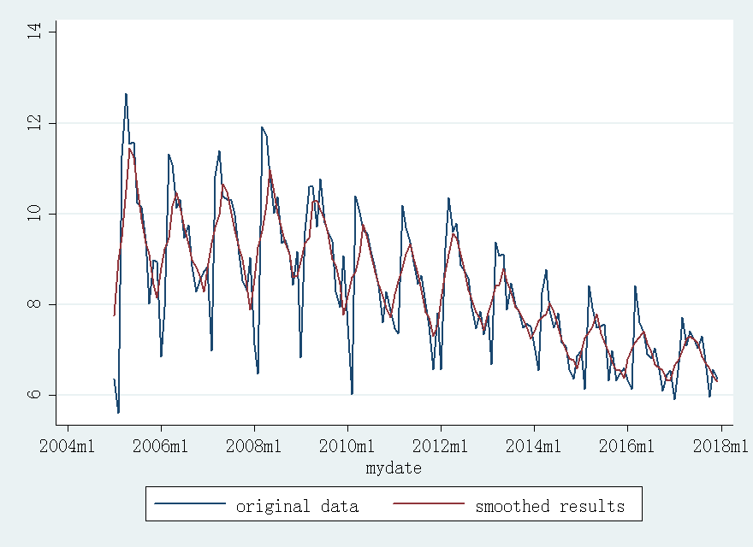

Supplementary Figure 1 Monthly notification rate of tuberculosis and the smoothed results (Jan. 2005 to Dec. 2017)
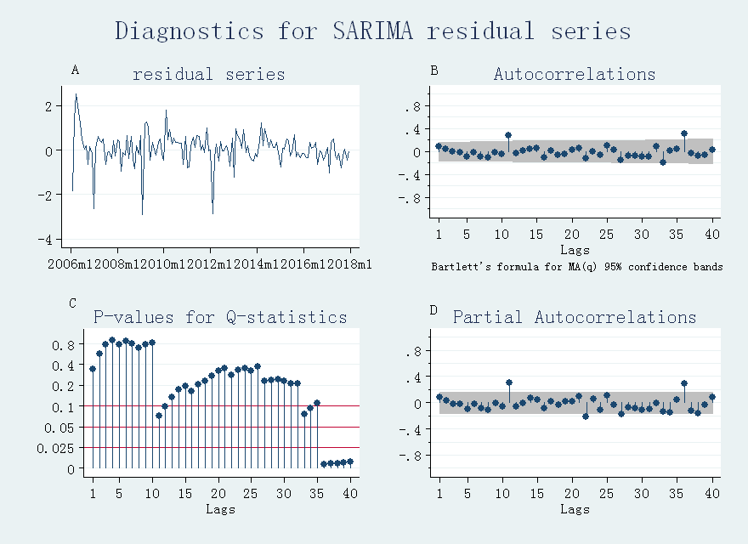
Supplementary Figure 2 Diagnostics for residual series from SARIMA. (A) stationary test; (B) autocorrelation coefficient graph; (C) white noise test; (D) partial autocorrelation coefficient graph.

Supplementary Figure 3 the selection of smoothing factor (A) The smoothing factor between 0.001 and 0.01 with an interval of 0.001; (B) The smoothing factor between 0. 01 and 1.00 with an interval of 0.01; (C) The smoothing factor between 1.00 and 50 with an interval of 1.

