Epidemiology and Infection, Time series modeling and forecasting of hand, foot, and mouth disease cases in China from 2008 to 2018, C.W. Tian, H. Wang, W.M. Wang, X.M. Luo
Supplementary Material

Supplementary Table 1 Comparison of candidate models
Model | AIC | BIC | Parametric test |  | Residual series are white noise at lags(30)
Model | AIC | BIC | Parameter | P value | Residual series are white noise at lags(30)
sarima(2,1,2) (1,1,1)₁₂ | 28.60 | 47.44 | AR1  AR2  MA1  MA2  SAR1  SMA1 | <0.01  0.61  0.02  0.06  0.55  <0.01 | Yes
sarima(2,1,1) (1,1,1)₁₂ | 29.57 | 45.72 | AR1  AR2  MA1  SAR1  SMA1 | <0.01  <0.01  <0.01  0.34  <0.01 | Yes
sarima(2,1,0) (1,1,1)₁₂ | 33.50 | 46.96 | AR1  AR2  SAR1  SMA1 | <0.01  <0.01  0.73  <0.01 | Yes
sarima(2,1,2) (0,1,1)₁₂ | 26.89 | 43.04 | AR1  AR2  MA1  MA2  SMA1 | <0.01  0.63  0.02  0.05  <0.01 | Yes
sarima(2,1,2) (1,1,0)₁₂ | 30.10 | 46.25 | AR1  AR2  MA1  MA2  SAR1 | 0.01  0.64  0.03  0.09  <0.01 | Yes
sarima(2,1,1) (0,1,1)₁₂ | 28.34 | 41.80 | AR1  AR2  MA1  SMA1 | <0.01  <0.01  <0.01  <0.01 | Yes
sarima(2,1,1) (1,1,0)₁₂ | 31.13 | 44.59 | AR1  AR2  MA1  SAR1 | <0.01  <0.01  <0.01  <0.01 | Yes
sarima(2,1,0) (0,1,1)₁₂ | 31.61 | 42.38 | AR1  AR2  SMA1 | <0.01  <0.01  <0.01 | Yes
sarima(2,1,0) (1,1,0)₁₂ | 36.93 | 47.69 | AR1  AR2  SAR1 | <0.01  <0.01  <0.01 | Yes
sarima(1,1,2) (1,1,1)₁₂ | 26.95 | 43.10 | AR1  MA1  MA2  SAR1  SMA1 | <0.01  <0.01  <0.01  0.58  <0.01 | Yes
sarima(1,1,1) (1,1,1)₁₂ | 38.43 | 51.88 | AR1  MA1  SAR1  SMA1 | 0.26  <0.01  0.81  <0.01 | No
sarima(1,1,0) (1,1,1)₁₂ | 43.64 | 54.40 | AR1  SAR1  SMA1 | 0.03  0.54  <0.01 | No
sarima(1,1,2) (0,1,1)₁₂ | 25.20 | 38.66 | AR1  MA1  MA2  SMA1 | <0.01  <0.01  <0.01  <0.01 | Yes
sarima(1,1,2) (1,1,0)₁₂ | 28.44 | 41.89 | AR1  MA1  MA2  SAR1 | <0.01  <0.01  <0.01  <0.01 | Yes
sarima(1,1,1) (0,1,1)₁₂ | 42.39 | 53.15 | AR1  MA1  SMA1 | <0.01  <0.01  <0.01 | No
sarima(1,1,1) (1,1,0)₁₂ | 42.93 | 53.69 | AR1  MA1  SAR1 | 0.21  <0.01  <0.01 | No
sarima(1,1,0) (0,1,1)₁₂ | 41.95 | 50.02 | AR1  SMA1 | 0.02  <0.01 | No
sarima(1,1,0) (1,1,0)₁₂ | 47.97 | 56.05 | AR1  SAR1 | 0.06  <0.01 | No
sarima(0,1,2) (1,1,1)₁₂ | 35.44 | 48.90 | MA1  MA2  SAR1  SMA1 | 0.02  <0.01  0.68  <0.01 | Yes
sarima(0,1,1) (1,1,1)₁₂ | 38.41 | 49.18 | MA1  SAR1  SMA1 | <0.01  0.82  <0.01 | No
sarima(0,1,0) (1,1,1)₁₂ | 46.37 | 54.45 | SAR1  SMA1 | 0.38  <0.01 | No
sarima(0,1,2) (0,1,1)₁₂ | 33.60 | 44.37 | MA1  MA2  SMA1 | 0.01  <0.01  <0.01 | Yes
sarima(0,1,2) (1,1,0)₁₂ | 38.02 | 48.79 | MA1  MA2  SAR1 | 0.25  <0.01  <0.01 | Yes
sarima(0,1,1) (0,1,1)₁₂ | 36.45 | 44.53 | MA1  SMA1 | <0.01  <0.01 | No
sarima(0,1,1) (1,1,0)₁₂ | 43.40 | 51.48 | MA1  SAR1 | <0.01  <0.01 | No
sarima(0,1,0) (0,1,1)₁₂ | 45.03 | 50.42 | SMA1 | <0.01 | No
sarima(0,1,0) (1,1,0)₁₂ | 49.64 | 55.02 | SAR1 | <0.01 | No

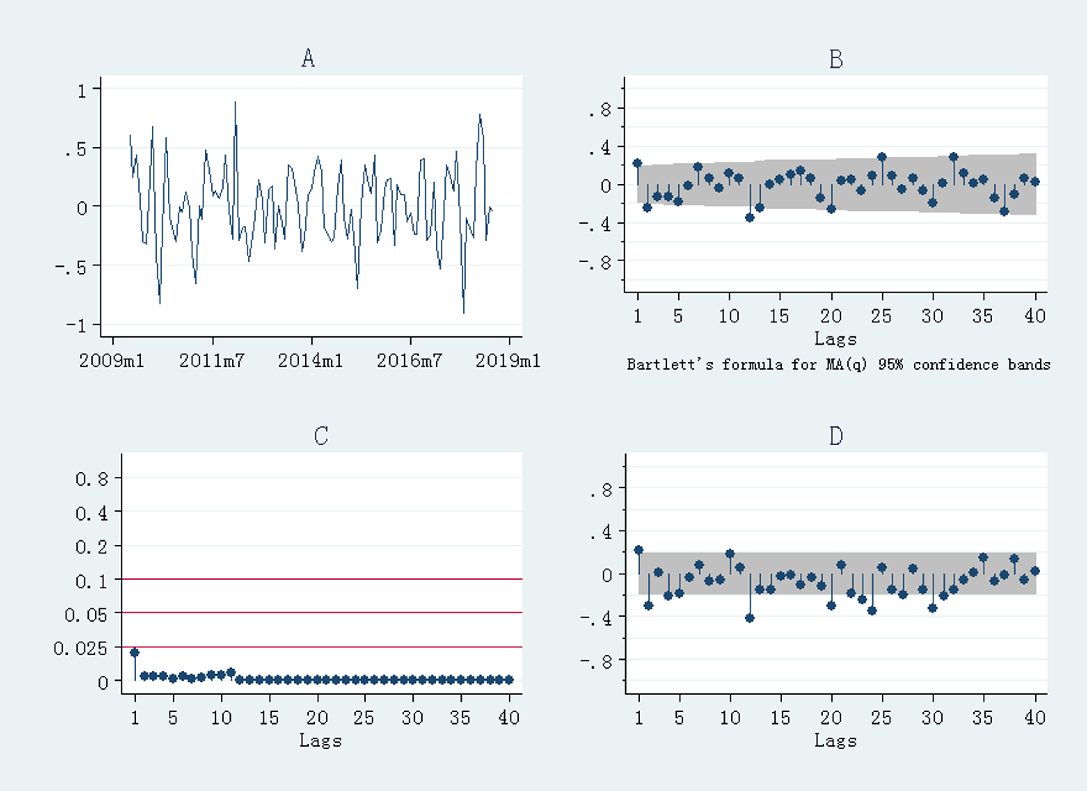
Supplementary Figure 1 Diagnostics for HFMD after first-order regular difference and one seasonal difference. (A) stationary test; (B) autocorrelation coefficient graph; (C) white noise test; (D) partial autocorrelation coefficient graph.

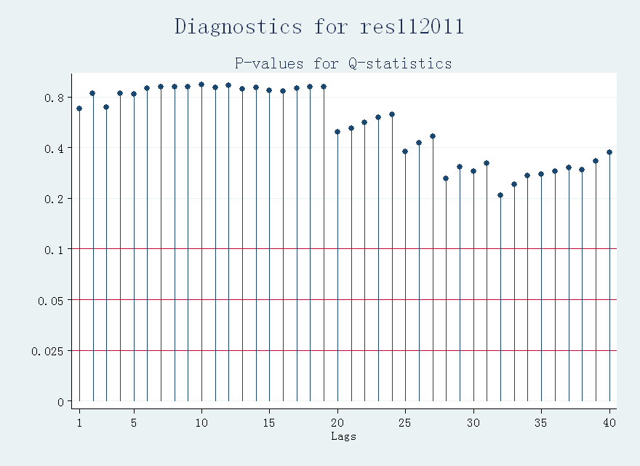
Supplementary Figure 2 White noise tests of residual series (res112011).

