Supplementary Table 1. Country characteristics and COVID-19 related outcomes at day 60 following epidemic start in each country (N=140)
Variable | Number of Countries | Mean (SD) | Median [min, max]
Healthcare access and quality index in 2016 | 140 | 63.2 (22.75) | 68.1 [18.6, 97.1]
BCG index 2005 (BCG2005) ª | 136 | 0.23 (0.14) | 0.24 [0, 0.5]
BCG index 1995 (BCG1995) ª | 131 | 0.4 (0.23) | 0.43 [0, 0.82]
BCG index 1985 (BCG1985) ª | 104 | 0.63 (0.31) | 0.68 [0, 1.17]
BCG index 1980 (BCG1980) ª | 63 | 0.6 (0.33) | 0.69 [0, 1.26]
MCV index 2005 (MCV2005) ^{b} | 138 | 0.23 (0.09) | 0.23 [0.11, 0.47]
MCV index 1995 (MCV1995) ^{b} | 136 | 0.4 (0.14) | 0.4 [0.18, 0.76]
MCV index 1985 (MCV1985) ^{b} | 110 | 0.59 (0.18) | 0.59 [0.26, 1.05]
MCV index 1980 (MCV1980) ^{b} | 53 | 0.65 (0.18) | 0.66 [0.31, 1.15]
Cumulative COVID-19 deaths/million population ^{c} | 140 | 48.43 (115.94) | 8.47 [0, 721.16]
Cumulative COVID-19 cases/million population ^{c} | 140 | 1075.17 (1518.79) | 400.24 [3.33, 9862.16]
Cumulative COVID-19 deaths (log per million) ^{c} | 140 | 2.4 (1.68) | 2.19 [-0.69, 6.58]
Cumulative COVID-19 cases (log per million) ^{c} | 140 | 5.98 (1.62) | 5.99 [1.2, 9.2]

Abbreviations: BCG, Bacillus Calmette–Guérin; MCV, Measles-containing-vaccine; SD, standard deviation.
ª Estimated proportion of vaccinated people with BCG in the country during the last 14, 24, 34 and 39 years, respectively.
^{b} Estimated proportion of vaccinated people with MCV in the country during the last 14, 24, 34 and 39 years, respectively.
^{c} Cumulative death or case rate for the 60 days since beginning of epidemic in each country, classified as day when 100 total cases had been recorded. Windows at risk differ for each country depending on epidemic start, and were censored at 7/13/20.

Supplementary Figure 1. Relationships between vaccine indices that describe different exposure periods.
Scatterplots depict the relationship of each vaccine index by year (2005 vs. 1980) among countries relevant data available. (A) BCG index 2005 vs. BCG index 1980 (p<0.001), (B) MCV index 2005 vs. MCV index 1980 (p<0.001). The vaccine index represents the total proportion of the population in that country who would have been vaccinated between that year and 2018 (cumulative proportion vaccinated for the last 14 or 39 years, respectively).
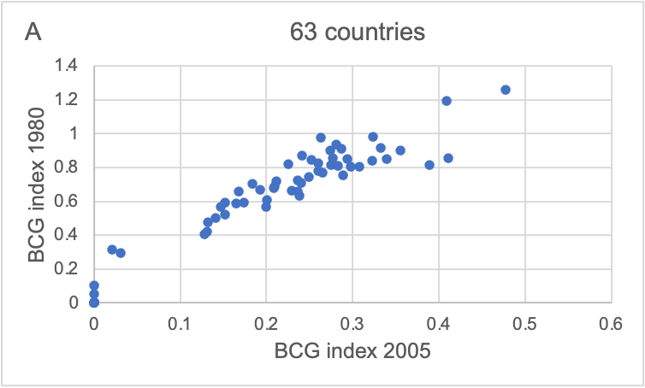

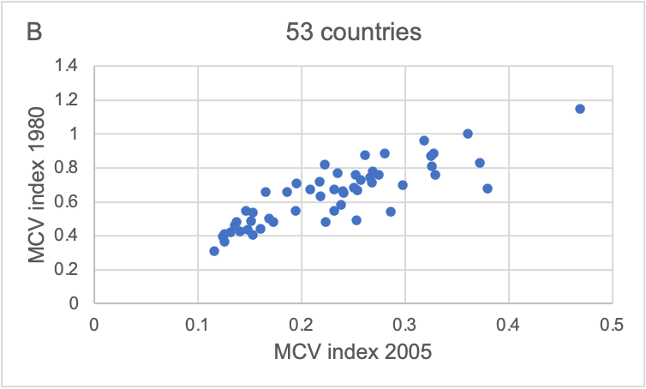

Supplementary Figure 2. Relationship between individual healthcare metrics, the Healthcare access and quality index (HAQI), vaccine index 2005 and COVID-19 metrics
Scatterplots depict the relationship between several important healthcare metrics among countries for which the relevant data were available. (A) Cumulative number of COVID-19 tests per million population (log) by the 60th day following the epidemic start in each country vs. BCG index 2005 (R2 = -0.66, p<0.001), (B) Cumulative number of COVID-19 tests per million population (log) by the 60th day following the epidemic start each country vs. MCV index 2005 (R2 = -0.62, p<0.001), (C) Life expectancy at birth in 2019 vs. BCG index 2005 (R2 = -0.79, p<0.001), (D) Life expectancy at birth in 2019 vs. MCV index 2005 (R2 = -0.67, p<0.001), (E) Hospital beds per 1,000 people (most recent year available since 2010) vs. BCG index 2005 (R2 = -0.51, p<0.001), (F) Hospital beds per 1,000 people (most recent year available since 2010) vs. MCV index 2005 (R2 = -0.58, p<0.001), (G) Cumulative number of COVID-19 tests per million population (log) by the 60th day following the epidemic start in each country vs. HAQI 2016 (R2 = 0.69, p<0.001), (H) Cumulative number of COVID-19 tests per million population (log) by the 60th day following the epidemic start in each country vs. cumulative COVID-19 related deaths per million population (log) by the 60th day following the epidemic start in each country (R2 = 0.47, p<0.001), (I) Life expectancy at birth in 2019 vs. cumulative COVID-19 related deaths per million population (log) by the 60th day following the epidemic start in each country (R2 = 0.53, p<0.001), (J) BCG index 2005 vs. cumulative COVID-19 related deaths per million population (log) by the 60th day following the epidemic start in each country (R2 = -0.61, p<0.001), (K) MCV index 2005 vs. cumulative COVID-19 related deaths per million population (log) by the 60th day following the epidemic start in each country (R2 = -0.52, p<0.001).

