***Epidemiology and Infection***

**Effect of temperature and its interaction with other meteorological factors on bacillary dysentery in Jilin Province, China**

Yingshuang Wang, Meina Li, Zhongqi Li, Ruiyu Chai, Xinxin Dong, Han Xu, Jin Wang, Laishun Yao, Yang Zhang, Qinglong Zhao, Yan Yao

**Supplemental Materials**

**Figure S1** Spearman correlation matrix between the daily meteorological factors and the number of cases of bacillary dysentery

**Figure S2** Sensitivity analyses for one-stage model by changing the df of ns for weather variables

**Figure S3** Sensitivity analyses for one-stage model by changing the df/year of ns for time

**Figure S4** Sensitivity analyses for one-stage model by changing the maximum lag days

**Figure S5** Residual distribution and normal QQ plot

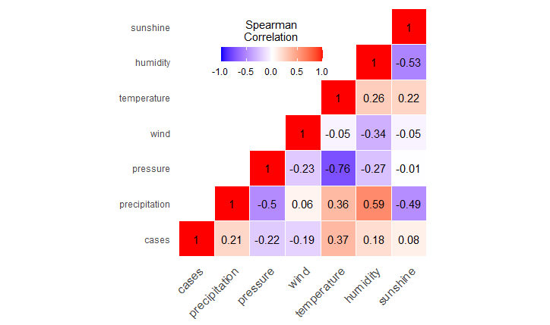

**Figure S1** Spearman correlation matrix between the daily meteorological factors and the number of cases of bacillary dysentery

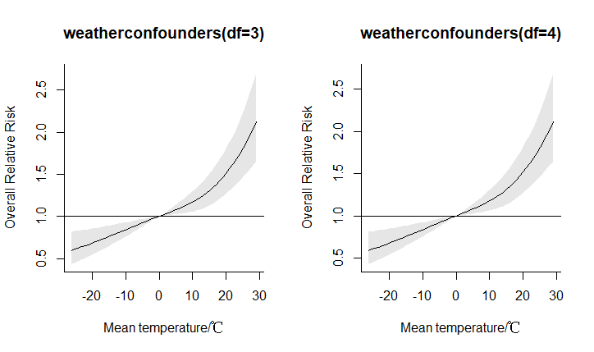

**Figure S2** Sensitivity analyses for one-stage model by changing the df of ns for weather variables

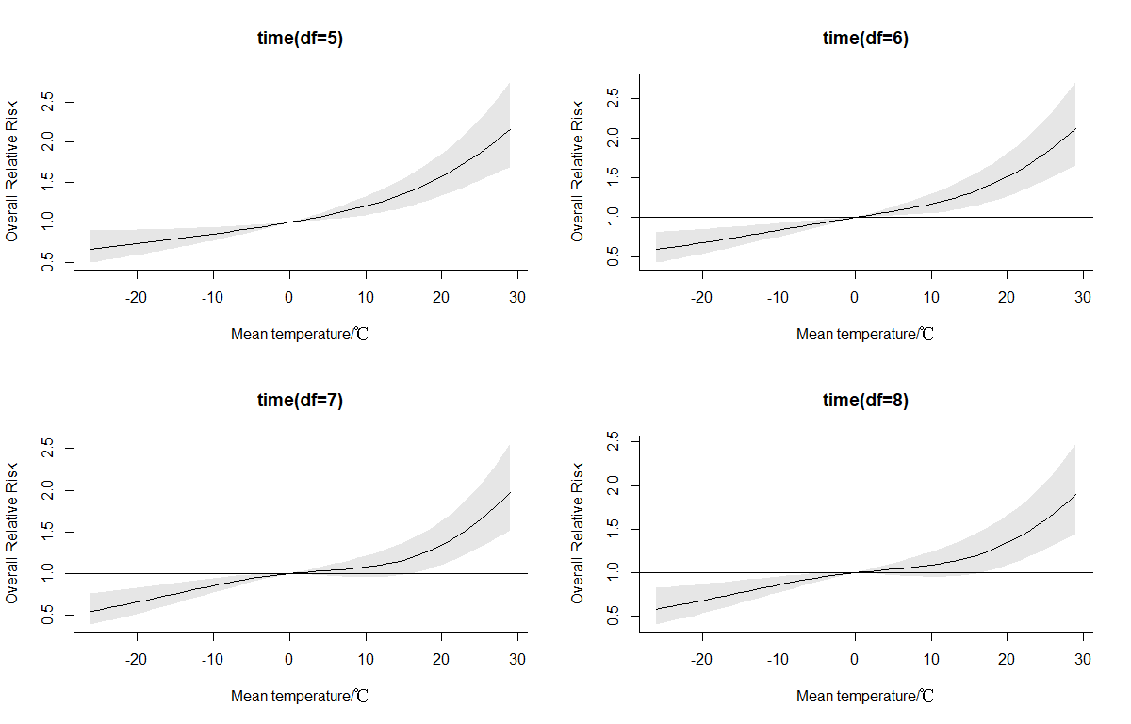

**Figure S3** Sensitivity analyses for one-stage model by changing the df/year of ns for time

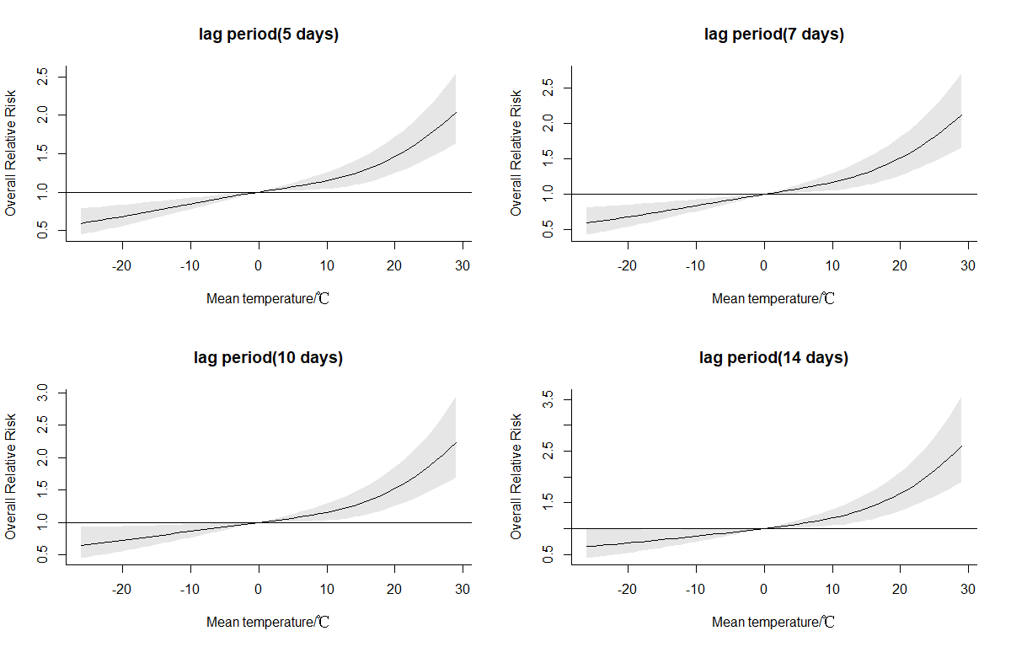

**Figure S4** Sensitivity analyses for one-stage model by changing the maximum lag days

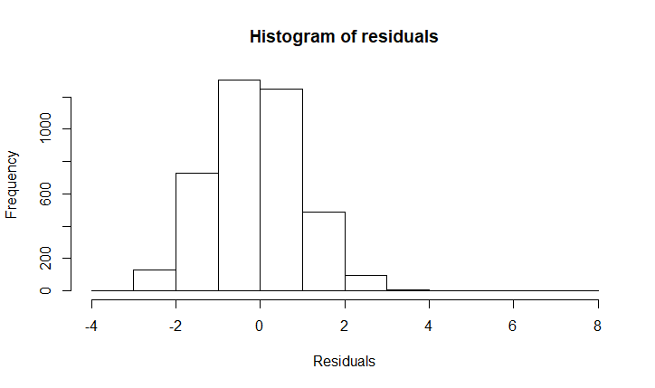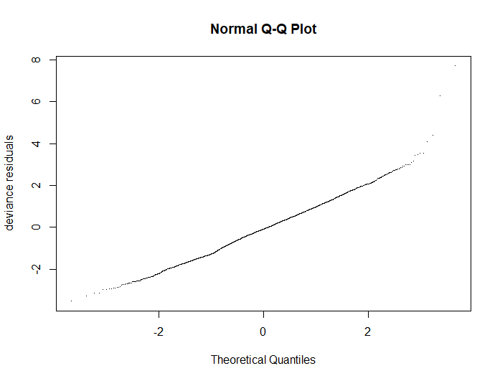

**Figure S5** Residual distribution and normal QQ plot