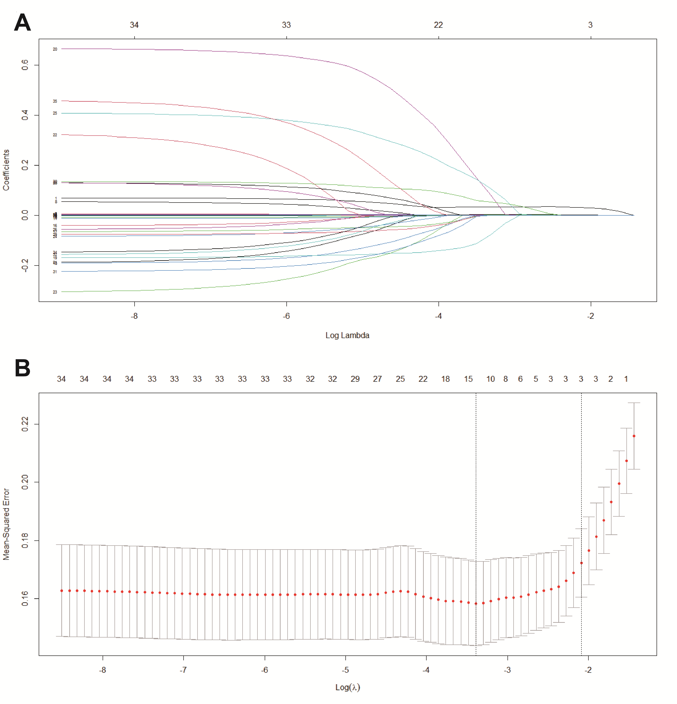
Figure S1. LASSO regression analysis of 17 variables.
A. Features’ selection using LASSO regularization. LASSO coefficient profiles (y-axis) of the 17 features. The lower x-axis indicates the log (λ). The top x-axis indicates the average number of predictors. B. Identification of the optimal penalization coefficient (λ) in the LASSO model based on mean squared error. LASSO, Least-absolute shrinkage and selection operator.
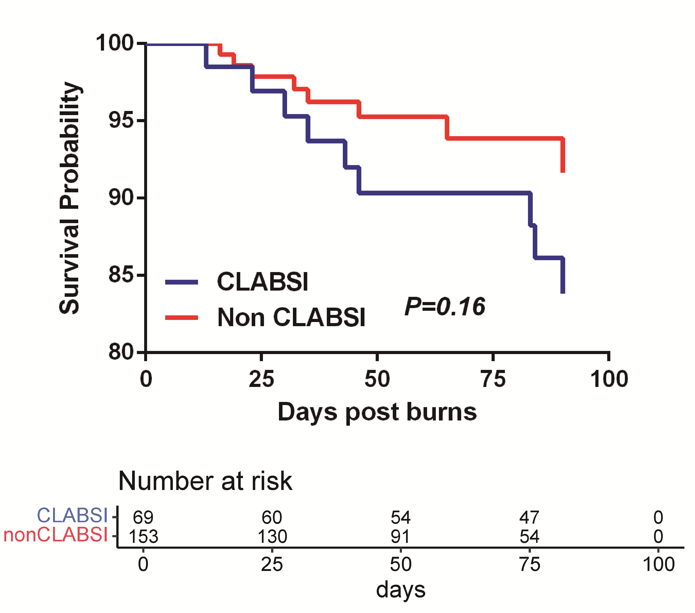
Figure S2. Kaplan–Meier survival analysis of burn patients with or without CLABSI
Table S1. Assignment of the collected 17 factors in the Logistic regression analysis of CLABSI
Risk factors | Variables | Evaluation
Gender | X1 | Male=1, Female=0
Age | X2 | Quantitative value
BMI | X3 | Quantitative value
Burn cause | X4 | Flame&scald=1, Others=0
Baux score | X5 | Quantitative value
Burn index | X6 | Quantitative value
Full-thickness burns | X7 | Quantitative value
Hyperlipidemia | X8 | Yes=1, No=0
Hormone therapy | X9 | Yes=1, No=0
Diabetes | X10 | Yes=1, No=0
Smoking | X11 | Yes=1, No=0
Hypertension | X12 | Yes=1, No=0
Inhalation injury | X13 | Yes=1, No=0
Days post injury | X14 | 0-7d=1,8-14d=2,15-21d=3,>21d=4
Line days | X15 | 0-7d=1,8-14d=2,15-21d=3,>21d=4
Catheterization on wound | X16 | Yes=1, No=0
Catheterization times | X17 | 0=0,1=1,2=2,3=3,4 or more=4
CLABSI | Y | Yes=1, No=0

Table S2. The pathogen distribution of CLABSI in burn patients
Strains | Number | Percentage (%)
Gram-negative bacteria | 124 | 76.07%
Acinetobacter baumannii | 64 | 39.26%
Pseudomonas aeruginosa | 30 | 18.40%
Stenotrophomonas maltophilia | 13 | 7.98%
Klebsiella pneumoniae | 8 | 4.91%
Serratia marcescens | 3 | 1.84%
Enterobacter cloacae | 2 | 1.23%
colon bacillus | 2 | 1.23%
Others | 2 | 1.23%
Gram-positive bacteria | 39 | 23.93%
Staphylococcus aureus | 21 | 12.88%
Enterococcus faecium | 6 | 3.68%
Staphylococcus haemolyticus | 5 | 3.07%
Staphylococcus epidermidis | 4 | 2.45%
Others | 3 | 1.84%

Table S3. Risk factors of mortality by COX regression analysis

Variables | B | SE | Wald | OR | 95% CI |  | P
With Inhalation injury | 1.477 | 0.778 | 3.605 | 4.380 | 0.95-20.12 | 0.058
Area of full-thickness burns | 0.694 | 0.250 | 7.696 | 2.003 | 1.22-3.27 | 0.006
With CLABSI | 0.109 | 0.547 | 0.040 | 1.115 | 0.38-3.26 | 0.842
Older age | 0.013 | 0.016 | 0.658 | 1.013 | 0.98-1.05 | 0.417
Higher BMI | -0.017 | 0.059 | 0.081 | 0.983 | 0.88-1.10 | 0.775
Male | -0.938 | 0.573 | 2.683 | .391 | 0.13-1.20 | 0.101

