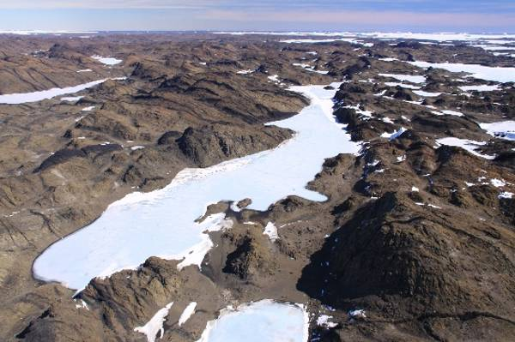
1
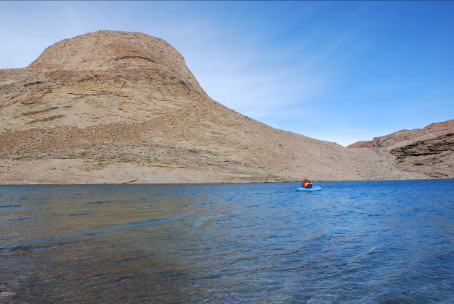
3
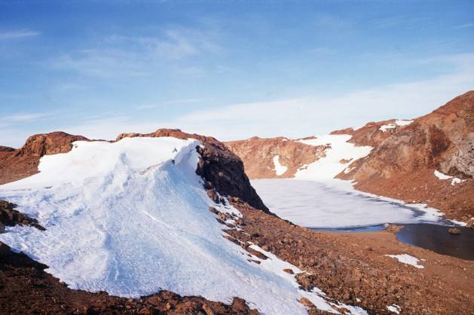
5
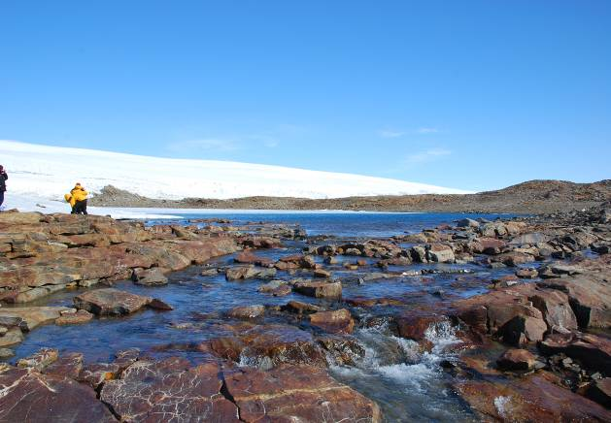
2
1
1
1
1
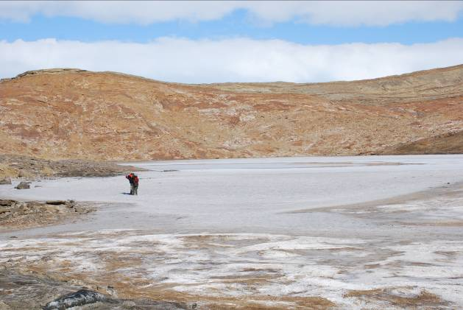
4
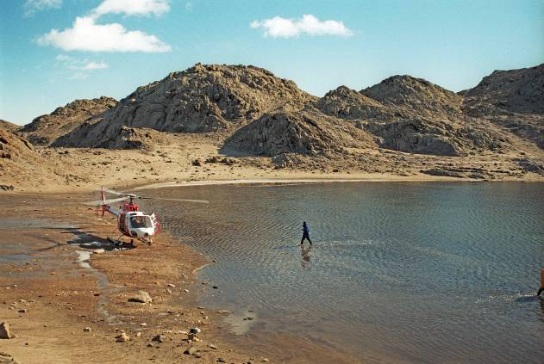
6

Figure S1. A subsample of lakes in the East Antarctic limnological dataset. (1) Lake Veretino (VVE) Vestfold Hills (courtesy of Australian Antarctic Data Centre). (2) Lake Pomornik (SC10) and overflow stream to Lake Glubokoye (SC13), Schirmacher Oasis. (3) Meromictic Kobachi Ike (SK4) and Mount Surbati, Skarvsnes, Syowa Oasis. (4) Saline Lake Itiziku (LA5), Langhovde, Lützow Holm Bay. (5) Lake Nella (L72) Larsemann Hills, Prydz Bay. (6) Lake R1 (RI1), Rauer Islands, Prydz Bay.

