Table S1. Multivariate dispersion index (MVDISP) of each site
Sites | MVDISP for absence/presence of T-RFs | MVDISP for proportional peak height of T-RFs
KB | 1.39 | 1.49
AC | 1.26 | 1.33
RO | 0.92 | 0.99
AI | 0.83 | 0.76
IC | 1.27 | 0.74
LI | 0.33 | 0.70

Table S2. The average PERMANOVA similarity between the 6 study sites. a) bacterial membership (absence/presence of T-RFs) b) bacterial composition (proportional peak height of the T-RFs).
a. | LI | AI | RO | AC | IC | KB
LI | 47.22
AI | 23.67 | 36.78
RO | 18.21 | 21.53 | 34.43
AC | 14.96 | 15.61 | 15.92 | 26.28
IC | 8.58 | 8.420 | 5.68 | 11.25 | 25.99
KB | 18.77 | 17.98 | 16.71 | 13.39 | 4.39 | 23.63

b. | LI | AI | RO | AC | IC | KB
LI | 50.02
AI | 29.08 | 51.17
RO | 21.77 | 23.99 | 44.25
AC | 13.04 | 16.33 | 18.94 | 34.54
IC | 7.266 | 6.77 | 5.602 | 13.46 | 54.01
KB | 21.97 | 24.23 | 26.30 | 15.71 | 3.145 | 32.11

Table S3. Possible origin of the retrieved clones based on the top five matches from a BLAST search. The number of X indicates the number of match with GenBank database. ªThe unknown or unclassifiable sequences included sequences which show <97% similarity to the available sequences in the GenBank database, or show >97% similarity to sequences whose origin were not defined or that were not sourced from environmental samples (i.e. biofilm, bioreactor, etc)
Clones | Site (s) | Phylum/ Class | Non-marine origin | Marine origin | Unknown/ unclassificableª
UMAB-cl-085 | AI | β-proteobacteria | XX | X | XX
UMAB-cl-086 | AI, LI | Flavobacteria |  | X | XXXX
UMAB-cl-087 | AI | Sphingobacteria | XXXXX
UMAB-cl-088 | AI | Flavobacteria | XX | XXX
UMAB-cl-089 | AI | Sphingobacteria |  | XXX | XX
UMAB-cl-090 | AI | Unclassified phylum | XXXXX
UMAB-cl-091 | AI | Actinobacteria | XXXXX
UMAB-cl-092 | AI | Sphingobacteria | X |  | XXXX
UMAB-cl-093 | AI | Flavobacteria |  | XXX | XX
UMAB-cl-094 | AI | γ-proteobacteria |  |  | XXXXX
UMAB-cl-095 | AI, KB | Sphingobacteria | XX | XXX
UMAB-cl-096 | AI | Actinobacteria | XXXX |  | X
UMAB-cl-097 | AI | Ktedonobacteria |  |  | XXXXX
UMAB-cl-098 | AI | Erysipelotrichi |  |  | XXXXX
UMAB-cl-099 | AI, LI | γ-proteobacteria | XXX | XX
UMAB-cl-100 | AI | Bacilli | X |  | XXXX
UMAB-cl-101 | AI, IC | Bacilli | X | XX | XX
UMAB-cl-102 | AI, LI | Clostridia |  |  | XXXXX
UMAB-cl-103 | AI | Sphingobacteria |  |  | XXXXX
UMAB-cl-104 | AI | Acidobacteria Gp4 | XXX |  | XX
UMAB-cl-105 | AI | Verrucomicrobiae |  |  | XXXXX
UMAB-cl-106 | AI | Bacilli |  |  | XXXXX
UMAB-cl-107 | AI, LI | Flavobacteria | XXX | X | X
UMAB-cl-108 | RO | δ-proteobacteria |  |  | XXXXX
UMAB-cl-109 | RO | Sphingobacteria | XXXXX
UMAB-cl-110 | RO, LI | β-proteobacteria | XXXXX
UMAB-cl-111 | RO | Gemmatimonadetes |  |  | XXXXX
UMAB-cl-112 | RO | Gemmatimonadetes | XXXX |  | X
UMAB-cl-113 | RO | Acidobacteria Gp7 | X |  | XXXX
UMAB-cl-114 | RO | Sphingobacteria | XXX | X | X
UMAB-cl-115 | RO | Sphingobacteria | XXXX |  | X
UMAB-cl-116 | RO | Sphingobacteria |  |  | XXXXX
UMAB-cl-117 | RO | Opitutae | XXXX |  | X
UMAB-cl-118 | RO | β-proteobacteria | XXXXX
UMAB-cl-119 | RO, IC | Verrucomicrobiae | XXXX |  | X
UMAB-cl-120 | RO | Flavobacteria | XXXX |  | X
UMAB-cl-121 | RO | Acidobacteria Gp4 |  |  | XXXXX
UMAB-cl-122 | RO | Sphingobacteria | XXX |  | XX
UMAB-cl-123 | RO | Acidobacteria Gp4 | XXXXX
UMAB-cl-124 | RO | Gemmatimonadetes | XXXX | X
UMAB-cl-125 | RO | Actinobacteria | XX |  | XXX
UMAB-cl-126 | RO | Sphingobacteria | XXXXX
UMAB-cl-127 | RO | α-proteobacteria | XXXXX
UMAB-cl-128 | RO | Sphingobacteria | XXXX |  | X
UMAB-cl-129 | RO | β-proteobacteria | XXXXX
UMAB-cl-130 | RO | γ-proteobacteria | XX |  | XXX
UMAB-cl-22 | RO, AC | Sphingobacteria | XXXXX
UMAB-cl-131 | LI, KB | Spartobacteria | XX | X | XX
UMAB-cl-132 | LI, KB | Sphingobacteria | X | XXXX
UMAB-cl-133 | LI | Sphingobacteria | XXXX |  | X
UMAB-cl-134 | LI, KB | Flavobacteria | XXX | X | X
UMAB-cl-135 | LI | Sphingobacteria |  | XXXXX
UMAB-cl-136 | LI | Flavobacteria | XXX | X | X
UMAB-cl-137 | LI, KB | Sphingobacteria | XXXX |  | X
UMAB-cl-138 | LI | TM7 | XX |  | XXX
UMAB-cl-139 | LI | Unclassified phylum | XXXXX
UMAB-cl-140 | LI | Bacilli | XXXX |  | X
UMAB-cl-141 | LI | β-proteobacteria | XXXXX
UMAB-cl-142 | LI | β-proteobacteria | XXXX | X
UMAB-cl-143 | LI | Ktedonobacteria |  |  | XXXXX
UMAB-cl-144 | LI | Flavobacteria | XXXX |  | X
UMAB-cl-145 | LI | γ-proteobacteria | XXXX |  | X
UMAB-cl-146 | LI | Actinobacteria | X | XXX | X
UMAB-cl-147 | LI | Unclassified |  |  | XXXXX
UMAB-cl-148 | KB | Actinobacteria | XXXX |  | X
UMAB-cl-149 | KB | Flavobacteria |  |  | XXXXX
UMAB-cl-150 | KB | Unclassified phylum |  | XXX | XX
UMAB-cl-151 | KB | Sphingobacteria |  |  | XXXXX
UMAB-cl-152 | KB | Acidobacteria Gp4 | XXXXX
UMAB-cl-153 | KB | γ-proteobacteria | XX |  | XXX
UMAB-cl-154 | KB | Gemmatimonadetes | XXXX | X
UMAB-cl-155 | KB | α-proteobacteria |  |  | XXXXX
UMAB-cl-156 | KB | Acidobacteria Gp7 | XXXXX
UMAB-cl-157 | KB | γ-proteobacteria | XXX |  | XX
UMAB-cl-158 | KB | Actinobacteria |  |  | XXXXX
UMAB-cl-159 | KB | β-proteobacteria |  |  | XXXXX
UMAB-cl-160 | KB | γ-proteobacteria | XX |  | XXX
UMAB-cl-161 | KB | Unclassified phylum |  |  | XXXXX
UMAB-cl-162 | KB | Bacilli |  |  | XXXXX
UMAB-cl-05 | AC | Acidobacteria Gp4 | XXXXX
UMAB-cl-53 | AC | Cyanobacteria | XXXXX
UMAB-cl-163 | AC | Acidobacteria Gp4 | XXXXX
UMAB-cl-164 | AC | Spartobacteria | XXXX | X
UMAB-cl-165 | AC | Thermomicrobia |  |  | XXXXX
UMAB-cl-166 | AC | Acidobacteria Gp3 | XXXXX
UMAB-cl-167 | AC | Unclassified phylum |  |  | XXXXX
UMAB-cl-168 | AC | Acidobacteria Gp3 | XX |  | XXX
UMAB-cl-169 | AC | Gemmatimonadetes | XXXXX
UMAB-cl-170 | AC | Acidobacteria Gp3 | XXXXX
UMAB-cl-171 | AC | Spartobacteria |  |  | XXXXX
UMAB-cl-172 | AC | Unclassified phylum |  |  | XXXXX
UMAB-cl-173 | AC | Unclassified phylum |  |  | XXXXX
UMAB-cl-174 | AC | Ktedonobacteria |  |  | XXXXX
UMAB-cl-175 | AC | Sphingobacteria | X |  | XXXX
UMAB-cl-176 | AC | β-proteobacteria | XX |  | XXX
UMAB-cl-177 | AC | Acidobacteria Gp4 | X |  | XXXX
UMAB-cl-178 | AC | Acidobacteria Gp1 | X |  | XXXX
UMAB-cl-179 | AC | Gemmatimonadetes |  |  | XXXXX
UMAB-cl-180 | AC | α-proteobacteria |  |  | XXXXX
UMAB-cl-181 | AC | Cyanobacteria | X |  | XXXX
UMAB-cl-182 | AC | β-proteobacteria | XXX | XX
UMAB-cl-183 | AC | δ-proteobacteria | X |  | XXXX
UMAB-cl-184 | AC | β-proteobacteria |  |  | XXXXX
UMAB-cl-185 | AC | Unclassified phylum |  |  | XXXXX
UMAB-cl-186 | IC | Unclassified phylum |  |  | XXXXX
UMAB-cl-187 | IC | Ktedonobacteria | X |  | XXXX
UMAB-cl-188 | IC | Actinobacteria |  |  | XXXXX
UMAB-cl-189 | IC | Actinobacteria | XXX |  | XX
UMAB-cl-190 | IC | Unclassified phylum | XXXXX
UMAB-cl-191 | IC | Unclassified phylum | XXXXX
UMAB-cl-192 | IC | TM7 | X |  | XXXX
UMAB-cl-193 | IC | Acidobacteria Gp1 | XXXXX
UMAB-cl-194 | IC | β-proteobacteria |  | XXX | XX
UMAB-cl-195 | IC | Unclassified phylum | XX |  | XXX
UMAB-cl-196 | IC | Planctomycetacia |  |  | XXXXX
UMAB-cl-197 | IC | TM7 | XXX |  | XX
UMAB-cl-198 | IC | Acidobacteria Gp1 | XXXXX
UMAB-cl-199 | IC | Unclassified phylum |  |  | XXXXX
UMAB-cl-200 | IC | Planctomycetacia |  |  | XXXXX
UMAB-cl-201 | IC | Unclassified phylum | XXXX |  | X

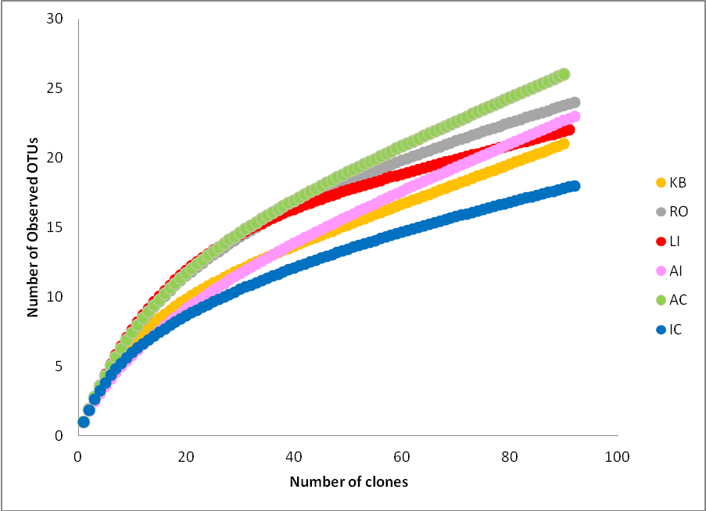
Fig S1. Rarefaction curve obtained from each clone library. The OTUs was defined based on RFLP and 97% sequence homology cutoff.

