<CL> Language Variation and Change, 28 (2016), 000–000.
© Cambridge University Press, 2016. 0954–3945/16 $16.00
doi:
<LRH> william d. raymond, esther l. brown, and alice f. healy
<RRH> cumulative context effects

<AT>Cumulative context effects and variant lexical representations: Word use and English final t/d deletion
<AU>William D. Raymond, Esther L. Brown, and Alice F. Healy
<AA>University of Colorado, Boulder

<z>online appendix a: anova of experimental data
The 1713 fluently produced nonerror target responses were analyzed in terms of proportion of deletions of -t/d segments in each target pair using two mixed factorial analyses of variance, one with subjects as the random effect (F₁) and the other with items as the random effect (F₂). The analyses included factors of paragraph (Paragraph 1, Paragraph 2), Paragraph 1 following context (Paragraph 1 consonant, Paragraph 1 vowel), Paragraph 2 following context (Paragraph 2 consonant, Paragraph 2 vowel), and list repetition (repeated, not repeated). Effects are reported only if they were significant (or marginally significant) in both subject and item analyses (with one exception). Note that the following contexts for the two paragraphs were examined separately in the analysis of variance, unlike in the generalized linear mixed-effects model.
There was a main effect of the Paragraph 2 following context, reflecting more -t/d deletion across both paragraphs in words followed by a consonant in Paragraph 2 than in words followed by a vowel in that paragraph (F₁[1, 44] = 7.57, MSE = .105, p = .009; F₂[1, 29] = 15.68, MSE = .110, p < .001). The effect of Paragraph 1 following context across both paragraphs was marginally significant in the subject analysis, but significant in the item analysis (F₁[1, 44] = 3.34, MSE = .105, p = .074; F₂[1, 29] = 12.64, MSE = .066, p = .001), again reflecting greater deletion when words were followed by a consonant in Paragraph 1 than by a vowel in that paragraph.
Although there were main effects of both paragraph contexts, interactions of paragraph and following contexts from each paragraph qualified these main effects and showed that the context effects were strictly local (although one of the item analyses was not significant). The interaction of paragraph and Paragraph 2 following context was significant in both subject and item analyses (F₁[1, 44] = 15.85, MSE = .17, p < .001; F₂[1, 29] = 11.46, MSE = .074, p = .002), reflecting greater deletion of Paragraph 2 words before second paragraph consonants than before second paragraph vowels, but no effect of Paragraph 2 following context on the deletion of the words in Paragraph 1 (see Figure A1b). The interaction of paragraph and Paragraph 1 following context was significant in the subject analysis, but not in the item analysis (F₁[1, 44] = 5.04, MSE = .017, p = .030; F₂[1, 29] = 2.36, MSE = .128, p = .135), and the pattern of results was the converse of that in the prior interaction (see Figure A1a).
There was no effect of list repetition on deletion, nor were there any first- or second-order interactions with list repetition, so there was no evidence that word repetition affected deletion status, regardless of the contexts in which the deletion occurred. {List repetition participated in one significant four-way interaction (F₁[1, 44] = 4.34, MSE = .016, p = .043; F₂[1, 29] = 4.55, MSE = .048, p = .041); this complex and unexpected interaction involved nonrepeated words and not repeated words, so it will not be fully described or discussed here.}

<z>online appendix b: data coding conventions and examples
Figures B1 through B4 show example spectrograms from the experiment data of both lexical /t/ and /d/ words realized in each of the coding categories employed to illustrate coding criteria. Figures B1a and B1c show canonical realizations of lexical /t/ as full-form [t] in C-contexts and V-contexts, respectively. The [t]s can be identified in the spectrograms as a closure with no voicing followed by a release burst and aspiration. In some instances, the burst is weak or nonexistent, but the presence of closure and of aspiration were considered sufficient to code an instance as [t]. In cases where the /t/ was followed by a consonant at a different place of articulation, there was frequently no release or aspiration, but these cases were also coded as [t] as long as the formant transitions into the closure indicated an alveolar target; in sonorant environments, a [t] identification was aided by the length of the closure and a difference in formant transitions into or out of adjacent segments. Figures B1b and B1d show canonical realization of /d/ as full form [d]. The [d]s can be identified in the spectrograms from a closure with voicing (and weak formants) followed by a release burst. As with [t]s, unreleased [d] identification may be aided by closure length and transitions in contexts that inhibit a release.
Figures B2a and B2b show realizations coded as flaps in tokens of target words with lexical /t/ and /d/, respectively. In both cases, the flap appears in the spectrogram as a very short closure (see Byrd, 1993) with (at least partial) voicing, but without a strong release burst or aspiration (see de Jong, 1998). Nasal flaps can occur in English as a reduction of intervocalic [nt] clusters, but only one token, shown in Figure B2c, occurred in the data with /nt/ realized as a nasal flap. The shorter duration and lack of a strong release burst can help to differentiate flaps from [d], although both are voiced; flaps were on average shorter (29 msec) than [d]’s (50 msec). But note that in a careful analysis of flapping, de Jong (1998) concluded that flapping is a gradient articulatory phenomenon (see also Stone & Hamlet, 1982), which led in his study to transcriber confusion between [d] and [ɾ] (flap) and, to a lesser extent, between [t] and [ɾ]. However, although categorizing [t], [d], and [ɾ] may be problematic, especially in fast speech, any confusion among these categories has no consequences for the analysis of deletion, which is the focus of the present study.
Figures B3a and B3b show tokens coded as glottalization from canonical /t/ and /d/, respectively. Glottalized realizations result from complete glottal closure or glottal constriction, causing slowed or irregular flapping of the vocal folds. As can be seen in Figures B3a and B3b, glottalizations showed somewhat weakened formant lines interrupted by irregular or widening striations (see Davidson, 2011). Realizations of -t/d as a complete glottal closure, or glottal stop, also occurred, although they were much less common than glottalization; glottal stops could be recognized by a short period with no voicing after the striations, reflecting the glottal closure. There were two phenomena of English speech patterns that complicated the identification of glottalized -t/d segments. First, glottalization is a common occurrence at the beginning of vowel-initial words in English, regardless of the preceding phonological context; an example of this phenomenon is shown in Figure B3c in a context without a -t/d (at the beginning of the word “a”). Thus, to be considered -t/d glottalization, and not just vowel-initial glottalization, the striations resulting from glottal constriction must have begun during the final sonorant segment (vowel or consonant) of the -t/d word, and not just on the initial vowel of the following word. A second complication stems from the fact that laryngealization was a common feature of many of the participants’ speech. Laryngealization also results in irregular or widely spaced glottal striations in vowels, but can be recognized by its frequent reoccurrence in vowel realizations (see Figure B3d). Thus, for a target realization to be considered, glottalization striations must not be a feature that extends across other nearby sonorants (especially vowels) not adjacent to the -t/d location. In addition to these problems, studies of transcription consistency have reported some confusion among transcribers in the labeling of realizations of -t between glottals and [t] (e.g., Raymond, 2003; Raymond, Pitt, Johnson, Hume, Makashay, Dautricourt, & Hilts, 2002); however, identification difficulties between these two categories will not affect the analyses of deletion conducted in the present study.
Segment deletions from canonical /t/ and /d/ are shown in Figure B4 for all combinations of contexts {C,V}_{C,V}. Deletions are characterized by a lack of the closure, release, and aspiration associated with canonical segments (cf. Zimmerer, Scharinger, & Reetz, 2014). There is also no interruption of the formant intensity relative to adjacent segments seen with flapping, and no indication of glottal pulsing at the point where an articulation of -t/d is expected, as with glottalization.
There are some phonetic environments that can result in attenuated or ambiguous gestures that were coded as deletions because they did not meet the criteria of any of the segment variants. Figure B5a shows a realization coded as deleted when preceded by [s]. In this example, there is a diminution of fricative intensity followed by a reintensification of frication, which can be associated with a /t/ gesture; however, there is no closure or burst at the -t location. Figure B5b shows a realization in which there is some aspiration following a preceding segment closure ([k]), but no burst, suggesting only a partial [t] gesture. Figure B5c shows an example of the target pair “gold jewelry,” which contains the neutralizing sequence /d dʒ/. Most of the neutralizing sequence pairs were coded as deleted; however, a few (4 out of 16 pairs) were coded as not deleted, because there were two separate releases, as seen in Figure B5c.
<Z>references
<REF>Byrd, Dani. (1993). 54,000 American stops. UCLA Working Paper in Phonetics 83:97–115.
Davidson, Lisa. (2011). Characteristics of stop releases in American English spontaneous speech. Speech Communications 53:1042–1058.
de Jong, Kenneth. (1998). Stress-related variation in the articulation of coda alveolar stops: Flapping revisited. Journal of Phonetics 26:283–310.
Raymond, William D. (2003). An analysis of coding consistency in the transcription of spontaneous speech from the Buckeye corpus. In K. Maekawa (ed.), Proceedings of the 1st Session of the 10th International Symposium on Spontaneous Speech: Data and Analysis. Tokyo: The National Institute for Japanese Language. 55–71.
Raymond, William D., Pitt, Mark, Johnson, Keith, Hume, Elizabeth, Makashay, Matthew, Dautricourt, Robin, & Hilts, Craig. (2002). An analysis of transcription consistency in spontaneous speech from the Buckeye corpus. Proceedings of the 7th International Conference on Spoken Language Processing ICSLP-2002:1125–1128.
Stone, Maureen, & Hamlet, Sandra. (1982). Variation in jaw and tongue gestures observed during the production of unstressed /d/s and flaps. Journal of Phonetics 10:401–415.
Zimmerer, Frank, Scharinger, Mathias, & Reetz, Henning. (2014). Phonological and morphological constraints on German /t/-deletions. Journal of Phonetics 45:64–75. </REF>

a. b.
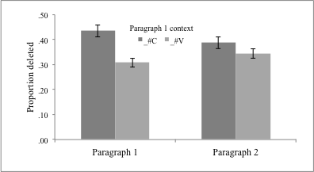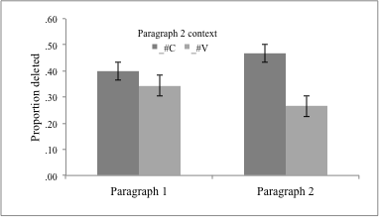
<CAPT>figure a1. Interactions of (a) paragraph by Paragraph 1 following context, and (b) paragraph by Paragraph 2 following context.
a. Canonical /t/#C- b. Canonical /d/#C-
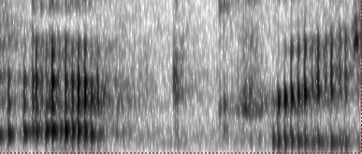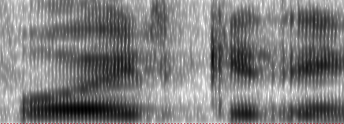
æ k t k ɹ ei z v oi d g ɪ ɾ i
“act craz[y]” “[a]void getti[ng]
c. Canonical /t/#V- d. Canonical /d/#V-
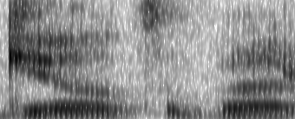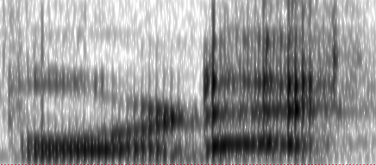
g ɪ l t ə b aʊ b o ɹ d æ k
“guilt about” “board ac[ting]”
<CAPT>figure b1. Example spectrograms of token codings of nondeleted -t/d segments realized as canonical [t] and [d].
a. Flapped /t/ b. Flapped /d/
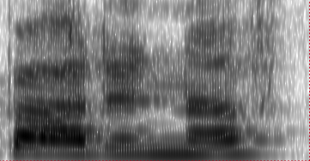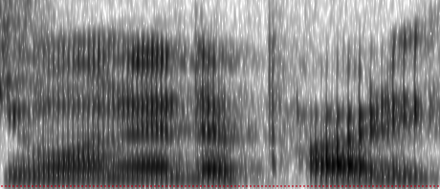
b a ɾ ɪ n ʌ f w a n ɪ ɾ ə p a ɹ i
“bought enough” “wanted a party”
c. al flapped /nt/
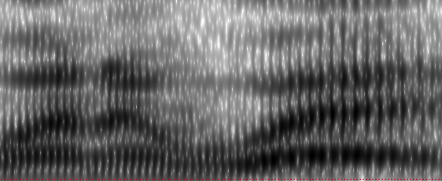
w ɛ ɾ̃ ə w e
“went away”
<CAPT>figure b2. Example spectrograms of token codings of nondeleted -t/d segments realized as flaps.
a. Glottalized /t/ b. Glottalized /d/
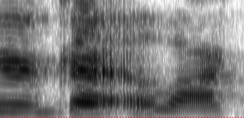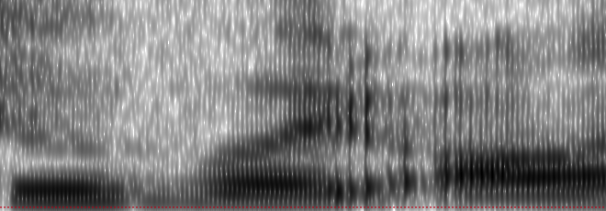
ɝ g ɹ ɛ ʔ ə l æ k t u v oi ʔ a l
“regret a lack” “to avoid all”
c. Vowel-initial glottalization d. Laryngealization of /d/
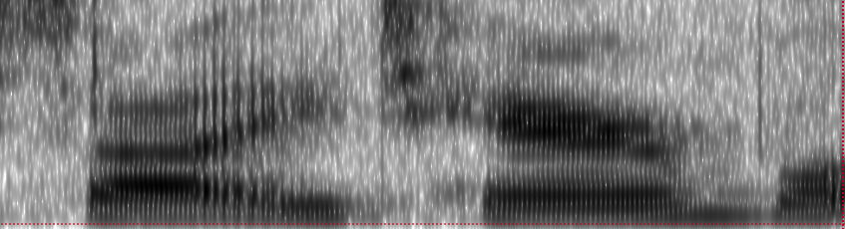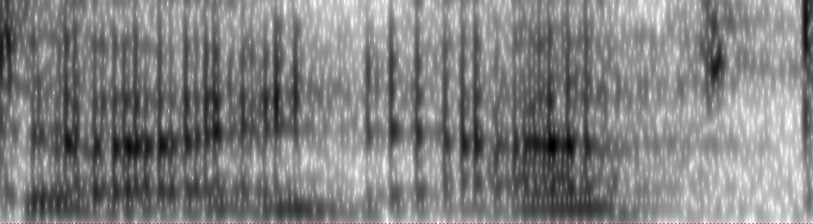
s a ʔ ʌ t ɛ ɝ b l d ai d æ f t
“saw a terrible” “died aft[er]”
<CAPT>figure b3. Example spectrograms of token codings of nondeleted -t/d segments realized with glottal constriction.
a. Deleted C/t/#C b. Deleted C/d/#C
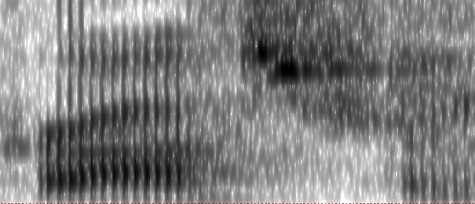
æ k ɹ ei z k ɹ a s f ɝ m
“act craz[y]” “crossed from”
c. Canonical C/t/#V- d. Canonical C/d/#V-
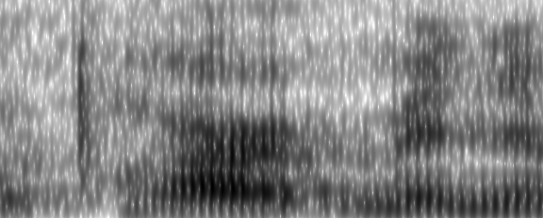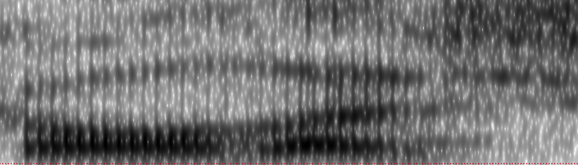
ə p a ɹ m ə n ɪ g o l aɪ s
“apartment in” “gold I s[ee]”
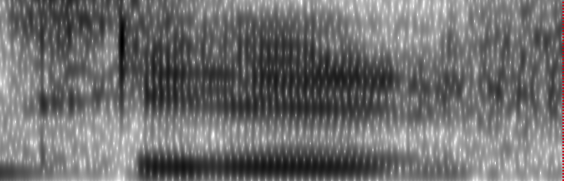
e. Deleted V/t/#C f. Deleted V/d/#C
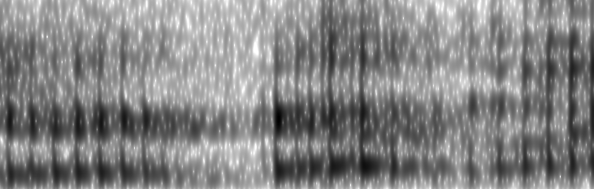
ɝ g ɹ ɛ m ə s i ɛ f
“regret my” “seated f[or]”
g. Deleted V/t/#V h. Deleted V/d/#V
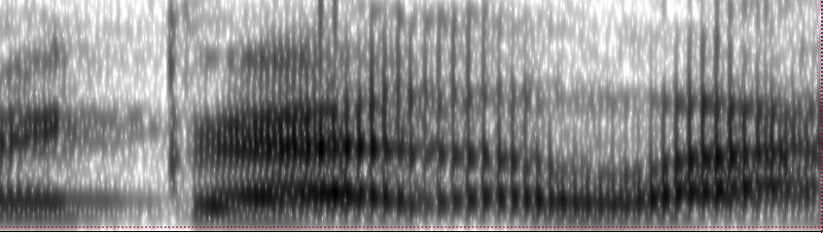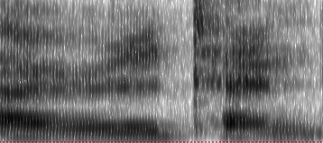
ɹ ə g ɹ ɛ ʌ l æ aɪ ɝ ɪ t ɛ n
“regret a la[ck]” “[t]ired atten[dees]”
<CAPT>figure b4. Example spectrograms of token codings of deleted -t/d segments in the four major phonological environments.
a. Deleted [s]/t/#V b. Deleted [k]/t/#j
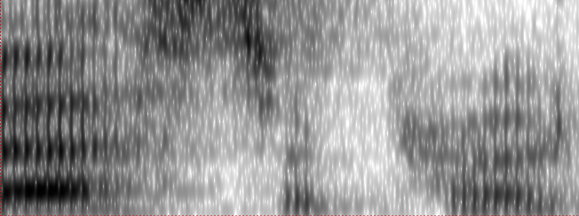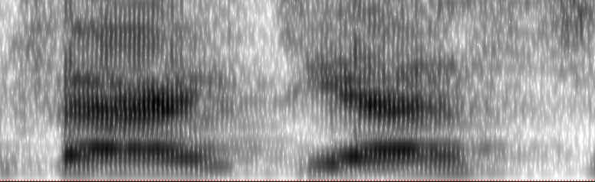
[b] ɛ s ə p ɹ o t f æ k j ɛ s
“[b]est approa[ch]” “fact yes[terday]”
c. Neutralizing /d dʒ/ as [d]
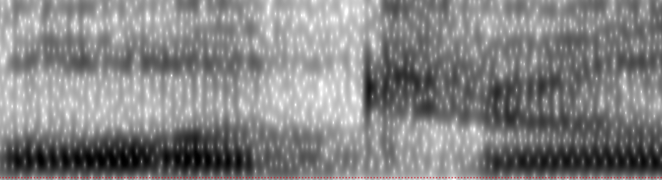
o l d dʒ ʊ l
[g]old jew[elry]”
<CAPT>figure b5. Examples of deletions and nondeletions in specific environments.

