Supplementary Materials
Pubertal Status Determination
This paper only investigated adolescents who had entered puberty. This was to ensure that the results would be interpretable within the incident risk framework of depressive symptoms, which is highest within the 14- to 17-year framework. There is also the uncertain nature of depressive symptom causality in the prepubertal years that may be different than those latent mechanisms in the postpubertal period. Therefore, the results for prepubertal participants focused on boys only (because most girls are prepubertal) are being written up in a separate paper.
There was a total of 605 girls and 509 boys within the sample before the pubertal status was determined. Pubertal status was established by combining two sources of indices. For girls, these indices were onset of menarche and self-report Tanner Pubertal Scales (Taylor, Whincup, Hindmarsh, Odoki, & Cook, 2001). Adolescent girls were only considered prepubertal and excluded if reported to have not reached menarche (n = 47) and scored 1 or 2 on both the breast development and pubic hair Tanner pictures (n = 8 of the 47). One girl who had not reached menarche was considered prepubertal because we had no Tanner assessments for this individual. Therefore, we excluded 9, leaving 596 girls in the study.
For boys, puberty was established with self-reported Tanner Pubertal Scales and morning testosterone levels (measured with salivary samples). Adolescent boys responding to the Tanner drawings have been shown to be slightly biased in terms of overreporting their pubertal development if they are behind their peers (Shirtcliff, Dahl, & Pollak, 2009). Therefore, we assigned boys as pubertal if they scored 4 or 5 on both the genital development and the pubic hair Tanner Scales. If they scored 1 or 2 on both scales they were considered prepubertal. The remainder of adolescents had mixed ratings. To determine pubertal status of these individuals we used a cutoff at the 25th percentile of testosterone for the boys who were considered pubertal (4 or 5 on both Tanner measurements). Adolescent self-reported pubertal stage has been shown to be associated with testosterone levels (Shirtcliff et al., 2009). Those who scored above the cutoff were considered pubertal and those below the cutoff were considered prepubertal. This was a good differentiating mechanism, because the combination of very little pubic hair combined with advanced genital development was found in 3% of boys of whom 93% had a testosterone level below the 25th percentile. In total, 100 or 19.57% of boys were considered prepubertal by these criteria and were excluded. Thus, 409 of the 509 boys were included in the current study.

Model Determination
The baseline path analysis model was constructed in a chronological manner. The initial model tested had all the links shown in Figure S.1. All models covaried for any episode of an affective disorder before the age of 13. For the early childhood adversity models, we also used a binary covariate that indicated whether individuals moved from a class with less adversity in early childhood to a class with more adversity in later childhood. The models investigating the effects of childhood adversities between 6 and 11 years also contained a binary covariate of whether there had been adversity (optimal vs. aberrant parenting, discordant and hazardous classes) within the first 5 years of life.
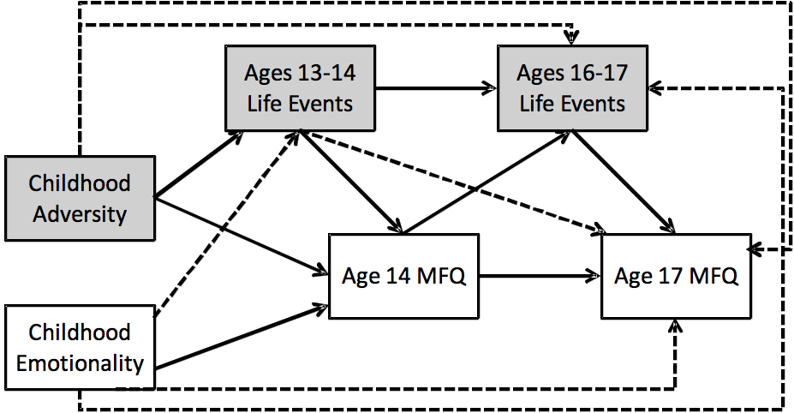
Figure S.1. The initial model linking childhood adversity, negative emotionality, age 13 to 14 and 16 to 17 life events and age 14 and 17 Moods and Feelings Questionnaire total scores. Dotted lines indicate nonsignificant paths in both genders within the early childhood adversity models.

We used the MLR estimator in MPlus to determine the final model. We used the KNOWNCLASS command to run both the boy and girl estimates within the same overall model. The full model with all links in Figure S.1 was the initial model. Where there were nonsignificant paths in both genders, we sequentially deleted paths and determined whether the relative model fit was better in the trimmed model. For both boy and girl models nonsignificant links (dotted lines) were found for (a) early adversity with age 16 life events and age 17 depression scores; (b) emotionality with ages 13 to 14 life events, ages 16 to 17 life events, and age 17 depressive symptoms; and (c) early adolescent life events to age 17 depressive symptoms. When each of these paths were sequentially deleted the subsequent Akaike information criterion and Bayesian information criterion indicated a better model fit.
We next investigated whether the final models identified above were a good fit to the observed data (rather than the relative fit compared above) using the WLSMV estimator in MPlus. The chi-square of model fit for all final models was nonsignificant (ps > .05) and the root mean square error of approximation was <0.05, the comparative fit index (CFI) was 0.99, and the Tucker–Lewis fit index (TLI) was 0.99 for the early adversity model. For the later adversity model the CFI was 0.98 and the TLI was 0.93. Overall, both models had excellent fit to the data. Modification indices indicated there were no missing paths.

Further details of analytic strategy
In order to ensure that sparse rates of life events did not unduly influence the models, we restricted the upper limit of life events to include at least 5% of the sample for each gender. For life events between age 13 and 14, all life events greater than two were recoded to be two, which accounted for 4.08% of the sample with between three and seven life events. For life events between ages 16 and 17, all life events above three were recoded to be three, which accounted for 3.82% of the sample with life events between four and eight. The life events variables were defined as ordered categorical variables.

Recent negative life events, temperament, and adversity classes
Girls reported more negative life events than boys at both ages, β = 1.16, 95% confidence interval [CI] (0.88, 1.44), p < .001 for ages 13 to 14 and β = 0.98, 95% CI (0.70, 1.26), p < .001 for ages 16 to 17). Parents reported higher levels of negative emotionality, β = 0.33, 95% CI (0.22, 0.44), p < .001, for girls compared to boys.
When looking at adversity class differences, there were no differences for boys in the mean number of reported recent life events by adversity classes in either early or later childhood. For girls, both the discordant and hazardous early childhood adversity classes had increased early and late adolescent life events when compared to the optimal class, β = 0.43, 95% CI (0.03, 0.83), p < .05, and β = 0.96, 95% CI (0.28, 1.65), p < .01, respectively, for ages 13–14 life events; β = 0.45, 95% CI (0.03, 0.87), p < .05, and β = 1.07, 95% CI (0.29, 1.85), p < .01, respectively, for ages 16–17 life events. The hazardous early childhood adversity class also had increased life events at both ages when compared to the aberrant parenting adversity class, β = 1.0, 95% CI (0.11, 1.89), p < .05 for ages 13–14 life events and β = 1.10, 95% CI (0.15, 2.06), p < .05. With the later childhood adversity, adolescent girls in the hazardous class had an increase in ages 13 to 14 life events when compared to each of the remaining adversity classes, β = 1.19, 95% CI (0.64, 1.74), p < .001, and β = 1.13, 95% CI (0.26, 1.99), p < .05, and β = 1.01, 95% CI (0.42, 1.60), p < .005, respectively, whereas the hazardous later childhood adversity class only had increased ages 16–17 life events when compared to the optimal class, β = 0.77, 95% CI (0.17, 1.38), p < .05.
For boys, there were increased levels of negative emotionality in the aberrant parenting and hazardous class when compared to the optimal class, β = 0.38, 95% CI (0.01, 0.76), p < .05, and β = 0.29, 95% CI (0.01, 0.57), p < .05, respectively. For later childhood adversity, there was only significantly increased negative emotionality in the aberrant parenting class when compared to the optimal class, β = 0.48, 95% CI (0.06, 0.89), p < .05.
For girls, there were no differences in negative emotionality for the early childhood adversity classes, but for later childhood adversity classes the aberrant parenting, discordant, and hazardous classes all had increased levels of negative emotionality when compared to the optimal class, β = 0.37, 95% CI (0.01, 0.72), p < .05, β = 0.23, 95% CI (0.07, 0.40), p < .01, and β = 0.33, 95% CI (0.03, 0.63), p < .05, respectively.

Table S.1. Means (SD) for the life events and negative emotionality for boys and girls at age 14 and 17 within each of the early and later childhood adversity classes
Adolescent Boys | Early Childhood Adversity
Age 14 | Optimal  (n = 275) | Aberrant Parenting  (n = 30) | Discordant  (n = 75) | Hazardous  (n = 29)
Life events | 0.26 (0.54) | 0.31 (0.54) | 0.35 (0.63) | 0.25 (0.59)
Negative emotionality | 1.96 (0.84) | 2.34 (1.03) | 2.12 (0.73) | 2.25 (0.72)
Age 17
Life events | 0.45 (0.77) | 0.35 (0.59) | 0.51 (0.86) | 0.87 (1.01)
 | Later Childhood Adversity
Age 14 | Optimal  (n = 243) | Aberrant Parenting  (n = 26) | Discordant  (n = 91) | Hazardous  (n = 49)
Life events | 0.27 (0.53) | 0.32 (0.56) | 0.31 (0.62) | 0.28 (0.62)
Negative emotionality | 1.95 (0.80) | 2.42 (1.05) | 2.13 (0.89) | 2.09 (0.72)
Age 17
Life events | 0.46 (0.77) | 0.33 (0.59) | 0.47 (0.82) | 0.74 (0.99)
Adolescent Girls | Early childhood adversity
Age 14 | Optimal  (n = 417) | Aberrant Parenting  (n = 41) | Discordant  (n = 110) | Hazardous  (n = 28)
Life events | 0.71 (1.05) | 0.63 (0.81) | 0.88 (1.00) | 1.25 (1.32)
Negative emotionality | 2.31 (0.86) | 2.41 (0.79) | 2.48 (0.99) | 2.58 (0.81)
Age 17
Life events | 0.95 (1.22) | 0.86 (1.00) | 1.21 (1.31) | 1.53 (0.96)
 | Later Childhood Adversity
Age 14 | Optimal  (n = 352) | Aberrant Parenting  (n = 31) | Discordant  (n = 163) | Hazardous  (n = 50)
Life events | 0.66 (0.94) | 0.68 (0.87) | 0.82 (1.19) | 1.31 (1.21)
Negative emotionality | 2.25 (0.82) | 2.62 (0.99) | 2.49 (0.90) | 2.58 (1.03)
Age 17
Life events | 0.89 (1.14) | 1.04 (1.06) | 1.17 (1.40) | 1.34 (1.20)

Negative Emotionality and Depressive Symptoms
Negative emotionality, although reported independently of the adolescent, may be a proxy marker for early depressive symptoms and therefore may not reflect a distinct construct. A partial correlation (r_{p}) for depressive symptoms was conducted that took account of the potential effects of negative emotionality. The symptom associations remained essentially the same (boys: r_{p} = 0.45, p < .001; girls: r_{p} = 0.43, p < .001). Thus, parental report of negative emotionality is very unlikely to be measuring the same construct as the adolescent self-report reported depressive symptoms.

Childhood Adversity Class Specificity
Within the models presented in the main analysis, childhood adversity was included as four classes (optimal, aberrant parenting, discordant, and hazardous), which did not allow us to understand which classes might be driving the effects found within the early childhood and later childhood adversity path analyses. We sought to answer this question by bringing out specific effects of individual classes or a combination of classes and comparing them to the results in the main article.
For early childhood adversity, we found similar findings for adolescent boys and girls when isolating the hazardous class, as well as a combination of the hazardous and discordant class. However, integration of the aberrant parenting class caused the effect of early childhood adversity to age 14 depressive symptoms to become nonsignificant, indicating that the aberrant parenting class was not contributing to the effect of early childhood adversity in both genders. We then isolated the discordant class with the hazardous class excluded entirely from the model and found the link between early childhood adversity and age 14 depressive symptoms disappeared, but we did find the effect of age 16 to 17 negative life events to age 17 depressive symptoms became significant within the discordant class in adolescent boys (p < .05).
For later childhood adversity and adolescent boys the best approximation for specific groups was the combination of the discordant and hazardous class, although this also included a significant effect to age 14 depressive symptoms. When the hazardous class alone was isolated the coefficients were strong, but the overall effects of later childhood adversity on both age 14 and 17 depressive symptoms were nonsignificant. There were no effects of later childhood adversity when the aberrant parenting class was included or when the discordant class was isolated from the hazardous class.
The situation was different for adolescent girls. When isolating the hazardous class, there was no effect from later childhood adversity to age 14 depressive symptoms, although the coefficients were strong, as in the adolescent boys model. However, when including both the discordant and hazardous classes the findings were replicated, with the exception of a marginal effect on later childhood adversity to age 13 to 14 life events (p = 0.09). In addition, inclusion of the aberrant parenting class created a model that retained the significant link between adversity and early adolescent depressive symptoms, but the link between later childhood adversity and age 13 to 14 life events disappeared. Similarly, when isolating the discordant class without the hazardous class we still found a significant link between adversity and depressive symptoms, but no effect to adolescent life events.

References
Dunn, V. J., Abbot, R. A., Croudace, T. J., Wilkinson, P., Jones, P. B., Herbert, J., et al. (2011). Profiles of family-focused adverse experiences through childhood and early adolescence: The ROOTS Project a community investigation of adolescent mental health. BMC Psychiatry, 11, 109. Available at http://www.biomedcentral.com/1471-1244X/1411/1109
Shirtcliff, E. A., Dahl, R. E., & Pollak, S. D. (2009). Pubertal development: Correspondence between hormonal and physical development. Child Development, 80, 327–337.
Taylor, S. J. C., Whincup, P. H., Hindmarsh, P. C., Odoki, K., & Cook, D. G. (2001). Performance of a new pubertal self-assessment questionnaire: a preliminary study. Paediatric and Perinatal Epidemiology, 15, 88–94.
White, E., Armstrong, B. K., & Saracci, R. (2008). The design of questionnaires. Principles of exposure measurement in epidemiology: Collecting, evaluating and improving measures of disease risk factors (2nd ed., pp. 175–212). Oxford: Oxford University Press.

