eTable 1.
Results for males vs. females for the developmental cascade model evaluating MDD symptoms in the context of interpersonal relationships (excluding romantic relationship problem variables) (N = 1,517).
Path | Males  (n = 744) | Females  (n = 762) | ΔSB χ²  (1 df)
Stability Paths

- Parent-Child Rel. Prob. 11 → Parent-Child Rel. Prob. 14 | .55*** (.05) | .53*** (.05) | .07
- Antisocial Peer Aff.11 → Antisocial Peer Aff. 14 | .34*** (.05) | .30*** (.05) | .31
- MDD 11 → MDD 14 | .28*** (.07) | .04 (.06) | 8.01**
- Parent-Child Rel. Prob. 14 → Parent-Child Rel. Prob.17 | .61*** (.05) | .44*** (.05) | 6.07*
- Antisocial Peer Aff. 14 → Antisocial Peer Aff. 17 | .63*** (.04) | .43*** (.05) | 11.11***
- MDD 14 → MDD 17 | .10 (.08) | .34*** (.08) | 4.95*
- Antisocial Peer Aff. 17 → Antisocial Peer Aff. 20 | 1.94*** (.15) | 2.06*** (.17) | .26
- MDD 17 → MDD 20 | .40*** (.10) | .26*** (.05) | 1.69
- Antisocial Peer Aff. 20 → Antisocial Peer Aff. 24 | .65*** (.03) | .53*** (.04) | 6.67**
- MDD 20 → MDD 24 | .32*** (.06) | .37*** (.06) | .32
- Antisocial Peer Aff. 24 → Antisocial Peer Aff. 29 | .49*** (.03) | .43*** (.03) | 2.24
- MDD 24 → MDD 29 | .30*** (.06) | .39*** (.05) | 1.41
Cross-Paths

- MDD 11 → Parent-Child Rel. Prob. 14 | 1.84 (2.36) | -2.84 (2.74) | 1.70
- Parent-Child Rel. Prob. 11 → MDD 14 | .002* (.001) | .002* (.001) | .16
- MDD11 → Antisocial Peer Aff. 14 | .10 (.20) | -.02 (.25) | .13
- Antisocial Peer Aff. 11 → MDD 14 | -.00 (.01) | .01 (.01) | 1.15
5. Antisocial Peer Aff. 11 → Parent-Child Rel. Prob. 14 | .40 (.59) | 1.48** (.55) | 2.02
- Parent-Child Rel. Prob. 11 → Antisocial Peer Aff. 14 | .01* (.005) | .01* (.005) | .00
- MDD 14 → Parent-Child Rel. Prob. 17 | 4.57 (3.24) | -1.76 (2.29) | 3.09
- Parent-Child Rel. Prob. 14 → MDD 17 | .00 (.00) | .00 (.00) | .00
9. MDD 14 → Antisocial Peer Aff. 17 | -.34 (.19) | -.09 (.17) | .91
- Antisocial Peer Aff. 14 → MDD 17 | .02 (.01) | .02 (.02) | .18
- Antisocial Peer Aff. 14 → Parent-Child Rel. Prob. 17 | .50 (.47) | -.40 (.64) | 1.32
- Parent-Child Rel. Prob. 14 → Antisocial Peer Aff. 17 | .01* (.004) | .01** (.003) | .09
- Parent-Child Rel. Prob. 17 → MDD 20 | .00 (.00) | .00 (.01) | .05
14. MDD 17 → Antisocial Peer Aff. 20 | -.46 (.60) | .05 (.41) | .49
15. Antisocial Peer Aff. 17 → MDD 20 | .01 (.01) | .02 (.02) | .39
16. Parent-Child Rel. Prob. 17 → Antisocial Peer Aff. 20 | .03* (.01) | .02 (.01) | .38
17. MDD 20 → Antisocial Peer Aff. 24 | .77 (.42) | .95** (.35) | .12
18. Antisocial Peer Aff. 20 → MDD 24 | .007* (.003) | .01 (.00) | .07
- MDD 24 → Antisocial Peer Aff. 29 | .53 (.34) | .31 (.26) | .26
- Antisocial Peer Aff. 24 → MDD 29 | .01* (.003) | .00 (.01) | 2.09
Residual Correlations

1. Parent-Child Rel. Prob. 11 ↔ MDD 11 | .09 (.09) | .10 (.07) | .02
2. Parent-Child Rel. Prob. 11 ↔ Antisocial Peer Aff. 11 | 1.86* (.86) | 1.42*** (.31) | .23
3. MDD 11 ↔ Antisocial Peer Aff. 11 | .01 (.01) | .01* (.01) | .20
4. Parent-Child Rel. Prob. 14 ↔ MDD 14 | .09 (.09) | .25* (.12) | 1.08
5. Parent-Child Rel. Prob. 14 ↔ Antisocial Peer Aff. 14 | 1.57** (.47) | 3.31*** (.54) | 7.24**
6. MDD 14 ↔ Antisocial Peer Aff. 14 | .03** (.01) | .03* (.01) | .15
7. Parent-Child Rel. Prob. 17 ↔ MDD 17 | .02 (.13) | .31* (.14) | 2.08
8. Parent-Child Rel. Prob. 17 ↔ Antisocial Peer Aff. 17 | 1.70*** (.43) | 1.00** (.35) | 1.55
9. MDD 17 ↔ Antisocial Peer Aff. 17 | .01 (.01) | .01 (.01) | .02
10. MDD 20 ↔ Antisocial Peer Aff. 20 | .09* (.02) | .04 (.03) | 1.21
11. MDD 24 ↔ Antisocial Peer Aff. 24 | .05 (.03) | .06 (.04) | .03
12. MDD 29 ↔ Antisocial Peer Aff. 29 | -.01 (.02) | .06** (.02) | 5.13*
Notes. Parent-Child Rel. Prob = Parent-Child Relationship Problems, Antisocial Peer Aff. = Antisocial Peer Affiliation, Rom. Rel. Problems = Romantic Relationship Problems, MDD = log-transformed MDD symptom count. Showing unstandardized coefficients (standard errors) for associated stability and cross-paths. Model fit statistics for this model that allowed all paths to vary by gender were as follows: χ² (122) = 345.68, p < .001; RMSEA = .05, p = .58; CFI = .92; TLI = .87; SRMR = .06 (standardized coefficients are presented in Figure 3 in the main manuscript). Significant differences in unstandardized coefficients for corresponding paths by gender were tested by constraining each path to be equivalent and using the Satorra-Bentler Chi-Square Difference Test (ΔSB χ² on 1 df) to test for significant decrement in fit between the free and constrained models. Results showed no statistically significant differences in any of the cross-paths by gender at p < .05. The only significant differences found concerned stability paths and none of these differences reached statistical significance when correcting the alpha for multiple testing by gender (.05/44 paths tested (12 stability tests + 20 cross-paths + 12 residual correlations) would require p < .001), except for the path Antisocial Peer Aff. 14 → Antisocial Peer Aff. 17 (see row 5), which was significantly more stable for males than females.
Statistical significance is denoted by ***p < .001, **p < .01, *p < .05. Coefficients that are not significantly different zero are indicated in gray.
eTable 2.
Results for those in a romantic relationship vs. not in a romantic relationship by age 29 for the
developmental cascade model evaluating MDD symptoms in the context of interpersonal relationships (excluding romantic relationship problem variables) (N = 1,517).
Path | No Relationship  (n = 390) | Relationship (n = 1,127) | ΔSB χ²  (1 df)
Stability Paths

- Parent-Child Rel. Prob. 11 → Parent-Child Rel. Prob. 14 | .42*** (.07) | .56*** (.04) | 3.45
- Antisocial Peer Aff.11 → Antisocial Peer Aff. 14 | .37*** (.06) | .33*** (.05) | .36
- MDD 11 → MDD 14 | .25* (.10) | .14** (.05) | 1.18
- Parent-Child Rel. Prob. 14 → Parent-Child Rel. Prob.17 | .53*** (.08) | .52*** (.04) | .03
- Antisocial Peer Aff. 14 → Antisocial Peer Aff. 17 | .67*** (.07) | .53*** (.04) | 3.18
- MDD 14 → MDD 17 | .18 (.12) | .27*** (.07) | .42
- Antisocial Peer Aff. 17 → Antisocial Peer Aff. 20 | 1.97*** (.22) | 2.17*** (.13) | .64
- MDD 17 → MDD 20 | .32** (.10) | .29*** (.05) | .07
- Antisocial Peer Aff. 20 → Antisocial Peer Aff. 24 | .67*** (.05) | .62*** (.02) | 1.05
- MDD 20 → MDD 24 | .36*** (.09) | .35*** (.05) | .02
- Antisocial Peer Aff. 24 → Antisocial Peer Aff. 29 | .53*** (.04) | .48*** (.02) | 1.53
- MDD 24 → MDD 29 | .39*** (.08) | .36*** (.04) | .10
Cross-Paths

- MDD 11 → Parent-Child Rel. Prob. 14 | -1.83 (3.23) | .34 (2.15) | .33
- Parent-Child Rel. Prob. 11 → MDD 14 | .00 (.00) | .002* (.001) | .09
- MDD11 → Antisocial Peer Aff. 14 | .22 (.26) | -.07 (.18) | 1.04
- Antisocial Peer Aff. 11 → MDD 14 | -.01 (.01) | .01 (.01) | .45
5. Antisocial Peer Aff. 11 → Parent-Child Rel. Prob. 14 | .48 (.68) | .74 (.48) | .13
6. Parent-Child Rel. Prob. 11 → Antisocial Peer Aff. 14 | .01* (.006) | .02*** (.004) | .14
- MDD 14 → Parent-Child Rel. Prob. 17 | 2.77 (3.78) | -.42 (2.29) | .54
- Parent-Child Rel. Prob. 14 → MDD 17 | .00 (.00) | .00 (.00) | .82
8. MDD 14 → Antisocial Peer Aff. 17 | -.53 (.35) | -.14 (.14) | 1.21
- Antisocial Peer Aff. 14 → MDD 17 | -.00 (.02) | .02 (.01) | .86
- Antisocial Peer Aff. 14 → Parent-Child Rel. Prob. 17 | .39 (.73) | .18 (.44) | .08
- Parent-Child Rel. Prob. 14 → Antisocial Peer Aff. 17 | .01 (.01) | .01*** (.003) | .45
- Parent-Child Rel. Prob. 17 → MDD 20 | .00 (.00) | .002* (.001) | .06
14. MDD 17 → Antisocial Peer Aff. 20 | -.67 (.58) | -.36 (.40) | .24
15. Antisocial Peer Aff. 17 → MDD 20 | .02 (.02) | .01 (.01) | .25
16. Parent-Child Rel. Prob. 17 → Antisocial Peer Aff. 20 | .03 (.02) | .03** (.01) | .01
17. MDD 20 → Antisocial Peer Aff. 24 | .33 (.62) | .77* (.32) | .41
18. Antisocial Peer Aff. 20 → MDD 24 | .01 (.01) | .00 (.00) | .43
- MDD 24 → Antisocial Peer Aff. 29 | .16 (.41) | .29 (.23) | .10
- Antisocial Peer Aff. 24 → MDD 29 | .00 (.01) | .00 (.00) | .00
Residual Correlations

1. Parent-Child Rel. Prob. 11 ↔ MDD 11 | .04 (.13) | .11 (.06) | .23
2. Parent-Child Rel. Prob. 11 ↔ Antisocial Peer Aff. 11 | 1.01 (.68) | 2.23*** (.50) | 1.87
3. MDD 11 ↔ Antisocial Peer Aff. 11 | .00 (.01) | .02* (.01) | 1.21
4. Parent-Child Rel. Prob. 14 ↔ MDD 14 | .22 (.12) | .17 (.09) | .09
5. Parent-Child Rel. Prob. 14 ↔ Antisocial Peer Aff. 14 | 2.22*** (.61) | 2.47*** (.42) | .11
6. MDD 14 ↔ Antisocial Peer Aff. 14 | .03* (.01) | .03*** (.01) | .05
7. Parent-Child Rel. Prob. 17 ↔ MDD 17 | .20 (.26) | .08 (.09) | .20
8. Parent-Child Rel. Prob. 17 ↔ Antisocial Peer Aff. 17 | 1.80** (.65) | 1.39*** (.29) | .33
9. MDD 17 ↔ Antisocial Peer Aff. 17 | .01 (.01) | .00 (.01) | .62
10. MDD 20 ↔ Antisocial Peer Aff. 20 | .10 (.06) | .05 (.03) | .77
11. MDD 24 ↔ Antisocial Peer Aff. 24 | -.02 (.06) | .05 (.03) | 1.25
12. MDD 29 ↔ Antisocial Peer Aff. 29 | .03 (.04) | .02 (.02) | .06
Notes. Parent-Child Rel. Prob = Parent-Child Relationship Problems, Antisocial Peer Aff. = Antisocial Peer Affiliation, Rom. Rel. Problems = Romantic Relationship Problems, MDD = log-transformed MDD symptom count. Showing unstandardized coefficients (standard errors) for associated stability and cross-paths. Model fit statistics for this model that allowed all paths to vary by involvement vs. no involvement in a romantic relationship were as follows: χ² (122) = 375.652, p < .001; RMSEA = .05, p = .25; CFI = .92; TLI = .87; SRMR = .06. Significant differences in unstandardized coefficients for corresponding paths by romantic relationship status were tested by constraining each path to be equivalent and using the Satorra-Bentler Chi-Square Difference Test (ΔSB χ² on 1 df) to test for significant decrement in fit between the free and constrained models. Results showed no statistically significant differences in any of the stability, cross-paths, or residual correlations by romantic relationship status at p < .05.
Statistical significance is denoted by ***p < .001, **p < .01, *p < .05. Coefficients that are not significantly different zero are indicated in gray.
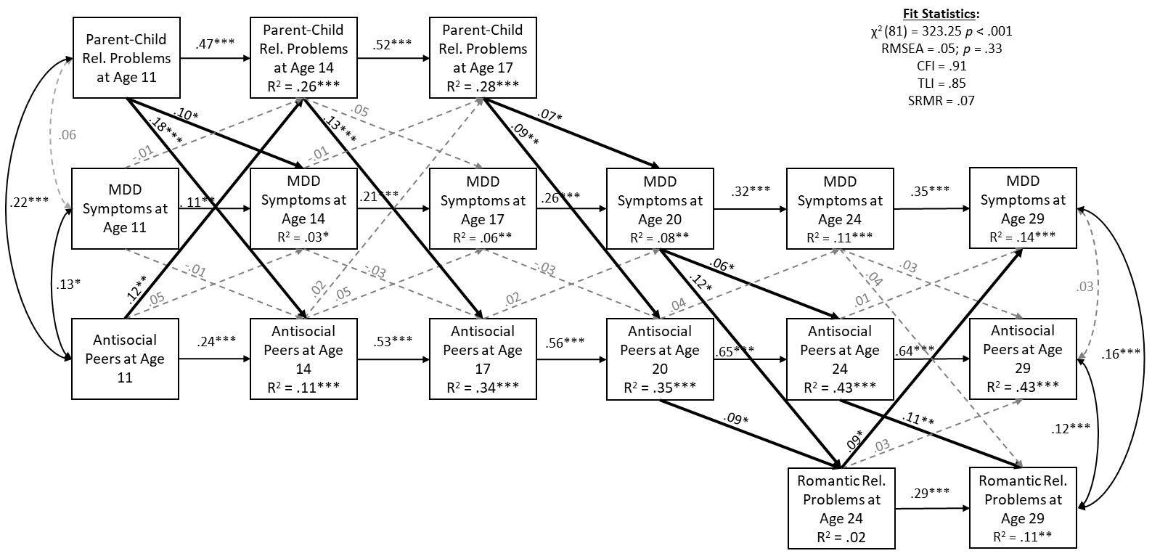
eFigure 1. Developmental cascade model evaluating Major Depressive Disorder (MDD) symptoms in the context of interpersonal relationships from early adolescence through young adulthood: Using child-report of antisocial peer affiliation at age 11 (N = 1,127). This figure shows standardized coefficients from the full developmental cascade model for males and females involved in a romantic relationship by age 29, however, only child-report of antisocial peer affiliation at 11 was used instead of the average of the standardized self- and teacher- reports reported in the manuscript (Figure 2). The only difference from Figure 2 was there was evidence for significant bi-directionality in the prospective associations between parent-child relationship problems at antisocial peer affiliation from ages 11 to 14; whereas in Figure 2, only parent-child relationship problems at age 11 significantly predicted antisocial peer affiliation at age 14. Note: only females were given this measure at the age 11 assessment so cannot test for gender differences without excluding this variable from the model. Residual correlations are included at each time point but are not shown at ages 14, 17, 20, and 24 for clarity of presentation: at age 14, the residual correlation between parent-child relationship problems and MDD symptoms was not significant (r = .08, p = .06); however, the correlation between parent-child relationship problems and antisocial peer affiliation was (r = .26, p < .001), as was the correlation between MDD symptoms and antisocial peer affiliation (r = .16, p < .001). At age 17, the residual correlation between parent-child relationship problems and MDD symptoms was not significant (r = .03, p = .38), neither was the residual correlation between MDD symptoms and antisocial peer affiliation (r = .01, p = .69). However, the residual correlation between parent-child relationship problems and antisocial peer affiliation at age 17 was significant (r = .18, p < .001). At age 20, the residual correlation between MDD symptoms and antisocial peer affiliation was not significantly different than zero (r = .06, p = .10). At age 24, the residual correlation between MDD symptoms and antisocial peer affiliation was not significant from zero (r = .07, p = .05), neither was the residual correlation between MDD symptoms and romantic relationship problems (r = .07, p = .11); however, the residual correlation between antisocial peer affiliation and romantic relationship problems at age 24 was (r = .17, p < .001).
For clarity, paths that are not significantly different from zero (p > .05) are dashed and shown in gray. Cross-paths that are significantly differenct from zero are in bolded black. Statistical significance is denoted by ***p < .001, **p < .01, *p < .05.
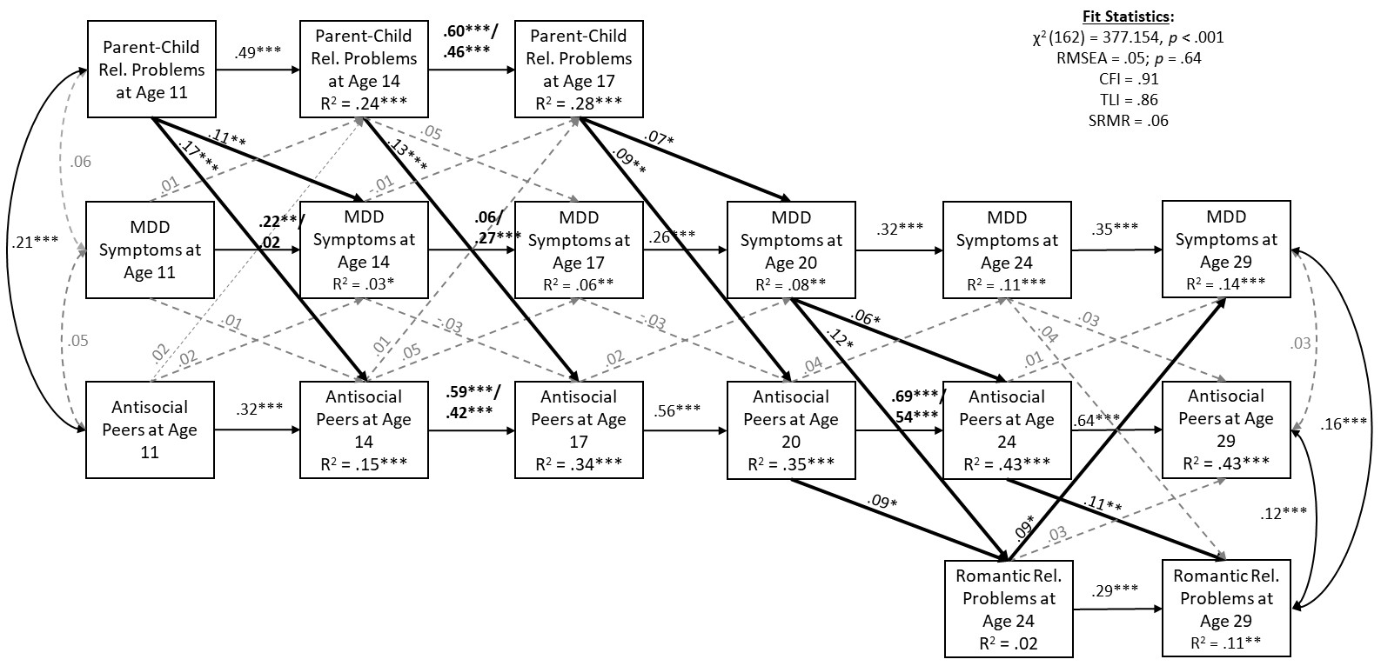
eFigure 2. Developmental cascade model evaluating Major Depressive Disorder (MDD) symptoms in the context of interpersonal relationships from early adolescence through young adulthood: Using teacher report of antisocial peer affiliation at age 11 (N = 1,127). This figure shows standardized coefficients from the full developmental cascade model for males and females involved in a romantic relationship by age 29, however, only teacher-report of antisocial peer affiliation at 11 was used instead of the average of the standardized self- and teacher- reports reported in the manuscript (Figure 2). Results that significantly varied by gender are shown in bold, results shown before the slash are those for males and after the slash are those for females. Coefficients that were not significantly different by gender were replaced with standardized coefficients from the model that evaluated for results for the entire sample (fit statistics for that model: χ² (81) = 321.39, p < .001; RMSEA = .05, p = .35; CFI = .91; TLI = .85; SRMR = .06; R² shown also refer to those from the model using the entire sample). There were no notable differences from Figure 2, other than the residual correlation between antisocial peer affiliation at age 11 and MDD symptoms at age 11 was not significantly different than zero (in Figure 2, r = .10, p = .04). No significant gender differences were found for the paths involving antisocial peer affiliation at age 11. Residual correlations are included at each time point but are not shown at ages 14, 17, 20, and 24 for clarity of presentation (none were significantly different across gender): At age 14, the residual correlation between parent-child relationship problems and MDD symptoms was significant (r = .09, p = .04), as was the residual correlation between parent-child relationship problems and antisocial peer affiliation was (r = .30, p < .001) and the residual correlation between MDD symptoms and antisocial peer affiliation (r = .17, p < .001). At age 17, the residual correlation between parent-child relationship problems and MDD symptoms was not significant (r = .03, p = .37), neither was the residual correlation between MDD symptoms and antisocial peer affiliation (r = .01, p = .69). However, the residual correlation between parent-child relationship problems and antisocial peer affiliation at age 17 was significant (r = .18, p < .001). At age 20, the residual correlation between MDD symptoms and antisocial peer affiliation was not significantly different than zero (r = .06, p = .10). At age 24, the residual correlation between MDD symptoms and antisocial peer affiliation was not significant from zero (r = .07, p = .05), neither was the residual correlation between MDD symptoms and romantic relationship problems (r = .07, p = .11); however, the residual correlation between antisocial peer affiliation and romantic relationship problems at age 24 was (r = .17, p < .001).
For clarity, paths that are not significantly different from zero (p > .05) are dashed and shown in gray. Cross-paths that are significantly differenct from zero are in bolded black. Statistical significance is denoted by ***p < .001, **p < .01, *p < .05.

