Appendices
Appendix 1: Analyses of Effect of Intervention Condition
Analytic Strategy
We controlled for intervention condition in all analyses. Whenever the intervention condition was a significant predictor of the dependent variable, we investigated differences in hypothesized relations by estimating multiple group models in which paths were estimated freely across intervention and control conditions, and compared these models with fully constrained models using Satorra-Bentler scaled Chi-squared difference tests. When these tests are significant, this means that there are differences in the model estimates across intervention groups and the best-fitting model is the one in which paths are estimated freely across these groups.
Results
In the bidirectional direct effects model (Figure 2 in main text), intervention condition had a significant effect on the random intercept of victimization. However, effects did not differ for intervention condition groups, as constraining model estimates to be equivalent for intervention and control conditions did not significantly worsen model fit, χ² (8) = 12.2, p = .14. In the indirect effects models, both the one based on self-reported victimization (Figure 3 in main text) and the one based on the peer nomination strategy of peer victimization (Figure A1), intervention condition did not have a significant effect on any of the outcomes. Further, constraining model estimates to be equivalent for intervention and control conditions did not significantly worsen model fit: for the self-report model, χ² (24) = 20.0, p = .70, and for the peer nomination model, χ² (24) = 19.2, p = .74.

Appendix 2: Sensitivity analyses for conduct problems (T4 mediated)
The results of regression analyses supported the finding that conduct problems significantly mediated the effect of peer victimization on parental rejection and warmth (for rejection, b = .010; 95%CI[.007,.014], for warmth, b = -.012; 95%CI[-.015,-.008]). Peer victimization (T2) predicted higher levels of conduct problems (T4; β = .15), which in turn predicted higher levels of parental rejection (T5; β = .10, p < .001) and lower levels of parental warmth (T5; β = -.10, p < .001). Gender significantly predicted parent-child relationships at T4, but Satorra-Bentler comparisons of model fit to test showed that constraints across sex did not significantly worsen model fit (χ² (2) = 4.3, p = .12). The intervention condition did not predict any of the outcomes.

Appendix 3: Robustness check using peer-reported victimization
As a robustness check, we analyzed the mediation model using a peer victimization measure that was based on asking all students who indicated that they had bullied classmates at least once/twice, to nominate the classmates they bullied (“Who do you bully?”). For each student, received nominations were summed and divided by the number of participating classmates, resulting in proportion scores for victimization (0–1).
The indirect effects model (Figure A1, see Figure A4 for unstandardized effects) included reciprocal relationships from parental warmth and rejection at T2 to maladjustment symptoms at T3 (except for conduct problems, which were assessed at T2) and to peer victimization at T4, and vice versa. The model showed an excellent fit (CFI = .97, TLI = .92, RMSEA = .03, 90%CI[.03;.03]). Regarding parents-to-peers effects, parent-child relationships predicted all maladjustment symptoms, and only bullying perpetration in turn predicted peer victimization. The results of the indirect effects analyses also showed that bullying perpetration mediated the effects of parental warmth on peer victimization (b = -.002; 95%CI[-.004,-.001]).
Regarding the peers-to-parents indirect effects, peer victimization predicted all maladjustment symptoms, which all predicted higher rejection and lower warmth in parent-child relationships. The results of indirect effects analyses showed that most indirect effects were significant: for social anxiety, rejection (b = .001; 95%CI[.00,.003]) but not warmth; for the other maladjustment symptoms, both rejection (depressive symptoms, b = .006; 95%CI[.003,.008], conduct problems, b = .005; 95%CI[.002,.008], bullying perpetration, b .006; 95%CI[.002,.009]) and warmth (depressive symptoms, b = -.006; 95%CI[-.009,-.003], conduct problems, b = -.006; 95%CI[-.009,-.002], bullying perpetration, b = -.008; 95%CI[-.012,-.003]). Gender predicted parent-child relationships, and constraints across boys and girls worsened model fit to some extent, χ2 (24) = 44.8, p = .01. Gender was retained as a control variable to compare the outcomes with the model reported on in the main text.
The results of the model using peer-reported victimization were thus overall comparable with those obtained using the self-reported peer victimization measure (see findings reported in the main text), supporting the robustness of the findings across child and peer informants.
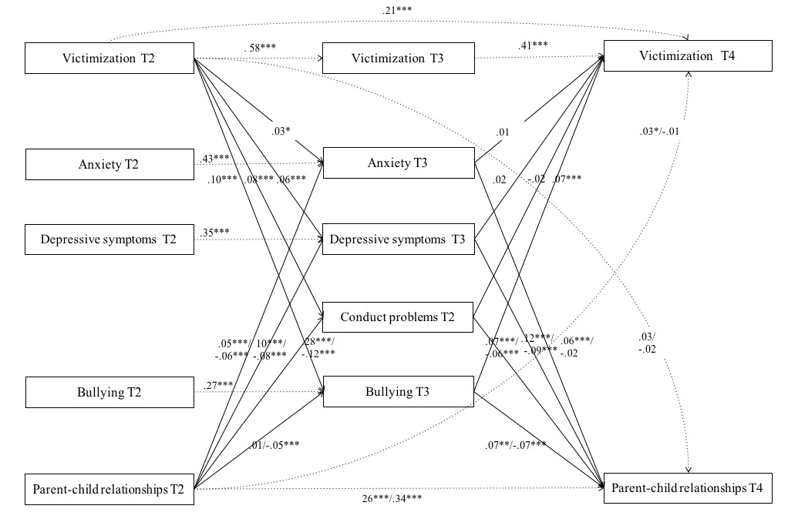
Figure A1. Indirect Effects as Mediators Explaining Spillover Effects between Parent-Child Relationships and Peer-Reported Victimization.
Note. Numbers before the slash represent parental rejection and after the slash represent parental warmth. The model was controlled for gender and intervention condition. Concurrent associations were estimated but are not shown here.
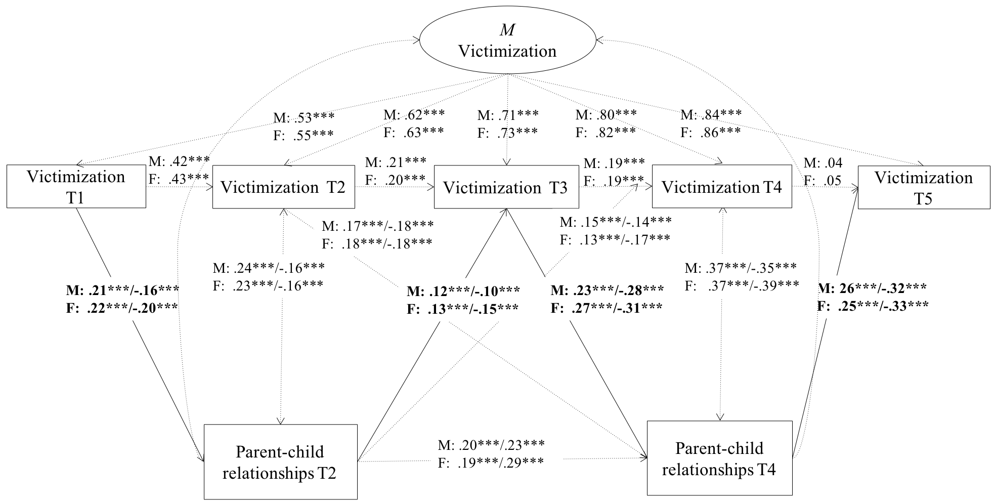
Figure A2. For Mothers (M) and Fathers (F) Separately: Direct Effects between Parent-Child Relationships and Victimization.
Note. T = Time. Standardized associations between parent-child relationships and victimization are shown. Numbers before the slash represent parental rejection and after the slash represent parental warmth. The indirect effects are in bold. The model was controlled for gender and intervention condition. *** p < .001.

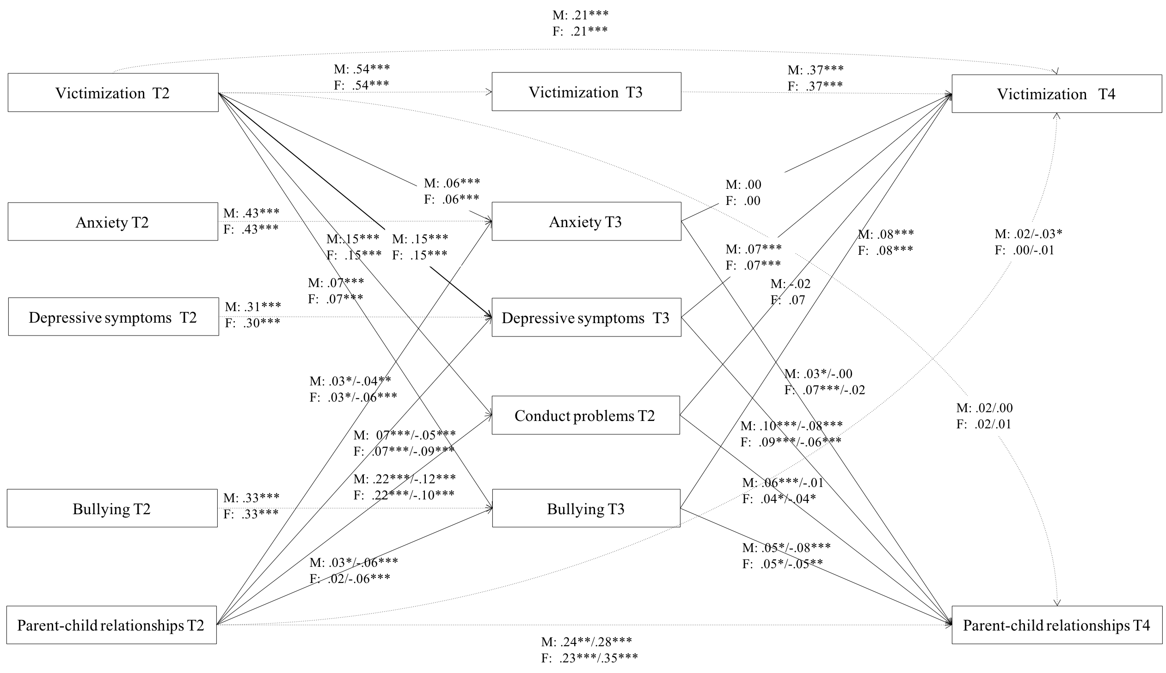
Figure A3. For Mothers (M) and Fathers (F) Separately, Indirect Effects between Parent-Child Relationships and Victimization.
Note. Numbers before the slash represent parental rejection and after the slash represent parental warmth. The model was controlled for gender and intervention condition. Concurrent associations were estimated but are not shown here. The results were similar across mothers and fathers, with the exception that the effect of peer victimization on lower parental warmth through conduct problems was significant for fathers (b = .006, p = .04; 95%CI[-.011,.001]), and not for mothers (b = -.002, p = .43, 95%CI[-.006,.003]).
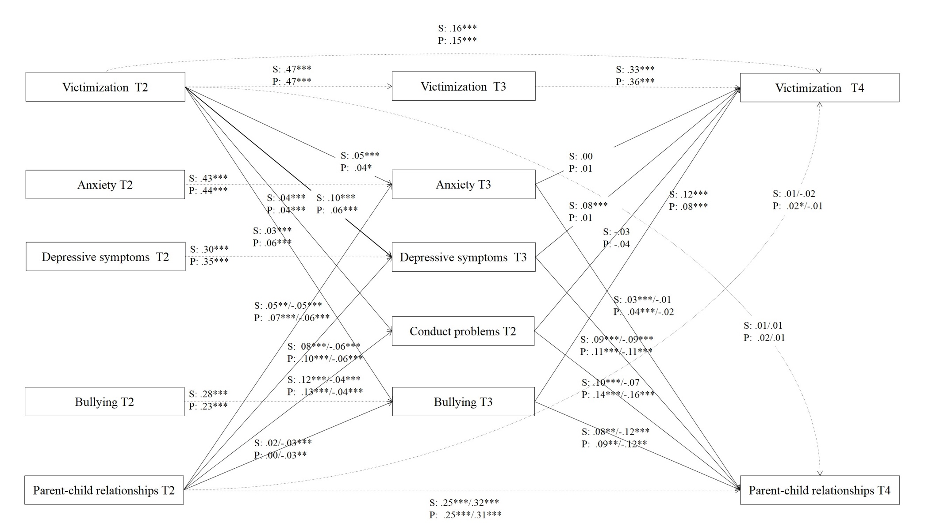Figure A4. For Self-reported (S) and Peer-reported (P) Victimization Separately, Unstandardized Indirect Effects between Parent-Child Relationships and Peer Victimization.
Note. Numbers before the slash represent parental rejection and after the slash represent parental warmth. The model was controlled for gender and intervention condition.

