Table S1. Means, standard deviations, and associations among key variables
 | 1 | 2 | 3 | 4 | 5 | 6 | 7 | 8 | 9 | 10 | 11 | 12 | 13 | 14 | 15 | 16 | 17 | 18 | 19 | 20 | 21 | 22 | M | SD
1.RSAspeech |  | -0.14 | -0.11 | -0.08 | 0.57*** | 0.03 | -0.09 | -0.09 | 0.11 | 0.05 | -0.15 | 0.06 | 0.08 | -0.08 | 0.23* | -0.18 | -0.04 | 0.14 | -0.54*** | -0.20 | -0.15 | 0.25* | 0.16 | 1.13
2.EDAspeech | 0.10 |  | -0.10 | 0.52*** | -0.11 | -0.02 | -0.01 | -0.11 | -0.11 | -0.15 | -0.16 | 0.23* | -0.15 | 0.04 | -0.13 | 0.23* | -0.23* | -0.29** | 0.04 | 0.12 | -0.03 | -0.18 | 4.70 | 1.76
3.EpiStrs | 0.03 | 0.02 |  | -0.11 | -0.22* | 0.36** | 0.30** | 0.31** | -0.04 | 0.51*** | 0.31** | -0.48*** | 0.47*** | 0.03 | 0.27* | -0.13 | 0.13 | 0.22* | -0.09 | -0.36** | -0.03 | -0.30** | 2.75 | 1.88
4.EDAprep | -0.09 | 0.37** | 0.16 |  | -0.13 | -0.12 | -0.01 | -0.20 | -0.11 | -0.15 | -0.24* | 0.03 | -0.24* | 0.01 | -0.23* | 0.30** | -0.06 | -0.27* | 0.21 | 0.12 | 0.00 | -0.04 | 2.99 | 1.86
5.RSAprep | 0.71*** | 0.22 | 0.03 | -0.04 |  | 0.01 | -0.06 | -0.10 | 0.13 | -0.14 | -0.18 | 0.19 | -0.11 | 0.04 | 0.17 | 0.08 | 0.02 | 0.12 | -0.34** | -0.16 | -0.15 | 0.14 | 0.04 | 1.03
6.StateAnx | 0.15 | -0.05 | 0.14 | -0.18 | 0.23 |  | 0.32* | 0.26* | 0.13 | 0.52*** | 0.50*** | -0.51*** | 0.73*** | 0.03 | 0.55*** | -0.04 | -0.01 | 0.45*** | -0.20 | -0.40** | -0.05 | -0.25* | 36.64 | 13.58
7.PrgnAnx | 0.01 | 0.13 | 0.05 | 0.03 | 0.11 | 0.33* |  | 0.2 | -0.02 | 0.14 | 0.19 | -0.28* | 0.38** | -0.02 | 0.23* | 0.07 | -0.01 | 0.36*** | 0.05 | -0.31** | -0.03 | -0.24* | 18.64 | 5.02
8.ChildTrauma | 0.11 | 0.03 | 0.23 | -0.02 | 0.09 | 0.29* | 0.13 |  | 0.20 | 0.37** | 0.53*** | -0.33** | 0.34** | -0.11 | 0.31** | -0.12 | 0.01 | 0.24* | -0.11 | -0.16 | -0.02 | -0.33** | 3.52 | 0.30
9.HairCort | -0.02 | -0.08 | 0.18 | -0.16 | 0.03 | 0.18 | -0.06 | 0.26* |  | -0.01 | 0.21 | -0.10 | 0.13 | 0.12 | 0.15 | -0.08 | 0.07 | 0.28* | -0.09 | -0.02 | -0.05 | 0.00 | 1.31 | 0.73
10.EcoHard | 0.07 | 0.14 | 0.37** | -0.02 | 0.15 | 0.38** | 0.17 | 0.40*** | 0.31* |  | 0.57*** | -0.73*** | 0.59*** | -0.10 | 0.27* | 0.02 | -0.06 | 0.11 | -0.21 | -0.17 | 0.03 | -0.06 | 0.06 | 2.95
11.ChrStrs | -0.02 | -0.02 | 0.37** | 0.13 | -0.05 | 0.35* | 0.03 | 0.36** | 0.14 | 0.41*** |  | -0.58*** | 0.62*** | -0.08 | 0.38*** | 0.00 | -0.11 | 0.37*** | -0.18 | -0.32** | 0.01 | -0.20 | 2.36 | 0.42
12.FamRsrc | -0.05 | 0.06 | -0.35** | 0.20 | -0.11 | -0.53*** | -0.13 | -0.32** | -0.28* | -0.64*** | -0.47*** |  | -0.73*** | 0.11 | -0.24* | 0.01 | -0.09 | -0.32** | 0.20 | 0.17 | -0.18 | 0.22* | 122.23 | 20.90
13.DailyStr | 0.11 | 0.04 | 0.39** | 0.02 | -0.03 | 0.22 | 0.32** | 0.31** | 0.16 | 0.49*** | 0.38** | -0.48*** |  | 0.04 | 0.45*** | -0.04 | 0.10 | 0.48*** | -0.10 | -0.41*** | 0.06 | -0.26* | 11.32 | 9.88
14.AffctInt | 0.10 | 0.24* | 0.12 | -0.02 | 0.30* | 0.14 | 0.18 | 0.11 | 0.11 | 0.09 | -0.01 | -0.10 | 0.17 |  | 0.24* | 0.02 | -0.05 | 0.05 | 0.02 | -0.03 | -0.04 | 0.00 | 3.91 | 0.51
15.Impulsive | 0.01 | 0.17 | 0.14 | -0.09 | 0.13 | 0.56*** | 0.37** | 0.29* | 0.05 | 0.11 | 0.26* | -0.35** | 0.20 | 0.34** |  | 0.06 | -0.04 | 0.55*** | -0.34** | -0.46*** | 0.01 | -0.16 | 2.12 | 0.67
16.EDAcry | 0.01 | 0.30* | 0.21 | 0.41*** | 0.06 | -0.06 | 0.13 | -0.09 | -0.04 | -0.09 | -0.13 | 0.07 | 0.11 | 0.17 | 0.01 |  | -0.05 | 0.00 | 0.12 | -0.08 | 0.04 | -0.06 | 0.85 | 1.58
17.RSAcry | 0.08 | 0.09 | 0.07 | 0.11 | 0.05 | -0.03 | -0.06 | -0.02 | -0.08 | -0.05 | 0.09 | -0.01 | 0.11 | -0.03 | -0.02 | 0.20 |  | 0.26* | 0.13 | 0.08 | 0.21 | 0.01 | -0.54 | 0.83
18.DERSstrtgy | -0.03 | 0.02 | 0.30* | -0.11 | 0.05 | 0.60*** | 0.39*** | 0.39*** | 0.05 | 0.31** | 0.28* | -0.33** | 0.50*** | 0.28* | 0.71*** | 0.06 | -0.05 |  | -0.24* | -0.59*** | -0.08 | -0.39*** | 16.63 | 7.81
19.bslnRSA | -0.62*** | 0.03 | -0.11 | -0.04 | -0.56*** | -0.22 | -0.09 | -0.15 | 0.10 | -0.04 | -0.16 | 0.09 | -0.02 | -0.10 | -0.18 | 0.00 | 0.01 | -0.07 |  | 0.25* | -0.03 | -0.07 | 5.24 | 1.01
20.Mindful | -0.04 | -0.15 | -0.40** | 0.02 | -0.10 | -0.46*** | -0.37** | -0.32** | -0.04 | -0.26* | -0.25* | 0.28* | -0.45*** | -0.29* | -0.61*** | 0.04 | 0.08 | -0.73*** | 0.07 |  | -0.24* | 0.22* | 4.10 | 0.85
21.NNNS arou | -0.16 | -0.05 | -0.28* | -0.04 | -0.05 | -0.09 | -0.19 | -0.05 | -0.10 | -0.02 | 0.08 | 0.10 | -0.17 | -0.08 | -0.10 | -0.20 | 0.05 | -0.18 | 0.21 | 0.24* |  | -0.01 | 0.03 | 0.81
22.NNNS att | 0.07 | 0.17 | 0.02 | 0.02 | 0.02 | -0.03 | 0.27* | -0.05 | -0.05 | -0.10 | -0.07 | 0.13 | 0.09 | 0.21 | 0.11 | -0.08 | 0.05 | 0.10 | -0.15 | -0.09 | -0.26* |  | 0.04 | 0.95
M | 0.20 | 4.73 | 2.87 | 3.39 | -0.06 | 39.98 | 19.94 | 3.70 | 1.31 | -0.18 | 2.37 | 120.78 | 13.81 | 3.83 | 2.19 | 1.33 | -0.51 | 18.02 | 5.28 | 4.01 | -0.03 | -0.01
SD | 0.83 | 1.93 | 1.90 | 1.85 | 0.73 | 13.60 | 5.21 | 0.38 | 0.68 | 2.44 | 0.47 | 19.56 | 10.51 | 0.48 | 0.62 | 1.79 | 0.74 | 7.19 | 1.27 | 0.78 | 0.77 | 0.92

﻿Note. Figures for boy infants are below the diagonal; figures for girl infants are above the diagonal. RSAspeech = RSA reactivity to the speech task; EDAspeech = EDA reactivity to the speech task; EpiStrs = Number of episodic stress experience during pregnancy; EDAprep = EDA reactivity to preparation; RSAprep = RSA reactivity to preparation; StateAnx = State anxiety; PrgnAnx = Pregnancy-related anxiety; ChildTrauma = childhood traumatic experience; HairCort = Hair cortisol; EcoHard = Economic hardship; ChrStrs = Chronic stress experience; FamRsrc = Family Resources; DailyStr = Day-to-day stress; AffctInt = Affect intensity; Impulsive = impulsiveness; EDAcry = EDA reactivity to baby’s cry; RSAcry = RSA reactivity to babies’ cry; DERSstrtgy = difficulties in accessing and employing emotion regulation strategies; bslnRSA = Baseline RSA; Mindful = Mindfulness; NNNS arou = Arousal score in NNNS test; NNNS att = Attention score in NNNS test

* p < .05, ** p < .01, *** p < .001

Figure S1. ﻿Multigroup path models that constrained the paths to be equal across males and females. The role of Acute Threat (S1a), Potential Threat (S1b), Sustained Threat (S1c), Arousal (S1d), and Regulatory (S1e) RDoCs domains in predicting newborn’s neurobehavioral outcomes were examined.
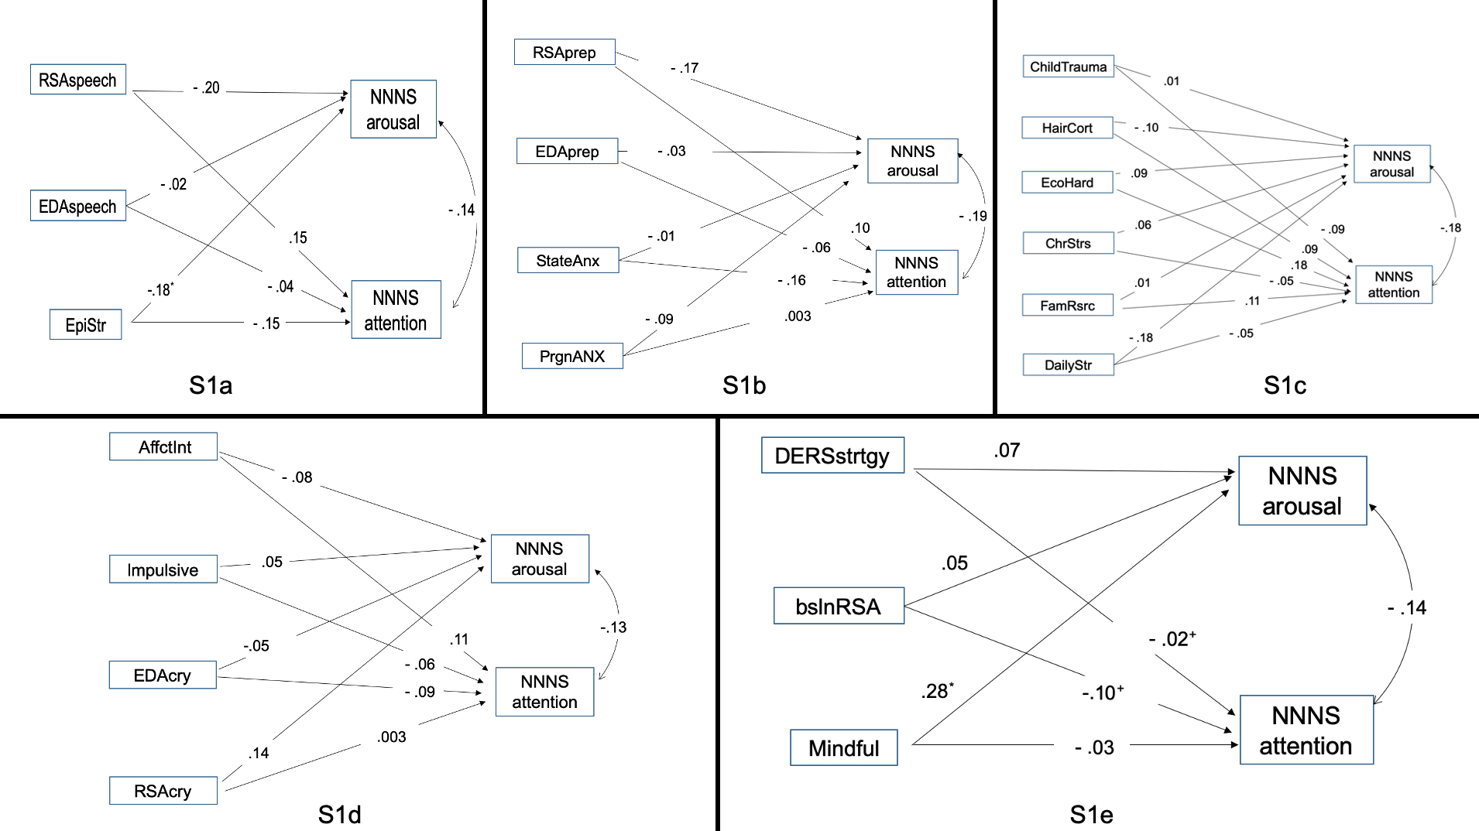

Note. RSAspeech = RSA reactivity to the speech task; EDAspeech = EDA reactivity to the speech task; EpiStrs = Number of episodic stress experience during pregnancy; EDAprep = EDA reactivity to preparation; RSAprep = RSA reactivity to preparation; StateAnx = State anxiety; PrgnAnx = Pregnancy-related anxiety; ChildTrauma = childhood traumatic experience; HairCort = Hair cortisol; EcoHard = Economic hardship; ChrStrs = Chronic stress experience; FamRsrc = Family Resources; DailyStr = Day-to-day stress; AffctInt = Affect intensity; Impulsive = impulsiveness; EDAcry = EDA reactivity to baby’s cry; RSAcry = RSA reactivity to babies’ cry; DERSstrtgy = difficulties in accessing and employing emotion regulation strategies; bslnRSA = Baseline RSA; Mindful = Mindfulness; NNNS arousal = Arousal score in NNNS test; NNNS attention = Attention score in NNNS test
* p < .05, ⁺ p < .10;

