Supplemental Information

Methods

Participants
Clinical diagnoses in the sample. Data from the Kiddie-Schedule for Affective Disorders and Schizophrenia (K-SADS) collected at age 12 was examined to understand the extent of clinical diagnoses in the present sample. The K-SADS is a semi-structured interview conducted to measure current and past symptoms of various psychopathology in children between the ages of 6 and 18 (Chambers et al., 1985). It incorporates reports from both parent and child, as well as the clinician’s clinical assessment. As demonstrated by Figure S1, no participants in the sample suffer from Disruptive Mood Dysregulation Disorder (DMDD), a diagnosis for which severe, chronic irritability is the primary symptom (Kircanski et al., 2018), and only 23% of the sample have been diagnosed with Attention Deficit Hyperactivity Disorder (ADHD).
Measures
Sample sizes that completed each questionnaire measure. Table S1 provides the sample sizes (n=291 who were originally recruited for the study) that completed each questionnaire measure of interest as well as their descriptive statistics.
Early Childhood Irritability. Table S2 provides correlations between the Child Behavior Checklist (CBCL; Achenbach & Edelbrock, 1983) early childhood irritability data at all 5 timepoints (ages 2, 3, 4, 5, and 7).
Parental Emotion Socialization. Table S3 provides correlations between all six subscales of the Coping with Children’s Negative Emotions Scale (CCNES; Fabes et al., 1990), which were used to measure parental emotion socialization behaviors.
Correlations between all measures of interest. Table S4 provides bivariate correlations between all measures of interest.
Histogram plots for all key variables. Figures S2-S4 provide histogram plots for all key variables.
QQ plot for moderation analysis model. Figure S5 provides the QQ plot for the moderation analysis. This plot demonstrates that the assumptions of linear regression were met and that conducting a regression analysis was appropriate for this dataset.
Results
Early childhood irritability and parent-report of parent behaviors
All data are parent-report measures. As such, parents who report their children as irritable may be more likely to report other negative behaviors as present than parents who fail to report their children as irritable. To evaluate this possibility, we ran a series of one-way ANOVAs to evaluate whether there were group differences in the other questionnaire measures of parenting. Results indicated a significant main effect of early childhood group membership on negative parental emotion socialization (F(2,168)= 5.25, p= .006) and positive parental emotion socialization behaviors (F(2,168)= 2.68, p= .071). A post-hoc between-subjects t-test revealed that children in the high stable irritability group had parents who reported greater negative parental emotion socialization (p= .008) and fewer positive parental emotion socialization (p= .033) behaviors than children in the high decreasing irritability group. Further, there was a main effect of early childhood irritability group membership on positive parental control behavior (F(2,196)= 4.44, p= .013) such that children in the high stable irritability group had parents who reported fewer positive control behaviors than children in the high decreasing irritability group (p= .003). There was no main effect of early childhood irritability group membership on negative parental control behavior.
How does the selection of the reference group impact results?
In the main text, we elected to set the reference group to be the low-stable irritability group for ease of interpretation and to minimize the number of statistical tests run. However, it is possible that changing the reference group could change the results. As such, we provide these additional analyses below. In each subsection, we outline how the results change if each of the other groups were selected as the reference group.
Reference group: Low-increasing irritability. Relative to the low-increasing irritability group, those with high stable childhood irritability and high negative emotion socialization scored higher on ARI (β= 4.105, p=. 030). There were no significant interactions between childhood irritability trajectory and positive emotion socialization, negative control, or positive control.
Reference group: High-decreasing irritability. Results indicated that relative to the high-decreasing irritability group, those with high stable childhood irritability and high negative emotion socialization exhibited higher ARI scores in adolescence (β= 2.446, p= .005). There were no significant interactions found for positive emotion socialization, negative control, or positive control.
Reference group: High-stable irritability. Results show that relative to the high-stable irritability group, individuals in all irritability groups who experienced high negative emotion socialization exhibited lower ARI scores. (low-stable group: β= -2.094, p= .002; low-increasing: β= -4.105, p= .030, high-decreasing: β= -2.446, p= .006). There were no significant interactions with positive emotion socialization, negative control, or positive control. However, the positive control model did show a main effect of positive control, indicating that positive control is associated with lower ARI scores (β= -.789, p= .033).
Overall, these results are in line with the findings in the main text. Results overwhelmingly demonstrate that the interaction for the high stable irritability group and negative parental emotion socialization persists regardless of reference group, indicating that this pattern is robust. Results also illustrate that high positive control is associated with lower irritability in adolescence when the model considers the high stable irritability group as the reference group.
Evaluating whether results change if another proxy for early childhood irritability is used
From the analyses in the main text, it remains unclear whether the approach of evaluating irritability trajectories over childhood provides unique information. It is possible that another simpler proxy for irritability would change the results. To evaluate this possibility, we replicated our primary analyses replacing the early childhood irritability trajectory group scores with various continuous measures of irritability. The first analyses make use of the latest timepoint of irritability (i.e., CBCL at age 7). The second analysis takes an average of CBCL scores across all five timepoints. The third analysis utilizes the continuous probability scores indicative of how likely a participant’s CBCL data fits the pattern of high stable irritability.
Early childhood irritability at age 7. Primary analyses were re-run using CBCL irritability at age 7 as the measure of early childhood irritability (i.e., in place of irritability trajectory groups). Results indicated that higher irritability at age 7 was correlated with higher ARI scores (β= .557, p= .0002). Additionally, results indicated that only negative parental emotion socialization (β= .93, p= .005) moderated the relation between early childhood irritability at age 7 and irritability symptoms in adolescence (see Table S5). Positive parental emotion socialization and parental control behaviors (positive and negative) did not moderate the relation between early childhood irritability at age 7 and adolescent irritability symptoms (ps> .331). Overall, these results mirror the findings in the main text.
Average irritability across all 5 early childhood timepoints. Given that irritability was correlated at each of the early childhood timepoints, we re-ran our primary analyses using average irritability across all 5 timepoints (replacing the irritability trajectory group measure). Correlational analyses indicated that average irritability was correlated with ARI at age 12 (β= .550, p= .005). In this model, none of the parenting behaviors moderated the relation between irritability in early childhood and adolescent irritability symptoms (ps> .243; see Table S6). This differs from the primary analyses in the main text and could suggest that perhaps trajectories are capturing meaningful individual differences in the childhood irritability patterns that are predictive of irritability in adolescence.
Continuous probability scores for high stable irritability. Lastly, we re-ran the primary analyses using continuous probability scores indicative of the likelihood of being in the high stable irritability group. Correlation analysis revealed that children with higher probability scores for high stable irritability had higher ARI scores. Conversely, children with high probability scores for low stable irritability had lower ARI scores. The other two irritability groups (low-increasing and high decreasing) were not significantly correlated with ARI scores (See Table S7).
Moderation analyses further revealed that negative parental emotion socialization moderated the relation between the probability of being in the high stable irritability group and irritability symptoms in adolescence (β= 2.95, p= .004; see Table S8). This moderation illustrates that children with high stable irritability and parents that exhibited greater negative emotion socialization had higher irritability in adolescence. Positive parental emotion socialization and parental control behaviors did not moderate the relation between the probability of being in the high stable irritability group and adolescent irritability symptoms (ps> .331). These results converge with those reported in the main text.
Correlation between 12-year irritable temperament measure (i.e., CBCL) and ARI.
In the main text, irritability composite scores from the CBCL were used to obtain early childhood irritability trajectories, and mean ARI scores were used to assess adolescent irritability. The decision to use the ARI as the outcome measure was a practical one that stemmed from our longstanding collaboration with clinicians at the National Institute of Mental Health. Our aim with this collaboration is to maximize consistency in measure of irritability symptoms in adolescence—thus, we decided a priori to use the ARI to measure symptoms of irritability. Nevertheless, the shift from using CBCL (a measure of irritable temperament) to using ARI (a measure of symptoms) to assess irritability may have impacted the results. Thus, we evaluated the relations between CBCL irritability composite (at age 12), parent- and child-report ARI scores, and mean ARI scores. CBCL irritability composite was significantly correlated with parent-report ARI (r(77)=0.46, p< .001), child-report ARI (r(79)=0.23, p= .036), and Mean ARI scores (r(77)=0.41, p< .001). These correlations indicate at most moderate associations between parent-reports on the CBCL and ARI scores. Thus, it is possible that these assessments are measuring different constructs. As such, we conceptualize the measurement in early childhood as being about irritable temperament and the measurement in adolescence as being about symptoms (particularly because the ARI is used as a diagnostic tool). The modest associations between the CBCL and ARI in this dataset suggest that additional research should be conducted to evaluate stability in temperamental measures of irritability and clinical diagnostic tools.
Using multiple imputation to address the issue of missing data
In the main text, the primary regression analysis examined the interaction between parenting and childhood irritability on adolescent irritability using listwise deletion. Notably, only 26.03% of individuals had all data used in this analysis. See Figure S9 for missing data pattern analysis. Indeed, only 23.32% of participants were missing data across all timepoints used in this analysis—indicating that ~76.68% of subjects provided data at some or all time points. One concern might be that (1) by choosing listwise deletion, this analysis is biased (Madley-Dowd et al., 2019; van Ginkel et al., 2020) or (2) that the N-to-predictor ratio in the main text analyses (78 to 14) is not optimal. To address these concerns, we re-ran our analyses using multiple imputation. Multiple imputation was conducted using the mice package in R (van Buuren & Groothuis-Oudshoorn, 2011). This packages iteratively imputes missing data (resultant sample size of n=242). All estimates of missing data were pooled across the 5 iterations.
Using the pooled imputed data, high stable childhood irritability (relative to low-stable irritability) was associated with higher mean ARI scores in adolescence (p= .041; See Table S9). Results further indicated that there was a marginally significant interaction between high stable irritability (relative to low-stable irritability) and negative emotion socialization on adolescent irritability symptoms (β= 1.33, p= .067; See Table S9). Specifically, relative to children with low-stable irritability, those children with both high stable irritability and parents who exhibited more negative emotion socialization had higher irritability in adolescence. This pattern directly replicates the findings in the main text. No other significant effects or interactions relative to the reference group were found. These results suggest that perhaps not all negative parenting behaviors moderate trajectories of irritability. Furthermore, results demonstrate that positive parenting behaviors did not protect against developing irritability in adolescence in our sample.

References
Achenbach, T. M., & Edelbrock, C. S. (1983). Manual for the child behavior checklist and revised child behavior profile. Burlington: University of Vermont.
Chambers, W. J., Puig-Antich, J., Hirsch, M., Paez, P., Ambrosini, P. J., Tabrizi, M. A., & Davies, M. (1985). The assessment of affective disorders in children and adolescents by semistructured interview: Test-retest reliability of the Schedule for Affective Disorders and Schizophrenia for School-Age Children, Present Episode Version. Archives of General Psychiatry, 42(7), 696–702.
Fabes, R. A., Eisenberg, N., & Bernzweig, J. (1990). The coping with children’s negative emotions scale: Procedures and scoring. Available from Authors. Arizona State University.
Kircanski, K., Clayton, M. E., Leibenluft, E., & Brotman, M. A. (2018). Psychosocial Treatment of Irritability in Youth. Current Treatment Options in Psychiatry, 5(1), 129–140. https://doi.org/10.1007/s40501-018-0141-5
Madley-Dowd, P., Hughes, R., Tilling, K., & Heron, J. (2019). The proportion of missing data should not be used to guide decisions on multiple imputation. Journal of Clinical Epidemiology, 110, 63–73. https://doi.org/10.1016/j.jclinepi.2019.02.016
van Buuren, S., & Groothuis-Oudshoorn, K. (2011). mice: Multivariate Imputation by Chained Equations in R. Journal of Statistical Software, 45(3). https://doi.org/10.18637/jss.v045.i03
van Ginkel, J. R., Linting, M., Rippe, R. C. A., & van der Voort, A. (2020). Rebutting existing misconceptions about multiple imputation as a method for handling missing data. Journal of Personality Assessment, 102(3), 297–308. https://doi.org/10.1080/00223891.2018.1530680

Figure S1. Current KSADS diagnoses at age 12.

Table S1
Descriptive Statistics for all Key Study Variables
Measure | N | Mean | SD | Range
Early Childhood Irritability Group (CBCL; age 2-7)  Low stable irritability  Low-increasing irritability  High-decreasing irritability  High stable irritability | 234  131  25  42  36 | -  -  -  - | -  -  -  - | -  -  -  -
Negative Parental Control (CRPR; age 5) | 227 | 58.33 | 10.634 | 29-87
Positive Parental Control (CRPR; age 5) | 227 | 97.44 | 8.448 | 32-108
Negative Parental Emotion Socialization (CCNES; age 7) | 196 | 2.553 | 0.572 | 1.25-4.28
Positive Parental Emotion Socialization (CCNES; age 7) | 196 | 5.374 | 0.696 | 2.83-6.94
Irritability symptoms in Adolescence (ARI; age 12) | 91 | 1.577 | 1.540 | 0-6.50

Note. CBCL=Child Behavior Checklist. CRPR=Child Rearing Practices Report. CCNES=Coping with Children’s Negative Emotions Scale. ARI=Affective Reactivity Index (mean of parent- and child-report).

Table S2

Bivariate Correlations Between Early Childhood Irritability Scores at Each of the 5 Timepoints
 |  | 1 | 2 | 3 | 4 | 5
1. | Irritability at Age 2 | -
2. | Irritability at Age 3 | .38** | -
3. | Irritability at Age 4 | .36** | .40** | -
4. | Irritability at Age 5 | .23** | .26** | .46** | -
5. | Irritability at Age 7 | .21** | .25** | .32** | .35** | -

*p< .05, **p< .01.

Table S3
Correlations Between Subscales of the Coping with Children’s Negative Emotions Scale (CCNES)
 |  | 1 | 2 | 3 | 4 | 5 | 6
1. | Distress Reactions | -
2. | Punitive Reactions | .42** | -
3. | Minimization Reactions | .25** | .67** | -
4. | Emotion Focused Reactions | -.21** | -.12 | .05 | -
5. | Problem Focused Reactions | -.29** | -.26** | -.14 | .63** | -
6. | Expressive Encouragement | -.32** | -.32** | -.25** | .43** | .52** | -
*p < .05, **p <.01.

Table S4
Bivariate Correlations Between all Measures of Interest
 |  | 1 | 2 | 3 | 4 | 5
1. | Positive Parental Emotion Socialization (CCNES; age 7) | -
2. | Negative Parental Emotion Socialization (CCNES; age 7) | -.32** | -
3. | Positive Parental Control (CRPR; age 5) | -.28** | -.15* | -
4. | Negative Parental Control (CRPR; age 5) | -.11 | .42** | -.07 | -
5. | Irritability symptoms in Adolescence (ARI; age 12) | -.08 | .28* | -.16 | .21 | -
*p< .05, **p< .01.

Note. CCNES=Coping with Children’s Negative Emotions Scale. CRPR=Child Rearing Practices Report. ARI=Affective Reactive Index (mean of parent- and child-report).

Early Childhood Irritability Class

Figure S2. Distribution of early childhood irritability scores and adolescent irritability scores.

Negative Parental Emotion Socialization
Positive Parental Emotion Socialization

Figure S3. Distribution of parental emotion socialization behavior scores.

Negative Parental Control
Positive Parental Control

Figure S4. Distribution of parental control behavior scores.

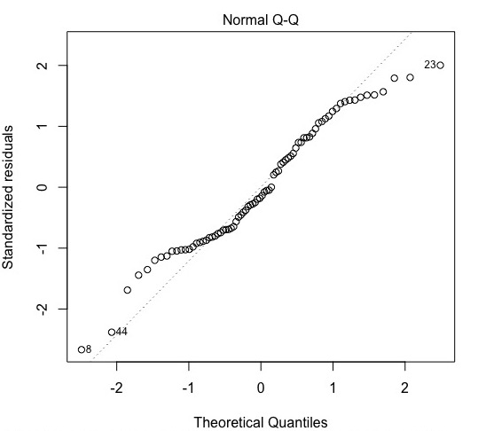

Figure S5. QQ plot for regression analysis with all four parenting behaviors as the moderators.

Table S5
Regression Results with Age 7 Irritability Scores Predicting Mean ARI
Model | β | se | t | p | Fit
Constant | 1.10 | 0.20 | 5.38 | <.001** | R²=.33,  p< .001
Age 7 irritability | 0.47 | 0.16 | 3.04 | .003
Negative Parental Emotion Socialization | -0.22 | 0.38 | -0.58 | .564
Positive Parental Emotion Socialization | 0.08 | 0.34 | 0.23 | .819
Negative Parental Control | 0.28 | 0.22 | 1.27 | .208
Positive Parental Control | -0.24 | 0.26 | -0.90 | .371
Negative Parental Emotion Socialization X Age 7 Irr | 0.93 | 0.32 | 2.93 | .005**
Positive Parental Emotion Socialization X Age 7 Irr | 0.10 | 0.21 | 0.47 | .637
Negative Parental Control X Age 7 Irr | -0.18 | 0.19 | -0.98 | .331
Positive Parental Control X Age 7 Irr | 0.08 | 0.15 | 0.49 | .625
*p < .05, **p <.01.
Note: Mean ARI indicates the average of parent- and child- report on the ARI.

*p < .05, **p <.01.
Table S6
Regression Results with Average Irritability Scores Across all 5 Timepoints Predicting Mean ARI
Model | β | se | t | p | Fit
Constant | 0.94 | 0.33 | 2.83 | .006 | R²=.27,  p= .018
Average Irritability | 0.40 | 0.21 | 1.90 | .063
Negative Parental Emotion Socialization | -0.47 | 0.70 | -0.68 | .499
Positive Parental Emotion Socialization | 0.45 | 0.56 | 0.81 | .423
Negative Parental Control | -0.13 | 0.36 | -0.35 | .726
Positive Parental Control | -0.44 | 0.48 | -0.92 | .363
Negative Parental Emotion Socialization X Average Irr | 0.50 | 0.46 | 1.08 | .285
Positive Parental Emotion Socialization X Average Irr | -0.18 | 0.31 | -0.59 | .558
Negative Parental Control X Average Irr | 0.30 | 0.25 | 1.18 | .243
Positive Parental Control X Average Irr | 0.14 | 0.26 | 0.54 | .595
Note: Mean ARI indicates the average of parent- and child- report on the ARI.

Table S7
Correlation Coefficients for Probability of Being in Each Irritability Group and Mean ARI at Age 12
Probability of being in each irritability group | ARI age 12
Low stable irritability | -.282*
Low increasing irritability | .112
High decreasing irritability | -.042
High stable irritability | .350**
*p< .05, **p< .01.
Note: Mean ARI indicates the average of parent- and child- report on the ARI.

Table S8
Regression Results with Probability Scores of Being in High Stable Irritability Group Predicting Mean ARI
Model | β | se | t | p | Fit
Constant | 1.32 | 0.17 | 7.55 | <.001** | R²=.31,  p< .001
Probability of Being in High Stable Irritability Group (Group 4 Probability) | 1.11 | 0.50 | 2.22 | .030
Negative Parental Emotion Socialization | -0.04 | 0.34 | -0.13 | .898
Positive Parental Emotion Socialization | 0.15 | 0.24 | 0.61 | .546
Negative Parental Control | 0.18 | 0.19 | 0.97 | .333
Positive Parental Control | -0.18 | 0.13 | -1.33 | .189
Negative Parental Emotion Socialization X Group 4 Probability | 2.95 | 1.00 | 2.94 | .004**
Positive Parental Emotion Socialization X Group 4 Probability | 0.57 | 0.66 | 0.87 | .387
Negative Parental Control X Group 4 Probability | -0.24 | 0.73 | -0.33 | .743
Positive Parental Control X Group 4 Probability | 0.02 | 0.47 | 0.05 | .963
*p < .05, **p <.01.
Note: Mean ARI indicates the average of parent- and child- report on the ARI.

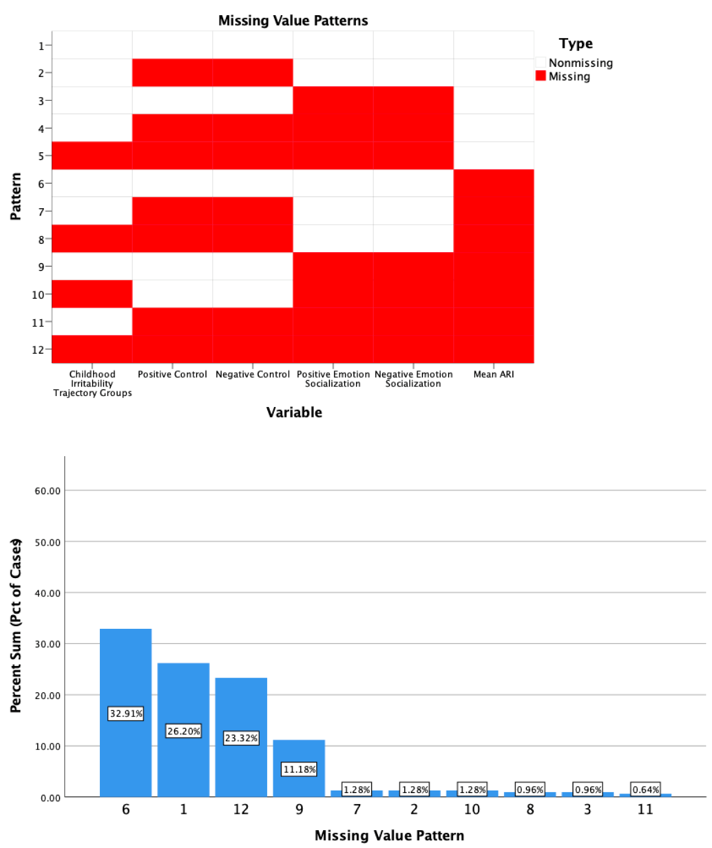

Figure S9. Missing data patterns for each variable of interest (top) and the 10 most frequently occurring patterns (bottom). Mean ARI indicates the average of parent- and child- report on the ARI.

Table S9
Regression Results for Primary Analyses Predicting Mean ARI
Model | β | se | t | p
Constant | 1.26 | 0.18 | 6.98 | <.001**
High Decreasing Childhood Irritability (High Dec Irr) | 0.40 | 0.30 | 1.33 | .195
High Stable Childhood Irritability (High Stable Irr) | 0.91 | 0.40 | 2.29 | .041*
Negative Parental Emotion Socialization | 0.35 | 0.29 | 1.21 | .241
Positive Parental Emotion Socialization | 0.17 | 0.20 | 0.86 | .394
Negative Parental Control | -0.01 | 0.23 | -0.04 | .969
Positive Parental Control | -0.07 | 0.22 | -0.31 | .759
Negative Parental Emotion Socialization X High Dec Irr | -0.18 | 0.56 | -0.32 | .752
Negative Parental Emotion Socialization X High Stable Irr | 1.33 | 0.68 | 1.96 | .067
Positive Parental Emotion Socialization X High Dec Irr | -0.08 | 0.40 | -0.20 | .846
Positive Parental Emotion Socialization X High Stable Irr | 0.44 | 0.48 | 0.91 | .369
Negative Parental Control X High Dec Irr | 0.58 | 0.46 | 1.28 | .236
Negative Parental Control X High Stable Irr | -0.06 | 0.40 | -0.14 | .886
Positive Parental Control X High Dec Irr | 0.47 | 0.40 | 1.17 | .259
Positive Parental Control X High Stable Irr | -0.07 | 0.23 | -0.30 | .762
*p < .05, **p <.01
Note: Mean ARI indicates the average of parent- and child- report on the ARI.

