Supplemental Methods
Latent Profile Analysis Stability and Robustness. To examine the stability of the four-class solution from the LPA we performed an alternative data-driven clustering method. We applied k-means cluster analysis to the full sample (n = 6, 571) using the cluster and factorextra packages in R (Maechler et al., 2019; Kassambara & Mundt, 2017). The optimal number of clusters (k) was determined using the elbow method (Kodinariya & Makwana, 2013) and “gap” statistic using bootstrapping with 500 samples (the suggested default) to evaluate the goodness of clustering (Tibshirani et al., 2001).
KSADS-5 PL Mental Health Diagnoses and CBCL Dimensional Subscales. To evaluate whether the mental health symptomatology-related results replicated at a diagnostic level we re-ran the mixed effect and post-hoc comparison analyses described in the main text using diagnostic data for all KSADS-5 PL modules described in the main text. Again, Bonferroni correction was applied to account for the total number of outcome variables (n = 54, including our main analyses and the KSADS-5 PL Diagnoses and the CBCL subscales described below).
While including a semi-structured clinical interview to capture youth mental health is a strength of the present study, subscales of dimensional parent-reported psychopathology and behavior symptoms also were evaluated in exploratory ancillary analyses. Accordingly, we re-ran the analyses described in the main text including the 8 CBCL subscales released in the ABCD Study Dataset: Aggressive Behavior, Anxious/Depressed, Attention Problems, Delinquent Behavior, Somatic Complaints, Social Problems, Thought Problems, Withdrawn/Depressed.

Supplemental Results
Latent Profile Analysis Robustness and Validation. Results from the alternative k-means cluster analysis revealed that k = 4 clusters provided substantial fit as evidenced by the bend in the plot comparing total within-cluster sum of squares (wss) to different values of k (elbow method; Supplemental Figure 2) and corresponding “gap” statistic solutions (k = 2–4 all 0.82; Supplemental Figure 3). Results of the alternative data-driven cluster analysis demonstrated a stable best fitting four-class solution.
KSADS-5 PL Mental Health Diagnoses and CBCL Dimensional Subscales. Results from the supplemental mental health diagnoses analysis (Supplemental Table 5) largely replicated the analysis presented in our main text and demonstrated that membership in the Low Threat profile at T1 was associated with lower ADHD, conduct, DBD, mood, neurodevelopmental, and suicidality diagnoses at T2 relative to one or more of the elevated threat profiles. The Low Threat profile was not significantly different from the elevated threat profiles in alcohol/substance use, anxiety, eating, homicidality, OCD, psychotic, or trauma/stress diagnoses at T2. Conversely, membership in the Elevated Threat profile was associated with increased ADHD, conduct, DBD, and suicidality disorder diagnoses at T2 relative to the Low Threat profile. Furthermore, membership in the Elevated Threat profile was related to even greater Conduct Disorder and suicidality diagnoses relative to the Elevated Family profile and even greater ADHD, conduct, DBD, and suicidality diagnoses relative to the Elevated Neighborhood profile. Membership in the Elevated Family profile at T1 was significantly associated with increased DBD diagnoses at T2 relative to the Elevated Neighborhood profile. Lastly, membership in the Elevated Neighborhood profile at T1 did not show significantly increased mental health diagnoses relative to the Elevated Family or the Elevated Threat profile.
Next, results from the ancillary CBCL subscale analysis (Supplemental Table 5) demonstrated that membership in the Low Threat Profile at T1 was associated with lower Aggressive Behavior, Anxious/Depressed symptoms, Attention Problems, Rule-Breaking Behavior, Social Problems, Somatic Complaints, Thought Problems, and Withdrawn/Depressive symptoms at T2 relative to one or more of the elevated profiles. Conversely, membership in the Elevated Threat profile at T1 was associated with increased Aggressive Behavior, Anxious/Depressive symptoms, Attention Problems, Rule-Breaking Behavior, Social Problems, Somatic Complaints, Thought Problems, and Withdrawn/Depressive symptoms at T2 relative to the Low Threat profile. In addition, membership in the Elevated Threat profile was related to even greater Anxious/Depressive symptoms, Attention Problems, Rule-Breaking Behavior, Social Problems, Somatic Complaints, and Withdrawn/Depressive symptoms at T2 relative to the Elevated Family profile and even greater Aggressive Behavior, Attention Problems, Rule-Breaking Behavior, Social Problems, Somatic Complaints, Thought Problems, and Withdrawn/Depressive symptoms at T2 relative to the Elevated Neighborhood profile. Consistent with the supplemental findings reported above and results in the main text, membership in the Elevated Neighborhood profile did not show significantly increased mental health symptoms relative to the Elevated Family or Elevated Threat profiles.

Supplemental References

Kassambara A, Mundt F. factoextra: extract and visualize the results of multivariate data analyses. R package version 1.0.5. 2017. https://CRAN.R-project.org/package=factoextra.
Kodinariya, T. M., & Makwana, P. R. (2013). Review on determining number of Cluster in K-Means Clustering. International Journal, 1(6), 90-95. doi:10.18576/amis/100428
Maechler, M, Rousseeuw, P, Struyf, A, Hubert, M, Hornik, K. cluster: Cluster Analysis Basics and Extensions. R package version 2.0.8. 2019. Retrieved from https://cran.r-project.org/web/packages/cluster/citation.html.
Tibshirani, R., Walther, G., & Hastie, T. (2001). Estimating the number of clusters in a data set via the gap statistic. Journal of the Royal Statistical Society: Series B (Statistical Methodology), 63(2), 411-423. doi:10.1111/1467-9868.00293

Supplemental Figures
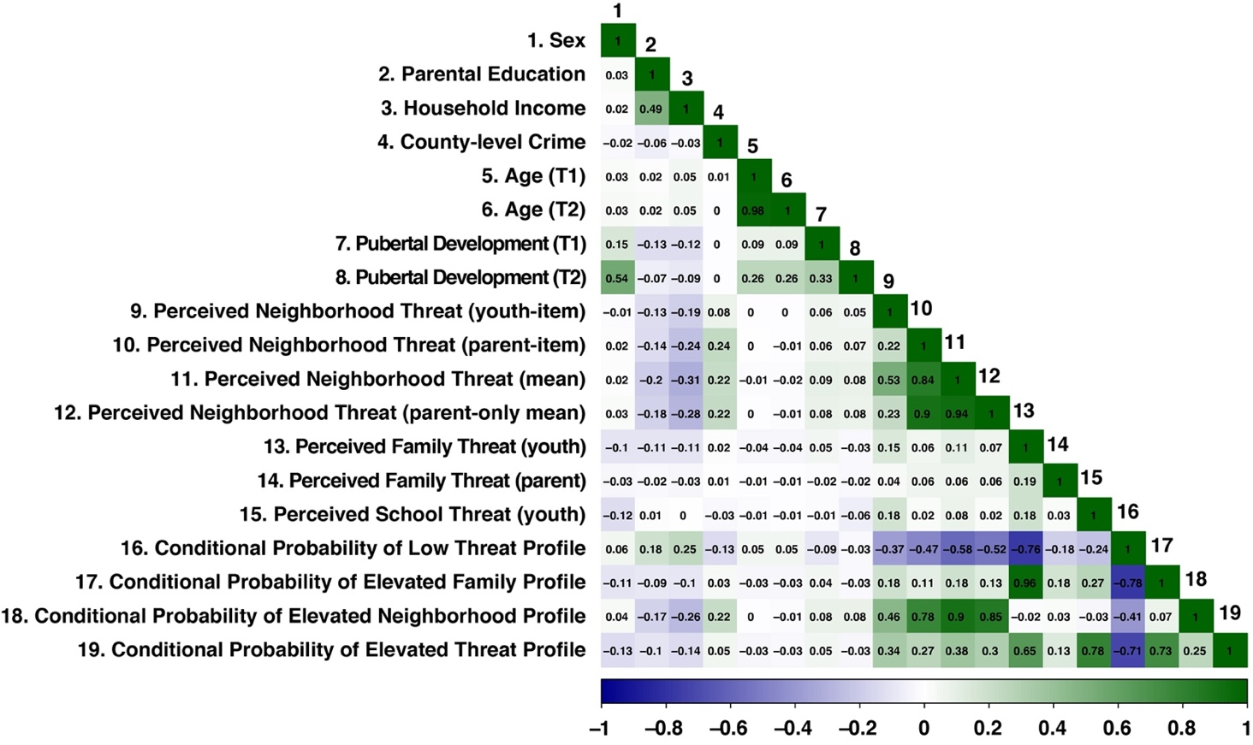Supplemental Figure 1. Heatmap showing Spearman correlations across demographic variables, youth- and parent-report perceived environmental threat variables, and conditional probability of membership in each profile.

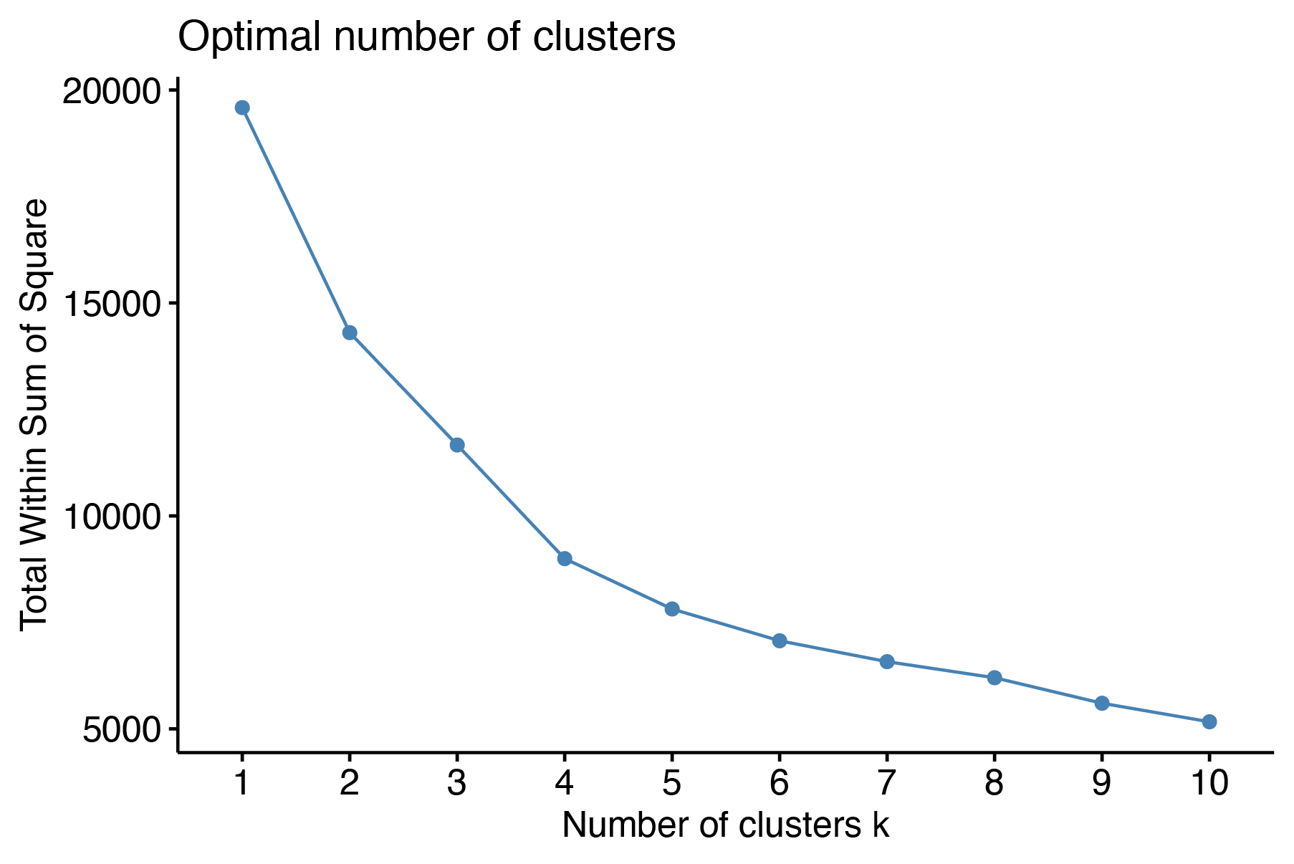

Supplemental Figure 2. The elbow method is represented with a line plot comparing total intra-cluster variation (total within sum of squares) to number of clusters (k).
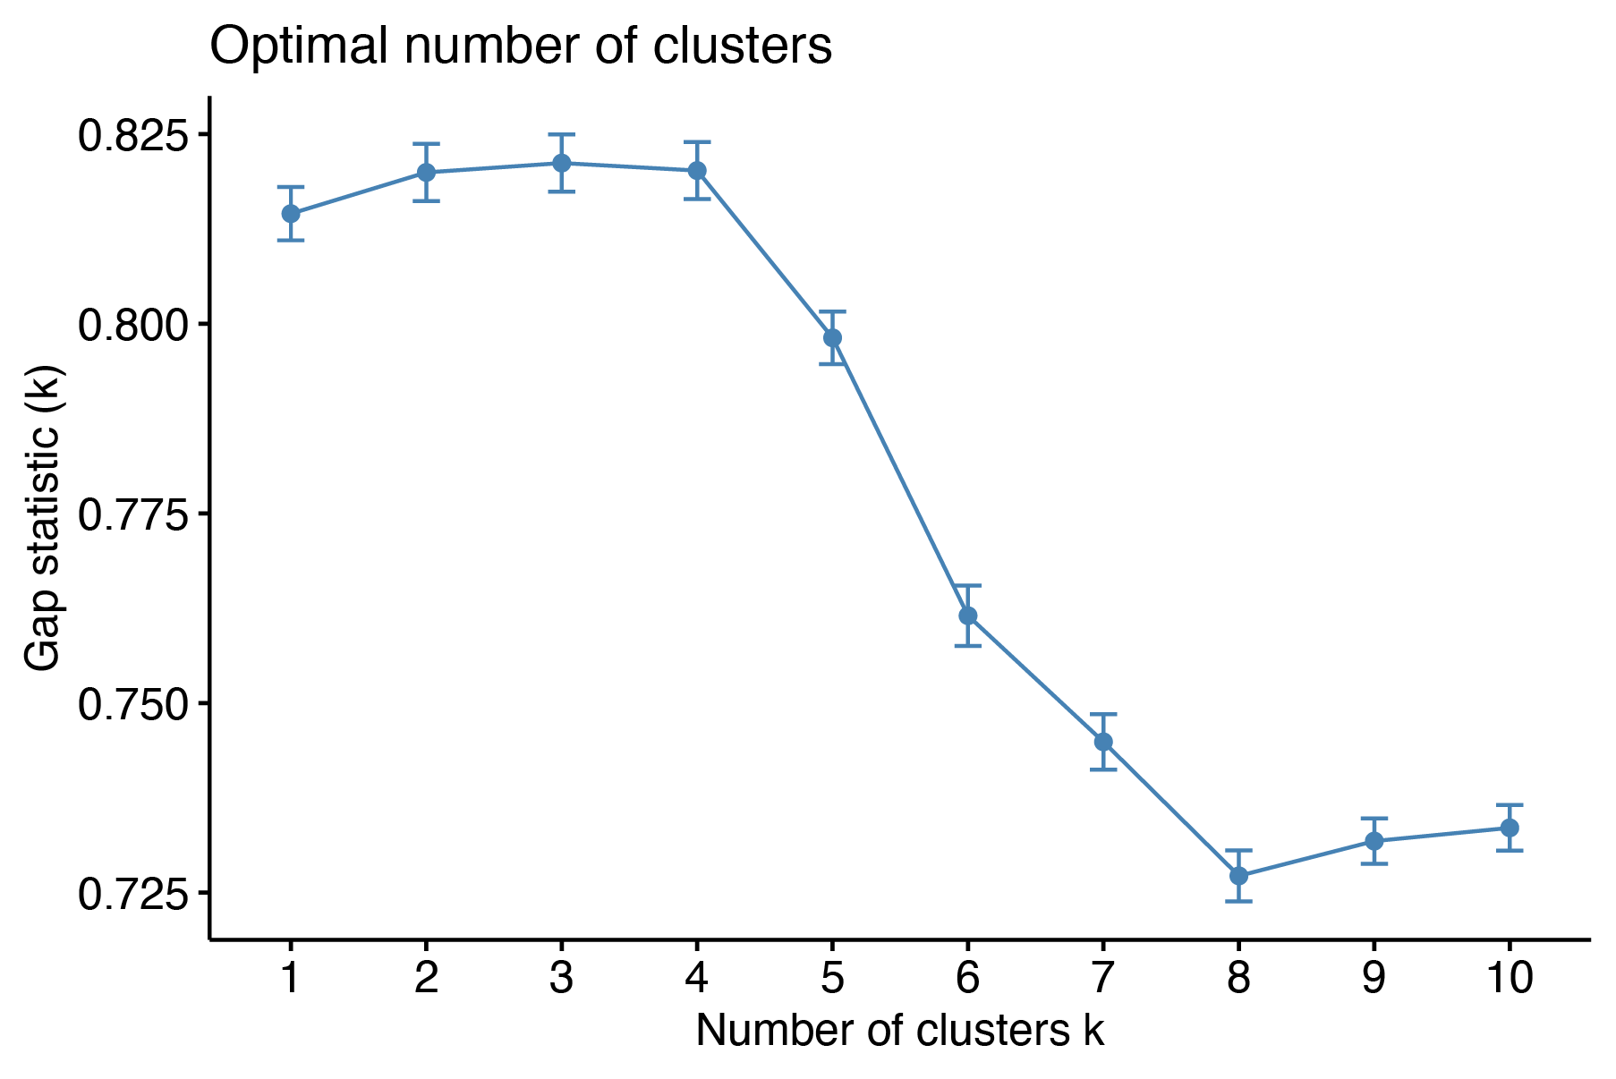
Supplemental Figure 3. Line plot showing solutions generated from the “gap” statistic for hypothetical number of clusters (k) demonstrates optimal fit for 2–4 clusters.

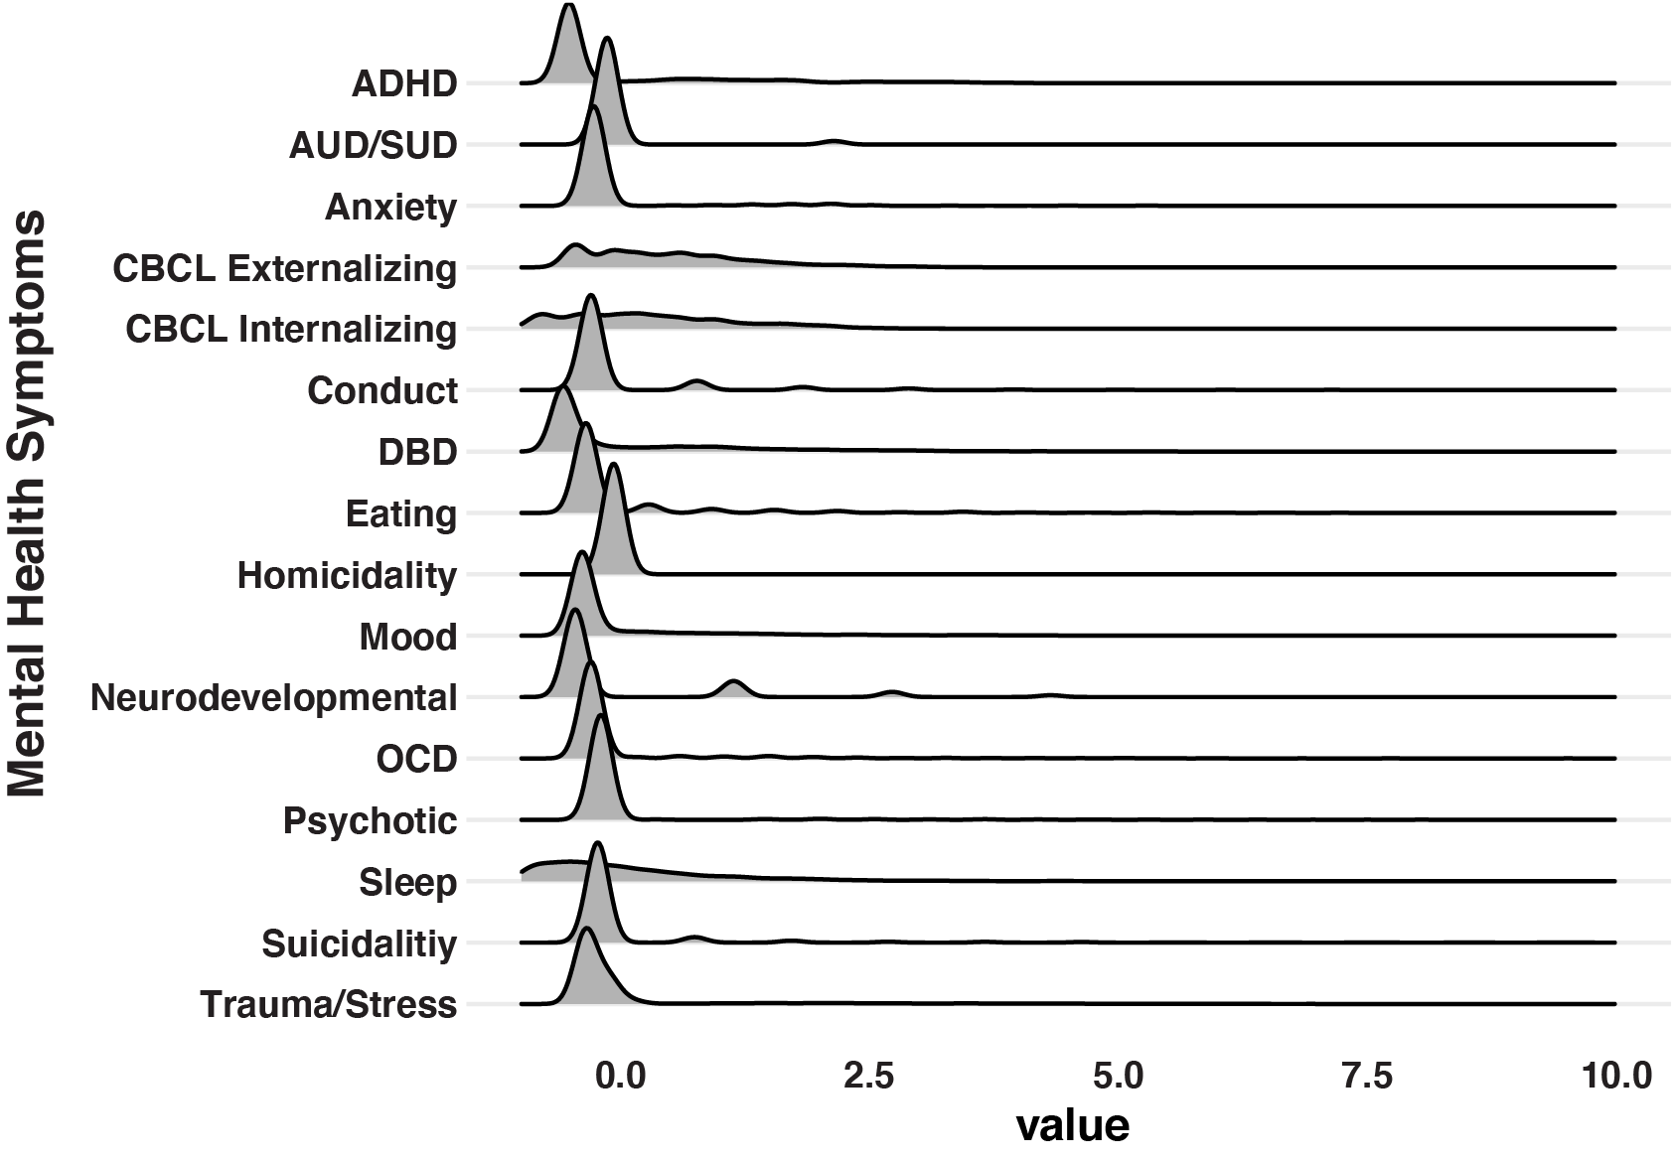
Supplemental Figure 4a. Density plot showing distribution of standardized mental health symptoms. ADHD = Attention Deficit Hyperactivity Disorder; AUD/SUD = Alcohol Use Disorder/Substance Use Disorder; DBD = Disruptive Behavior Disorders; OCD = Obsessive and Compulsive Disorders; CBCL = Child Behavior Checklist

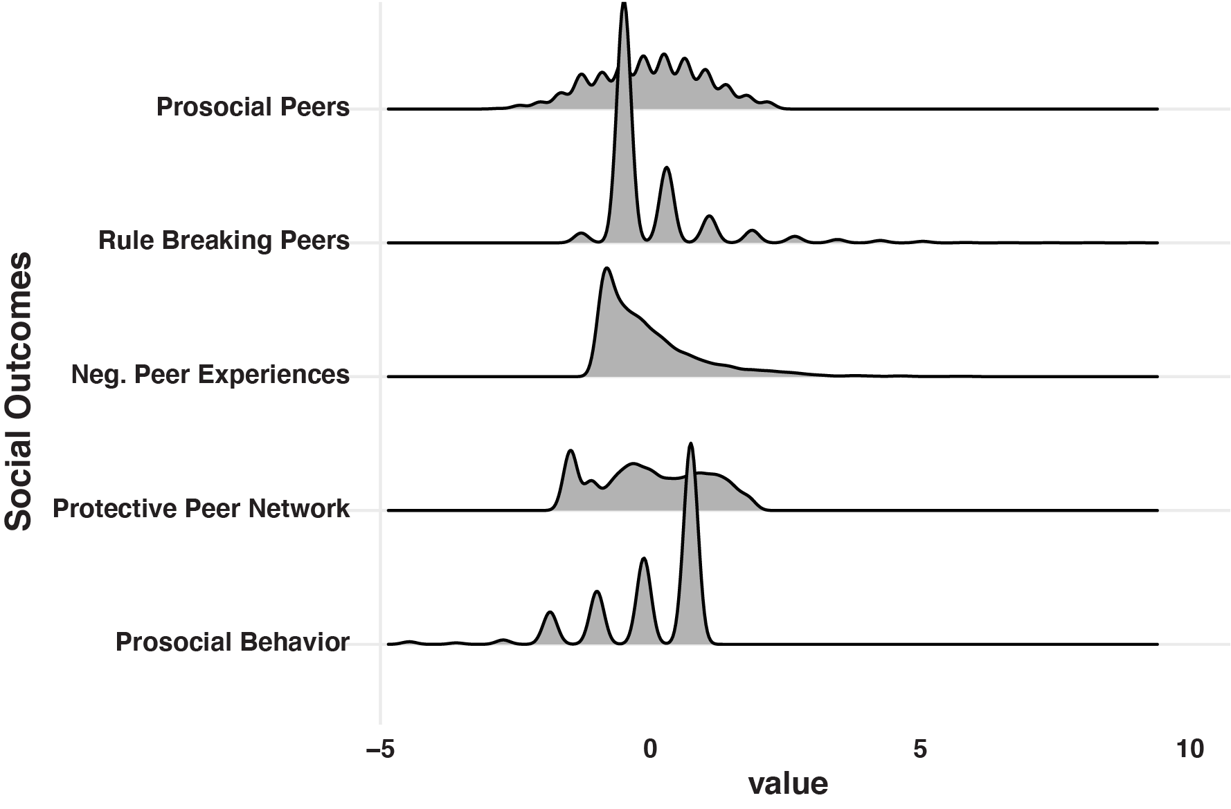Supplemental Figure 4b. Density plot showing distribution of standardized social outcomes.

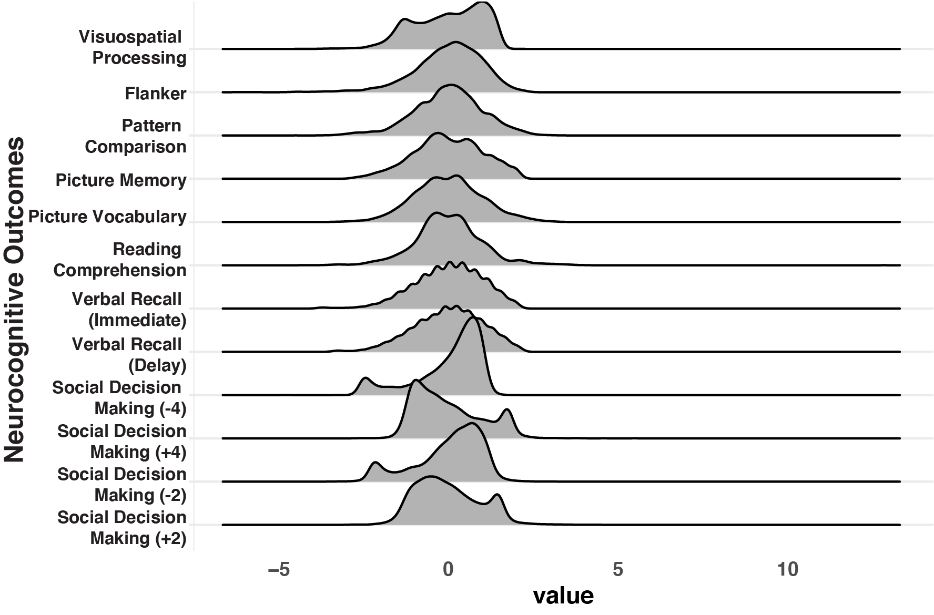Supplemental Figure 4c. Density plot showing distribution of standardized neurocognitive outcomes.
Supplemental Tables

Supplemental Table 1a. Distribution of demographic variables assessed at baseline (T1) across participants with and without T2 data included in Data Release 3.0
 | T2 Included in 3.0 | T2 Not Included in 3.0 | p
n | 6571 | 5307
Baseline Age (mean (SD)) | 119.58 (7.42) | 118.23 (7.52) | <0.001
Female n (%) | 3105 (47.3) | 2576 (48.6) | 0.148
Race/Ethnicity n (%) |  |  | <0.001
White | 3738 (56.9) | 2436 (46.1)
Black | 768 (11.7) | 1011 (19.1)
Hispanic | 1271 (19.3) | 1136 (21.5)
Asian | 140 (2.1) | 112 (2.1)
Other | 654 (10.0) | 591 (11.2)
Parental Education n (%) |  |  | <0.001
< HS Diploma | 262 (4.0) | 330 (6.2)
HS Diploma/GED | 500 (7.6) | 631 (11.9)
Some College | 1657 (25.3) | 1421 (26.8)
Bachelor | 1794 (27.3) | 1220 (23.0)
Post Graduate Degree | 2348 (35.8) | 1695 (32.0)
Household Income n (%) |  |  | <0.001
<50K | 1643 (27.0) | 1579 (33.1)
>=50K & <100K | 1799 (29.5) | 1271 (26.7)
>=100K | 2647 (43.5) | 1918 (40.2)
County-level Crime  (mean (SD)) | 49456.12 (78922.40) | 56478.70 (92325.37) | <0.001
ABCD Site n (%) |  |  | <0.001
site01 | 185 (2.8) | 221 (4.2)
site02 | 323 (4.9) | 236 (4.4)
site03 | 349 (5.3) | 282 (5.3)
site04 | 491 (7.5) | 256 (4.8)
site05 | 202 (3.1) | 174 (3.3)
site06 | 325 (4.9) | 259 (4.9)
site07 | 82 (1.2) | 257 (4.8)
site08 | 185 (2.8) | 168 (3.2)
site09 | 194 (3.0) | 238 (4.5)
site10 | 447 (6.8) | 293 (5.5)
site11 | 151 (2.3) | 302 (5.7)
site12 | 230 (3.5) | 378 (7.1)
site13 | 395 (6.0) | 329 (6.2)
site14 | 371 (5.6) | 236 (4.4)
site15 | 246 (3.7) | 213 (4.0)
site16 | 589 (9.0) | 420 (7.9)
site17 | 345 (5.3) | 232 (4.4)
site18 | 199 (3.0) | 185 (3.5)
site19 | 358 (5.4) | 192 (3.6)
site20 | 481 (7.3) | 225 (4.2)
site21 | 402 (6.1) | 198 (3.7)
site22 | 21 (0.3) | 13 (0.2)
Note: Group differences evaluated with χ² tests for categorical variables and two-sample t-tests for continuous variables (i.e., age)

Supplemental Table 1b. Mean (SD) for perceived environmental threat variables assessed at baseline (T1) across participants with and without T2 data included in Data Release 3.0
 | T2 Included in 3.0 | T2 Not Included in 3.0 | p
n | 6571 | 5307
Perceived Neighborhood Threat | 2.02 (0.81) | 2.14 (0.89) | <0.001
Perceived Family Threat | 1.98 (1.92) | 2.13 (1.99) | <0.001
Perceived School Threat | 5.04 (2.78) | 5.11 (2.90) | 0.188
Note: Group differences evaluated with two-sample t-tests

Supplemental Table 1c. Mean (SD) for dependent variables assessed at baseline (T1) across participants with and without T2 data included in the 3.0 Data Release
 | T2 Included in 3.0 | T2 Not Included in 3.0 | p
n | 6571 | 5307
Mental Health
ADHD | 7.06 (11.21) | 6.87 (12.01) | 0.367
Alcohol/Substance Use | 0.06 (0.60) | 0.06 (0.48) | 0.433
Anxiety | 0.64 (2.25) | 0.53 (1.98) | 0.007
DBD | 3.40 (5.41) | 3.55 (5.76) | 0.149
Homicidality | 0.01 (0.09) | 0.01 (0.11) | 0.302
Mood | 5.23 (5.56) | 2.64 (5.18) | <0.001
Neurodevelopmental | 0.38 (0.70) | 0.39 (0.72) | 0.198
OCD | 0.87 (2.48) | 0.87 (2.48) | 0.917
Psychotic | 0.37 (1.90) | 0.42 (2.13) | 0.180
Suicidality | 0.26 (0.95) | 0.24 (0.93) | 0.269
Trauma/Stress | 1.66 (4.16) | 1.69 (4.53) | 0.675
CBCL-Externalizing | 45.58 (10.26) | 45.91 (10.43) | 0.086
CBCL-Internalizing | 48.56 (10.55) | 48.30 (10.74) | 0.196
CBCL-Anxious/Depressive | 53.48 (5.93) | 53.47 (6.00) | 0.921
CBCL-Withdrawn/Depressive | 53.47 (5.71) | 53.57 (5.90) | 0.328
CBCL-Somatic Complaints | 54.95 (6.07) | 54.80 (6.02) | 0.175
CBCL-Social Problems | 52.73 (4.63) | 52.87 (4.86) | 0.114
CBCL-Thought Problems | 53.71 (5.71) | 53.90 (6.14) | 0.074
CBCL-Attention Problems | 53.81 (6.06) | 54.02 (6.29) | 0.062
CBCL-Rule-Breaking Behavior | 52.63 (4.73) | 52.95 (5.10) | 0.001
CBCL-Aggressive Behavior | 52.78 (5.47) | 52.90 (5.61) | 0.242
Sleep Problems | 36.36 (8.11) | 36.75 (8.41) | 0.011
Social
Prosocial Behavior (Youth) | 5.03 (1.12) | 5.00 (1.16) | 0.139
Neurocognition
Visuospatial Processing | 0.60 (0.17) | 0.58 (0.17) | <0.001
Picture Vocabulary | 85.19 (8.01) | 83.54 (8.15) | <0.001
Flanker | 94.61 (8.79) | 93.25 (9.50) | <0.001
Pattern Comparison | 88.68 (14.42) | 87.28 (14.74) | <0.001
Picture Memory | 103.46 (12.13) | 101.99 (11.95) | <0.001
Reading Comprehension | 91.22 (6.73) | 90.41 (7.11) | <0.001
Verbal Recall (Immediate) | 9.82 (2.99) | 9.47 (3.12) | <0.001
Verbal Recall (Delay) | 9.35 (3.18) | 8.96 (3.22) | <0.001
Note: p values reflect results from two-sample t-tests comparing groups; ADHD = Attention Deficit Hyperactivity Disorder; DBD = Disruptive Behavior Disorders; OCD = Obsessive and Compulsive Disorders; CBCL = Child Behavior Checklist

Supplemental Table 2. Distribution of demographic variables across complete and incomplete datasets
 | Complete | Incomplete | p
n | 4684 | 841
Age (mean (SD)) | 143.25 (7.58) | 142.85 (7.92) | 0.168
Female = yes (%) | 2221 (47.4) | 362 (43.1) | 0.023
Race/Ethnicity (%) |  |  | 0.071
Asian | 111 (2.4) | 17 (2.0)
Black | 525 (11.2) | 118 (14.0)
Hispanic | 955 (20.4) | 173 (20.6)
Other | 460 (9.8) | 94 (11.2)
White | 2633 (56.2) | 439 (52.2)
Parental Education (%) |  |  | 0.030
< HS Diploma | 199 (4.3) | 36 (4.3)
HS Diploma/GED | 366 (7.8) | 65 (7.7)
Some College | 1143 (24.4) | 248 (29.5)
Bachelor | 1255 (26.8) | 216 (25.7)
Post Graduate Degree | 1715 (36.7) | 275 (32.7)
Household Income (%) |  |  | 0.198
<$50K | 1179 (27.2) | 232 (29.6)
$50-100K | 1279 (29.5) | 238 (30.4)
>=$100K | 1874 (43.3) | 313 (40.0)
ABCD Site (%) |  |  | <0.001
Site01 | 128 (2.7) | 38 (4.5)
Site02 | 175 (3.7) | 26 (3.1)
Site03 | 285 (6.1) | 40 (4.8)
Site04 | 372 (7.9) | 63 (7.5)
Site05 | 142 (3.0) | 39 (4.6)
Site06 | 246 (5.3) | 50 (5.9)
Site07 | 61 (1.3) | 14 (1.7)
Site08 | 143 (3.1) | 28 (3.3)
Site09 | 162 (3.5) | 26 (3.1)
Site10 | 357 (7.6) | 45 (5.4)
Site11 | 109 (2.3) | 27 (3.2)
Site12 | 183 (3.9) | 26 (3.1)
Site13 | 299 (6.4) | 65 (7.7)
Site14 | 197 (4.2) | 23 (2.7)
Site15 | 195 (4.2) | 27 (3.2)
Site16 | 435 (9.3) | 79 (9.4)
Site17 | 277 (5.9) | 50 (5.9)
Site18 | 175 (3.7) | 20 (2.4)
Site19 | 158 (3.4) | 43 (5.1)
Site20 | 280 (6.0) | 28 (3.3)
Site21 | 289 (6.2) | 79 (9.4)
Site22 | 16 (0.3) | 5 (0.6)
Note: Group differences evaluated with χ² tests for categorical variables and two-sample t-tests for continuous variables (i.e., age)

Supplemental Table 3. Demographics for 4-class solution from Latent Profile Analysis
 | Low Threat | Elevated Family | Elevated Neighborhood | Elevated Threat | p
n | 3953 | 974 | 458 | 140
Age (mean (SD)) | 143.45 (7.68) | 142.71 (7.56) | 142.39 (7.41) | 141.66 (7.03) | <0.001
Female (%) | 1872 (47.4) | 430 (44.1) | 237 (51.7) | 44 (31.4) | <0.001
Race/Ethnicity (%) |  |  |  |  | <0.001
Asian | 102 (2.6) | 19 (2.0) | 6 (1.3) | 1 (0.7)
Black | 335 (8.5) | 133 (13.7) | 148 (32.3) | 27 (19.3)
Hispanic | 781 (19.8) | 178 (18.3) | 144 (31.4) | 25 (17.9)
Other | 377 (9.5) | 102 (10.5) | 55 (12.0) | 20 (14.3)
White | 2358 (59.7) | 542 (55.6) | 105 (22.9) | 67 (47.9)
Parental Education (%) |  |  |  |  | <0.001
< HS Diploma | 130 (3.3) | 44 (4.5) | 51 (11.1) | 10 (7.2)
HS Diploma/GED | 236 (6.0) | 94 (9.7) | 87 (19.0) | 14 (10.1)
Some College | 883 (22.4) | 270 (27.8) | 186 (40.6) | 52 (37.4)
Bachelor | 1119 (28.3) | 243 (25.0) | 73 (15.9) | 36 (25.9)
Post Graduate Degree | 1581 (40.0) | 321 (33.0) | 61 (13.3) | 27 (19.4)
Household Income (%) |  |  |  |  | <0.001
<$50K | 821 (22.2) | 284 (32.1) | 255 (63.4) | 51 (40.5)
$50-100K | 1094 (29.5) | 269 (30.4) | 103 (25.6) | 51 (40.5)
>=$100K | 1788 (48.3) | 331 (37.4) | 44 (10.9) | 24 (19.0)
Note: Group differences evaluated with χ² tests for categorical variables and two-sample t-tests for continuous variables (i.e., age)

Supplemental Table 4. Mean (SD) for dependent variables across complete and incomplete datasets
 | Complete | Incomplete | p
n | 4684 | 841
Mental Health Symptoms
ADHD | 5.41 (10.61) | 6.54 (11.57) | 0.005
Alcohol/Substance Use | 0.06 (0.39) | 0.07 (0.65) | 0.665
Anxiety | 0.66 (2.46) | 0.80 (2.80) | 0.141
Conduct | 0.28 (0.95) | 0.29 (0.87) | 0.737
DBD | 3.00 (5.15) | 3.30 (5.61) | 0.134
Eating | 0.56 (1.61) | 0.49 (1.42) | 0.215
Homicidality | 0.01 (0.09) | 0.01 (0.10) | 0.496
Mood | 1.81 (4.70) | 1.91 (4.92) | 0.579
Neurodevelopmental | 0.28 (0.62) | 0.32 (0.68) | 0.070
OCD | 0.65 (2.21) | 0.78 (2.42) | 0.099
Psychotic | 0.34 (1.76) | 0.46 (2.13) | 0.074
Suicidality | 0.23 (1.05) | 0.25 (0.93) | 0.769
Trauma/Stress | 1.50 (4.25) | 1.41 (4.32) | 0.557
CBCL-Externalizing | 44.52 (9.73) | 45.22 (9.76) | 0.057
CBCL-Internalizing | 47.90 (10.52) | 48.93 (10.64) | 0.009
Sleep Problems | 36.50 (8.00) | 37.54 (8.76) | 0.001
Social
Negative Peer Experiences | 23.06 (5.86) | 22.94 (5.87) | 0.593
Prosocial Behavior (Youth) | 5.17 (1.08) | 4.93 (1.46) | <0.001
Prosocial Peers | 9.37 (2.59) | 9.07 (2.73) | 0.004
Protective Peer Network | 12.09 (8.05) | 11.45 (8.42) | 0.039
Rule Breaking Peers | 3.63 (1.27) | 3.53 (1.25) | 0.076
Neurocognitive
Flanker | 100.39 (7.38) | 99.41 (8.13) | 0.001
Pattern Comparison | 103.74 (15.02) | 101.05 (15.96) | <0.001
Picture Memory | 109.74 (11.90) | 107.83 (12.53) | <0.001
Picture Vocabulary | 89.38 (8.31) | 88.57 (8.63) | 0.026
Reading Comprehension | 95.07 (6.56) | 94.08 (7.09) | 0.001
Visuospatial Processing | 0.74 (0.18) | 0.72 (0.19) | <0.001
Verbal Recall (Immediate) | 9.93 (2.66) | 9.69 (2.67) | 0.026
Verbal Recall (Delay) | 9.34 (2.84) | 9.01 (2.92) | 0.005
Social Decision Making (-4) | -1.15 (1.15) | -1.04 (1.16) | 0.014
Social Decision Making (-2) | -0.69 (0.59) | -0.63 (0.62) | 0.010
Social Decision Making (+2) | 0.93 (0.71) | 1.03 (0.85) | <0.001
Social Decision Making (+4) | 1.56 (1.40) | 1.62 (1.46) | 0.268
Note: p values reflect results from two-sample t-tests comparing groups; ADHD = Attention Deficit Hyperactivity Disorder; DBD = Disruptive Behavior Disorders; OCD = Obsessive and Compulsive Disorders; CBCL = Child Behavior Checklist

Supplemental Table 5. Results of mixed effect models and post-hoc pairwise comparisons from mental health diagnoses and dimensional mental health and problem behavior analyses
Mental Health Diagnoses
ADHD | β (SE) | CI | p | Pairwise Comparisons
Low Threat | -0.03 (0.02) | -0.07, 0.02 | 0.234 | LT vs EF; LT vs ET; EN vs ET
Elevated Family (EF) | 0.15 (0.04) | 0.07, 0.23 | <0.001 | LT vs EF; LT vs ET; EN vs ET
Elevated Neighborhood (EN) | 0.06 (0.06) | -0.06, 0.17 | 0.323 | LT vs EF; LT vs ET; EN vs ET
Elevated Threat (ET) | 0.33 (0.09) | 0.15, 0.52 | <0.001 | LT vs EF; LT vs ET; EN vs ET
Alcohol/Substance Use | β (SE) | CI | p | Pairwise Comparisons
Low Threat | -0.00 (0.02) | -0.04, 0.04 | 0.988
Elevated Family (EF) | 0.07 (0.04) | -0.02, 0.16 | 0.106
Elevated Neighborhood (EN) | -0.03 (0.06) | -0.16, 0.09 | 0.585
Elevated Threat (ET) | 0.22 (0.10) | 0.01, 0.42 | 0.036
Anxiety | β (SE) | CI | p | Pairwise Comparisons
Low Threat | -0.01 (0.02) | -0.05, 0.02 | 0.528
Elevated Family (EF) | 0.09 (0.04) | 0.01, 0.17 | 0.020
Elevated Neighborhood (EN) | -0.06 (0.06) | -0.17, 0.05 | 0.304
Elevated Threat (ET) | -0.01 (0.09) | -0.20, 0.17 | 0.891
Conduct | β (SE) | CI | p | Pairwise Comparisons
Low Threat (LT) | -0.06 (0.02) | -0.09, -0.03 | 0.002 | LT vs EN; LT vs ET; EF vs ET; EN vs ET
Elevated Family (EF) | 0.11 (0.04) | 0.04, 0.18 | 0.003 | LT vs EN; LT vs ET; EF vs ET; EN vs ET
Elevated Neighborhood (EN) | 0.21 (0.05) | 0.10, 0.31 | <0.001 | LT vs EN; LT vs ET; EF vs ET; EN vs ET
Elevated Threat (ET) | 0.46 (0.09) | 0.28, 0.63 | <0.001 | LT vs EN; LT vs ET; EF vs ET; EN vs ET
DBD | β (SE) | CI | p | Pairwise Comparisons
Low Threat (LT) | -0.05 (0.02) | -0.09, -0.00 | 0.039 | LT vs EF; LT vs ET; EF vs EN; EN vs ET
Elevated Family (EF) | 0.24 (0.04) | 0.16, 0.31 | <0.001 | LT vs EF; LT vs ET; EF vs EN; EN vs ET
Elevated Neighborhood (EN) | -0.02 (0.06) | -0.13, 0.09 | 0.777 | LT vs EF; LT vs ET; EF vs EN; EN vs ET
Elevated Threat (ET) | 0.35 (0.09) | 0.17, 0.53 | <0.001 | LT vs EF; LT vs ET; EF vs EN; EN vs ET
Eating | β (SE) | CI | p | Pairwise Comparisons
Low Threat (LT) | -0.00 (0.02) | -0.04, 0.03 | 0.839
Elevated Family (EF) | -0.01 (0.04) | -0.09, 0.07 | 0.838
Elevated Neighborhood (EN) | 0.02 (0.06) | -0.09, 0.13 | 0.686
Elevated Threat (ET) | 0.03 (0.09) | -0.16, 0.21 | 0.781
Homicidality | β (SE) | CI | p | Pairwise Comparisons
Low Threat (LT) | -0.01 (0.02) | -0.05, 0.03 | 0.603
Elevated Family (EF) | 0.08 (0.04) | -0.00, 0.16 | 0.055
Elevated Neighborhood (EN) | 0.03 (0.06) | -0.08, 0.15 | 0.595
Elevated Threat (ET) | 0.02 (0.10) | -0.17,0.21 | 0.014
Mood | β (SE) | CI | p | Pairwise Comparisons
Low Threat (LT) | -0.05 (0.02) | -0.09, -0.01 | 0.022 | LT vs EF
Elevated Family (EF) | 0.17 (0.04) | 0.09, 0.24 | <0.001 | LT vs EF
Elevated Neighborhood (EN) | 0.10 (0.06) | -0.01, 0.21 | 0.080 | LT vs EF
Elevated Threat (ET) | 0.22 (0.09) | 0.04, 0.39 | 0.018 | LT vs EF
Neurodevelopmental | β (SE) | CI | p | Pairwise Comparisons
Low Threat (LT) | -0.03 (0.02) | -0.08, 0.01 | 0.139 | LT vs EF
Elevated Family (EF) | 0.16 (0.04) | 0.08, 0.24 | <0.001 | LT vs EF
Elevated Neighborhood (EN) | 0.07 (0.06) | -0.04, 0.18 | 0.234 | LT vs EF
Elevated Threat (ET) | 0.17 (0.09) | -0.01, 0.36 | 0.068 | LT vs EF
OCD | β (SE) | CI | p | Pairwise Comparisons
Low Threat (LT) | -0.03 (0.02) | -0.07, 0.01 | 0.190
Elevated Family (EF) | 0.10 (0.04) | 0.02, 0.18 | 0.013
Elevated Neighborhood (EN) | 0.10 (0.06) | -0.01, 0.21 | 0.085
Elevated Threat (ET) | 0.13 (0.09) | -0.05, 0.32 | 0.154
Psychotic | β (SE) | CI | p | Pairwise Comparisons
Low Threat (LT) | -0.02 (0.02) | -0.05, 0.01 | 0.227
Elevated Family (EF) | 0.02 (0.04) | -0.06, 0.09 | 0.643
Elevated Neighborhood (EN) | 0.08 (0.05) | -0.02, 0.19 | 0.129
Elevated Threat (ET) | 0.10 (0.09) | -0.07, 0.28 | 0.239
Suicidality | β (SE) | CI | p | Pairwise Comparisons
Low Threat (LT) | -0.02 (0.02) | -0.06, 0.01 | 0.177 | LT vs ET; EF vs ET; EN vs ET
Elevated Family (EF) | 0.12 (0.04) | 0.04, 0.20 | 0.004 | LT vs ET; EF vs ET; EN vs ET
Elevated Neighborhood (EN) | -0.01 (0.06) | -0.12, 0.10 | 0.856 | LT vs ET; EF vs ET; EN vs ET
Elevated Threat (ET) | 0.47 (0.10) | 0.28, 0.66 | <0.001 | LT vs ET; EF vs ET; EN vs ET
Trauma/Stress | β (SE) | CI | p | Pairwise Comparisons
Low Threat (LT) | -0.02 (0.02) | -0.06, 0.02 | 0.282
Elevated Family (EF) | 0.08 (0.04) | 0.00, 0.16 | 0.040
Elevated Neighborhood (EN) | 0.06 (0.06) | -0.06, 0.17 | 0.329
Elevated Threat (ET) | 0.13 (0.09) | -0.05, 0.32 | 0.151
CBCL Subscales
Aggressive Behavior | β (SE) | CI | p | Pairwise Comparisons
Low Threat (LT) | -0.07 (0.03) | -0.13, -0.02 | 0.005 | LT vs EF; LT vs ET; EF vs ET; EN vs ET
Elevated Family (EF) | 0.22 (0.04) | 0.14, 0.29 | <0.001 | LT vs EF; LT vs ET; EF vs ET; EN vs ET
Elevated Neighborhood (EN) | 0.16 (0.06) | 0.05, 0.27 | 0.004 | LT vs EF; LT vs ET; EF vs ET; EN vs ET
Elevated Threat (ET) | 0.47 (0.09) | 0.29, 0.65 | <0.001 | LT vs EF; LT vs ET; EF vs ET; EN vs ET
Anxious/Depressed | β (SE) | CI | p | Pairwise Comparisons
Low Threat (LT) | -0.02 (0.03) | -0.08, 0.04 | 0.431 | LT vs ET; EF vs ET; EN vs ET
Elevated Family (EF) | 0.03 (0.04) | -0.05, 0.11 | 0.473 | LT vs ET; EF vs ET; EN vs ET
Elevated Neighborhood (EN) | 0.04 (0.06) | -0.07, 0.16 | 0.429 | LT vs ET; EF vs ET; EN vs ET
Elevated Threat (ET) | 0.37 (0.09) | 0.19, 0.55 | <0.001 | LT vs ET; EF vs ET; EN vs ET
Attention Problems | β (SE) | CI | p | Pairwise Comparisons
Low Threat (LT) | -0.04 (0.02) | -0.09, 0.00 | 0.053 | LT vs EF; LT vs ET; EF vs ET; EN vs ET
Elevated Family (EF) | 0.14 (0.04) | 0.07, 0.22 | <0.001 | LT vs EF; LT vs ET; EF vs ET; EN vs ET
Elevated Neighborhood (EN) | 0.12 (0.06) | 0.01, 0.23 | 0.032 | LT vs EF; LT vs ET; EF vs ET; EN vs ET
Elevated Threat (ET) | 0.46 (0.09) | 0.28, 0.65 | <0.001 | LT vs EF; LT vs ET; EF vs ET; EN vs ET
Rule-Breaking Behavior | β (SE) | CI | p | Pairwise Comparisons
Low Threat (LT) | -0.07 (0.03) | -0.12, -0.02 | 0.006 | LT vs EF; LT vs EN; LT vs ET; EF vs ET; EN vs ET
Elevated Family (EF) | 0.20 (0.04) | 0.12, 0.27 | <0.001 | LT vs EF; LT vs EN; LT vs ET; EF vs ET; EN vs ET
Elevated Neighborhood (EN) | 0.21 (0.06) | 0.10, 0.32 | <0.001 | LT vs EF; LT vs EN; LT vs ET; EF vs ET; EN vs ET
Elevated Threat (ET) | 0.46 (0.09) | 0.28, 0.64 | <0.001 | LT vs EF; LT vs EN; LT vs ET; EF vs ET; EN vs ET
Social Problems | β (SE) | CI | p | Pairwise Comparisons
Low Threat (LT) | -0.04 (0.02) | -0.08, -0.01 | 0.019 | LT vs ET; EF vs ET; EN vs ET
Elevated Family (EF) | 0.11 (0.04) | 0.03, 0.18 | 0.007 | LT vs ET; EF vs ET; EN vs ET
Elevated Neighborhood (EN) | 0.17 (0.06) | 0.06, 0.28 | 0.003 | LT vs ET; EF vs ET; EN vs ET
Elevated Threat (ET) | 0.53 (0.09) | 0.35, 0.71 | <0.001 | LT vs ET; EF vs ET; EN vs ET
Somatic Complaints | β (SE) | CI | p | Pairwise Comparisons
Low Threat (LT) | -0.01 (0.03) | -0.07, 0.03 | 0.350 | LT vs ET; EF vs ET; EN vs ET
Elevated Family (EF) | 0.05 (0.04) | -0.03, 0.13 | 0.205 | LT vs ET; EF vs ET; EN vs ET
Elevated Neighborhood (EN) | 0.17 (0.06) | 0.06, 0.28 | 0.003 | LT vs ET; EF vs ET; EN vs ET
Elevated Threat (ET) | 0.41 (0.09) | 0.22, 0.59 | <0.001 | LT vs ET; EF vs ET; EN vs ET
Thought Problems | β (SE) | CI | p | Pairwise Comparisons
Low Threat (LT) | -0.04 (0.03) | -0.09, 0.01 | 0.149 | LT vs ET; EF vs ET; EN vs ET
Elevated Family (EF) | 0.13 (0.04) | 0.05, 0.21 | 0.001 | LT vs ET; EF vs ET; EN vs ET
Elevated Neighborhood (EN) | 0.07 (0.06) | -0.04, 0.18 | 0.208 | LT vs ET; EF vs ET; EN vs ET
Elevated Threat (ET) | 0.39 (0.09) | 0.20, 0.57 | <0.001 | LT vs ET; EF vs ET; EN vs ET
Withdrawn/Depressed | β (SE) | CI | p | Pairwise Comparisons
Low Threat (LT) | -0.05 (0.02) | -0.10, -0.00 | 0.040 | LT vs EN; LT vs ET; EF vs ET; EN vs ET
Elevated Family (EF) | 0.10 (0.04) | 0.02, 0.17 | 0.017 | LT vs EN; LT vs ET; EF vs ET; EN vs ET
Elevated Neighborhood (EN) | 0.20 (0.06) | 0.09, 0.32 | <0.001 | LT vs EN; LT vs ET; EF vs ET; EN vs ET
Elevated Threat (ET) | 0.46 (0.09) | 0.27, 0.64 | <0.001 | LT vs EN; LT vs ET; EF vs ET; EN vs ET
Note: All models include household income and county-level crime as covariates. Bold p values indicate significant differences following Bonferroni correction. Listed pairwise comparisons (far right column) indicate significant differences (p < 0.05) between profiles. ADHD = Attention Deficit Hyperactivity Disorder; DBD = Disruptive Behavior Disorders; OCD = Obsessive and Compulsive Disorders; CBCL = Child Behavior Checklist

