Online supplemental materials for

The Bidirectional Spillover between Maladaptive Parenting and Peer Victimization and the Mediating Roles of Internalizing and Externalizing Problems: A Within-person Analysis among Chinese Early Adolescents

Authors’ note:

We developed these materials to provide additional technical information and to keep the main manuscript from becoming needlessly long.
Section 1
Results of Attrition Analysis
Table S1
ANOVAs for longitudinal participants’ attrition across waves
Variables | Time point | F | p | η² |  | Variables | Time point | F | p | η²
PC | T1 | 49.37 | <0.001 | 0.01 |  | INT | T1 | 27.55 | <0.001 | 0.01
PC | T2 | 48.71 | <0.001 | 0.01 |  | INT | T2 | 3.37 | 0.07 | 0
PC | T3 | 7.75 | <0.05 | 0 |  | INT | T3 | 0.1 | 0.75 | 0
PC | T4 | 14.64 | <0.001 | 0 |  | INT | T4 | 0.24 | 0.63 | 0
HP | T1 | 53.51 | <0.001 | 0.01 |  | EXT | T1 | 75.29 | <0.001 | 0.02
HP | T2 | 46.95 | <0.001 | 0.01 |  | EXT | T2 | 40.5 | <0.001 | 0.01
HP | T3 | 9.16 | <0.001 | 0 |  | EXT | T3 | 3.51 | 0.06 | 0
HP | T4 | 16.12 | <0.001 | 0 |  | EXT | T4 | 3.69 | 0.06 | 0
 |  |  |  |  |  | SES | T1 | 5.62 | <0.05 | 0
BV | T1 | 16.12 | <0.001 | 0 |  | AGE | T1 | 12.65 | <0.001 | 0
BV | T2 | 29.31 | <0.001 | 0.01
BV | T3 | 9.21 | <0.001 | 0 |  |  |  | χ² (df)
BV | T4 | 8.00 | <0.001 | 0 |  | SEX | T1 | 32.38(1) | <0.001 | 0.01
HP Harsh punishment, PC Psychological control, INT Internalizing problems, EXT Externalizing problems, PV Peer victimization.

Section 2
The Results of Control Variables and the Fit Statistics and Model Comparisons of Gender Difference for Final RI-CLPMS

Table S2
The results of the roles of control variables for final RI-CLPMs
 | Age |  |  | Gender |  |  | SES
 | β | p |  | β | p |  | β | p
Analyses of RI-CLPM for harsh punishment, internalizing and externalizing problems, and peer victimization
RI-HP | -0.10 | < 0.001 |  | -0.002 | 0.82 |  | -0.16 | < 0.001
RI-INT | 0.03 | 0.30 |  | 0.02 | 0.10 |  | -0.05 | < 0.05
RI-EXT | 0.02 | 0.46 |  | 0.03 | 0.10 |  | -0.13 | < 0.001
RI-PV | -0.03 | 0.26 |  | -0.001 | 0.37 |  | -0.04 | < 0.05
T1 HP | -0.004 | 0.81 |  | -0.04 | 0.42 |  | -0.03 | 0.07
T1 INT | -0.03 | 0.051 |  | -0.01 | 0.13 |  | -0.03 | < 0.05
T1 EXT | -0.01 | 0.52 |  | -0.01 | 0.29 |  | -0.06 | < 0.01
T1 PV | -0.01 | 0.64 |  | 0.04 | 0.054 |  | -0.02 | 0.22
Analyses of RI-CLPM for psychological control, internalizing and externalizing problems, and peer victimization
RI-PC | 0.04 | 0.17 |  | 0.04 | 0.07 |  | -0.22 | <0.001
RI-INT | 0.03 | 0.32 |  | 0.02 | 0.10 |  | -0.05 | <0.05
RI-EXT | 0.02 | 0.49 |  | 0.03 | 0.10 |  | -0.13 | <0.001
RI-PV | -0.03 | 0.25 |  | -0.01 | 0.36 |  | -0.04 | <0.05
T1 PC | -0.03 | 0.06 |  | -0.01 | 0.10 |  | 0.004 | 0.76
T1 INT | -0.03 | <0.05 |  | -0.01 | 0.13 |  | -0.03 | 0.08
T1 EXT | -0.01 | 0.53 |  | -0.01 | 0.27 |  | -0.05 | <0.01
T1 PV | -0.01 | 0.65 |  | 0.04 | 0.054 |  | -0.02 | 0.24
HP Harsh punishment, PC Psychological control, INT Internalizing problems, EXT Externalizing problems, PV Peer victimization.
.

Table S3
Fit statistics and model comparisons of gender difference for RI-CLPMs
Model | χ² | df | RMSEA | CFI | TLI | SRMR | Comparison model | ΔCFI | ΔRMSEA | ΔSRMR
Analyses of gender difference in RI-CLPMs for harsh punishment, internalizing and externalizing problems, and peer victimization
M3a. M1c freely estimated across genders | 264.26 | 172 | 0.015 | 0.993 | 0.988 | 0.024
M3b. M1c fixed autoregressive effects to be equal across genders | 313.13 | 176 | 0.018 | 0.990 | 0.983 | 0.026 | M3b VS M3a | <0.01 | <0.015 | <0.030
M3c. M1c fixed cross-lagged effects to be equal across genders | 301.15 | 184 | 0.016 | 0.992 | 0.986 | 0.025 | M3c VS M3a | <0.01 | <0.015 | <0.030
M3d. M1c fixed autoregressive and cross-lagged effects to be equal across genders | 334.41 | 188 | 0.018 | 0.990 | 0.983 | 0.027 | M3d VS M3a | <0.01 | <0.015 | <0.030
Analyses of gender difference in RI-CLPMs for psychological control, internalizing and externalizing problems, and peer victimization
M4a. M2c freely estimated across genders | 282.17 | 172 | 0.016 | 0.994 | 0.989 | 0.024
M4b. M2c fixed autoregressive effects to be equal across genders | 333.70 | 176 | 0.019 | 0.991 | 0.984 | 0.027 | M4b VS M4a | <0.01 | <0.015 | <0.030
M4c. M2c fixed cross-lagged effects to be equal across genders | 314.17 | 184 | 0.017 | 0.992 | 0.988 | 0.026 | M4c VS M4a | <0.01 | <0.015 | <0.030
M4d. M2c fixed autoregressive and cross-lagged effects to be equal across genders | 345.36 | 188 | 0.019 | 0.991 | 0.985 | 0.028 | M4d VS M4a | <0.01 | <0.015 | <0.030

Section 3
The Analysis and Results of Cross-Lagged Panel Model (CLPM)

Standard CPLMs were constructed to compare the direction and magnitude of structural coefficients (e.g., autoregressive and cross-lagged effects) with the RI-CLPM. Student’s sex, age, and SES were entered in CLPM as covariates and were regressed on all variables at T1-T4. Similar to the RI-CLPMs analysis, we tested whether constraining the longitudinal parameters (autoregressive and cross-lagged coefficients) in the baseline unconstrained CLPMs in a stepwise manner resulted in a significantly decreased model fit. Given that students were nested within classes, The COMPLEX and CLUSTER commands were employed in the CLPMs for addressing violations of independence assumptions related to the clustering nature of the data, thereby achieving robust standard errors.

Overall, CLPMs fit worse than the corresponding RI-CLPMs. The fit and model comparison results for constrained and unconstrained CLPMs are presented in Table S3 in the online supplemental materials. Setting the autoregressive paths and cross-lagged paths to be equal over time did not significantly decrease the fit of the unconstrained model. Thus, based on parsimony, CLPMs with autoregressive and cross-lagged paths fixed to be time-invariant were chosen as the final model for harsh punishment and psychological control, respectively. Standardized cross-lagged paths of the final CLPM for harsh punishment and psychological control are summarized in Fig. S1 and Fig. S2, respectively. The standardized autoregressive paths, and within-person concurrent associations coefficients of the final CLPMs are summarized in Table S4 in the online supplemental materials.

CLPM for harsh punishment, internalizing and externalizing problems, and peer victimization. As shown in Fig. S1, the effects from harsh punishment at time T to peer victimization at time T+1 were statistically significant (βs = 0.03 to 0.04, ps < 0.01) and vice versa (βs = 0.08 to 0.09, ps < 0.001); the cross-lagged effects of harsh punishment and internalizing problems were not statistically significant; the effects from harsh punishment at time T to externalizing problems at time T+1 were statistically significant (βs = 0.04 to 0.05, ps < 0.01) and vice versa (βs = 0.12 to 0.13, ps < 0.001); the effects from peer victimization at time T to internalizing problems at time T+1 were all statistically significant (βs = 0.13, ps < 0.001) and vice versa (βs = 0.11, ps < 0.001); the effects from peer victimization at time T to externalizing problems at time T+1 were all statistically significant (βs = 0.10 to 0.11, ps < 0.001) and vice versa (βs = 0.04, ps < 0.001); and the effects from internalizing problems at time T to externalizing problems at time T+1 were all statistically significant (βs = 0.11 to 0.12, ps < 0.001) but not vice versa. The effects of the control variables in the final CLPMs for harsh punishment are presented in Table S5 in the online supplemental materials.
Percentile bootstrapping analysis (see Table S6) showed that the indirect pathway from harsh punishment at T1 to peer victimization at T3 via externalizing problems at T2 was statistically significant (β = 0.002, p < 0.05, 95% CI [0.000, 0.003]), and the indirect pathway from harsh punishment at T2 to peer victimization at T4 via externalizing problems at T3 was also statistically significant (β = 0.002, p < 0.05, 95% CI [0.000, 0.003]). Reversely, the indirect pathway from peer victimization at T1 to harsh punishment at T3 via externalizing problems at T2 was statistically significant (β = 0.013, p < 0.05, 95% CI [0.008, 0.017]), and the indirect pathway from peer victimization at T2 to harsh punishment at T4 via externalizing problems at T3 was also statistically significant (β = 0.014, p < 0.05, 95% CI [0.008, 0.018]). Furthermore, the indirect pathway involving internalizing problems at T+1 was nonsignificant from harsh punishment at T to peer victimization at T+2 and vice versa.

CLPM for psychological control, internalizing and externalizing problems, and peer victimization. As shown in Fig. S2, the cross-lag effects between each variable were all statistically significant, except for the path from externalizing problems to internalizing problems was not statistically significant. Percentile bootstrapping analysis (see Table 5) showed that the indirect effects of internalizing and externalizing problems at T+1 were all statistically significant from psychological control at T to peer victimization at T+2. Reversely, the indirect effects of internalizing and externalizing problems at T+1 were also all statistically significant from peer victimization at T to psychological control at T+2. The effects of the control variables in the final CLPM for psychological control are presented in Table S5 in the online supplemental materials.
Percentile bootstrapping analysis (see Table S6) showed that the indirect pathways from psychological control at T1 to peer victimization at T3 via internalizing at T2 (β = 0.008, p < 0.05, 95% CI [0.005, 0.011]) and externalizing problems at T2 (β = 0.003, p < 0.05, 95% CI [0.001, 0.006]) were statistically significant, and the indirect pathways from psychological control at T2 to peer victimization at T4 via internalizing at T3 (β = 0.008, p < 0.05, 95% CI [0.005, 0.011]) and externalizing problems at T3 (β = 0.004, p < 0.05, 95% CI [0.001, 0.006]) were also statistically significant. Reversely, the indirect pathways from peer victimization at T1 to psychological control at T3 via internalizing at T3 (β = 0.010, p < 0.05, 95% CI [0.007, 0.013]) and externalizing problems at T3 (β = 0.006, p < 0.05, 95% CI [0.003, 0.008]) were also statistically significant, and the indirect pathways from peer victimization at T2 to psychological control at T4 via internalizing at T3 (β = 0.010, p < 0.05, 95% CI [0.007, 0.013]) and externalizing problems at T3 (β = 0.006, p < 0.05, 95% CI [0.003, 0.008]) were also statistically significant.
Moreover, multi-group modeling analysis revealed that the final CLPMs revealed non-significant sex differences (see Table S7 in the online supplemental materials).
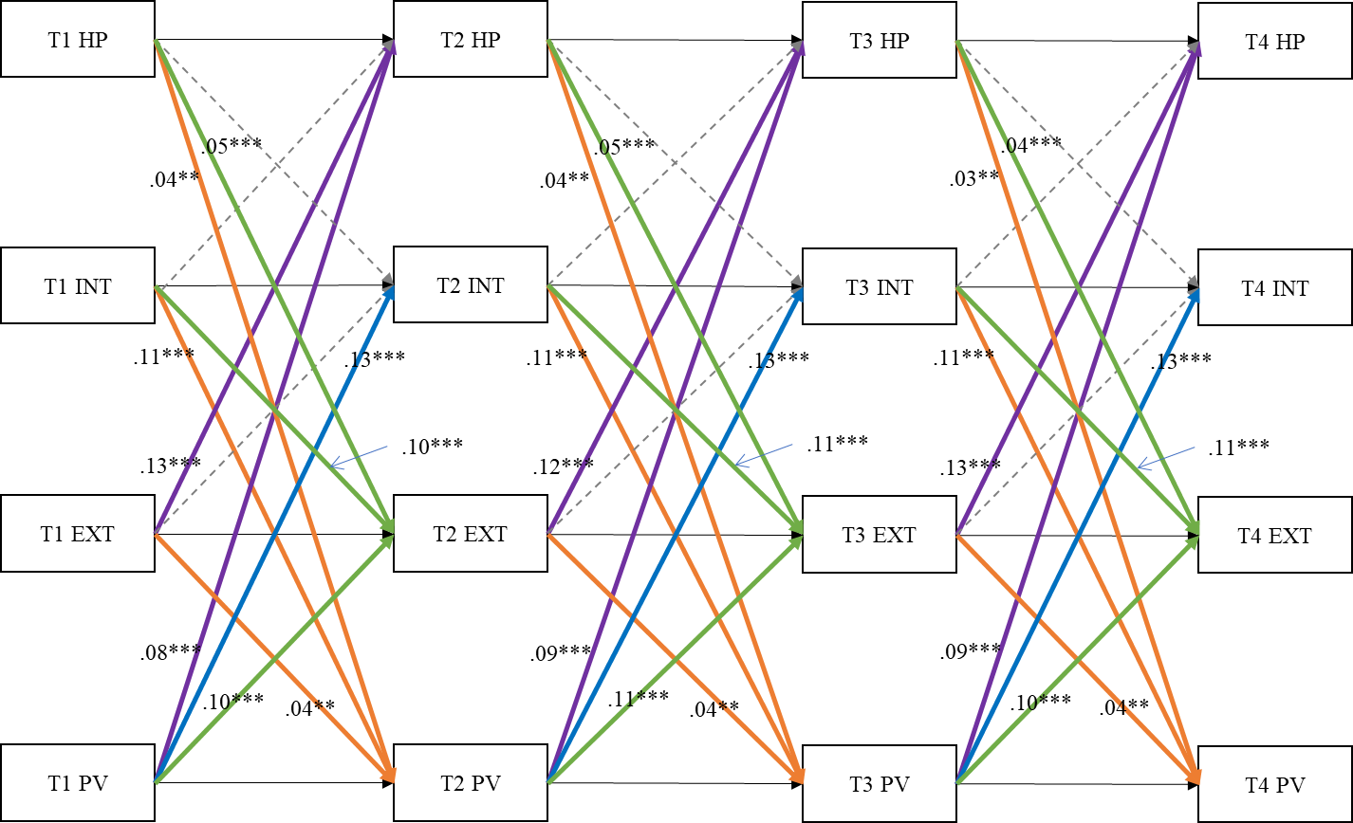

Fig. S1 Standardized path coefficients of the final CLPM for harsh punishment, internalizing and externalizing problems, and peer victimization. Dotted lines represent nonsignificant paths; solid lines represent significant paths. For simplicity, control variables, autoregressive coefficients and within-person concurrent associations are not presented in the figure. HP Harsh punishment, PC Psychological control, INT Internalizing problems, EXT Externalizing problems, PV Peer victimization.
*p < 0.05; **p < 0.01; ***p < 0.001.
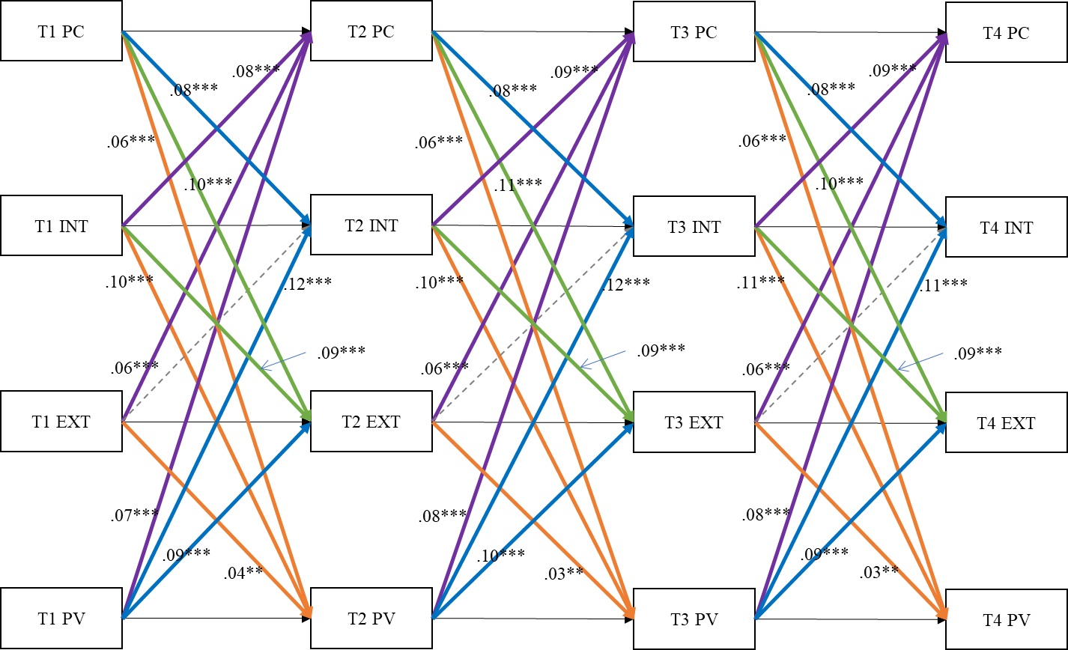

Fig. S2 Standardized path coefficients of the final CLPM for psychological control, internalizing and externalizing problems, and peer victimization. Dotted lines represent nonsignificant paths; solid lines represent significant paths. For simplicity, control variables, autoregressive coefficients and within-person concurrent associations are not presented in the figure. HP Harsh punishment, PC Psychological control, INT Internalizing problems, EXT Externalizing problems, PV Peer victimization.
**p < 0.01; ***p < 0.001.
Table S4
Fit statistics and model comparisons for CLPMs
Model | χ² | df | RMSEA | CFI | TLI | SRMR | Comparison model | ΔCFI | ΔRMSEA | ΔSRMR
Analyses of CLPMs for harsh punishment, internalizing and externalizing problems, and peer victimization
M5a: Baseline model (unconstrained model) | 680.05 | 48 | 0.053 | 0.958 | 0.854 | 0.046
M5b: Model with autoregressive paths fixed to be time-invariant | 670.52 | 56 | 0.048 | 0.959 | 0.878 | 0.046 | M1b VS M1a | <0.01 | <0.015 | <0.030
M5c: Model with cross-lagged paths fixed to be time-invariant | 700.64 | 72 | 0.043 | 0.958 | 0.903 | 0.047 | M1c VS M1a | <0.01 | <0.015 | <0.030
M5d: Model with autoregressive and cross-lagged paths fixed to be time-invariant | 707.79 | 80 | 0.041 | 0.959 | 0.913 | 0.047 | M1d VS M1a | <0.01 | <0.015 | <0.030
Analyses of CLPMs for psychological control, internalizing and externalizing problems, and peer victimization
M6a: Baseline model (unconstrained model) | 907.70 | 48 | 0.062 | 0.954 | 0.839 | 0.044
M6b: Model with autoregressive paths fixed to be time-invariant | 879.87 | 56 | 0.056 | 0.956 | 0.876 | 0.043 | M2b VS M2a | <0.01 | <0.015 | <0.030
M6c: Model with cross-lagged paths fixed to be time-invariant | 898.28 | 72 | 0.049 | 0.956 | 0.897 | 0.044 | M2c VS M2a | <0.01 | <0.015 | <0.030
M6d: Model with autoregressive and cross-lagged paths fixed to be time-invariant | 907.41 | 80 | 0.047 | 0.956 | 0.907 | 0.044 | M2d VS M2a | <0.01 | <0.015 | <0.030
Bold indicates final selected model.

Table S5
Standardized autoregressive and within-person concurrent associations coefficients for final CLPMs.
 | T1→T2 |  |  |  |  |  |  | T2→T3 |  |  |  |  |  |  | T3→T4
 | β | SE |  | p |  |  |  | β |  | SE |  | p |  |  | β |  | SE |  | p
Final CLPM for harsh punishment, internalizing and externalizing problems, and peer victimization
Autoregressive paths
HP→HP | 0.33 | 0.02 |  | <0.001 |  |  |  | 0.34 |  | 0.02 |  | <0.001 |  |  | 0.33 |  | 0.02 |  | <0.001
INT→INT | 0.50 | 0.02 |  | <0.001 |  |  |  | 0.52 |  | 0.02 |  | <0.001 |  |  | 0.51 |  | 0.02 |  | <0.001
EXT→EXT | 0.38 | 0.03 |  | <0.001 |  |  |  | 0.35 |  | 0.03 |  | <0.001 |  |  | 0.33 |  | 0.03 |  | <0.001
PV→PV | 0.51 | 0.01 |  | <0.001 |  |  |  | 0.52 |  | 0.01 |  | <0.001 |  |  | 0.52 |  | 0.02 |  | <0.001
Within-person concurrent associations
 | T1 |  |  |  | T2 |  |  |  |  |  | T3 |  |  |  |  | T4
 | β | SE | p |  | β |  | SE |  | p |  | β |  | SE | p |  | β |  | SE |  | p
HP↔INT | 0.32 | 0.02 | <0.001 |  | 0.21 |  | 0.02 |  | <0.001 |  | 0.21 |  | 0.03 | <0.001 |  | 0.15 |  | 0.02 |  | <0.001
HP↔EXT | 0.34 | 0.03 | <0.001 |  | 0.25 |  | 0.03 |  | <0.001 |  | 0.25 |  | 0.04 | <0.001 |  | 0.21 |  | 0.03 |  | <0.001
HP↔PV | 0.30 | 0.02 | <0.001 |  | 0.23 |  | 0.04 |  | <0.001 |  | 0.23 |  | 0.02 | <0.001 |  | 0.17 |  | 0.02 |  | <0.001
INT↔EXT | 0.56 | 0.02 | <0.001 |  | 0.49 |  | 0.02 |  | <0.001 |  | 0.51 |  | 0.02 | <0.001 |  | 0.49 |  | 0.02 |  | <0.001
INT↔PV | 0.44 | 0.02 | <0.001 |  | 0.34 |  | 0.02 |  | <0.001 |  | 0.30 |  | 0.02 | <0.001 |  | 0.29 |  | 0.02 |  | <0.001
PV↔EXT | 0.29 | 0.03 | <0.001 |  | 0.21 |  | 0.02 |  | <0.001 |  | 0.22 |  | 0.02 | <0.001 |  | 0.18 |  | 0.02 |  | <0.001
 | T1→T2 |  |  |  |  |  |  | T2→T3 |  |  |  |  |  |  | T3→T4
 | β | SE |  | p |  |  |  | β |  | SE |  | p |  |  | β |  | SE |  | p
Final CLPM for psychological control, internalizing and externalizing problems, and peer victimization
Autoregressive paths
PC→PC | 0.47 | 0.01 |  | <0.001 |  |  |  | 0.50 |  | 0.01 |  | <0.001 |  |  | 0.49 |  | 0.01 |  | <0.001
INT→INT | 0.49 | 0.02 |  | <0.001 |  |  |  | 0.50 |  | 0.02 |  | <0.001 |  |  | 0.49 |  | 0.02 |  | <0.001
EXT→EXT | 0.37 | 0.03 |  | <0.001 |  |  |  | 0.34 |  | 0.03 |  | <0.001 |  |  | 0.32 |  | 0.03 |  | <0.001
PV→PV | 0.51 | 0.01 |  | <0.001 |  |  |  | 0.51 |  | 0.02 |  | <0.001 |  |  | 0.52 |  | 0.01 |  | <0.001
Within-person concurrent associations
 | T1 |  |  |  | T2 |  |  |  |  |  | T3 |  |  |  |  | T4
 | β | SE | p |  | β |  | SE |  | p |  | β |  | SE | p |  | β |  | SE |  | p
PC↔INT | 0.39 | 0.02 | <0.001 |  | 0.28 |  | 0.02 |  | <0.001 |  | 0.25 |  | 0.02 | <0.001 |  | 0.22 |  | 0.02 |  | <0.001
PC↔EXT | 0.37 | 0.01 | <0.001 |  | 0.23 |  | 0.02 |  | <0.001 |  | 0.26 |  | 0.02 | <0.001 |  | 0.19 |  | 0.02 |  | <0.001
PC↔PV | 0.34 | 0.02 | <0.001 |  | 0.22 |  | 0.02 |  | <0.001 |  | 0.22 |  | 0.02 | <0.001 |  | 0.15 |  | 0.02 |  | <0.001
INT↔EXT | 0.56 | 0.02 | <0.001 |  | 0.49 |  | 0.02 |  | <0.001 |  | 0.51 |  | 0.02 | <0.001 |  | 0.48 |  | 0.02 |  | <0.001
INT↔PV | 0.44 | 0.02 | <0.001 |  | 0.34 |  | 0.02 |  | <0.001 |  | 0.29 |  | 0.02 | <0.001 |  | 0.29 |  | 0.02 |  | <0.001
PV↔EXT | 0.29 | 0.03 | <0.001 |  | 0.21 |  | 0.02 |  | <0.001 |  | 0.21 |  | 0.02 | <0.001 |  | 0.17 |  | 0.02 |  | <0.001
HP Harsh punishment, PC Psychological control, INT Internalizing problems, EXT Externalizing problems, PV Peer victimization.

Table S6
The results of the roles of control variables for final CLPMs
 | Age |  |  | Gender |  |  | SES
 | β | p |  | β | p |  | β | p
Analyses of Final CLPM for harsh punishment, internalizing and externalizing problems, and peer victimization
T1 Harsh punishment | -0.05 | <0.01 |  | -0.03 | 0.66 |  | -0.10 | <0.001
T2 Harsh punishment | -0.03 | <0.05 |  | 0.001 | 0.80 |  | -0.03 | <0.05
T3 Harsh punishment | -0.04 | <0.05 |  | -0.01 | 0.16 |  | -0.05 | <0.001
T4 Harsh punishment | -0.04 | <0.05 |  | -0.003 | 0.46 |  | -0.05 | <0.001
T1 Internalizing problems | -0.01 | 0.53 |  | 0.01 | 0.24 |  | -0.07 | <0.001
T2 Internalizing problems | 0.04 | <0.01 |  | 0.02 | 0.06 |  | 0.002 | 0.85
T3 Internalizing problems | 0.01 | 0.55 |  | -0.004 | 0.37 |  | -0.02 | 0.22
T4 Internalizing problems | -0.02 | 0.11 |  | -0.01 | 0.11 |  | 0.01 | 0.73
T1 Externalizing problems | 0.00 | 0.99 |  | -0.01 | 0.17 |  | -0.12 | <0.001
T2 Externalizing problems | 0.03 | <0.05 |  | 0.02 | 0.06 |  | -0.02 | 0.17
T3 Externalizing problems | -0.004 | 0.84 |  | -0.006 | 0.20 |  | -0.05 | <0.01
T4 Externalizing problems | 0.002 | 0.89 |  | -0.001 | 0.84 |  | -0.01 | 0.47
T1 Peer victimization | -0.02 | 0.36 |  | 0.04 | 0.06 |  | -0.04 | <0.05
T2 Peer victimization | 0.02 | 0.16 |  | -0.01 | 0.08 |  | 0.02 | 0.28
T3 Peer victimization | -0.02 | 0.22 |  | -0.01 | 0.11 |  | -0.02 | 0.24
T4 Peer victimization | -0.04 | <0.01 |  | -0.02 | 0.07 |  | 0.002 | 0.86
Analyses of Final CLPM for psychological control, internalizing and externalizing problems, and peer victimization
T1 Psychological control | -0.002 | 0.91 |  | 0.014 | 0.14 |  | -0.15 | <0.001
T2 Psychological control | 0.04 | <0.05 |  | 0.03 | 0.06 |  | -0.07 | <0.001
T3 Psychological control | 0.01 | 0.77 |  | -0.001 | 0.81 |  | -0.05 | <0.001
T4 Psychological control | 0.001 | 0.94 |  | 0.004 | 0.31 |  | -0.06 | <0.001
T1 Internalizing problems | -0.01 | 0.51 |  | 0.01 | 0.24 |  | -0.07 | <0.001
T2 Internalizing problems | 0.04 | <0.01 |  | 0.02 | 0.06 |  | 0.01 | 0.48
T3 Internalizing problems | 0.01 | 0.68 |  | -0.01 | 0.24 |  | -0.01 | 0.56
T4 Internalizing problems | -0.02 | 0.09 |  | -0.01 | 0.10 |  | 0.01 | 0.35
T1 Externalizing problems | -0.01 | 0.98 |  | -0.01 | 0.17 |  | -0.12 | <0.001
T2 Externalizing problems | 0.03 | <0.05 |  | 0.02 | 0.07 |  | -0.01 | 0. 34
T3 Externalizing problems | -0.01 | 0.56 |  | -0.01 | 0.13 |  | -0.04 | <0.05
T4 Externalizing problems | -0.003 | 0.84 |  | -0.003 | 0.49 |  | -0.003 | 0.84
T1 Peer victimization | -0.02 | 0.35 |  | 0.04 | 0.06 |  | -0.04 | <0.05
T2 Peer victimization | 0.02 | 0.22 |  | -0.02 | 0.08 |  | 0.02 | 0.18
T3 Peer victimization | -0.02 | 0.13 |  | -0.01 | 0.10 |  | -0.01 | 0.45
T4 Peer victimization | -0.04 | <0.01 |  | -0.02 | 0.07 |  | 0.01 | 0.59

Table S7

Percentile Bootstrapping analysis of the magnitude and statistical significance of indirect effects for CLPMs.
Indirect pathways | Standardized  indirect effect | 95% CI of  indirect effect | SE of  indirect effect | Total effect | SE of  total effect | 95% CI of total effect
Final CLPM for harsh punishment, internalizing and externalizing problems, and peer victimization
T1 HP→T2 INT→T3 PV | 0.001 | -0.002, 0.003 | 0.001 | 0.04 | 0.010 | 0.017, 0.054
T1 HP→T2 EXT→T3 PV | 0.002 | 0.000, 0.003 | 0.001 | 0.04 | 0.010 | 0.017, 0.054
T2 HP→T3 INT→T4 PV | 0.001 | -0.002, 0.004 | 0.001 | 0.04 | 0.009 | 0.016, 0.052
T2 HP→T3 EXT→T4 PV | 0.002 | 0.000, 0.003 | 0.001 | 0.04 | 0.009 | 0.016, 0.052
T1 PV→T2 INT→T3 HP | 0.001 | - 0.002, 0.006 | 0.002 | 0.09 | 0.010 | 0.060, 0.103
T1 PV→T2 EXT→T3 HP | 0.013 | 0.008, 0.017 | 0.002 | 0.09 | 0.010 | 0.060, 0.103
T2 PV→T3 INT→T4 HP | 0.001 | - 0.002, 0.007 | 0.002 | 0.09 | 0.010 | 0.064, 0.109
T2 PV→T3 EXT→T4 HP | 0.014 | 0.008, 0.018 | 0.003 | 0.09 | 0.010 | 0.064, 0.109
Final CLPM for psychological control, internalizing and externalizing problems, and peer victimization
T1 PC→T2 INT→T3 PV | 0.008 | 0.005, 0.011 | 0.001 | 0.07 | 0.011 | 0.048, 0.090
T1 PC→T2 EXT→T3 PV | 0.003 | 0.001, 0.006 | 0.001 | 0.07 | 0.011 | 0.048, 0.090
T2 PC→T3 INT→T4 PV | 0.008 | 0.005, 0.011 | 0.001 | 0.07 | 0.011 | 0.051, 0.095
T2 PC→T3 EXT→T4 PV | 0.004 | 0.001, 0.006 | 0.001 | 0.07 | 0.011 | 0.051, 0.095
T1 PV→T2 INT→T3 PC | 0.010 | 0.007, 0.013 | 0.002 | 0.09 | 0.009 | 0.072, 0.115
T1 PV→T2 EXT→T3 PC | 0.006 | 0.003, 0.008 | 0.001 | 0.09 | 0.009 | 0.072, 0.115
T2 PV→T3 INT→T4 PC | 0.010 | 0.007, 0.013 | 0.002 | 0.09 | 0.009 | 0.072, 0.116
T2 PV→T3 EXT→T4 PC | 0.006 | 0.003, 0.008 | 0.001 | 0.09 | 0.009 | 0.072, 0.116
HP Harsh punishment, PC Psychological control, INT Internalizing problems, EXT Externalizing problems, PV Peer victimization;
Bold indicates statistically significant indirect effects.

Table S8
Fit statistics and model comparisons of gender difference for CLPMs
Model | χ² | df | RMSEA | CFI | TLI | SRMR | Comparison model | ΔCFI | ΔRMSEA | ΔSRMR
Analyses of gender difference in CLPMs for harsh punishment, internalizing and externalizing problems, and peer victimization
M7a. M5d freely estimated across genders | 805.12 | 160 | 0.041 | 0.954 | 0.913 | 0.051
M7b. M5d fixed autoregressive effects to be equal across genders | 843.23 | 164 | 0.042 | 0.952 | 0.910 | 0.053 | M3b VS M3a | <0.01 | <0.015 | <0.030
M7c. M5d fixed cross-lagged effects to be equal across genders | 836.99 | 172 | 0.040 | 0.953 | 0.916 | 0.056 | M3c VS M3a | <0.01 | <0.015 | <0.030
M7d. M5d fixed autoregressive and cross-lagged effects to be equal across genders | 902.87 | 176 | 0.042 | 0.948 | 0.910 | 0.058 | M3d VS M3a | <0.01 | <0.015 | <0.030
Analyses of gender difference in CLPMs for psychological control, internalizing and externalizing problems, and peer victimization
M8a. M6d freely estimated across genders | 979.14 | 160 | 0.047 | 0.953 | 0.910 | 0.049
M8b. M6d fixed autoregressive effects to be equal across genders | 1011.09 | 164 | 0.047 | 0.951 | 0.909 | 0.050 | M4b VS M4a | <0.01 | <0.015 | <0.030
M8c. M6d fixed cross-lagged effects to be equal across genders | 1011.53 | 172 | 0.045 | 0.952 | 0.914 | 0.051 | M4c VS M4a | <0.01 | <0.015 | <0.030
M8d. M6d fixed autoregressive and cross-lagged effects to be equal across genders | 1069.81 | 176 | 0.046 | 0.948 | 0.911 | 0.055 | M4d VS M4a | <0.01 | <0.015 | <0.030

Section 4
The Alternate Models for Physical Victimization and Relational Victimization

In the main analysis, peer victimization was measured with a composite score of two subscales, including physical victimization and relational victimization; alternate models for physical victimization and relational victimization thus were conducted separately to test the robustness of the results. Specifically, four RI-CLPMs were conducted: (1) RI-CLPMs of harsh punishment, internalizing and externalizing problems, and physical victimization (M_S1); (2) RI-CLPMs of harsh punishment, internalizing and externalizing problems, and relational victimization (M_S2); (3) RI-CLPMs of psychological control, internalizing and externalizing problems, and physical victimization (M_S3); (4) RI-CLPMs of psychological control, internalizing and externalizing problems, and relational victimization (M_S4). For M_S1-M_S4, setting the autoregressive paths or the cross-lagged paths or both the autoregressive and cross-lagged paths to be equal over time did not significantly decrease the fit of the unconstrained model. Thus, the constrained models were chosen using cross-wave equality constraints on both autoregressive and cross-lagged effects for M_S1-M_S4.
The results of final M_S1-M_S4 are summarized in Fig. S3-S6. The results showed that there was no statistically significant difference in the results between M_S1 and M_S2, as well as M_S3 and M_S4, except for some slight differences in the absolute values of the coefficients. Moreover, by comparing the models via composite scores of physical and relational victimization, only a few minor changes emerged for some path coefficients in these four models, none of which affected the main conclusions of the study.

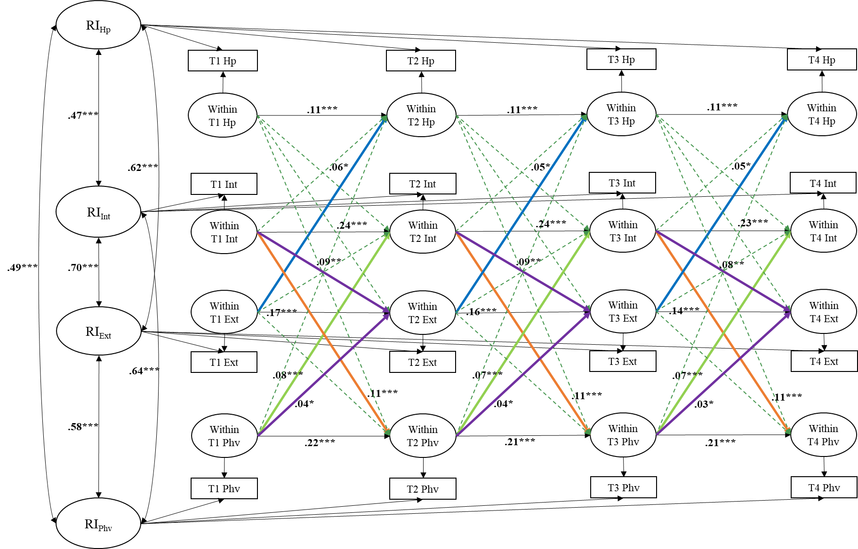
Fig. S3 Standardized path coefficients of the final RI-CLPM for harsh punishment, internalizing and externalizing problems, and physical victimization. Dotted lines represent nonsignificant paths; solid lines represent significant paths. For simplicity, control variables and within-person concurrent associations are not presented in the figure. RI Random intercept, HP Harsh punishment, INT Internalizing problems, EXT Externalizing problems, PHV Physical victimization.
*p < 0.05; **p < 0.01; ***p < 0.001.
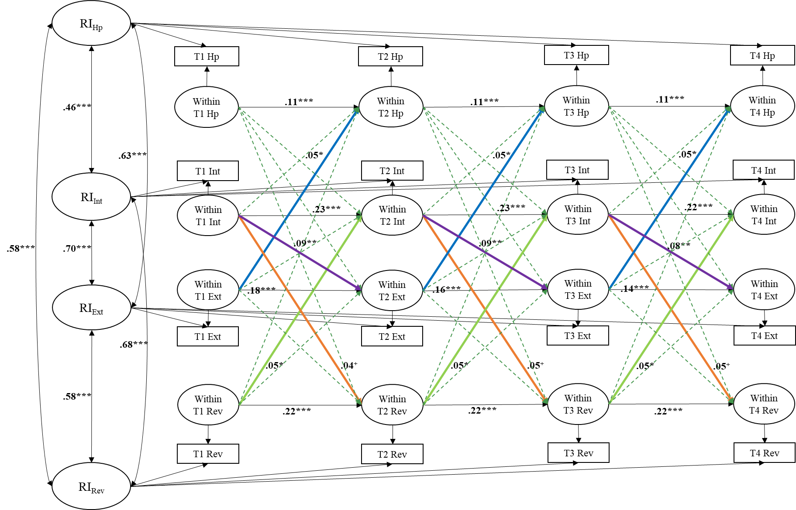
Fig. S4 Standardized path coefficients of the final RI-CLPM for harsh punishment, internalizing and externalizing problems, and relational victimization. Dotted lines represent nonsignificant paths; solid lines represent significant paths. For simplicity, control variables and within-person concurrent associations are not presented in the figure. RI Random intercept, HP Harsh punishment, INT Internalizing problems, EXT Externalizing problems, REV Relational victimization.
⁺p < 0.10; *p < 0.05; **p < 0.01; ***p < 0.001.
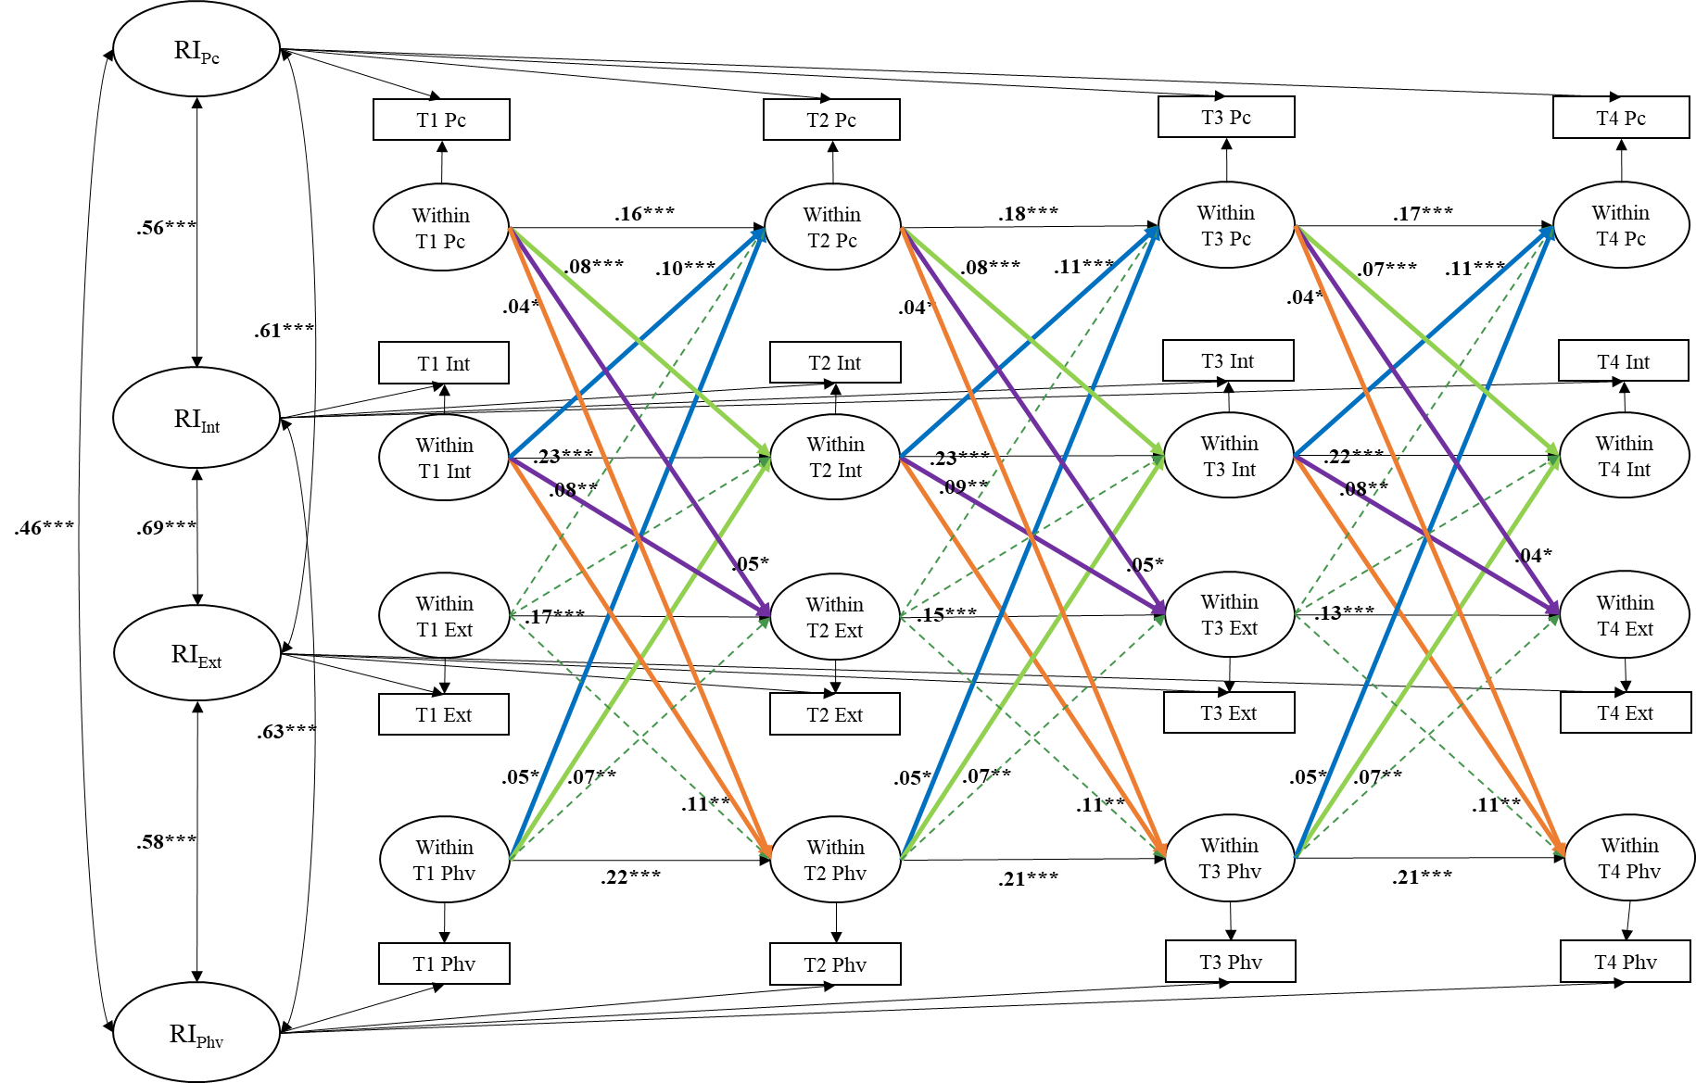
Fig. S5 Standardized path coefficients of the final RI-CLPM for psychological control, internalizing and externalizing problems, and physical victimization. Dotted lines represent nonsignificant paths; solid lines represent significant paths. For simplicity, control variables and within-person concurrent associations are not presented in the figure. RI Random intercept, PC Psychological control, INT Internalizing problems, EXT Externalizing problems, PHV Physical victimization.
*p < 0.05; **p < 0.01; ***p < 0.001.
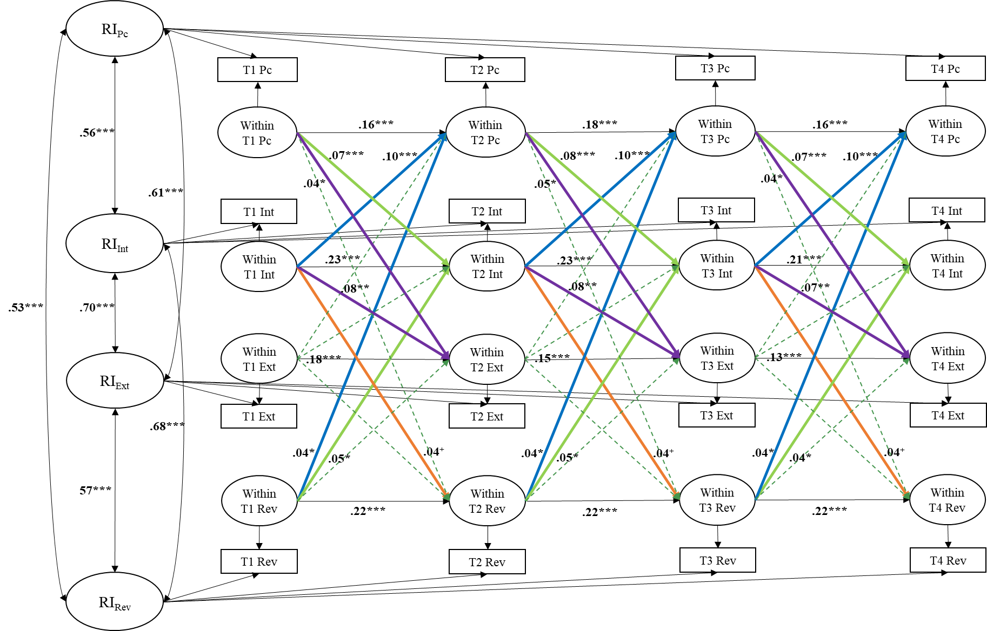
Fig. S6 Standardized path coefficients of the final RI-CLPM for psychological control, internalizing and externalizing problems, and relational victimization. Dotted lines represent nonsignificant paths; solid lines represent significant paths. For simplicity, control variables and within-person concurrent associations are not presented in the figure. RI Random intercept, PC Psychological control, INT Internalizing problems, EXT Externalizing problems, REV Relational victimization.
⁺p < 0.10; *p < 0.05; **p < 0.01; ***p < 0.001.

