Supplementary figure for

Gene-environment interplays between family chaos and emotional problems among Nigerian adolescents: A twin study

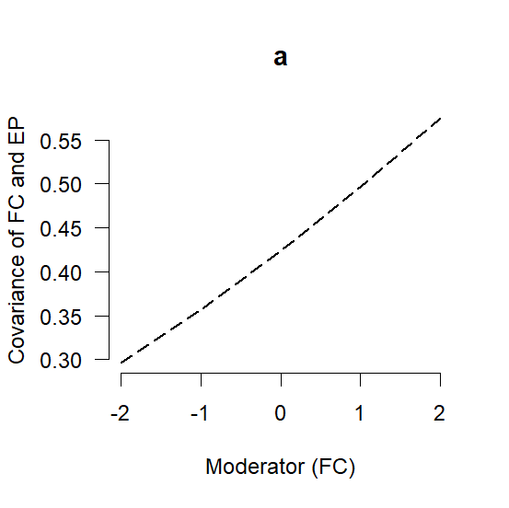
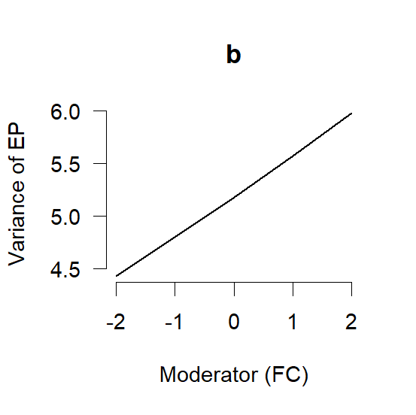

Note. Unbroken line indicates significant moderation while broken line indicates non-significant moderation.

Figure S1. Moderation of Variance in Emotional Problems (EP – b) and its covariance with Family Chaos (FC – a) by FC.

