**Supplementary Material**

**Results of the best fit model**

To fit the optimal model, we present the final models obtained through a stepwise elimination procedure for fixed effects and a forward fitting procedure for random effects. In Table S1 and S2, summarized are the final best fit model in which the parametric coefficients indicated a significant difference between the reference level (i.e., Congruent condition in TD group) as well as the other Group-condition interactions (i.e., Incongruent condition in TD group, Congruent condition in ADHD group, Incongruent condition in ADHD group). Additionally, in Table S1 and S2, the smooth terms (by abbreviation, "s") S1 and S2 revealed the significance of nonlinear patterns associated with the predictor variables. For instance, the notation of "s(Time): Congruent.TD" represented the smooth Congruent condition in the TD group. While the *edf* values from the GAMM results reflected the degree of non-linearity of a curve with values equivalent to 1, which indicated a linear relationship as well as those greater than 1 implied non-linear relationships. Furthermore, the Ref.df values in these tables provided the number of reference degrees of freedom used for hypothesis testing in relation to the associated F-value. In Table S1, a summary of the GAMM model results included Object and Face AOIs, while Table S2 included Eye and Mouth AOIs. Finally, shown in Figure S1 and S2, are the difference plots of interest areas for the Groups and Conditions of Time Window-2 using GAMM as seen in Table S1 and S2.

**Table S1**. The effect of group, condition and time for face and object AOIs

|  |  |  |  |  |  |  |  |  |
| --- | --- | --- | --- | --- | --- | --- | --- | --- |
| ***Area of Interest: Object*** | ***Time Window-1*** | | | | ***Time Window-2*** | | | |
| *Parametric coefficients:* | Estimate | SE | t | p | Estimate | SE | t | p |
| (Intercept) | − | − | − | − | -0.29 | 0.53 | -0.55 | 0.58 |
| Incongruent.TD | − | − | − | − | -0.76 | 0.67 | -1.14 | 0.25 |
| Congruent.ADHD | − | − | − | − | -0.46 | 0.34 | -1.34 | 0.18 |
| Incongruent.ADHD | − | − | − | − | -1.23 | 0.75 | -1.64 | 0.10 |
| *Smooth terms:* | edf | Ref.df | F | p | edf | Ref.df | F | p |
| s(Time):Congruent.TD | − | − | − | − | 8.37 | 8.51 | 29.54 | <.001 |
| s(Time):Incongruent.TD | − | − | − | − | 6.00 | 6.39 | 4.54 | <.001 |
| s(Time):Congruent.ADHD | − | − | − | − | 7.24 | 7.51 | 10.14 | <.001 |
| s(Time):Incongruent.ADHD | − | − | − | − | 7.74 | 7.98 | 4.02 | <.001 |
| s(Time,Subject) | − | − | − | − | 493.22 | 539.00 | 20.80 | <.001 |
| s(Time,Trial) | − | − | − | − | 126.35 | 143.00 | 24.03 | <.001 |
| ***Area of Interest: Face*** | ***Time Window-1*** | | | | ***Time Window-2*** | | | |
| *Parametric coefficients:* | Estimate | SE | t | p | Estimate | SE | t | p |
| (Intercept) | 0.41 | 0.20 | 2.04 | <.05 | -1.61 | 0.20 | -7.93 | <.001 |
| Incongruent.TD | 0.43 | 0.23 | 1.85 | 0.06 | 0.12 | 0.20 | 0.60 | 0.55 |
| Congruent.ADHD | -0.04 | 0.17 | -0.21 | 0.83 | 0.21 | 0.21 | 0.99 | 0.32 |
| Incongruent.ADHD | 0.12 | 0.28 | 0.43 | 0.67 | 0.62 | 0.29 | 2.13 | <.05 |
| *Smooth terms:* | edf | Ref.df | F | p | edf | Ref.df | F | p |
| s(Time):Congruent.TD | 3.53 | 4.33 | 11.81 | <.001 | 3.31 | 4.02 | 2.68 | <.05 |
| s(Time):Incongruent.TD | 2.99 | 3.65 | 8.06 | <.001 | 2.51 | 2.99 | 2.96 | <.05 |
| s(Time):Congruent.ADHD | 3.48 | 4.27 | 11.47 | <.001 | 1.03 | 1.04 | 1.84 | 0.17 |
| s(Time):Incongruent.ADHD | 3.47 | 4.26 | 12.57 | <.001 | 3.36 | 4.08 | 1.39 | 0.27 |
| s(Time,Subject) | 165.22 | 538.00 | 1.93 | <.001 | 201.25 | 539.00 | 4.32 | <.001 |
| s(Time,Trial) | 43.98 | 142.00 | 3.40 | <.001 | 62.00 | 143.00 | 3.76 | <.001 |

Summary of the results of the GAMM model for the effect of Group, Condition and Time for Object and Face AOIs, showing the parametric coefficients and approximate significance of smooth terms in the model: estimated degrees of freedom (edf), reference degrees of freedom (Ref.df), F- and p- values for smooth terms.

**Table S2**.The effect of group, condition and time for eye and mouth AOIs

|  |  |  |  |  |  |  |  |  |
| --- | --- | --- | --- | --- | --- | --- | --- | --- |
| ***Area of Interest: Eye*** | ***Time Window-1*** | | | | ***Time Window-2*** | | | |
| *Parametric coefficients:* | Estimate | SE | t | p | Estimate | SE | t | p |
| (Intercept) | -1.27 | 0.18 | -6.93 | <.001 | -1.56 | 0.25 | -6.35 | <.001 |
| Incongruent.TD | -0.37 | 0.22 | -1.68 | 0.09 | -0.38 | 0.32 | -1.16 | 0.25 |
| Congruent.ADHD | -0.11 | 0.15 | -0.73 | 0.46 | 0.08 | 0.14 | 0.60 | 0.55 |
| Incongruent.ADHD | -0.42 | 0.26 | -1.64 | 0.10 | -0.25 | 0.35 | -0.72 | 0.47 |
| *Smooth terms:* | edf | Ref.df | F | p | edf | Ref.df | F | p |
| s(Time):Congruent.TD | 3.67 | 4.39 | 4.98 | <.001 | 2.32 | 2.76 | 1.10 | 0.36 |
| s(Time):Incongruent.TD | 2.77 | 3.29 | 3.06 | <.05 | 1.00 | 1.01 | 0.44 | 0.51 |
| s(Time):Congruent.ADHD | 3.33 | 3.96 | 3.88 | <.01 | 3.56 | 4.28 | 3.67 | <.01 |
| s(Time):Incongruent.ADHD | 2.72 | 3.21 | 2.12 | 0.09 | 4.18 | 5.05 | 3.31 | <.01 |
| s(Time,Subject) | 243.01 | 539.00 | 2.92 | <.001 | 198.57 | 540.00 | 2.40 | <.001 |
| s(Time,Trial) | 72.21 | 143.00 | 5.36 | <.001 | 63.03 | 144.00 | 8.26 | <.001 |
| ***Area of Interest: Mouth*** | ***Time Window-1*** | | | | ***Time Window-2*** | | | |
| *Parametric coefficients:* | Estimate | SE | t | p | Estimate | SE | t | p |
| (Intercept) | -2.53 | 0.05 | -51.50 | <.001 | -2.52 | 0.08 | -29.93 | <.001 |
| Incongrunet.TD | -0.10 | 0.05 | -2.02 | <.05 | -0.04 | 0.11 | -0.36 | 0.72 |
| Congruent.ADHD | -0.04 | 0.05 | -0.73 | 0.47 | 0.05 | 0.05 | 0.94 | 0.35 |
| Incongruent.ADHD | -0.08 | 0.07 | -1.13 | 0.26 | 0.00 | 0.12 | 0.01 | 0.99 |
| *Smooth terms:* | edf | Ref.df | F | p | edf | Ref.df | F | p |
| s(Time):Congruent.TD | 6.35 | 7.43 | 3.13 | <.01 | 6.29 | 7.21 | 2.62 | <.05 |
| s(Time):Incongruent.TD | 2.09 | 2.45 | 0.80 | 0.39 | 5.02 | 5.86 | 2.65 | <.05 |
| s(Time):Congruent.ADHD | 4.41 | 5.33 | 3.79 | <.01 | 6.84 | 7.71 | 4.39 | <.001 |
| s(Time):Incongruent.ADHD | 1.00 | 1.01 | 1.24 | 0.26 | 6.39 | 7.31 | 2.90 | <.01 |
| s(Time,Subject) | 239.96 | 539.00 | 2.21 | <.001 | 220.39 | 538.00 | 1.75 | <.001 |
| s(Time,Trial) | 43.94 | 143.00 | 1.53 | <.001 | 86.41 | 142.00 | 4.36 | <.001 |

Summary of the results of the GAMM model for the effect of Group, Condition and Time for Eye and Mouth AOIs, showing the parametric coefficients and approximate significance of smooth terms in the model: estimated degrees of freedom (edf), reference degrees of freedom (Ref.df), F- and p- values for smooth terms.

**Interactions between SRS scores and eye-movements**

To determine a link between participants’ scores regarding autistic traits evaluated by SRS and participants’ eye-movements, we added smoothing function of SRS-scores to the model. Therefore, the GAMM included smoothing function for the variables SRS-scores, categorical variable Group (TD, ADHD), random effect of Trial and Subject, and the proportion of fixations to AOIs as a dependent variable. Also, presented in Table S3, are the differences of using an ordered factor difference smooth for SRS-Scores. In Figure S1, on the other hand, smooth and difference plots showed the differences between groups for all AOIs.

**Table S3.** Interactions between SRS scores and proportion of fixations on AOIs

|  |  |  |  |  |
| --- | --- | --- | --- | --- |
|  | edf | Ref.df | F | p |
| ***Area of Interest: Face*** |  |  |  |  |
| s(SRS-Total):Congruent.Group.O | 1.00 | 1.00 | 1.02 | 0.91 |
| s(SRS-Total):Incongruent. Group.O | 1.01 | 1.01 | 0.03 | 0.87 |
| ***Area of Interest: Object*** |  |  |  |  |
| s(SRS-Total):Congruent. Group.O | 1.00 | 1.00 | 1.50 | 0.22 |
| s(SRS-Total):Incongruent. Group.O | 1.00 | 1.01 | 0.55 | 0.46 |
| ***Area of Interest: Eye*** |  |  |  |  |
| s(SRS-Total):Congruent.Group.O | 1.00 | 1.01 | 0.14 | 0.71 |
| s(SRS-Total):Incongruent. Group.O | 1.00 | 1.00 | 0.72 | 0.40 |
| ***Area of Interest: Mouth*** |  |  |  |  |
| s(SRS-Total):Congruent.Group.O | 1.00 | 1.00 | 0.05 | 0.82 |
| s(SRS-Total):Incongruent.Group.O | 1.00 | 1.00 | 0.09 | 0.77 |

GAMM results of the ordered factors with contrast treatment, showing SRS-Total, Group with the approximate significance of smooth terms in the model for four AOIs of Time Window-2: estimated degrees of freedom (edf), reference degrees of freedom (Ref.df), F- and p- values for smooth terms. Ordered factors with contrast treatment: Congruent.Group.O = TD-ADHD contrast of the Congruent condition; Incongruent.Group.O = TD-ADHD contrast of the Incongruent condition; s = smooth term

**Figure S1.** Comparison of proportion of fixations on AOIs between groups

Smooth (left) and difference (right) plots of Group factors for the AOIs using GAMMs. Shaded areas indicate windows of significant differences in the difference plots.

**GAMM results for the Condition factor**

In the current study, to reveal differences between the two Conditions (Congruent and Incongruent), we set the contrasts of the ordered factor to contrast treatment (see Table S4). Furthermore, the proportion of fixations (Elog) to Object and Face AOIs against time and the difference plots of Object and face AOIs for the Conditions of Time Window-2 (TW-2) are shown in Figure 2. Similarly, the proportion of fixations (Elog) to the Eye and Mouth AOIs against time and the difference plots for Time Window-2 (TW-2) are shown in Figure 3.

**Table S4.** Comparisons of proportion of fixations on AOIs between conditions

|  |  |  |  |  |  |  |  |  |
| --- | --- | --- | --- | --- | --- | --- | --- | --- |
|  | ***Time Window-1*** | | | | ***Time Window-2*** | | | |
|  | edf | Ref.df | F | p | edf | Ref.df | F | p |
| ***Area of Interest: Object*** |  |  |  |  |  |  |  |  |
| s(Time):Condition.O | − | − | − | − | 5.25 | 5.62 | 3.75 | <.001 |
| s(Time):TD.Condition.O | − | − | − | − | 5.90 | 6.52 | 4.79 | <.001 |
| s(Time):ADHD. Condition.O | − | − | − | − | 6.26 | 6.88 | 4.42 | <.001 |
| ***Area of Interest: Face*** |  | | | |  | | | |
| s(Time):Condition.O | 1.11 | 1.17 | 0.32 | 0.96 | 1.18 | 1.25 | 0.58 | 0.41 |
| s(Time):TD.Condition.O | 2.03 | 2.49 | 0.96 | 0.35 | 1.01 | 1.01 | 3.03 | 0.08 |
| s(Time):ADHD. Condition.O | 1.00 | 1.00 | 0.25 | 0.62 | 2.98 | 3.65 | 1.17 | 0.25 |
| ***Area of Interest:Eye*** |  | | | |  | | | |
| s(Time):Condition.O | 1.00 | 1.00 | 0.91 | 0.34 | 1.49 | 1.67 | 0.19 | 0.72 |
| s(Time):TD.Condition.O | 1.00 | 1.01 | 0.65 | 0.42 | 1.69 | 1.97 | 0.51 | 0.56 |
| s(Time):ADHD. Condition.O | 1.01 | 1.01 | 1.07 | 0.30 | 3.22 | 3.91 | 1.39 | 0.31 |
| ***Area of Interest: Mouth*** |  | | | |  | | | |
| s(Time):Condition.O | 3.90 | 4.71 | 2.18 | 0.08 | 3.49 | 3.91 | 1.21 | 0.34 |
| s(Time):TD.Condition.O | 1.24 | 1.38 | 0.05 | 0.89 | 1.51 | 1.64 | 0.23 | 0.69 |
| s(Time):ADHD. Condition.O | 2.27 | 2.77 | 1.57 | 0.20 | 6.00 | 7.03 | 2.49 | <.05 |

GAMM results of the ordered factors of Conditions with contrast treatment for all AOIs, showing the parametric coefficients and approximate significance of smooth terms in the model: estimated degrees of freedom (edf), reference degrees of freedom (Ref.df), F- and p- values for smooth terms. Ordered factors with contrast treatment: Condition.O = Congruent-Incongruent contrast; TD.Condition.O = Congruent-Incongruent contrast of the TD group; ADHD.Condition.O = Congruent-Incongruent contrast of the ADHD group; s = smooth term

**Figure S2.** Comparisons of conditions in object and face AOIs

Smooth (left) and difference (right) plots of Condition factors for the Object and Face AOIs using GAMMs. Shaded areas indicate windows of significant differences in the difference plots.

**Figure S3.** Comparisons of conditions in eye and mouth AOIs

Smooth (left) and difference (right) plots of Condition factors for the Eye and Mouth AOIs using GAMMs. Shaded areas indicate windows of significant differences in the difference plots.

**GAMM results for the gender of the face stimuli**

To reveal whether the gender of the face stimuli has an effect on fixations, we compared the female face and the male face on the stimuli (i.e., whether a male or female face was presented). As the congruent (the corner where the object appeared) or incongruent (the opposite corner with no object) gaze emerged in TW-2, we present here only the analysis results for TW-2 regarding the effect of the gender of the face stimuli. We set the contrasts of the ordered factor to contrast treatment (see Table S5). In Figure S4, smooth and difference plots showed the differences between a male or female face stimuli for object and face AOIs of Time Window-2 (TW-2), while smooth and difference plots for eye and mouth AOIs of Time Window-2 (TW-2) are shown in Figure S5.

**Table S5.** Comparison of proportion of fixations between the gender of the face stimuli for all AOIs in TW-2

|  |  |  |  |  |  |  |  |  |
| --- | --- | --- | --- | --- | --- | --- | --- | --- |
|  | ***Area of Interest:Object*** | | | | ***Area of Interest:Face*** | | | |
|  | edf | Ref.df | F | p | edf | Ref.df | F | p |
| s(Time):Gender.O | 2.38 | 2.66 | 0.54 | 0.54 | 1.00 | 1.01 | 2.27 | 0.13 |
| s(Time):Control.Gender.O | 8.68 | 8.94 | 12.77 | <.01 | 1.96 | 2.34 | 2.66 | 0.06 |
| s(Time):ADHD.Gender.O | 1.00 | 1.01 | 0.01 | 0.95 | 2.60 | 3.16 | 0.85 | 0.41 |
|  | ***Area of Interest:Eye*** | | | | ***Area of Interest:Mouth*** | | | |
|  | edf | Ref.df | F | p | edf | Ref.df | F | p |
| s(Time):Gender.O | 1.00 | 1.00 | 0.01 | 0.99 | 1.02 | 1.03 | 0.05 | 0.85 |
| s(Time):Control.Gender.O | 1.65 | 1.98 | 0.38 | 0.66 | 1.01 | 1.01 | 0.16 | 0.73 |
| s(Time):ADHD.Gender.O | 1.00 | 1.00 | 0.08 | 0.78 | 1.01 | 1.02 | 0.01 | 0.97 |

GAMM results of the ordered factors with contrast treatment for all AOIs, showing the parametric coefficients and approximate significance of smooth terms in the model: estimated degrees of freedom (edf), reference degrees of freedom (Ref.df), F- and p- values for smooth terms. Ordered factors with contrast treatment: Gender.O= the female and the male contrast in both groups; Control.Gender.O = the female and the male contrast in Control group; ADHD.Gender.O = the female and the male contrast in ADHD group; s = smooth term.

**Figure S4.** Comparisons of the gender of the face stimuli in object and face AOIs in TW-2

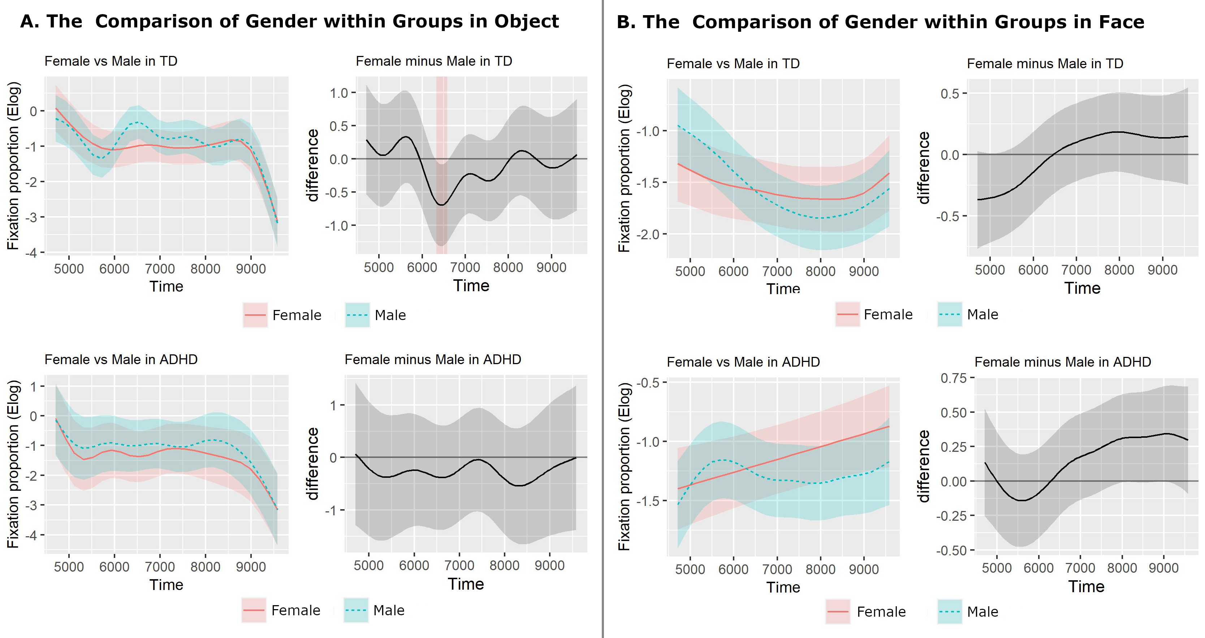

Smooth (left) and difference (right) plots of Condition factors for the Object and Face AOIs using GAMMs. Shaded areas indicate windows of significant differences in the difference plots.

**Figure S5.** Comparisons of the gender of the face stimuli in eye and mouth AOIs in TW-2

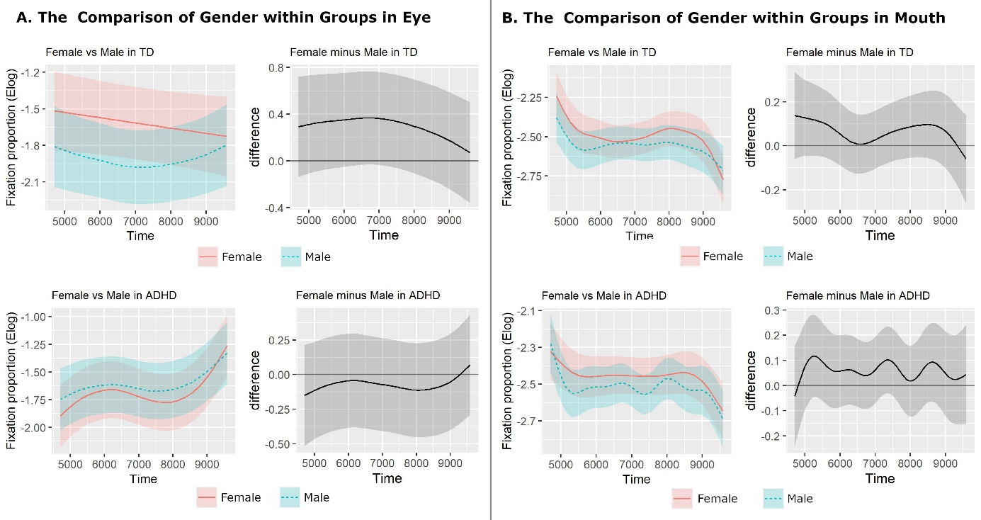

Smooth (left) and difference (right) plots of Condition factors for the Object and Face AOIs using GAMMs. Shaded areas indicate windows of significant differences in the difference plots.