Supplemental Table 1. Reliability of the 2D:4D from duplicate finger measurements in Colombian adolescents

 | Mean 2D:4D ± SD |  |  | Median (IQR) |  |  | Maximum difference |  | Variance |  |  | ICC
 | Measure 1 | Measure 2 |  | Measure 1 | Measure 2 |  |  |  | Between | Within
Boys
Right hand | 0.952 ± 0.031 | 0.953 ± 0.032 |  | 0.953 (0.931, 0.973) | 0.954 (0.933, 0.972) |  | 0.058 |  | 0.000876 | 0.000113 |  | 0.89
Left hand | 0.962 ± 0.033 | 0.963 ± 0.032 |  | 0.961 (0.936, 0.982) | 0.962 (0.939, 0.984) |  | 0.043 |  | 0.000978 | 0.000091 |  | 0.91
Girls
Right hand | 0.956 ± 0.033 | 0.958 ± 0.033 |  | 0.955 (0.933, 0.977) | 0.957 (0.934, 0.980) |  | 0.074 |  | 0.000955 | 0.000117 |  | 0.89
Left hand | 0.968 ± 0.037 | 0.970 ± 0.037 |  | 0.967 (0.943, 0.991) | 0.968 (0.944, 0.995) |  | 0.064 |  | 0.00127 | 0.000113 |  | 0.92
Abbreviations: 2D:4D, second-to-fourth digit ratio; ICC, intraclass correlation coefficient

Supplemental Table 2. Sociodemographic characteristics and 2D:4D in adolescent boys from the Bogotá School Children Cohort

Characteristics¹ | 2D:4D quintile (median right hand / left hand) |  |  |  |  | P, trend²
 | 1  n = 91  (0.91/0.92) | 2  n = 92  (0.94/0.94) | 3  n = 92  (0.95/0.96) | 4  n = 92  (0.97/0.98) | 5  n = 91  (0.99/1.00)
Right hand
Age (years) | 14.1 ± 1.7 | 14.8 ± 1.7 | 15.0 ± 1.6 | 14.5 ± 1.8 | 15.0 ± 1.5 | 0.002
Height-for-age Z score³ | -0.82 ± 0.9 | -0.52 ± 0.9 | -0.65 ± 1.0 | -0.78 ± 0.9 | -0.55 ± 0.8 | 0.24
Body mass index-for-age Z score³ | -0.12 ± 1.0 | -0.32 ± 1.1 | -0.27 ± 1.0 | -0.15 ± 1.0 | 0.09 ± 1.1 | 0.11
Left handedness, % | 11.0 | 3.3 | 13.0 | 9.8 | 7.7 | 0.99
Screen time (hours/week)⁴ | 20.6 ± 16 | 22.6 ± 15 | 21.9 ± 15 | 23.1 ± 15 | 25.6 ± 17 | 0.05
Maternal education (years) | 9.4 ± 3.7 | 9.6 ± 3.6 | 9.7 ± 3.7 | 9.5 ± 3.3 | 9.4 ± 3.1 | 0.85
Maternal parity | 2.8 ± 1.2 | 2.8 ± 1.1 | 2.7 ± 1.0 | 2.7 ± 1.0 | 2.8 ± 1.1 | 0.84
Maternal height (cm) | 155.6 ± 6.7 | 157.2 ± 5.4 | 157.5 ± 7.6 | 157.5 ± 5.4 | 156.9 ± 6.5 | 0.17
Maternal body mass index (kg/m²) | 25.1 ± 3.6 | 25.4 ± 4.0 | 24.9 ± 3.6 | 25.4 ± 4.1 | 25.6 ± 4.0 | 0.39
Food insecurity with hunger, % | 19.8 | 18.5 | 11.0 | 10.9 | 14.3 | 0.11
Socioeconomic status⁵ | 2.5 ± 0.7 | 2.6 ± 0.7 | 2.5 ± 0.6 | 2.5 ± 0.7 | 2.5 ± 0.6 | 0.56
Left hand
Age (years) | 14.5 ± 1.8 | 14.8 ± 1.6 | 14.9 ± 1.6 | 14.6 ± 1.8 | 14.7 ± 1.6 | 0.78
Height-for-age Z score³ | -0.59 ± 0.9 | -0.64 ± 0.9 | -0.86 ± 1.0 | -0.67 ± 0.9 | -0.56 ± 0.9 | 0.91
Body mass index-for-age Z score³ | -0.13 ± 1.0 | -0.31 ± 1.1 | -0.28 ± 1.0 | -0.16 ± 1.0 | 0.11 ± 1.1 | 0.05
Left handedness, % | 7.7 | 8.7 | 13.0 | 6.5 | 8.8 | 0.99
Screen time (hours/week)⁴ | 20.2 ± 14 | 21.3 ± 17 | 24.1 ± 15 | 23.1 ± 15 | 25.1 ± 16 | 0.02
Maternal education (years) | 9.5 ± 3.5 | 9.5 ± 3.6 | 9.6 ± 3.7 | 9.9 ± 3.6 | 9.2 ± 2.9 | 0.74
Maternal parity | 2.8 ± 1.2 | 2.7 ± 1.1 | 2.9 ± 1.0 | 2.7 ± 0.9 | 2.7 ± 1.1 | 0.39
Maternal height (cm) | 156.4 ± 6.4 | 157.4 ± 6.8 | 157.0 ± 6.2 | 155.9 ± 6.0 | 157.8 ± 6.6 | 0.49
Maternal body mass index (kg/m²) | 25.3 ± 3.9 | 25.1 ± 3.9 | 25.3 ± 3.8 | 25.2 ± 3.8 | 25.6 ± 4.0 | 0.63
Food insecurity with hunger, % | 23.1 | 14.3 | 15.2 | 13.0 | 8.8 | 0.01
Socioeconomic status⁵ | 2.5 ± 0.6 | 2.6 ± 0.7 | 2.6 ± 0.7 | 2.6 ± 0.6 | 2.5 ± 0.7 | 0.85

¹ Data are means ± SD unless noted otherwise.
² For dichotomous variables, Cochran-Armitage test. For continuous variables, Wald test for an ordinal variable representing categories of each characteristic, introduced into a linear regression model as a continuous predictor.
³ According to the World Health Organization growth reference for children and adolescents.
⁴ Time spent watching television or playing video games.
⁵ Per the local government’s classification for tax and public services fees.

Supplemental Table 3. 2D:4D and externalizing behavior problem subscales in adolescent boys from Bogotá, Colombia

Behavior problems | 2D:4D quintile (median right hand / left hand) |  |  |  |  | P, trend¹
 | 1  n = 91  (0.91/0.92) | 2  n = 92  (0.94/0.94) | 3  n = 92  (0.95/0.96) | 4  n = 92  (0.97/0.98) | 5  n = 91  (0.99/1.00)
Right hand
Aggressive behavior
Mean ± SD | 53.6 ± 5.3 | 55.9 ± 6.7 | 56.9 ± 8.7 | 55.0 ± 6.2 | 56.6 ± 7.9 | 0.01
Adjusted difference (95% CI) ² | -3.3 (-5.5, -1.1) | -0.8 (-3.1, 1.4) | Reference | -1.8 (-4.0, 0.4) | -0.4 (-2.8, 2.1) | 0.02
Rule breaking behavior
Mean ± SD | 52.5 ± 3.4 | 54.3 ± 4.9 | 56.1 ± 6.2 | 53.5 ± 4.5 | 54.8 ± 5.6 | 0.003
Adjusted difference (95% CI) | -3.7 (-5.2, -2.2) | -1.8 (-3.4, -0.3) | Reference | -2.5 (-4.1, -0.9) | -1.3 (-3.0, 0.4) | 0.007
Left hand
Aggressive behavior
Mean ± SD | 55.0 ± 6.1 | 56.0 ± 7.6 | 55.3 ± 6.5 | 55.4 ± 7.4 | 56.3 ± 7.9 | 0.42
Adjusted difference (95% CI) | -0.4 (-2.3, 1.5) | 0.6 (-1.5, 2.8) | Reference | 0.1 (-2.0, 2.2) | 1.1 (-1.1, 3.4) | 0.32
Rule breaking behavior
Mean ± SD | 53.5 ± 4.0 | 54.2 ± 5.5 | 54.6 ± 5.4 | 54.5 ± 5.5 | 54.4 ± 5.2 | 0.20
Adjusted difference (95% CI) | -1.3 (-2.7, 0.2) | -0.4 (-2.0, 1.3) | Reference | 0.0 (-1.7, 1.7) | -0.1 (-1.8, 1.6) | 0.12

¹ Wald test for an ordinal variable representing quintile medians, introduced into a linear regression model as a continuous predictor.
² From multiple linear regression adjusted for child’s age and handedness, maternal height, socioeconomic status, and presence of household food insecurity with hunger. Robust estimates of variance were specified in all models. Complete case analysis (n=448).

Supplemental Table 4. 2D:4D and internalizing behavior problem subscales in adolescent boys from Bogotá, Colombia

Behavior problems | 2D:4D quintile (median right hand / left hand) |  |  |  |  | P, trend¹
 | 1  n = 91  (0.91/0.92) | 2  n = 92  (0.94/0.94) | 3  n = 92  (0.95/0.96) | 4  n = 92  (0.97/0.98) | 5  n = 91  (0.99/1.00)
Right hand
Anxious/depressed
Mean ± SD | 55.1 ± 6.1 | 55.4 ± 6.9 | 57.1 ± 7.0 | 55.1 ± 5.9 | 55.8 ± 6.4 | 0.52
Adjusted difference (95% CI)² | -2.1 (-4.1, -0.1) | -1.3 (-3.3, 0.7) | Reference | -1.9 (-3.8, 0.0) | -1.2 (-3.2, 0.7) | 0.53
Withdrawn/depressed
Mean ± SD | 54.3 ± 5.4 | 55.2 ± 6.1 | 56.3 ± 6.3 | 55.1 ± 6.5 | 55.9 ± 5.9 | 0.08
Adjusted difference (95% CI) | -2.0 (-3.8, -0.2) | -1.0 (-2.8, 0.8) | Reference | -1.1 (-2.9, 0.8) | -0.5 (-2.2, 1.3) | 0.11
Somatic complaints
Mean ± SD | 54.7 ± 5.2 | 56.6 ± 6.7 | 57.1 ± 7.4 | 55.6 ± 6.6 | 56.5 ± 6.7 | 0.15
Adjusted difference (95% CI) | -2.5 (-4.3, -0.5) | -0.1 (-2.2, 2.0) | Reference | -1.3 (-3.4, 0.7) | -0.6 (-2.6, 1.5) | 0.14
Left hand
Anxious/depressed
Mean ± SD | 55.9 ± 7.2 | 55.7 ± 6.9 | 56.2 ± 6.8 | 55.1 ± 5.4 | 55.6 ± 6.1 | 0.60
Adjusted difference (95% CI) | -0.4 (-2.5, 1.7) | -0.6 (-2.6, 1.4) | Reference | -1.0 (-2.8, 0.8) | -0.6 (-2.5, 1.3) | 0.75
Withdrawn/depressed
Mean ± SD | 55.2 ± 6.5 | 54.7 ± 6.2 | 55.6 ± 6.2 | 55.4 ± 5.6 | 56.0 ± 5.9 | 0.27
Adjusted difference (95% CI) | -0.3 (-2.2, 1.6) | -0.9 (-2.6, 0.9) | Reference | 0.1 (-1.6, 1.8) | 0.5 (-1.2, 2.3) | 0.21
Somatic complaints
Mean ± SD | 55.3 ± 5.5 | 55.8 ± 6.6 | 57.1 ± 7.2 | 55.8 ± 6.0 | 56.5 ± 7.5 | 0.24
Adjusted difference (95% CI) | -1.9 (-3.8, -0.1) | -1.4 (-3.4, 0.6) | Reference | -1.2 (-3.1, 0.7) | -0.5 (-2.7, 1.6) | 0.17

¹ Wald test for an ordinal variable representing quintile medians, introduced into a linear regression model as a continuous predictor.
² From multiple linear regression adjusted for child’s age and handedness, socioeconomic status, presence of household food insecurity with hunger, and maternal height. Robust estimates of variance were specified in all models. Complete case analysis (n=448).

Supplemental Table 5. Sociodemographic characteristics and 2D:4D in adolescent girls from the Bogotá School Children Cohort

Characteristics¹ | 2D:4D quintile (median right hand / left hand) |  |  |  |  | P, trend²
 | 1  n = 116  (0.92/0.93) | 2  n = 117  (0.94/0.95) | 3  n = 117  (0.96/0.97) | 4  n = 117  (0.97/0.99) | 5  n = 117  (1.00/1.01)
Right hand
Age (years) | 14.7 ± 1.8 | 14.4 ± 1.8 | 14.7 ± 1.7 | 14.8 ± 1.6 | 15.0 ± 1.6 | 0.07
Height-for-age Z score³ | -0.84 ± 0.9 | -0.84 ± 0.8 | -0.77 ± 0.9 | -0.79 ± 1.0 | -0.81 ± 0.9 | 0.71
Body mass index-for-age Z score³ | 0.09 ± 0.9 | 0.16 ± 0.9 | 0.32 ± 1.0 | 0.20 ± 1.0 | 0.30 ± 0.9 | 0.07
Left handedness, % | 5.2 | 6.8 | 15.4 | 12.0 | 6.0 | 0.43
Screen time (hours/week)⁴ | 18.3 ± 14 | 19.5 ± 14 | 19.6 ± 13 | 19.7 ± 16 | 16.9 ± 11 | 0.43
Maternal education (years) | 9.3 ± 3.5 | 9.2 ± 3.9 | 9.3 ± 3.4 | 9.8 ± 3.4 | 8.9 ± 3.9 | 0.70
Maternal parity | 2.8 ± 1.2 | 2.8 ± 1.0 | 2.9 ± 1.1 | 2.7 ± 1.1 | 2.9 ± 1.2 | 0.76
Maternal height (cm) | 156.4 ± 6.0 | 156.5 ± 6.4 | 156.2 ± 6.1 | 157.5 ± 6.4 | 156.9 ± 6.3 | 0.34
Maternal body mass index (kg/m²) | 24.6 ± 4.2 | 26.0 ± 4.4 | 25.8 ± 4.1 | 25.1 ± 3.8 | 25.8 ± 4.3 | 0.25
Food insecurity with hunger, % | 17.2 | 18.1 | 17.1 | 17.2 | 14.5 | 0.57
Socioeconomic status⁵ | 2.5 ± 0.6 | 2.7 ± 0.6 | 2.5 ± 0.6 | 2.5 ± 0.6 | 2.5 ± 0.7 | 0.64
Left hand
Age (years) | 14.7 ± 1.7 | 14.8 ± 1.8 | 14.7 ± 1.8 | 14.7 ± 1.6 | 14.7 ± 1.7 | 0.62
Height-for-age Z score³ | -0.79 ± 0.9 | -0.89 ± 0.9 | -0.65 ± 0.9 | -0.95 ± 0.9 | -0.78 ± 0.9 | 0.90
Body mass index-for-age Z score³ | 0.14 ± 1.0 | 0.12 ± 0.8 | 0.30 ± 0.9 | 0.21 ± 0.9 | 0.30 ± 0.9 | 0.15
Left handedness, % | 4.3 | 11.1 | 7.7 | 10.3 | 12.0 | 0.09
Screen time (hours/week)⁴ | 19.2 ± 16 | 17.7 ± 11 | 19.5 ± 14 | 18.2 ± 14 | 19.3 ± 13 | 0.88
Maternal education (years) | 9.0 ± 3.9 | 9.3 ± 3.6 | 9.3 ± 3.4 | 9.4 ± 3.5 | 9.4 ± 3.8 | 0.45
Maternal parity | 2.7 ± 1.1 | 2.9 ± 1.1 | 2.9 ± 1.0 | 2.8 ± 1.2 | 2.7 ± 1.2 | 0.58
Maternal height (cm) | 156.0 ± 6.2 | 155.6 ± 5.8 | 157.9 ± 6.8 | 156.8 ± 6.0 | 157.1 ± 6.1 | 0.06
Maternal body mass index (kg/m²) | 25.4 ± 4.3 | 25.2 ± 3.9 | 25.8 ± 4.3 | 25.5 ± 4.7 | 25.3 ± 3.8 | 0.99
Food insecurity with hunger, % | 22.6 | 16.2 | 13.7 | 17.2 | 14.5 | 0.17
Socioeconomic status⁵ | 2.5 ± 0.7 | 2.6 ± 0.6 | 2.6 ± 0.6 | 2.5 ± 0.6 | 2.6 ± 0.6 | 0.11

¹ Data are means ± SD unless noted otherwise.
² Wald test for an ordinal variable representing categories of each characteristic, introduced into a linear regression model as a continuous predictor.
³ According to the World Health Organization growth reference for children and adolescents.
⁴ Time spent watching television or playing video games.
⁵ Per the local government’s classification for tax and public services fees

Supplemental Table 6. 2D:4D and externalizing behavior problem subscales in adolescent girls from Bogotá, Colombia

Behavior problems | 2D:4D quintile (median right hand / left hand) |  |  |  |  | P, trend¹
 | 1  n = 116  (0.92/0.93) | 2  n = 117  (0.94/0.95) | 3  n = 117  (0.96/0.97) | 4  n = 117  (0.97/0.99) | 5  n = 117  (1.00/1.01)
Right hand
Aggressive behavior
Mean ± SD | 55.4 ± 6.7 | 56.2 ± 7.1 | 58.3 ± 8.2 | 56.5 ± 7.5 | 57.0 ± 7.2 | 0.07
Adjusted difference (95% CI) ² | -2.9 (-4.8, -1.1) | -1.9 (-3.8, 0.1) | Reference | -1.8 (-3.8, 0.2) | -1.3 (-3.2, 0.6) | 0.09
Rule breaking behavior
Mean ± SD | 54.3 ± 4.7 | 53.6 ± 4.1 | 55.3 ± 5.4 | 54.4 ± 4.5 | 54.5 ± 4.4 | 0.40
Adjusted difference (95% CI) | -1.0 (-2.3, 0.3) | -1.6 (-2.8, -0.3) | Reference | -1.0 (-2.2, 0.3) | -0.9 (-2.2, 0.4) | 0.56
Left hand
Aggressive behavior
Mean ± SD | 56.0 ± 6.9 | 57.4 ± 8.0 | 57.4 ± 8.2 | 56.9 ± 7.2 | 55.7 ± 6.5 | 0.58
Adjusted difference (95% CI) | -1.6 (-3.6, 0.3) | -0.2 (-2.3, 1.8) | Reference | -0.5 (-2.4, 1.4) | -1.7 (-3.5, 0.1) | 0.80
Rule breaking behavior
Mean ± SD | 53.8 ± 4.7 | 54.6 ± 4.4 | 55.2 ± 5.2 | 54.1 ± 4.5 | 54.4 ± 4.4 | 0.57
Adjusted difference (95% CI) | -1.5 (-2.8, -0.2) | -0.7 (-1.9, 0.6) | Reference | -1.1 (-2.3, 0.1) | -0.8 (-2.0, 0.4) | 0.49

¹ Wald test for an ordinal variable representing quintile medians, introduced into a linear regression model as a continuous predictor.
² From multiple linear regression adjusted for child’s age and handedness, maternal height, socioeconomic status, and presence of household food insecurity with hunger. Robust estimates of variance were specified in all models. Complete case analysis (n=569).

Supplemental Table 7. 2D:4D and internalizing behavior problem subscales in adolescent girls from Bogotá, Colombia

Behavior problems | 2D:4D quintile (median right hand / left hand) |  |  |  |  | P, trend¹
 | 1  n = 116  (0.92/0.93) | 2  n = 117  (0.94/0.95) | 3  n = 117  (0.96/0.97) | 4  n = 117  (0.97/0.99) | 5  n = 117  (1.00/1.01)
Right hand
Anxious/depressed
Mean ± SD | 54.7 ± 6.2 | 55.1 ± 6.4 | 56.7 ± 7.7 | 56.1 ± 7.4 | 56.0 ± 6.8 | 0.07
Adjusted difference (95% CI)² | -1.9 (-3.7, 0.0) | -1.6 (-3.4, 0.2) | Reference | -0.8 (-2.7, 1.1) | -1.0 (-2.9, 0.8) | 0.20
Withdrawn/depressed
Mean ± SD | 55.3 ± 6.2 | 54.5 ± 5.5 | 56.7 ± 7.2 | 56.8 ± 7.6 | 55.8 ± 6.5 | 0.11
Adjusted difference (95% CI) | -1.4 (-3.1, 0.4) | -2.2 (-3.8, -0.6) | Reference | 0.0 (-1.8, 1.8) | -1.2 (-3.0, 0.5) | 0.23
Somatic complaints
Mean ± SD | 56.9 ± 8.5 | 56.8 ± 7.4 | 58.5 ± 7.8 | 58.3 ± 8.3 | 57.5 ± 7.1 | 0.28
Adjusted difference (95% CI) | -1.7 (-3.8, 0.4) | -1.7 (-3.6, 0.2) | Reference | 0.0 (-2.1, 2.1) | -1.1 (-3.0, 0.7) | 0.28
Left hand
Anxious/depressed
Mean ± SD | 55.4 ± 6.9 | 56.6 ± 7.7 | 55.7 ± 6.8 | 55.1 ± 6.6 | 55.8 ± 6.8 | 0.76
Adjusted difference (95% CI) | -0.3 (-2.0, 1.4) | 0.9 (-0.9, 2.8) | Reference | -0.6 (-2.2, 1.1) | -0.2 (-1.9, 1.5) | 0.52
Withdrawn/depressed
Mean ± SD | 56.0 ± 6.9 | 55.9 ± 6.7 | 56.2 ± 6.9 | 55.5 ± 6.0 | 55.6 ± 7.0 | 0.50
Adjusted difference (95% CI) | -0.2 (-1.9, 1.6) | -0.4 (-2.1, 1.2) | Reference | -0.9 (-2.4, 0.7) | -0.8 (-2.5, 0.9) | 0.41
Somatic complaints
Mean ± SD | 57.3 ± 8.4 | 57.6 ± 7.6 | 58.0 ± 7.7 | 58.4 ± 8.4 | 56.7 ± 7.1 | 0.82
Adjusted difference (95% CI) | -1.0 (-3.1, 1.1) | -0.6 (-2.5, 1.4) | Reference | 0.5 (-1.5, 2.5) | -1.5 (-3.4, 0.3) | 0.94

¹ Wald test for an ordinal variable representing quintile medians, introduced into a linear regression model as a continuous predictor.
² From multiple linear regression adjusted for child’s age and handedness, socioeconomic status, presence of household food insecurity with hunger, and maternal height. Robust estimates of variance were specified in all models. Complete case analysis (n=569).

Supplemental Table 8. Differences (95% CI) in adolescent behavior between 2D:4D quintiles additionally adjusted for BMI Z and screen time among Colombian boys

Behavior problems² | 2D:4D quintile (median right hand / left hand) |  |  |  |  | P, trend¹
 | 1  n = 91  (0.91/0.92) | 2  n = 92  (0.94/0.94) | 3  n = 92  (0.95/0.96) | 4  n = 92  (0.97/0.98) | 5  n = 91  (0.99/1.00)
Right hand
Total externalizing problems | -4.9 (-7.8, -2.0) | -0.5 (-3.2, 2.1) | Reference | -2.9 (-5.9, 0.0) | -1.0 (-4.0, 2.0) | 0.10
Aggressive behavior | -3.5 (-5.7, -1.3) | -0.8 (-3.1, 1.4) | Reference | -1.8 (-4.0, 0.4) | -0.5 (-2.9, 2.0) | 0.04
Rule breaking behavior | -3.8 (-5.3, -2.3) | -1.8 (-3.3, -0.3) | Reference | -2.5 (-4.1, -0.9) | -1.4 (-3.1, 0.3) | 0.02
Total internalizing problems | -3.6 (-6.5, -0.7) | -0.6 (-3.5, 2.3) | Reference | -2.5 (-5.4, 0.3) | -1.2 (-4.1, 1.7) | 0.42
Anxious/depressed | -2.2 (-4.2, -0.3) | -1.2 (-3.2, 0.8) | Reference | -2.0 (-3.9, -0.1) | -1.2 (-3.1, 0.7) | 0.61
Withdrawn/depressed | -2.2 (-3.9, -0.4) | -1.0 (-2.8, 0.8) | Reference | -1.1 (-2.9, 0.7) | -0.4 (-2.1, 1.4) | 0.09
Somatic complaints | -2.4 (-4.3, -0.5) | 0.0 (-2.2, 2.1) | Reference | -1.4 (-3.5, 0.6) | -0.6 (-2.7, 1.5) | 0.30
Attention problems | -1.5 (-2.6, -0.4) | -0.9 (-2.1, 0.4) | Reference | -0.4 (-1.6, 0.8) | -1.2 (-2.3, -0.1) | 0.36
Thought problems | -2.3 (-3.9, -0.7) | -0.7 (-2.5, 1.1) | Reference | -0.3 (-2.2, 1.5) | 0.0 (-1.8, 1.9) | 0.01
Social problems | -2.0 (-4.0, 0.0) | 0.2 (-1.8, 2.1) | Reference | -0.8 (-2.7, 1.2) | -0.5 (-2.5, 1.5) | 0.38
Left hand
Total externalizing problems | -0.4 (-3.3, 2.5) | 0.0 (-3.1, 3.1) | Reference | 0.6 (-2.4, 3.6) | 0.7 (-2.5, 3.8) | 0.38
Aggressive behavior | -0.4 (-2.4, 1.6) | 0.6 (-1.6, 2.7) | Reference | 0.1 (-2.0, 2.2) | 1.0 (-1.3, 3.2) | 0.36
Rule breaking behavior | -1.2 (-2.7, 0.3) | -0.4 (-2.1, 1.3) | Reference | 0.0 (-1.7, 1.7) | -0.2 (-1.9, 1.5) | 0.14
Total internalizing problems | -2.0 (-5.1, 1.1) | -2.0 (-4.9, 0.8) | Reference | -0.8 (-3.5, 1.8) | -0.2 (-3.0, 2.7) | 0.14
Anxious/depressed | -0.2 (-2.4, 1.9) | -0.7 (-2.6, 1.3) | Reference | -1.0 (-2.8, 0.8) | -0.5 (-2.5, 1.4) | 0.67
Withdrawn/depressed | -0.3 (-2.2, 1.6) | -1.0 (-2.7, 0.8) | Reference | 0.1 (-1.7, 1.8) | 0.7 (-1.1, 2.4) | 0.18
Somatic complaints | -1.9 (-3.8, 0.0) | -1.3 (-3.3, 0.7) | Reference | -1.3 (-3.2, 0.6) | -0.5 (-2.7, 1.7) | 0.22
Attention problems | -1.2 (-2.2, -0.2) | -0.5 (-1.6, 0.7) | Reference | -0.7 (-1.7, 0.2) | -0.8 (-1.8, 0.2) | 0.66
Thought problems | -2.3 (-4.1, -0.5) | -0.9 (-2.8, 1.0) | Reference | -0.6 (-2.5, 1.3) | -1.6 (-3.4, 0.2) | 0.37
Social problems | -0.1 (-2.1, 2.0) | 0.4 (-1.7, 2.5) | Reference | -0.6 (-2.4, 1.3) | -0.4 (-2.4, 1.5) | 0.44

¹ Wald test for an ordinal variable representing quintile medians, introduced into a linear regression model as a continuous predictor.
² From multiple linear regression adjusted for child’s age, handedness, BMI for age Z, and screen time, socioeconomic status, presence of household food insecurity with hunger, and maternal height. Robust estimates of variance were specified in all models. Complete case analysis (n=444).

Supplemental Table 9. Differences (95% CI) in adolescent behavior between 2D:4D quintiles additionally adjusted for BMI Z and screen time among Colombian girls

Behavior problems² | 2D:4D quintile (median right hand / left hand) |  |  |  |  | P, trend¹
 | 1  n = 116  (0.92/0.93) | 2  n = 117  (0.94/0.95) | 3  n = 117  (0.96/0.97) | 4  n = 117  (0.97/0.99) | 5  n = 117  (1.00/1.01)
Right hand
Total externalizing problems | -3.2 (-5.7, -0.7) | -2.3 (-4.7, 0.1) | Reference | -2.3 (-4.8, 0.1) | -1.6 (-4.0, 0.8) | 0.25
Aggressive behavior | -2.9 (-4.7, -1.0) | -1.8 (-3.8, 0.1) | Reference | -1.9 (-3.9, 0.1) | -1.2 (-3.1, 0.8) | 0.11
Rule breaking behavior | -0.9 (-2.2, 0.4) | -1.5 (-2.7, -0.3) | Reference | -1.0 (-2.2, 0.3) | -0.8 (-2.1, 0.5) | 0.66
Total internalizing problems | -3.5 (-6.2, -0.7) | -2.5 (-5.0, -0.1) | Reference | -0.5 (-3.1, 2.1) | -1.5 (-4.1, 1.0) | 0.05
Anxious/depressed | -1.9 (-3.7, 0.0) | -1.7 (-3.5, 0.1) | Reference | -0.9 (-2.7, 1.0) | -1.1 (-2.9, 0.8) | 0.22
Withdrawn/depressed | -1.4 (-3.2, 0.4) | -2.3 (-4.0, -0.7) | Reference | -0.1 (-1.9, 1.8) | -1.4 (-3.2, 0.4) | 0.23
Somatic complaints | -1.6 (-3.7, 0.5) | -1.7 (-3.7, 0.2) | Reference | -0.1 (-2.1, 2.0) | -1.1 (-3.0, 0.8) | 0.25
Attention problems | -0.9 (-1.8, 0.1) | -0.5 (-1.5, 0.5) | Reference | -0.9 (-1.7, 0.0) | 0.1 (-1.0, 1.1) | 0.19
Thought problems | -0.9 (-2.5, 0.7) | -1.0 (-2.5, 0.5) | Reference | 0.0 (-1.6, 1.6) | -0.4 (-2.0, 1.1) | 0.25
Social problems | -2.4 (-4.4, -0.4) | -1.7 (-3.7, 0.2) | Reference | -1.1 (-3.0, 0.9) | -0.7 (-2.8, 1.4) | 0.06
Left hand
Total externalizing problems | -2.0 (-4.6, 0.5) | 0.3 (-2.2, 2.8) | Reference | -0.5 (-2.9, 1.9) | -1.7 (-4.1, 0.6) | 0.94
Aggressive behavior | -1.5 (-3.5, 0.5) | 0.1 (-2.0, 2.2) | Reference | -0.4 (-2.3, 1.5) | -1.6 (-3.4, 0.2) | 0.71
Rule breaking behavior | -1.4 (-2.7, -0.1) | -0.4 (-1.7, 0.9) | Reference | -1.0 (-2.2, 0.2) | -0.7 (-1.9, 0.5) | 0.65
Total internalizing problems | -0.9 (-3.6, 1.8) | 0.9 (-1.6, 3.5) | Reference | 0.3 (-2.1, 2.7) | -1.3 (-3.8, 1.2) | 0.63
Anxious/depressed | -0.2 (-1.9, 1.6) | 1.2 (-0.6, 3.1) | Reference | -0.5 (-2.1, 1.2) | -0.2 (-1.9, 1.4) | 0.33
Withdrawn/depressed | -0.1 (-1.9, 1.6) | -0.2 (-1.9, 1.5) | Reference | -0.8 (-2.3, 0.8) | -0.8 (-2.5, 0.9) | 0.36
Somatic complaints | -0.8 (-2.9, 1.3) | -0.3 (-2.2, 1.6) | Reference | 0.6 (-1.4, 2.7) | -1.5 (-3.3, 0.3) | 0.84
Attention problems | 0.0 (-1.0, 1.0) | 0.4 (-0.6, 1.4) | Reference | 0.2 (-0.8, 1.2) | 0.0 (-0.9, 0.9) | 0.92
Thought problems | -1.5 (-3.0, 0.1) | 0.2 (-1.4, 1.8) | Reference | -1.0 (-2.5, 0.5) | -0.9 (-2.4, 0.6) | 0.91
Social problems | -1.6 (-3.3, 0.2) | 0.4 (-1.6, 2.4) | Reference | -0.3 (-2.2, 1.5) | -1.2 (-2.9, 0.6) | 0.97

¹ Wald test for an ordinal variable representing quintile medians, introduced into a linear regression model as a continuous predictor.
² From multiple linear regression adjusted for child’s age, handedness, BMI for age Z, and screen time, presence of household food insecurity with hunger, and maternal height. Robust estimates of variance were specified in all models. Complete case analysis (n=563).

Supplemental Figure 1. Adjusted differences in attention (A), thought (B), and social (C) behavior problems according to right hand 2D:4D in boys from Bogotá, Colombia.

A 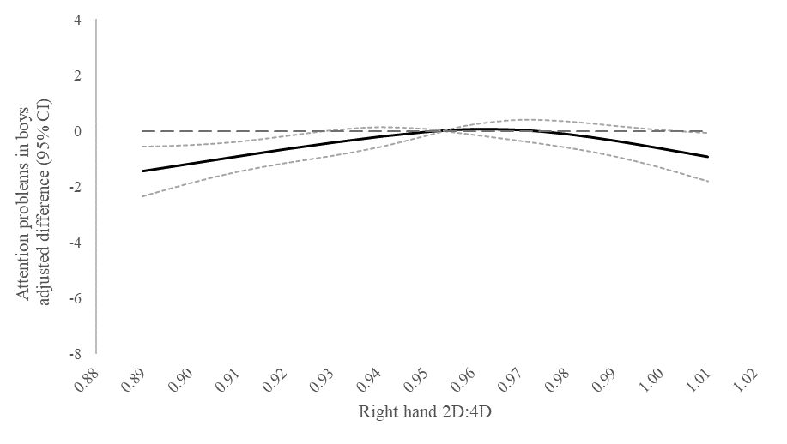
B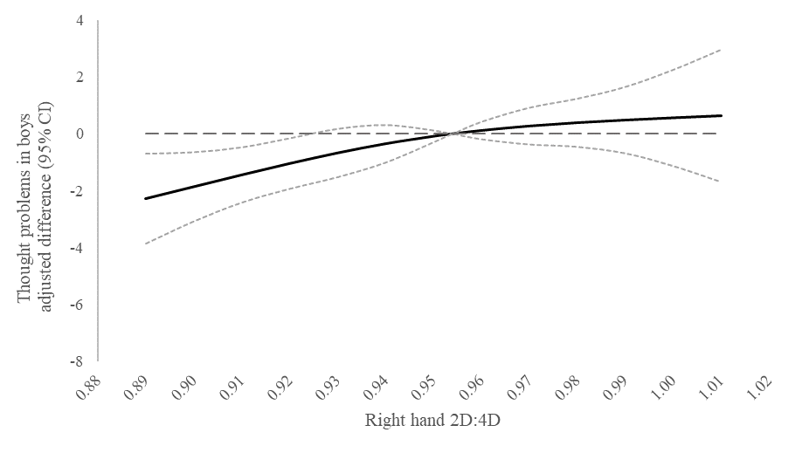
C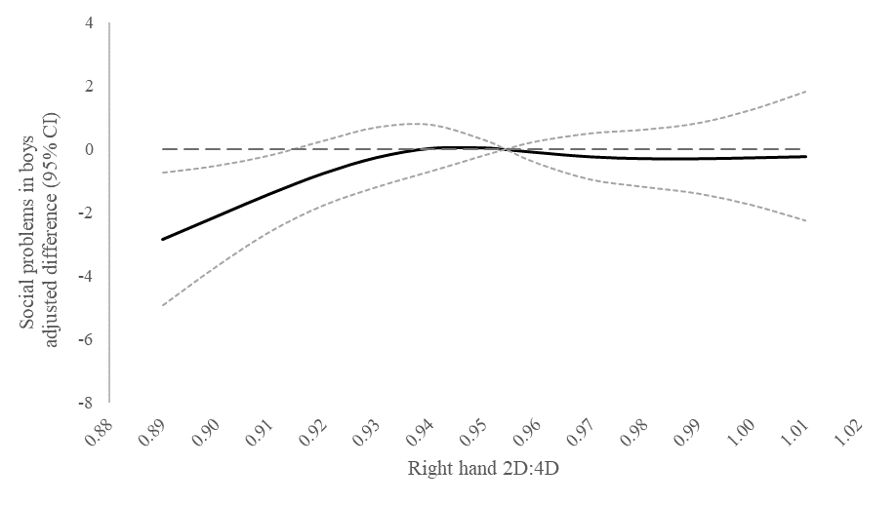

The solid line represents adjusted differences between behavior problem scores at each 2D:4D value and the problem score at the median value of the 2D:4D distribution. Dotted lines represent 95% confidence intervals. Estimates are from multivariable linear regression models with restricted cubic splines. Behavior score is the continuous outcome and predictors include linear and 2 spline terms for 2D:4D, child’s age and handedness, socioeconomic status, presence of food insecurity with hunger in the household, and maternal height. Robust estimates of variance were specified in all models. Complete case analysis (n=448).

Supplemental Figure 2. Adjusted differences in attention (A), thought (B), and social (C) behavior problems according to right hand 2D:4D in girls from Bogotá, Colombia.

A 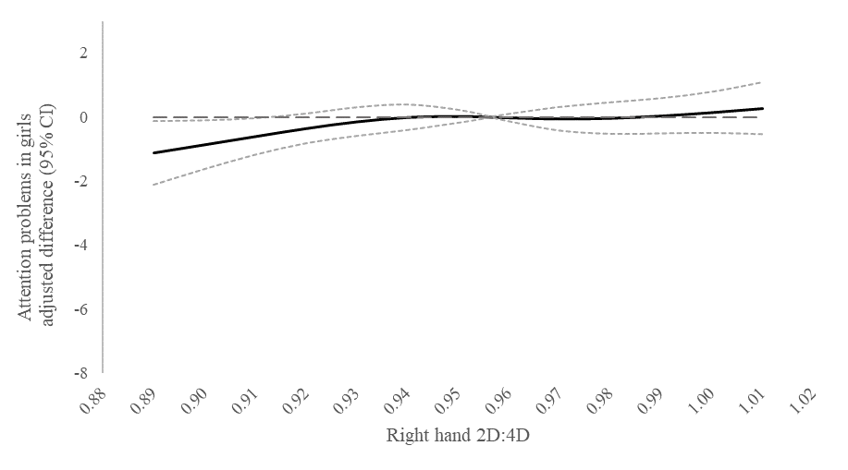
B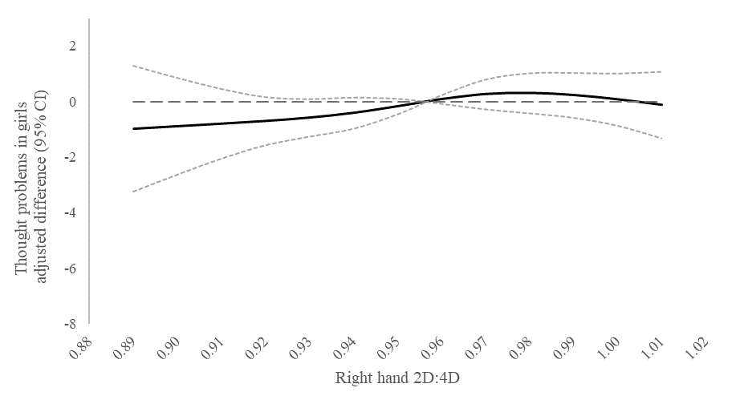
C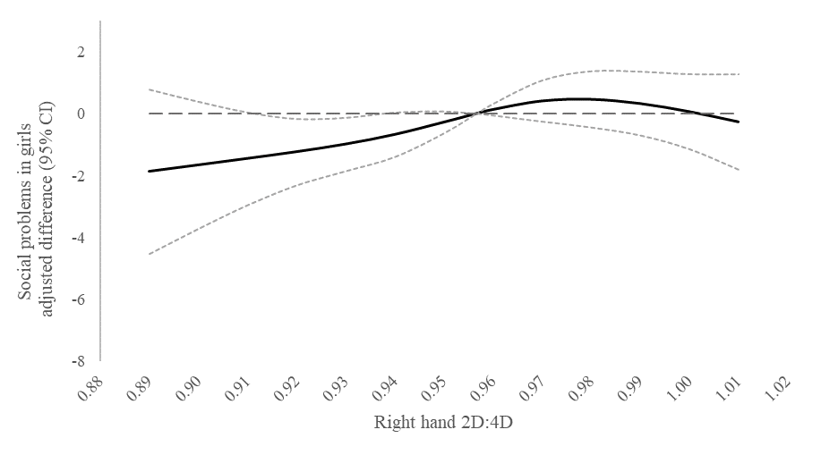

The solid line represents adjusted differences between behavior problem scores at each 2D:4D value and the problem score at the median value of the 2D:4D distribution. Dotted lines represent 95% confidence intervals. Estimates are from multivariable linear regression models with restricted cubic splines. Behavior score is the continuous outcome and predictors include linear and 2 spline terms for 2D:4D, child’s age and handedness, socioeconomic status, presence of food insecurity with hunger in the household, and maternal height. Robust estimates of variance were specified in all models. Complete case analysis (n=569).

